ELR GP Federation Ltd

Chief Operating Officer Report – October 2016

- Induction activities / meetings

I have continued my introduction meetings, including;

- Monthly Practice Managers’ Forum
- Primary care STP
- David Bell (LPT) – MCP lead
- Locality Meetings & Hub Meeting
- UHL - Mark Wightman, Catherine Headley, Ursula Montgomery
- LCC - Public Health (Adrian Allen) & BCF / Integration team (Cheryl Davenport)
- Rutland Council (Karen Kibblewhite, Mark Andrews, John Moreley)
- West Leics & Central Federations & West Leics CCG
- Helen Mather, Elective Care Alliance
- Jackie Thornber, PCL
- CCG team – Tim, Jamie, Paula, Locality Managers
- ELR practice
- LMC – AGM (& won the hamper!)
- Presented at the PPG network meeting on 30th September

I have been invited to join the Integration Executive and GP STP Programme Board. Tim Sacks has also indicated that he would like the Federation to be involved in reviewing the local GP SIP (£5.5M).

Based on these and other conversations - my early observations which I will expand upon are;

- Exciting potential
- Need to specify where we will add value
- Large & diverse patch - locality focus
- Quality people
- General ‘good will’ but there is an engagement challenge
- Sustainability challenge
- Workforce
- CCG commitment
- Facilitator, conductor, make connections
- Work plan categories and ideas

The project areas shown in the table below will be prioritized and converted into a work plan. Each project will need the agreed involvement of key practice staff to draw on the existing expertise and encourage engagement.

(a) Scale efficiencies
- Purchase Direct – non-medicine supplies, utilities, telephones (see below)
- Back office - finance, HR, payroll, legal, recruitment, locum support (clinical & admin)
- ‘Call centre’ – one booking system
- Coding support
- Pharmacy project (see below)
- Medicine management
- GP education & training
- Indemnity / insurance
- Workforce development
- PLT organisation
- Medical equipment testing
- Health & safety support
- Buildings – cleaning, maintenance, security

(b) More services delivered locally / new business
- Urgent care & home visiting
- Prevention services (sexual health, health checks, drug & alcohol brief advice, tobacco)
- Enhanced services – use local skills and resources
- Provider company – planned care

(c) Transformation / innovation
- STP
- Primary care transformation
- MCP - Integrated locality teams – ‘wrap around services’ (Out of Hospital Implementation Group)
- Telemedicine
- General practice development programme

- Projects update

(a) Urgent Care & Home Visiting

- MOU in place with DHU who are leading on the preparation of the bid for 4th November 2016;
- East, West & City Federations will work initially on a sub-contract basis to DHU;
- The West and City Federations are working to create a joint venture with DHU to deliver Lots 1 and 2 respectively in the medium term;
- DHU are working with CPA (ex-SSAFA) to be the main deliverer of the Home Visiting Lot. The Federations may have the opportunity to deliver elements of this on a sub-contract basis.
- We will be part of the consortium bid. Whilst the business opportunities will be limited – it is important to be an active partner, especially as the visiting service is LLR wide and as we look to the ELR Urgent Care Centres coming out to tender in 6 months.

(b) Pharmacy Project

A number of practices have expressed an interest in the opportunity to pool resources in come way to provide pharmacy support. Rysz has engaged with 3 companies who could support us who are preparing proposals for us to consider.

- Prescribing Support Services
- Interface
- Medacy – who have made savings of £250K for one CCG

All could mobilise in 4-6 weeks and baseline all inclusive costs are c £34/ hour before negotiation.

(c) Purchase Direct -‘Reducing cost and saving time’

The Oakham practice has been using Purchase Direct successfully for a number of years. I have approached them and they will offer a Federation deal. There has been a fair degree of interest for the PM group. The key elements of the model are;

- All non-medicine supplies
  - Energy / utilities
  - Telecoms, data & IT
  - General supplies / overheads
- Experienced; > 100 practices, 20 years experience, 85 staff, multiple sectors
- Consultancy, broker and buying group
- Monthly fee – based on list size
- Federation rates
- 3 year contract - guarantee to indentify savings >3 times fee after 6 months – or option to walk away
- Work with each practice on an individual basis
- Benefit from PD’s buying power
- Average saving @ £1 per patient (over a range of practices)
- Oakham; >12% saving on utilities last week
- Potential to contribute to Federation costs on savings over an agreed level – basis TBD
- Savings performance shown in the table below;

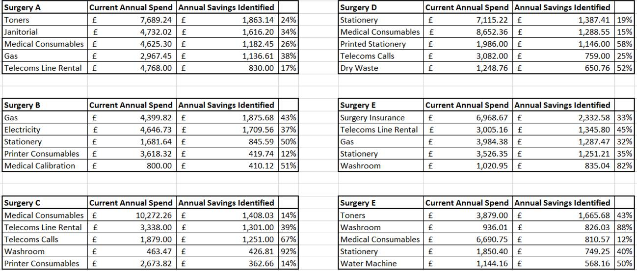

3. Communication

The following comms / initiatives have taken place;
  - COO introduction
  - Online listening form
  - Health news ticker
  - LLR health window on the world
  - Challenge champions
  - Urgent care members update
  - Preparations for the ‘give us your ideas’ campaign – timing TBA

- Board vacancy

Louise Ryan from the Oadby Central practice has applied to join the Board. We will advise the practices in Oadby & Wigston to check whether there is anyone else who would wish to stand.

- Budget

- Tim Sacks has indicated that the CCG will be looking for the budget for FY2016/17 to be reduced by a minimum of £65K and has requested an updated forecast for 16/17 and 17/18.
- Tim has agreed ‘in principle’ that the underspend this year could be carried over to 18/19 and requested that we include this proposal in the updated forecast paper.
- The draft forecasts for FY 2016/17 and FY2017/18 have been updated for discussion.

- Board to Board

- Tim Sacks / Jamie Barrett will be arranging for a Board to Board meeting to take place in November 2016e & Insurance

