ELR GP Federation Ltd

Chief Operating Officer Report – November 2016

- Work plan & strategic considerations

A draft work plan is included in the Board pack for comment. This work plan supports the vision and objectives outlined in the business plan and includes ideas raised by members. This is a first draft and I would welcome Board members’ critique.

The plan has been organised into the four categories listed below. Ideally, each project / works stream will have the agreed involvement of key practice based staff to draw on the their expertise and encourage engagement.

- Scale efficiencies;
- Business development;
- Primary care innovation / transformation;
- Federation matters.

Whilst progressing these areas of work is important – on their own they are unlikely to secure the sustainability of the Federation. As a Board, we need to develop a clear, compelling and owned vision and plan to position the Federation to play a key role in the development of sustainable integrated primary/community care in the ELR context.

In particular, we need to determine the Federation’s role in the development of MCPs / Integrated Locality Teams and Primary Care Homes in ELR. This may need to include formal alliances and partnerships. It is interesting to note that the 3Sixty GP Federation in North Northants (who have been established for approx. 3 years) have merged with their local Community Care / Mental Health NHS Trust in preparation for new models of working, to secure their sustainability and facilitate employment of NHS staff.

- Projects update

(a) Urgent Care & Home Visiting

- The consortium bid for Urgent Care services in the City and West Leics and the Home Visiting Service was submitted on 4th November 2016 – we await feedback. Interviews are scheduled for 6/7 December;
- The West & City Federations have agreed Heads of Terms to form respective Joint Ventures with DHU to deliver Lots 1 & 2 with a 50/50 profit share. This will form the basis of a JV agreement between ELR GP Federation and DHU for the forthcoming Urgent Care services tender for ELR;
- Whilst the business opportunities for ELR will be limited in this procurement – it has been important to be an active partner - as the visiting service is LLR wide and, in particular, as we look to the ELR Urgent Care Centres coming out to tender.
- A positive meeting was held with DHU on 16th November – see email attached at Appendix A. A planning workshop is to be arranged for w/c 12th December 2016 - the Board needs to agree the best team to attend.

(b) Pharmacy Project

Both preferred suppliers have now submitted proposals to support the Federation. A meeting has been held with Medacy to discuss their proposal and a meeting is being arranged with Prescribing Support Services.

Both could mobilise in 4-6 weeks and baseline all inclusive costs are approx £35/ hour.

(c) Purchase Direct -‘Reducing cost and saving time’

The ELR GP Federation Purchase Direct offer has been launched (see attachment at appendix B). This arrangement opens up this opportunity to the 17 practices with a list size less than 10,000 who would not otherwise be able to benefit from this service.

(d) Community Health Services

Leicestershire County Council will let a tender for community health services, including health checks and contraception services on 5th December 2016. The Public Health team has indicated that it would be pleased to receive a Federation bid. A number of practices have indicated that they would be interested to join a Federation bid. One has indicated that they will bid alone – on the basis that they would prefer to receive the full income rather than the Federation take a proportion.

I am liaising with the West Leics Federations who will also be bidding. I have also approached Anne Senior at LPT to possibly assist with the tender administration.

(e) GP SIP

The CCG have confidentially shared their ‘high level’ planning thoughts following an initial meeting – see appendix C. Tim and Jamie have indicated that they would be pleased for the Federation to contribute to this. My understanding is that this needs to be in place for 23rd December 2016 – so time is of the essence.

3. Communication

The following comms / initiatives have taken place;
  - Online listening form launched
  - Health news ticker launched
  - LLR health window on the world launched
  - The ‘give us your ideas’ campaign has been prepared for launch
  - Federation update circulated
  - JM will convert the agreed work plan into an effective comms format and update the website

- Board vacancy

The process has been concluded and we are delighted that Louise Ryan from the Oadby Central practice has agreed to join the Board.

- Budget

- Following the last Board meeting, a budget forecast paper was sent to the CCG (attached at appendix D). We await a formal response and confirmation regarding the principle that the underspend from this year can be carried over to FY18/19.
- However, discussion with the CCG FD indicated that a business case would be required in for this; I have asked Jamie Barrett to advise on the process.
- The forecast for FY 2016/17 has been updated for discussion (appendix E).
- We have now received a remittance advice for the second payment.

- Board to Board

- Tim Sacks / Jamie Barrett have indicated that they will be arranging for a Board to Board meeting to take place in December 2016e
&

Appendix A
Email from Kay Darby – dated, 16th November 2016

Hello James and Gareth

Good to meet you again today and I hope Gareth enjoyed his visit to LUCC

As discussed today

In advance of the east Leicester tender Lot being issued you wish to meet DHU to agree HoT- I will ask Peter Quinn/ Stephen Bateman to make contact with you

East Leicestershire Federation would be looking for similar terms to West & City
You are particularly interested in collaborating on:
- Delivery of some home visiting - particularly to remote areas where this would be more efficient to do so
- Nursing Home education and engagement - linked to the HV service built on the back of the existing network you have created with Nursing Homes in the East
- Provision of medical staff to ‘Lot 4’
- Primary Care engagement and development of pathways

We will start to develop our joint proposition - James to confirm availability for a workshop to scope our delivery model week commencing 12th December

Hopefully that captures the key points

Look forward to seeing you again soon

Regards Kay

Appendix B

ELR GP Federation Ltd

Purchase Direct -‘Reducing cost and saving time’

ELR GP Federation has worked with Purchase Direct to offer its members the opportunity to take part in the Federation scheme to drive efficiencies in the procurement of all non-medicine supplies.

- Purchase Direct

- Over 20 years of procurement experience across a number of sectors in the following categories;
  - Energy / utilities
  - Telecoms, data & IT
  - General supplies / overheads
- Work with > 100 GP practices in the healthcare sector;
- Work with each practice on an individual bespoke basis to identify savings;
- Buying power over multiple industry sectors;
- Average saving @ £1 per patient (over a range of practices) – some examples attached;
- PD have worked successfully with the Oakham practice over a number of years.

- Federation offer

- Monthly fixed fee @ £100 per 10,000 list – pro-rated to the size of the practice (this would increase on a sliding scale for non-federation practices);
- The scheme is available to all Federation members (minimum list size of 10,000 for non-Federation practices);
- 3 year contract;
- Savings guarantee @ 3 times fee after 6 months – or option to walk away / terminate the contract;
- A contribution to the Federation of 5% of implemented savings above the savings guarantee (@ 3 x 6 months fee) OR add 10% to fixed fee.

To take up this offer or for further information - please contact Dawn Langlais from Purchase Direct – M: 07920 565090; E: dawnlanglais@purchase-direct.co.uk) or James Watkins (M: 07805 515782; E: james.watkins@elrgpfed.com).

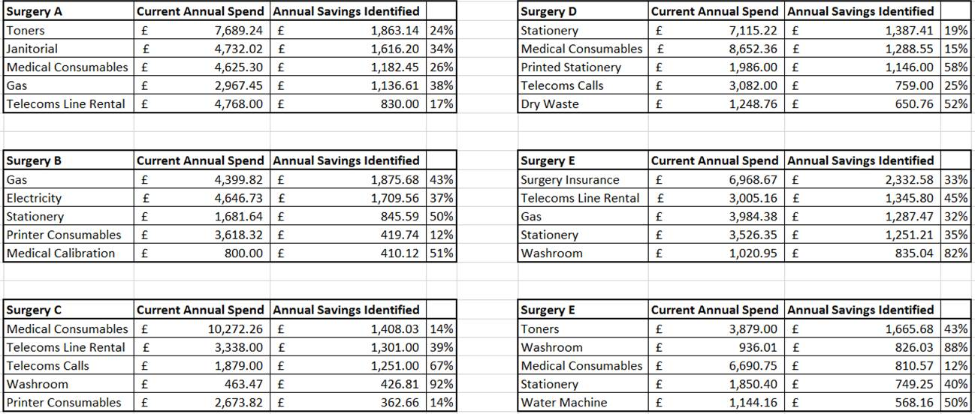

Appendix C

CCG High Level GP SIP thinking

GPSIP Chapters:

LTC/ BTC:
• The GPSIP needs to be the delivery model for these areas. We need to work with the BTC LTC group on exactly what areas we focus on, what are the inputs from General Practice, clinical outcomes etc. This needs to support the pathways, but we ned East level evidence on why these areas and what changes we want to see. This needs to be based on Atlas of variation data and commissioning for value information. This then gives a clear rationale for why this will help ELR patients. This will need to be worked through into KPIs and overall system benefits for QIPP. I think we need to consider whether this is ELR QIPP, or part of the BCT programme that we are delivering
• This will need support from the LTC team in the West, but also using the Public Health team here to support with the local and comparative data.

Mental Health:
• Focus on the national must dos of IAPT and Dementia
• Design KPIs, expectation of Practices and clinical benefits
• National data, Benchmarked and national targets

Emergency Admissions:
• Focus on 2 areas ( both need further work and involvement with clinicians e.g. Tabitha for childrens)
o 2% complex patients- includes care home / housebound / vulnerable
▪ What value added than the DES. An extra annual proactive longer appointment/ MDT to include review of care plan, Meds review, QOF and carer
▪ Link to Care homes and AVS- Education and managing risk
o Children
▪ Managing ultra-short stay admissions by utilising new OOH/ urgent care service- clearer pathway and managing risk
• Need to consider how manage inputs and outcomes, benchmarking locally and nationally and link to the new Integrated teams work. Need public health support on data

Planned Care:
• Needs to be the delivery model for the planned care and demand management work that Hilary is working on.
• Needs to make clear the extra processes and support in place e.g thresholds, pathways, PRISM, Advice and guidance etc.
• Needs local and national benchmarking by speciality
• Plan for practices in relation to Peer review, GP level referral data, clinical evidence for thresholds and referral patterns
• Part of the federation in delivery/ support / twinning- Do we incentivise them?

Other factors to Consider:

Practice specific or Generic / KPIs
• Do we set specific practice targets e.g for every practice to hit a baseline for prevalence, Dementia etc
• Do we have practice and speciality thresholds for referrals- If so what levels and using what evidence / expected benchmarked level targets
• Do we have generic or specific KPIs- pros and cons of both

Finance / Payment on outcomes
• There is just over £6 per patient for this
• There is a need to show both the quality and activity benefits
• Each areas will need to be able to accurately reflect how it delivers improved Outcomes for patients, clinical evidence that right thing to do, supports National, LLR and ELR strategic direction and has an impact on activity. We need to be much smarter and more accurate with how we manage this and count it. This has to be realistic though from bottom up approach based on evidence
• Do we fund this on delivery and if so what. Is it overall, by area, etc. Must be careful to not split it into lots of £0.50ps, but an all or nothing may be too much.

Timelines and process for Engagement – Internal and External
• I feel this needs to be worked through and some of the principles agreed, within the next 2 weeks
• Need to involve Nick, Tabitha and Hilary as a minimum clinically in the first instance
• Need a GP/ Tabitha session set up to run through this by end of November or latest 1st week of December
• Once updated I feel this needs to go to localities in December for practice views and ideas
• Will need to be signed off at January GB
• Sure there are other bits as well that I have missed

Appendix D

FY16/17 Financial Forecast & Way Forward @ October 2016

- Background

- ELR GP Federation expenditure was lower than budget in the first part of FY16/17 -mainly due to the fact that the COO did not take up post until mid-September 2016.
- ELR CCG are looking to reduce expenditure to the GP Federation in FY16/17;
- A financial forecast for FY16/17 has therefore been prepared and is attached at appendix 1 below;
- The proposed way forward is outlined in section 3 below.

2. Comments on the forecast

- The Board, COO, comms, rent, IT and admin related costs are fairly fixed;
- The main variable elements relate to the provisions included for;
  - Project, legal & professional support to deliver business development projects, and
  - Clinical governance / regulation costs (eg, CQC registration - TBC) to set the Federation up as a service provider.

3. Way forward

Following discussion with the CCG, the Federation proposes the following way forward;

- £50K will be held back for FY16/17;
- The forecast will be reviewed at the end of Q3;
- The payment that is held back from the Federation in FY16/17 will be carried forward to FY17/18 and/or FY18/19.

Appendix 1 – Financial Forecast for FY16/17

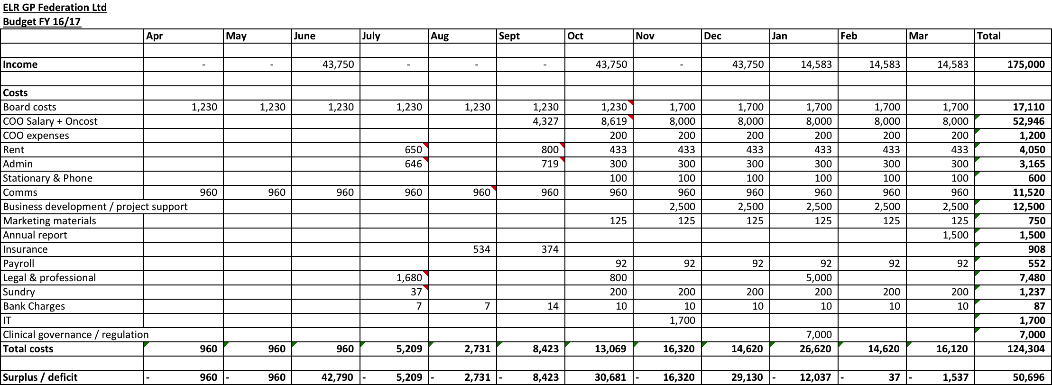

Appendix E
Budget update – November 2016

