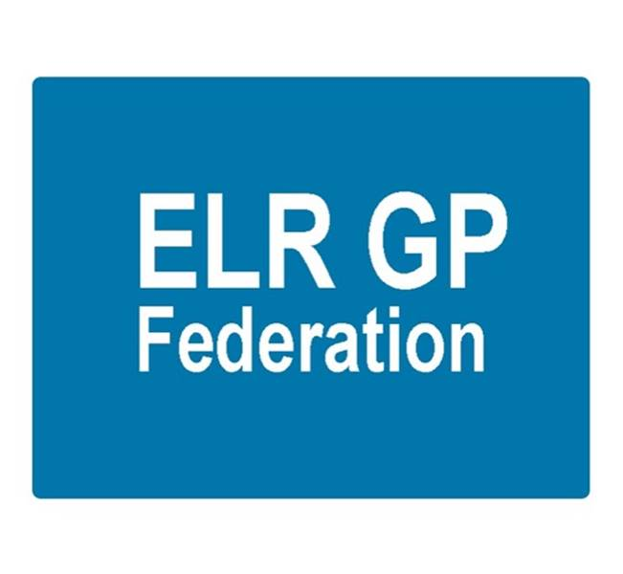

Board meeting
6.30pm Tuesday 13th June 2017 @ Syston Medical Centre
AGENDA

 |  | Paper
 | Apologies
 | Clare Sherman – Head of Primary Care
 | Review of Minutes of the Meeting held on 4th May 2017 | A
 | Matters arising
 | Away day – update from Manny ‘wash-up’ session | B
 | Report from the COO | B, C, D, E, F, G, H, I
 | Urgent care procurement | D
 | Insurance; vicarious liability | B
 | Financial update | Tabled
 | Annual Report and AGM – September 2017 | J
 | STP GP Five Year Forward View update | B
 | Localities update | B
 | PCL update  - H Pylori  - Diagnostics Hubs and Spokes | B  B  I
 | Communications update
 | Conflicts of Interest register
 | Board expenses policy / payroll
 | AOB
 | Date & venue of next meeting

