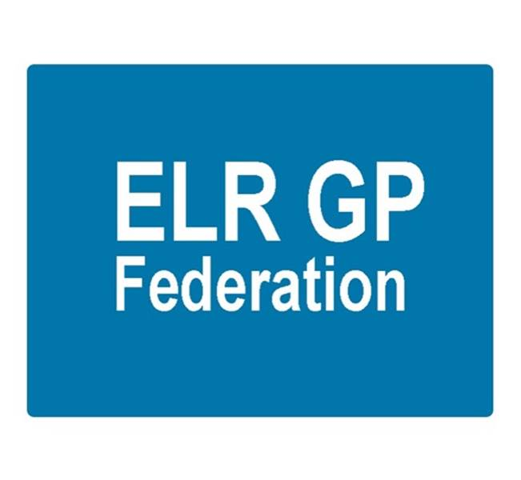

ELR GP Federation Ltd
Meeting 6.30pm Thursday 5th January 2017
Syston Medical Centre
AGENDA

- Apologies

- Review of Minutes of the Meeting held on 24th November 2016

- Matters arising

- Report from the COO

- Feedback from Federation representatives

- New business

- Conflicts of Interest register

- Budget & financial matters

- Communications & PR

10. AOB

11. Date & venue of next meeting

