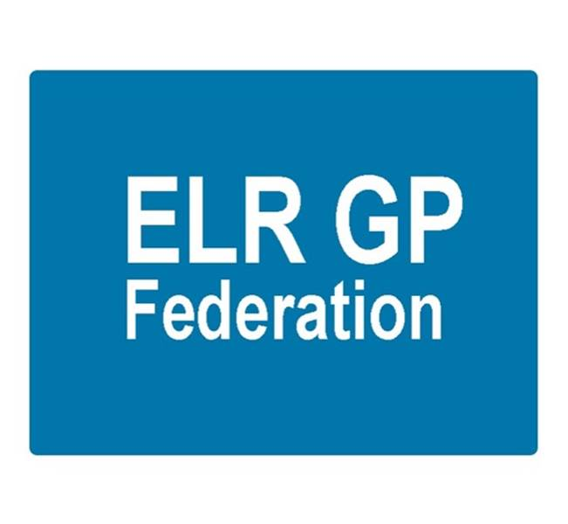

ELR GP Federation Ltd
Meeting 6.30pm Tuesday 7th February 2017
Syston Medical Centre
AGENDA

- Apologies

- Integrated Point of Access – Mark Dewick (presentation slides attached)

- Review of Minutes of the Meeting held on 5th January 2017

- Matters arising

- Report from the COO

- Feedback from Federation representatives

- New business

- Conflicts of Interest register

- Budget & financial matters

- Communications

11. AOB

12. Date & venue of next meeting

