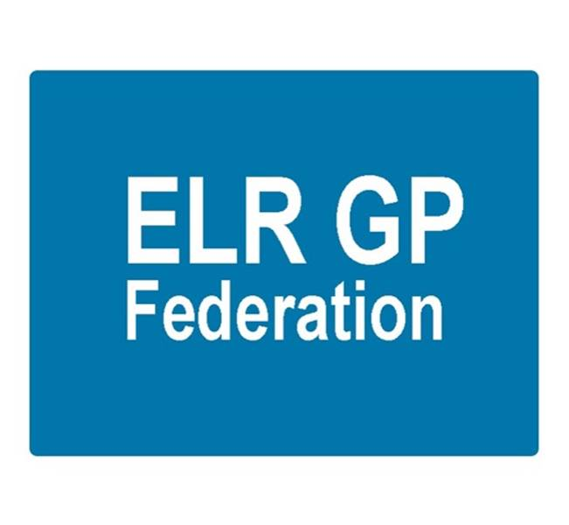

ELR GP Federation Ltd

Meeting 6.30pm Thursday 22nd September 2016

Syston Medical Centre

AGENDA

1. Apologies
2. Review of Minutes of the Meeting held on 24th August 2016
3. Matters arising
4. Conflicts of Interest register
5. Feedback from Federation representation
6. Feedback from Market Engagement Event
7. New business
8. Budget & financial matters
9. Communications & PR

10. AOB

11. Date & venue of next meeting