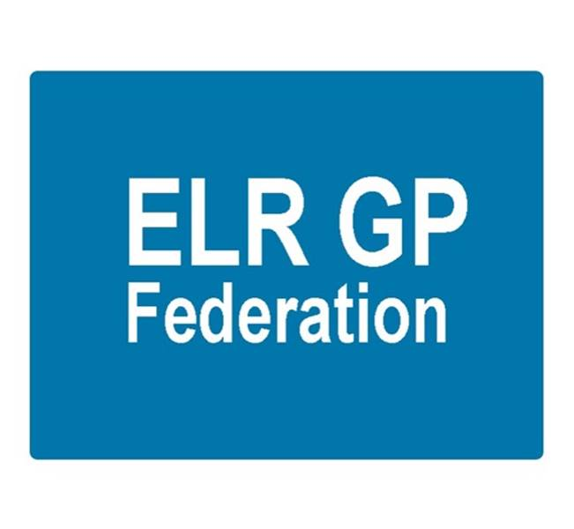

ELR GP Federation Ltd
Minutes of the meeting of The Board of Directors
Thursday 5th January 2017 – Syston Medical Centre

Present: Dr R Bietzk (RB); Dr G Chidlow (GC); Dr L Ryan (LR); Dr N Chotai (NC); Dr S Vincent (SV); Dr A Chahal (AC); J Watkins (JW); J McCrea (JM); H Patel (HP)

In the Chair: Dr R Bietzk

- Apologies
None

- To confirm the minutes of the meeting held on 24th November 2016.
The minutes should be updated to record that the Board formally approved the appointment of Dr Louise Ryan as a Director representing the Oadby & Wigston Locality.

- Matters arising
- AC has joined the LLR PCL Board.
- JW to review the Articles of Association & policies for approval.

- COO Report

4.1 Federation work plan – JW overviewed the updated work plan draft that has been organised into four categories;

- Scale efficiencies;
- Business development;
- Primary care transformation.

Key projects were discussed as below;

4.2 ‘GP SIP’ – A draft GP SIP document has been presented to the Locality Meetings in December 2016. The Board agreed to pursue the possibility of the Federation assisting in the following schemes;

- Demand Management – Action, JW & RB
- Prescribing – Action, JW & NC

In addition, JW / JM to arrange for the waiting times for the community hospitals out-patients to be published on the ELR GP Federation website – potentially, creating a ‘resource area’ – and in our regular news letter. Action JW / JM.

4.3 Urgent care tender

- The process for the City Hubs (Lot 2) has been suspended and will be re-procured.
- The decision on the West Leics urgent care centres and the home visiting service has been delayed.
- The indications are that the ELR urgent care procurement process will be delayed with a likely start date now set for April 2018.
- A ‘workshop’ was held with DHU on 15th December 2016 to discuss the ELR urgent care centres. The pressure on this process has reduced in light of the likely delay to the procurement process.

4.4 Pharmacy project – Prescribing Support Services have been appointed as the Federation’s preferred provider and the scheme launched to practices in December 2016. Two Oadby practices have signed up to the scheme.

Tim Sacks has confirmed that it will be acceptable for practices to use this scheme for a six month pilot period from January 2017 – despite the SLA documentation stating that prectices need to directly employ pharmacists from January 2017.

JW to circulate further comms. Action, JW.

4.5 Purchase Direct scheme – the Federation offer has been finalized and launched – opening the scheme to the 17 practices with a list size less than 10,000. Over two thirds of our practices have arranged to meet with Purchase Direct.

  - Community Based Services procurement – the tender is due to be submitted 13th January 2017. At the time of the Board meeting 10 practices had confirmed that they would bid with the Federation and further practices will be named as sub-contractors for the purpose of inter-practice referrals for IUD/IUS/SDI services.

JW/GC to finalise the bid.

  - GP Teaching Academy – JW and AC are working to produce a Federation bid in conjunction with the practices who have expressed an interest. Applications are due to be submitted on 14th January 2017. Action JW / AC.

  - Improving Access to General Practice scheme – The Federation has been awarded a contract to manage the scheme to administer this scheme to provide additional on the day urgent appointments to alleviate the pressure on the urgent care and emergency department system over the winter period. Action JW.

  - Integrated Locality Teams – Four integrated locality teams are planned in ELR;

- Melton & Rutland
- Market Harborough
- Oadby & Wigston
- Blaby & Lutterworth

These will require effective federated working between primary care providers and represents an opportunity for the Federation to perform a key role in supporting the development of this initiative. The Federation has a seat on the ‘Out of Hospital Board’, chaired by Andy Ker, that oversees this work in ELR.

Currently, JW attends the Blaby & Lutterworth Leadership Team; LR attends Oadby & Wigston.

  - Vision, Strategy and Board Development – Areas for development;
- Locality Meetings are a ready made forum to facilitate federated working between practices. Tim Sacks will be reviewing with Andy Ker.
- CCG can assist with the development of federated working between practices by ‘formalising’ projects that require the Federation to work with its shareholders – eg, the ‘winter money’ contract.
- We should invest in ‘Board development’ to clarify the purpose and vision and team working arrangements. Action JW.

  - Board to Board meeting – 2nd February 2017 offered. Directors cannot make this date so JW will rearrange. Action JW.

- Conflicts of Interest Register
To be completed. Once finalized, JM will arrange for it to be added to website.

- Feedback from Federation Representation

RB updated that Rutland had been successful in its application for the Primary Care Home pilot.

- Budget & Financial matters

HP confirmed that we within the budget and a budget update will be circulated with the minutes. Action: JW / HP.

The Board approved that;
- JW be set up as a signatory on the bank account
- HP arrange for internet banking to be set up
- JW to have authorization limit up to £10,000

JW to draft company authorization levels for formal Board approval. Action JW.

- Communications & PR
- The Board approved the establishment of the online discussion fora as per JM’s paper
- JM to work with LR on a short video to help communicate the purpose of the Federation. Action JM / LR.
- JW / JM to develop the website to provide information on training / research events and courses / investigate providing a locum service to members. Action JW / JM.

- Date & venue of next meeting

Tuesday 7th February 2017 at 6.30pm at Syston Medical Centre.

