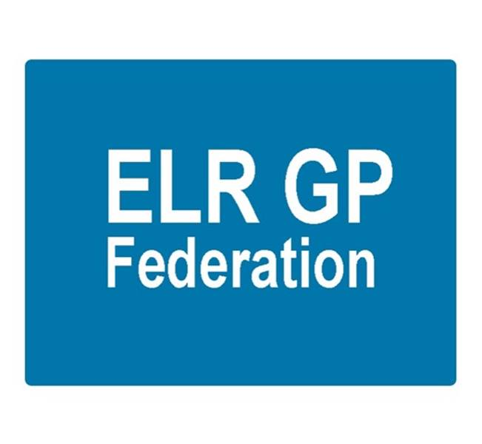

ELR GP Federation Ltd
Minutes of the meeting of The Board of Directors
Thursday 24th November 2016 – Syston Medical Centre

Present: Dr R Bietzk (RB); Dr G Chidlow (GC); Dr L Ryan (LR); Dr N Chotai (NC); Dr S Vincent (SV); Dr A Chahal (AC); J Watkins (JW); J McCrea (JM)

In the Chair: Dr R Bietzk

Louise Ryan was welcomed to her first Board meeting.

- Apologies
H Patel

- To confirm the minutes of the meeting held on 27th October 2016.
Confirmed as an accurate record.

- Matters arising
- NC advised that he will not join the LLR PCL Board. AC indicated that he will pursue this.
- JW to review the Articles of Association & policies for approval.

- COO Report

4.1 Federation work plan – JW overviewed the draft that has been organised into four categories;

- Scale efficiencies;
- Business development;
- Primary care transformation.

Comments to be forwarded to JW.

4.2 ‘GP SIP’ – CCG ‘high level’ thoughts were circulated which will be developed for consultation in December 2016.

It was noted that West Leics CCG had contracted with their GP Federations to manage their prescribing SIP. It was agreed that ELR Federation should propose that it takes a similar role in ELR. JW/NC to progress.

4.3 Urgent care tender – the consortium led by DHU and including Federations across the City, East & West Leics was submitted on 4th November 2016 and interviews are scheduled for 6/7 December. Heads of Terms have been developed between DHU and the City and West Leics Federations respectively in respect of establishing Joint Ventures to deliver Lots 1 & 2. These will form the basis for the working arrangement between ELR GP Federation and DHU for ‘Lot 4’ (ELR urgent care centres) which is anticipated to be released in March/April 2017.

JW to offer DHU 15th December @ 1830 at Melton hospital for the workshop to start planning for the ELR urgent care centres tender. The Federation team will be Gareth, Simon, Rysz and James.

4.4 Pharmacy project – Interview held with Medacy; Prescribing Support Services scheduled for 25th Nov. The Board agreed for RB/JW to make the final decision and launch the scheme to practices.

NC noted that the practices’ contract requires pharmacists to be directly employed from April 2017. JW to clarify.

4.5 Purchase Direct scheme – the Federation offer has been finalized and launched – opening the scheme to the 17 practices with a list size less than 10,000. Initial interest from 10 practices.

  - Community Based Services procurement – the tender is due to be released on 5th December 2016. Some practices have indicated that they will bid themselves on the basis that they wish to retain the full income within their practice rather than the Federation take a proportion.

The Board confirmed that the Federation should progress with a bid for these services with interested practices. In addition, the Federation should facilitate inter-practice referrals for IUD/IUS/SDI services. JW/GC to progress.

4.7 Training – It was agreed to investigate the possibility of forming a Federation GP Training Academy and involving in pharmacists training. JW to progress.

4.8 Board to Board meeting – to be arranged for early 2017.

- Conflicts of Interest Register
To be completed. Once finalized, JM will arrange for it to be added to website.

- Feedback from Federation Representation

The LLR Sustainability and Transformation Plan (STP) has been launched and focuses 5 priority areas;
- New models of care focused on prevention and moderating demand growth;
- Service configuration to ensure clinical and financial sustainability;
- Redesign pathways to deliver improved outcomes for patients and deliver core access and quality;
- Operational efficiencies;
- Getting the enablers right.

- Budget & Financial matters
JW presented the budget forecast and associated assumptions.

The budget forecast paper has been sent to the CCG outlining the principle of carrying forward an ‘underspend’ resulting from the slow start to the FY16/17 into subsequent year(s). We await a formal response.

- Communications & PR
- JM to upload the link to the STP on the website.
- Further work is required to explain the purpose of the Federation and how it differs from the CCG.
- Suggested that JM work on a short video to help communicate the purpose of the Federation.
- AC suggested that the website provides information on training / research events and courses and provides a locum service to members.

- AOB

- JW reported that the CCG had approached the Federation to assist with coordinating training for reception staff.
- RB suggested that the Federation investigate facilitating police checks on behalf of member practices.

- Date & venue of next meeting

Thursday 5th January 2017 at 6.30pm at Syston Medical Centre.

