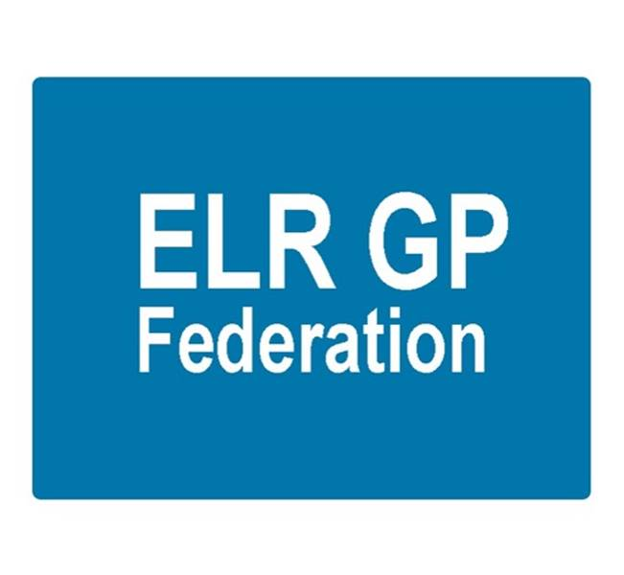

ELR GP Federation Ltd
Minutes of the meeting of The Board of Directors
Thursday 4th May 2017 – Syston Medical Centre

Present: Dr R Bietzk (RB); Dr G Chidlow (GC); Dr N Chotai (NC); Dr S Vincent (SV); J Watkins (JW); H Patel (HP), J McCrea (JM)

In the Chair: Dr R Bietzk

- Apologies
Dr A Chahal, Dr L Ryan

- To confirm the minutes of the meeting held on 7th February 2017.
The minutes were confirmed as an accurate record.

- Matters arising
- JW to review the Articles of Association & policies for approval. Action, JW – 6 weeks.
- Demand Management proposal – awaiting feedback from CCG. Action, JW.
- Board to Board meeting – went well – see COO report. Important to promote our achievements. Action JW / annual report.
- Comms circulation – JM to advise on management of circulation lists. Action JM.
- JW has met with Rachel Billsborough and Anne Senior from LPT – who suggested that it would be useful to hold a Board to Board event. Action JW/RB.

- Away Day Outcome

The Board confirmed that the outputs from the Away Day session, as summarized in Board Paper B, accurately reflect the Board’s vision for the Federation and the key relationships, roles and responsibilities of Board members to progress the Federation’s agenda.

Next steps;

- RB/JW to meet Manny for ‘wash up’ session. Action JW/RB
- In relation to developing working relationship with the Localities;
  - RB/JW to meet with Girish Purohit to discuss involvement in MRH Locality. Action JW/RB.
  - JW to work with LR in O&W and approach the Locality Chair. Action LR/JW.
- JW/AC to work with Paula Vaughan to establish the Harborough ILT. Action AC/JW.
- GC to lead on Planned Care. Action GC.
- AC to take the lead in education and training. Action AC.
- RB to consider doing 1 session per fortnight for the Federation. Action RB.
- Determine the best approach to communicating with our members. Action JW/RB/JM.

- COO Report

  - Pharmacy project – The Prescribing Support Services scheme is progressing well with the two Oadby practices who have signed up.

The CCG has confirmed that it will be acceptable for practices to use this scheme until the end of September 2017. A number of ELR practices use a similar organisation, MMS, to provide their pharmacist. It is likely that a procurement process will be undertaken to determine a preferred provider. The Federation may be asked to be involved in this process.

  - NHS England; Clinical pharmacists in general practice – JW to progress with interested practices. Action, JW.

  - Purchase Direct scheme – 16 practices signed up. Over £90K of savings identified.

  - Community Based Services procurement –The Federation bid for the Leicestershire County Council community based services, including health checks, alcohol reduction and contraception was successful. 12 practices bid with the Federation and a further seven practices were named as a sub-contractor to the Federation to enable inter-practice referrals for IUD/IUS/SDI services. LCC have also confirmed that a further two practices (who did not bid as part of the procurement process) will be added to the Federation contract.

We await the formal contract documentation.

  - Improving Access to General Practice scheme – The Federation was awarded a contract by ELR CCG to manage the Improving Access to General Practice scheme – to increase access to primary care for an 8 week winter period (9th January to 3rd March 2017) – with a target of providing 5,144 additional bookable URGENT 'on the day' appointments, with no reduction in other appointments or activity (including extended hours).

We exceeded the target for additional appointments and all participating practices have been paid for their additional work (£82.5K budget). Consideration will be given to organizing a Federation offer before next winter – so that we are prepared to respond to a similar opportunity.

  - ELR GP Federation Teaching Academy – The ELR GP Federation Teaching Academy was not awarded a contract for third year student placements but we have been encouraged to consider other opportunities including;

- Very Early Clinical Experience (VECE) for first year students – 2 week practice placement
- Compassionate, Holistic Diagnostic Detective (CHDD) course
- Fifth year apprenticeship – 6 week practice placement for senior students
- Student Selected Components and electives
- Mentoring
- Examining

  - Kingsway ‘clinical top up service’ – The Federation has been awarded a contract to provide short term support to the Kingsway surgery team to provide GP, ANP, nurse support over four months. We are working well with the practice and have identified additional GP and ANP sessions.

  - Other back office projects –
- Draft buildings management offer has been prepared which needs finalizing for consultation
- Working with Locktons on an insurance offer for consideration
- Approached the ‘Bristol Locums’ provider – awaiting feedback

- Urgent Care Procurement

- The ELR Urgent Care services procurement is likely take place for a start in April 2018 (this could be pushed back as far as October 2018 if public consultation is required).
- Both DHU and Vocare, the incumbent, will bid for this work.
- Gareth and James have held positive meetings with DHU who are keen to partner with the Federation on a similar basis to that employed in the West Leics urgent care centres. The summary outline of this approach was included in the Board pack. Further information in relation to the Heads of Terms, clinical commitment, Federation responsibilities and financial model to be sought. Action JW/GC.
- Rysz and James will meet with Vocare, who are also keen to partner with the Federation in this tender process. Vocare have also suggested that we work with them to support the effective delivery of urgent care services to our patients within their existing contract. Action RB/JW.
- NC/SV to approach Dr Dick Hurwood in relation to the progress on urgent care. Action NC/SV.
- The Board needs to determine its strategy thereafter. Action all.

- Insurance; vicarious liability

The Public Health CBS contract requires medical malpractice insurance up to £2M.

LCC are content to rely upon the individual practitioners and practices indemnity arrangements and our practices have been providing these details. Our insurers have suggested that the Federation should hold its own insurance for medical malpractice vicarious liability. The Board agreed that this should not be necessary but directed that JW ensure that the sub-contracting arrangements with practices clearly states the requirement to hold appropriate clinical negligence insurance arrangements. Action JW.

- Financial update

- FY 2016/17 out turn was summarized;
  - Income @ £195K including the winter capacity scheme. A reduced final payment @ £21K was agreed with the CCG, reflecting the late start of COO etc.
  - A small surplus will be reported.
  - HP to finalise the accounts which will be reviewed by our accountants. Action HP.

- The FY2017/18 budget forecast was reviewed by the Board.

- HP updated the Board regarding potential VAT implications of some of the Federation schemes. HP/JW are working with our accountants on this issue. Action HP/JW.

- Communications update
- JM to finalise arrangements for the online discussion fora as per JM’s paper. Action, JM.
- JM/JW to draft the annual report. Action, JM/JW.
- Configure Campaign Monitor to communicate with patient group – including the PPG Chairs. Action, JW / JM.
- Meet with North Staffs GP Federation. Action, JW / JM.
- JM to update the GP lists. Action JM.
- JM to advise on process in relation to circulating future comms with GPs. Action JM.

- Annual report and AGM

JW to check when an AGM needs to be held with a view to holding it in September 2017. Action JW.

- 5 Year Forward View update

The ‘Blueprint for General Practice’ document has been launched to guide the delivery of the GP Five Year Forward View agenda in LLR; laying out the vision for sustainable General Practice over the next five years. Fundamental to this vision is retaining General Practice at the heart of the model and that practices will come together to meet patients’ needs at scale. The Federation is stated as being a key element in the delivery of this vision and plan.

As such, the Federation is a member of the Programme Board (JW & RB) tasked with delivering this plan. As part of this work, we are working on a guidance / tool kit document to demonstrate the areas that practices could work together to provide practical tools / templates for practices who wish to work at scale. Action JW.

- Localities update

There are four ILTs in ELR which will require effective working between primary care providers, LPT, social services and third sector providers. Update;

Oadby & Wigston; Louise is a member of the Leadership Team that is looking at improved working arrangements with Care Homes.

Blaby & Lutterworth; James is a member of the Leadership Team. The group is working on a number of initiatives, including;

- MDT teleconferencing / Skype
- MDT care homes / ward round
- UTI project with UHL Geriatrician
- Blaby DC disease prevention project
- Active Blaby

Melton, Syston and Rutland; Initiatives include;
- Rutland experience / wellbeing workers / primary care home
- Melton DC workers embedded in the practice

Harborough; Anuj has agreed to help set up a Leadership Team and is working with the CCG accordingly.

- PCL update

GC update the Board;
- A number of AQP contracts will be transferring to PCL from July 2017. The intention is for H Pylori breath tests to be commissioned via the Federations.
- A diagnostic hubs and spokes model is being developed, with the hubs being focused on the community hospitals.
- Community physiotherapy arrangements will change in October 2017.

- Conflicts of Interest Register

HP completed. JM will arrange for it to be added to website. Action JM.

- Board expenses policy / payroll

It has been confirmed that IR35 does not apply to Federations. The Board agreed that Directors will continue to submit claims as currently.

- Date & venue of next meetings

Thursday 13th June 2017 – Board meeting at Syston Health Centre.

