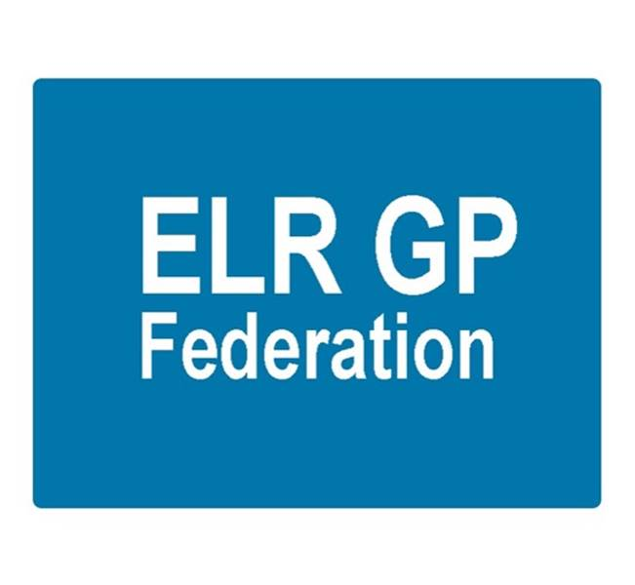

ELR GP Federation Ltd
Minutes of the meeting of The Board of Directors
Thursday 7th February 2017 – Syston Medical Centre

Present: Dr R Bietzk (RB); Dr G Chidlow (GC); Dr L Ryan (LR); Dr N Chotai (NC); Dr S Vincent (SV); Dr A Chahal (AC); J Watkins (JW); H Patel (HP)

In the Chair: Dr R Bietzk

- Apologies
J McCrea

- Integrated point of access
Mark Dewick presented an update on this project.

- To confirm the minutes of the meeting held on 7th February 2017.
The minutes were confirmed as an accurate record.

- Matters arising
- JW to review the Articles of Association & policies for approval. Action, JW.

- COO Report

  - Federation work plan – the updated work plan was included in the Board pack and the key issues were discussed as part of the COO report.

  - Urgent care tender – It was agreed that discussions should be continued with DHU and Vocare in preparation for the likely Urgent Care service procurement for East Leicestershire and Rutland. Indications are that the procurement process will be timed to allow start date in April 2018. An options paper will need to be prepared. Action, RB, GC, JW

  - Pharmacy project – The Prescribing Support Services scheme is progressing well with the two Oadby practices who have signed up. A pharmacist started in January 2017 to work between the two practices.

Tim Sacks has confirmed that it will be acceptable for practices to use this scheme for a six month pilot period despite the SLA documentation stating that practices need to directly employ pharmacists from April 2017.

  - NHS England; Clinical pharmacists in general practice – JW to email practices to ascertain the level of interest in a joint Federation bid. Action, JW.

  - Purchase Direct scheme – following the launch of the Federation offer, over two thirds of our practices have arranged to meet with Purchase Direct. Initial feedback is that good savings are being identified for those that have signed up to the scheme.

  - Community Based Services procurement – the Federation bid has been submitted. 12 practices bid with the Federation and a further seven practices were named as a sub-contractor to the Federation to enable inter-practice referrals for IUD/S and SDI services. The contract is due to start in April 2017. We await feedback.

  - Improving Access to General Practice scheme – The Federation has been awarded a contract to manage the scheme to administer this scheme to provide additional on the day urgent appointments to alleviate the pressure on the urgent care and emergency department system over the winter period. The scheme is progressing well with two thirds of practices taking part. Action, JW.

  - ELR GP Federation Teaching Academy – an application for ELR GP Federation Teaching Academy has been submitted to Leicester University. The Academy is made up of seven practices; Enderby, Two Shires, Forest House, Billesdon, Wycliffe, The Limes and Glenfield. We await feedback.

  - GP SIP – the Federation has submitted a proposal to lead the demand management element. We await feedback. Action, JW / RB.

  - Integrated Locality Teams – Four integrated locality teams are planned in ELR;

- Melton & Rutland
- Market Harborough
- Oadby & Wigston (Louise Ryan attends)
- Blaby & Lutterworth (James Watkins attends)

These will require effective federated working between primary care providers and represents an opportunity for the Federation to perform a key role in supporting the development of this initiative. The Federation has a seat on the ‘Out of Hospital Board’, chaired by Andy Ker, that oversees this work in ELR.

  - STP – GP Five Year Forward View Programme Board – The Federation is part of this Board which is focused on transforming approaches to primary care delivery in LLR.

  - Vision, Strategy and Board Development – Areas for development;

- Locality Meetings are a ready made forum to facilitate federated working between practices. Tim Sacks will be reviewing with Andy Ker. Action, RB, JW to follow up.

- A ‘Board development’ will take place on 30th March to clarify the purpose and vision and team working arrangements. JW to organize a facilitator and venue. Action, JW.

  - Board to Board meeting – 2nd February 2017 offered. Scheduled for 23rd February 2017. Rysz, Louise and James to attend. Action JW, RB, LR.

- Conflicts of Interest Register
To be completed. Once finalized, JM will arrange for it to be added to website.

- Budget & Financial matters

The Board reviewed the budget update and noted that the Federation will be underspent for FY16/17. JW will liaise with Donna Enoux (ELR CCG FD) regarding the end of year position. Action, JW.

JW to draft company authorization levels for formal Board approval. Action JW.

- Communications & PR

- JM to finalise arrangements for the online discussion fora as per JM’s paper. Action, JM.
- JM to draft the annual report. Action, JM.
- JW / JM to follow up on the ‘Bristol Locums’ idea. Action, JW / JM.
- Consider how to involve patient groups with the work of the Federation. Action, JW / JM.
- Arrange a meeting with North Staffs GP Federation. Action, JW / JM.

- AOB

- Coordinate meeting with LPT. Action, JW.

- Date & venue of next meetings

Thursday 30th March 2017 – Board Development session at College Court.
Thursday 4th May 2017 – Board meeting at Syston Health Centre.

