Leicester, Leicestershire & Rutland health and social care
Delivering the General Practice 5 Year Forward View across LLR - models of care and contract mechanisms in General Practice
Considerations for Practices wishing to work at scale

J Watkins
4/21/2017

FIRST DRAFT FOR DISCUSSION AND COMMENT

CONTENTS

 | Page
- Introduction | 2
- Practical considerations for joint working between practices (yet to be completed) | 3
- Practical considerations for mergers between practices | 4
- GP Federations | 6
- Multispecialty Community Provider (MCP) | 7
- The Primary Care Home | 9
- An overview of the vanguard sites | 10
- An overview of local LLR projects | 26
- Sources | 27
Appendices
Appendix A – The Four levels of the MCP Care model | 28
Appendix B – MCP contractual models. | 29
Appendix C – 10 High Impact Actions | 30

- Introduction
LLR’s Blueprint for General Practice lays out the vision for the development of General Practice over the next five years. Fundamental to this vision is that General Practice with registered lists will remain at the heart of the model and that practices will come together to meet patients’ needs at scale.
This paper summarises the key market changes in General Practice and the drivers for closer working at scale, the options for working at scale and an overview of the;
- Practical considerations for joint working between practices
- Practical considerations for mergers between practices
- Opportunities for working with Federations
- Multispecialty Community Provider (MCP) new care model and contract issues
- Primary Care Home model
- Vanguard sites
- Local LLR projects

Market changes in General Practice
- Trend away from the ‘traditional’ small business model
- GP Five Year Forward View encouraging primary care at scale and new contract models
- New voluntary contract for practices of Federations covering at least 30,000 patients and offering 7 day services.
- Alternative Provider contract - new larger organisations and super-practices
- Out of hospital care
- New Care Models providing closer integration between providers – eg, Multispecialty Community Provider
Drivers for closer working between practices
- Succession planning; retirement of partners
- Unsustainable workloads for Partners
- Desire for larger or better premises
- Offer a wider range of services
- Benefit of sharing staff and expertise and building an MDT
- Gain more influence in the local healthcare economy
- Opportunity for a more business-led management structure
- Opportunity to increase list size and practice income
- Respond to the challenges arising from 5 Year Forward View
Options for achieving the benefits of working at scale include;
- Networks / clustering – either informally or through a contractual mechanism
- Federations – practices retain separate partnership deeds
- Mergers of practices – key considerations outlined below
- Salaried models – such as the Hurley Group with 80 salaried GPs and four partners
- Vertical integration – with hospital or community providers delivering primary care (eg, Northumberland, Waveney and North Essex
- Super-partnerships – eg, Lakeside, Corby (100,000 patients); Vitality, Sandwell (70,000 patients); Our Health Partnership, Birmingham. The Suffolk GP Federation has set up a super-practice of 14 practices serving 112,000 patients.
- Practical considerations for joint working between practices
To be completed – to include;
Guidance / framework for joint clinics and inter-practice referrals (eg, minor surgery / coil fitting);
- IT / inter-operability issues
- Consent / patient registration issues
- Information governance
- Clinical governance
- Indemnity
- Contract and financial mechanisms
- Comms and engagement

** The West Leicestershire Federations have developed a framework for inter-practice referrals and we will draw on this work. **

- Practical considerations for mergers between Practices

  - Potential advantages of merger
- Greater economies of scale and flexibility
- Ability to offer greater specialisation
- Wider skill mix
- More attractive, flexible and diverse career, training and employment options
- Rationalisation and harmonisation of clinical and administrative practices and policies
- Rationalisation of ‘back office’ support; management, IM&T, buildings
- Potential or joint ventures with other GP or NHS organisations
3.2 Potential disadvantages of merger
- Lack of openness and transparency
- Relationships breakdown
- Time consuming and expensive
- Liabilities belonging to each practice
- Loss of GP influence and control in a larger organisation
- Outside the ‘comfort zone’ of GPs
- Loss of tradition / history
- Patients may have difficulties in accessing services
- Staff concerns
- Initial decline in income due to profit sharing arrangements
3.3 Key criteria for successful joint working / merger
- Openness and transparency and TRUST
- Jointly owned vision / mission and values
- Clearly articulated objectives / business case
- Effective project management
- Effective engagement and communication with all stakeholders (Partners, staff, patients, NHS England, CCG, CQC)
3.4 Key considerations / checklist for merging practices
- All merger applications require approval by NHS England / CCG and the CQC – so involve them early
- The NHS England Area Team will assess the following (Refernce; NHS England Policy – Managing regulatory and contract variations);
  - Core contracts
  - Benefits to patients
  - Costs
  - Premises
  - Additional services / out of hours services
  - Procurement regulations
  - IT & telephone systems
- CQC – will look at who is responsible for delivering the regulated activity. The CQC process will take 8-10 weeks. A merger will trigger one of two scenarios;
  - Registration for a new provider, or;
  - Change in registration for an existing provider
- Contract arrangements for each practice (GMS, PMS, APMS). Options include;
  - Each party becomes a party to the other party’s contract by varying each contract.
  - Terminate Practice A’s existing contract and vary Practice B’s contact to include Practice A’s partners as party to the contract.
  - The parties enter into a new contract and existing contracts are terminated.

- Legal entity – options include;
  - Partnership agreement between partners
  - Company limited by guarantee
  - Company limited by shares

- Premises issues;
  - If owned;
    - Who are the owners
    - Personal ownership or asset of the partnership they operate in
    - Will the ‘merged practice’ buy the premises
    - Will new partners be expected to buy in
    - How will the premises value be determined
    - Will a ‘lease back’ be agreed
    - Who will be responsible for repairs and maintenance
  - If leased;
    - Is there a lease in place
    - What are the terms of the lease (break clause, provision for rents to track the level of reimbursement, provision to assign the lease, repair & maintenance obligations, service charges)
    - Historic liabilities (eg, dilapidations)
- Decision making structure – this is especially important within a large practice. Often partners may create an elected executive body to make decisions on behalf of the practice. This can be set out in the partnership agreement.
- Retiring partners
- Employment and TUPE issues – If TUPE applies, there are two key obligations set out in the Transfer of Undertakings (Protection of Employment) Regulations 2006;
  - Duty to inform and consult with staff and/or staff representatives (Regulation 13(2))
  - Duty to notify to the transferee any employee liability information no less than 28 days before transfer (Regulation 11)
- Pension issues – each contractor is regarded as an Employing Authority (EA) under the NHS Pension Scheme and is allocated a unique EA code.
- IT systems, telephones and software – appropriate harmonisation arrangements will need to be agreed.
3.5 Process and project management
Key elements of an effective process;
- Shared vision and values
- Project team
- Robust business case
- Clear business plan and timescales
- Patient consultation
- Non-disclosure agreement
- Heads of Terms
- Merger agreement (Business transfer agreement)
- Partnership agreement

- GP Federations

Many of the benefits of joint working at scale can be achieved through the formation of GP Federations which also allow individual practices to retain their autonomy. Practices across LLR have joined together to form a number of GP Federations in the form of Companies Limited by Shares. These Federations are key vehicles to enabling practices to realise the benefits of scale;
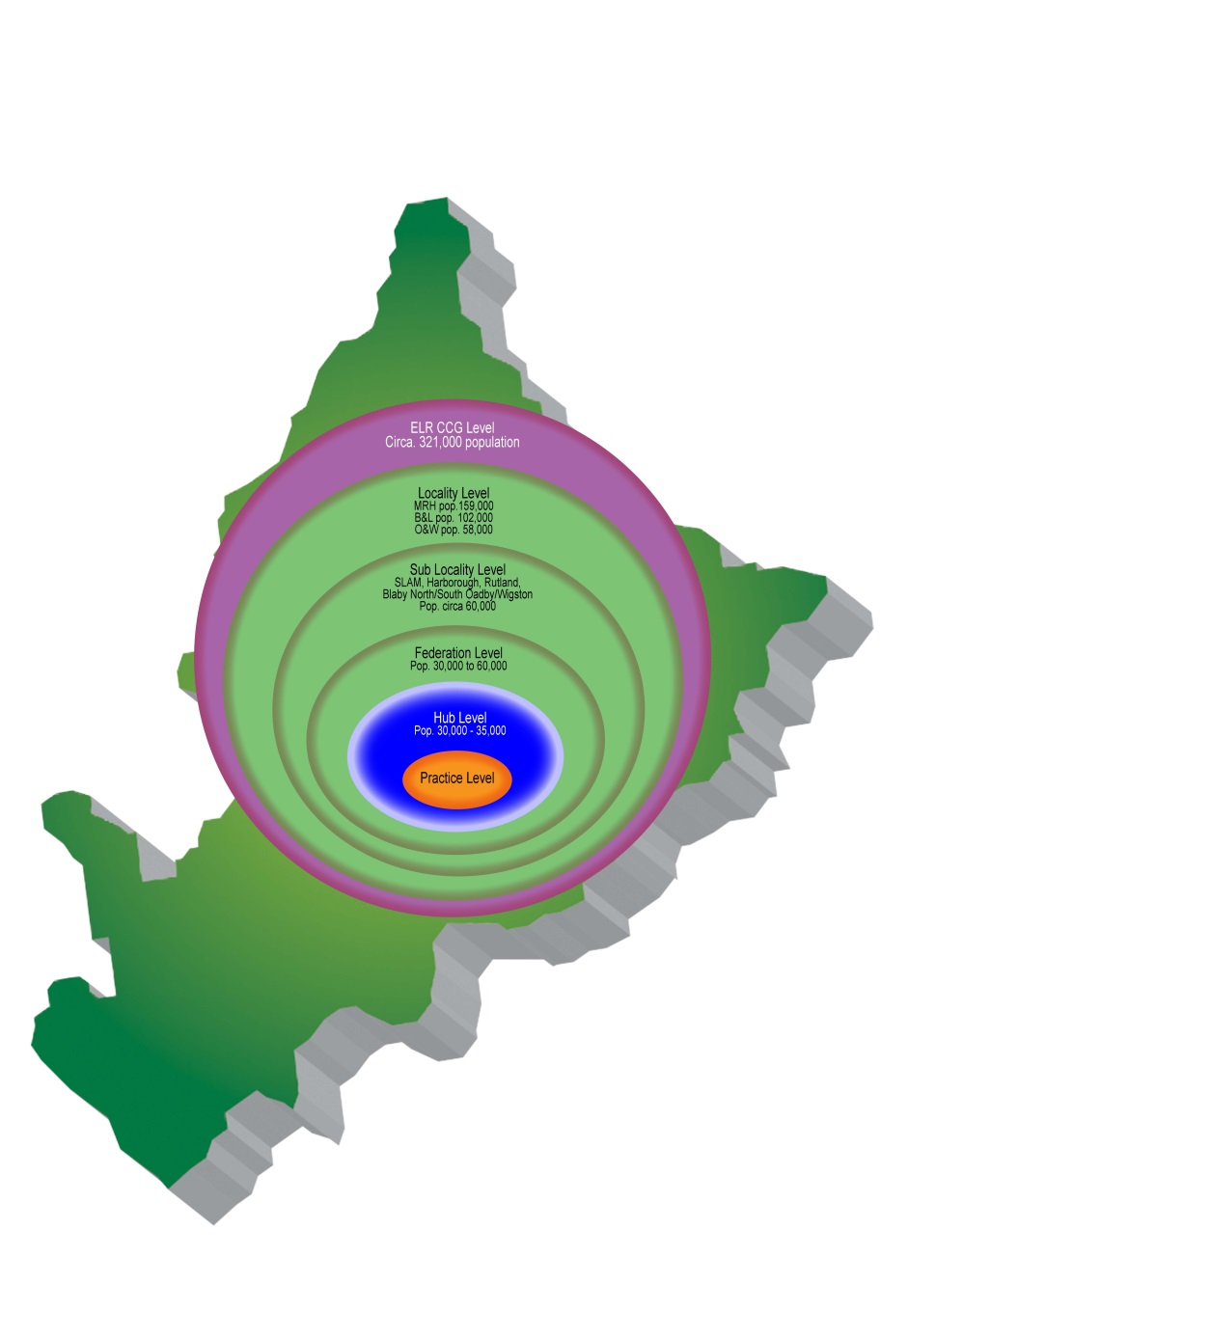
  - Enabling Practices to take advantage of opportunities normally only available to larger organisations, such as combining services for patients, combining back office functions, reorganising day to day working patterns to provide opportunities for GPs and nurses to offer a different model for patients and varied working patterns, whilst also building greater buying power, and bidding for tenders.
  - Enabling practices to form flexible alliances that can adapt to the needs of patients, whilst retaining individual practice autonomy.
  - Providing practices with a mechanism to work collaboratively at scale in the delivery of clinical services including those which are anticipated to transfer out of the hospital setting.
  - Creating larger organisations with standard operating models which make it more plausible for CCGs to commission improved and responsive wrap round community services to support GPs to look after their patients in a community setting.
  - Increasing the opportunity to develop a wider range of community services, whilst making more effective use of resources, including staff and premises.
  - Enabling practices to offer services that cater for larger patient cohorts over a wider geographical area.
  - Delivering services such as 7 day services, co-delivering urgent care services and the option to take on the employment and direct management of services.

- Multispecialty Community Provider (MCP)
Key features and benefits of the MCP new care model include;

- Local Integration; redesigning care around the health needs of the population - irrespective of existing institutional arrangements - to improve health and wellbeing, achieve better quality, reduce avoidable hospital admissions and elective activity, and unlock more efficient ways of delivering care at scale.
- Holistic and person-centred, place based care model with GP registered lists as the cornerstone.
- MCPs are made up of integrated ‘hubs’ of 30-50,000 – supported by multi-disciplinary teams; joining together to serve a population@ c.100,000.
- Combining primary care and community-based health and care services – which can include mental health, public health and social care services.
- Providing infrastructure and scale to improve population health and address pressures facing general practice.
- This greater scale and broader teams will enable patients to be directed to the most appropriate professional and reduce unnecessary burdens on GPs and release time for GPs to deliver high quality, personalised primary care; freeing GPs from the ‘treadmill of 10 minute appointments’.
- Multi-disciplinary team working will be fundamental and the extended primary and community care working should provide exciting development and career opportunities for all staff groups.
- Success will require strong local leadership, strong relationships and trust.
- Harness ‘community assets’, including the voluntary sector, sports clubs, community groups etc.
- Fundamental to an MCP’s success will be an understanding of the needs of the population; developing patient-level population datasets. Populations will be segmented at four levels (see appendix A);
  - Whole population
  - Urgent care needs
  - Ongoing care needs
  - Highest needs
- Harnessing technologies to improve access.
- Interoperable records, with appropriate data sharing agreements.
- An integrated, accessible and responsive urgent care system.
- Patient choice to be retained through choice of location and preference for named GP.

MCP contract issues
Involvement in an MCP model is entirely voluntary but to support effective MCP working; three contractual solutions have been developed which are summarised below and outlined in the diagramme at appendix B.
‘Virtual’ MCP;
- Practices, local community service providers and commissioners enter into an ‘alliance agreement’ which would overlay but not replace existing commissioning contracts.
- This agreement would establish a shared vision and commitment to managing resources together to deliver services operationally in an MCP-like model.
- Builds on the growth of GP Federations.
- In this model a new MCP contract is not awarded.

‘Partially-integrated’ MCP;
- Commissioners would re-procure all services that would be in the scope of a fully integrated MCP except for core general practice.
- The organisation holding the contract would enter into an ‘integration agreement’ with the practices to support its integration obligations.
- GP practices would retain their GMS/PMS contracts.
- GPs could take a management, leadership or ownership position in the MCP.

‘Fully-integrated’ MCP;
- Commissioners would re-procure, under a single contract, all ‘in scope’ services, including core general practice.
- A single ‘MCP organisation’ would be commissioned for the full range of community and primary medical services, with full responsibility for the integration of care.
- 10-15 year contract term to provide the stability required to incentivise for MCP partners to invest in the new care model and changes required.
- GP practices released from their GMS/PMS/APMS contracts; with provision to revert back to those contracts, if desired.

The MCP contract will be a combination of the NHS Standard Contract for non-core primary care and a contract which is legally appropriate for the commissioning of core primary medical services.
Template contract and agreement documents have been produced for each of the contractual solutions outlined above.
Payments to MCPs will comprise three parts;
- Whole population budget for the range of services offered
- Performance element; that replaces CQUIN and QOF
- Gain/risk share for acute activity
Organisational form - entities that could hold an MCP contract include Community Interest Companies, Limited Liability Company or Partnership (building out from a GP Federation or super-partnership), statutory NHS provider, corporate joint venture.
Procurement regulations – in particular the Public Contracts Regulations (PCR) 2015 - will require commissioners to procure MCP contracts in a transparent and fair way. Contracts with a lifetime value greater than £590,148 must be advertised in the Official Journal of the European Union (OJEU) & Contracts Finder.

- The Primary Care Home model
Primary Care Home (PCH) is a joint National Association of Primary Care (NAPC) and NHS Confederation Programme which has developed the PCH model in line with the MCP care hub or neighbourhood approach. Key features include;
- Provision of care to a defined, registered population of between 30,000 to 50,000 people.
- An integrated workforce, with strong partnerships spanning primary, secondary and social care.
- A combined focus on the personalisation of care with improvements in population health.
- Alignment of clinical and financial drivers with appropriate shared risks and rewards.

- An Overview of the vanguard sites
All Together Better Sunderland
Where | Sunderland
How many practices | 42
Population size | 275,500
Model | - The vanguard is providing a citywide ‘recovery at home’ service offering a rapid response either at home, or close to home, to prevent emergency admissions to hospital.  - Five Integrated teams consisting of community nurses, social workers, GPs and voluntary staff are based around groups of GP practices.  - GP practices working together to deliver enhanced care for patients with long term conditions who could benefit from guidance to improve how they manage their illnesses themselves to reduce reliance on general practice.  - by working collaboratively at scale the Sunderland GP alliance facilitate the delivery of standard and complex, system based, proactive and sustainable primary care to the residents of the city.  - deliver as much care as possible in the community, exploiting the latest technology and working more closely with voluntary organisations to make sure people can stay as well and as independent as possible for longer.
MCP model | Virtual- General practice under the Sunderland GP Alliance
What worked well | - Seen early signs of a reduction in emergency admissions for the over 65 cohort.  - significant increase in the number of referrals to the Recovery at Home service  - a reduction in the use of community beds at Farnborough Court (an intermediate care service)  - A fall in admissions to residential care and fewer delayed transfers of care  - Reduction of emergency 999 callouts to the care homes  - Reduction in visits to A&E  - Reduction in calls to the 111 service  - Potential for staff to identify and report irregular pulse rates to the GP  - Increased capacity for general practice as care homes will now be monitoring BP’s  - Improved level of satisfaction due to increased care provider empowerment and ownership to support decision making
What didn’t work well | Local evaluation being carried out 2017/18.  - A number of products available did not meet the requirements of the project in respect of design and cost.  - Interoperability – The present development (Integrates with the NHS Florenceystem) and as a part of this programme plans are in place to integrate data sharing with primary and community care systems.  - Care Homes – One of the main challenges within the care home was to gain agreement with care home managers to release staff for training due to operational pressures.  - Wi-Fi was required for data transmission which not all care homes had
Learnings from this model | Own learnings:  - Sticking to original scope and not letting the project creep outside of this scope despite several other ideas. This has been important to ensure that we start somewhere with further versions of the system at review stages.  - We underestimated how much time it would take to undertake the stakeholder engagement plan. A great deal of time has been spent dedicated to this with differencing methods of communication and this is ongoing.  - Workforce turnover  - Development of interoperability is ongoing and complex and needed to be priority earlier in the project.
References and | http://www.atbsunderland.org.uk/  http://www.nhsconfed.org/~/media/Confederation/Files/Publications/Documents/New%20care%20models_WEB.pdf  http://www.atbsunderland.org.uk/wp-content/uploads/2016/06/ATB-New-technology-using-universal-medical-assessments-NEWS-to-track-the-health-and-wellbeing-of-older-people-in-the-city.pdf

Better Local Care (Hampshire)
Where | Hampshire
How many practices | 27 originally, now expanded with another 12 areas
Population size | 220,000 originally, now expanded
Model | - Nurses, therapists, MH and LD staff, combined with GP practices to provide integrated care tailored to meet the local community’s needs.  - Improve and simplify access to a wider range of care through GP practices and primary care hubs.  - GPs will develop care plans with patients to help them maintain their independence and manage any existing health conditions, such as diabetes.  - New integrated care record will mean patients no longer have to repeat their medical history to different professionals.  - More problems will be addressed in a single visit, with extended opening hours, access 7 days a week and longer appointments.  - Paramedic Home Visiting Service has paramedics carry out home visits instead of GPs  - eConsult: online tool available for 58 practices that offers immediate self-help advice or to send an online consultation directly to the GP who will reply within 24 hours. Also has a symptom checker, and helps to manage certain conditions without visiting the surgery  - GP Same Day Access Service: patients ring their GP and will be put through to a phone triage service run by medical professionals who can either give them advice over the phone, or if necessary, book them in for an appointment with the appropriate clinician that same day. As they can access medical records this makes for more efficient triage.  - Local Federation New Forest Health Care Limited operates 8-9 7 days a week allowing longer consultations
MCP Model | Virtual, but with 6 federations involved
What worked well | - Paramedic Home Visiting Service has been effective, with paramedics visiting over 500 patients in the 6 months pilot  - eConsult: over 1,500 people a week have used the service, with 3,500+ appointments saved (13 appointments a week)  - GP Same Day Access: duplication and waiting times reduced  - Opening of the The Practice at Lymington New Forest Hospital: an “extended branch” of 7 GP practices in the area which has improved access by offering longer, more flexible appointments with extended opening hours
What didn’t work well | - Many of the federations are relatively young and do not have the benefit of the large infrastructure that is a part of older, large NHS providers.  - Over the last few years, making sure community services have been lined up with what GPs were doing in the communities and with the registered list has been neglected – this may pose difficultly for future development.
References and further reading | http://www.betterlocalcare.org.uk/in-your-area/gosport/news/gp-same-day-access-service-case-study/  https://www.kingsfund.org.uk/audio-video/chris-ash-creating-mcp-southern-hampshire  https://www.southampton.gov.uk/modernGov/documents/s27799/Update%20on%20the%20development%20of%20new%20care%20models%20in%20Southern%20Hampshire.pdf

Calderdale Health and Social Care Economy
Where | Calderdale, West Yorkshire
How many practices | 26 practices in Pennine GP Alliance (23 full members, 3 associate members)
Population size | 200,000
Model | - New organisational form built on both MCP and PACs models, creating an alliance model which delivers improved outcomes, experience and quality, built around the principles of Accountable Care Organisations, supported by new payment and contracting models.  - Redesigned first point of contact for improved access: care co-ordinators supported by community based volunteers and various professionals  - Shared records so patients only tell their story once  - Hub and spoke models across localities  - GP supported by multi-disciplinary teams of professionals working in a new localities models to create flexible, responsive local services ensuring equal access to services
MCP Model | Partially integrated (Federation)
What worked well | - Increased physical activity levels across Calderdale  - Home modifications in identified vulnerable service users  - Transformed walk-in to centre to a Super Walk-In Care  - High degree of replicability: the 4 discrete programme elements of Care Close to Home, work to case-find and support frail people using Electronic Frailty Index, transformation of walk-in centre  - Development of a career start scheme to attract and retain GPs
What didn’t work well | They recognise this will challenge their system and their relationships.
References and further reading | https://www.england.nhs.uk/ourwork/new-care-models/vanguards/care-models/community-sites/chsce/  http://www.gponline.com/mcp-vanguard-scheme-funds-indemnity-specialty-training-new-gps/article/1408825  http://www.calderdale.gov.uk/nweb/COUNCIL.minutes_pkg.view_doc?p_Type=AR&p_ID=43191

All Together Better Dudley
Where | Dudley, West Midlands
How many practices | 46
Population size | 318,000
Model | - Dudley is developing a network of GP-led teams of staff working together across health and care professions for the benefit of patients – known as ‘teams without walls’.  - Focus on enhanced primary care – including consistent and more co-ordinated support for people with long term conditions that is tailored to their needs
MCP Model | Virtual (network)
What worked well | Comments from patients:  - Ability to “just turn up to be seen”, “no problems getting an appointment”  - Choice of telephone or face-to-face consultation was found as helpful  - Practice manager’s signposting to other sources of help (eg. GP to dementia nurse) remarked as helpful  - Ability to self-refer means can be seen quicker, considered ideal for dementia patients  - Patients with most complex needs used GP 30% less than before: 30% fewer attendances, 25% fewer home visits, 30% fewer online and telephone consultations
What didn’t work well | Comments from patients:  - For dementia care, there needs to be a nominated person as a contact for dementia patients as seeing the same doctor is more important  - “Every practice is different and this is an issue because some people get certain services and others don’t” in regards to getting an appointment or seeing a GP quickly  - Communication not always adequate between different health services regarding a patient having a carer who needs to be involved in decision-making  - GPs and specialists occasionally contradict each other with diagnoses and where to send patients for appropriate care  - Computer literacy required for navigating health systems can be a problem for those who can’t use a computer  - Carers, older people and those with LDs remarked that it was difficult to know whether all surgeries offered the same or similar services
References and further reading | https://www.england.nhs.uk/ourwork/new-care-models/vanguards/care-models/community-sites/dudley/  http://www.atbdudley.org/  http://www.healthpluscare.co.uk/__media/18516-Local-Systems-Trans-Report-LR.pdf

Encompass
Where | Whitstable, Faversham, Canterbury, Ash and Sandwich.
How many practices | 16
Population size | 170,000
Model | - Treating patients closer to home using specialist GPs, health professionals such as occupational and physical therapists, and community-based consultants, who will coordinate and simplify services.  - Greater use of information technology-Telecare and telemedicine systems  - Shared single electronic patient records will support integrated care  - Four health and social care ‘hubs’ created. These will provide a central point for health and social care covering some nursing home and hospital in-patient services.  - Focus on preventing ill-health  - A federation of GPs will work in partnership with everyone involved in health and social care across the local area, including the voluntary sector and patient groups.  - A range of GP with special interest (GPwSI) community outpatient clinics with the aim of providing more local services whilst also reducing the burden on, and cost of, hospital outpatient services.
MCP model | Virtual- Federation
What worked well | - 10 per cent reduction in conveyances to hospital for the areas supported by the Paramedic Practitioner teams  - GPs report the time they are saving can be spent on patients who require longer appointment slots, such as complex LTC and end of life patients.
What didn’t work well | Challenging to identify the GP workforce to cover clinics across all three hub localities and take up appointments following extension of GP services to 8am-8pm six days a week
Learnings from this model | As a result of lack of workforce to cover longer hours the MCP is now focusing on scoping demand, review the workforce capacity to deliver extended services, explore options to operate a skills mix workforce model to deliver primary care services (inclusive of GPs, Nurse Practitioners and other professionals)
References and further reading | https://www.england.nhs.uk/ourwork/new-care-models/vanguards/care-models/community-sites/encompass/  http://www.encompass-mcp.co.uk/

Fylde Coast Local Health Economy
Where | Fylde, Lancashire
How many practices | 21 in Blackpool, 19 in Fylde and Wyre
Population size | 320,000
Model | - New community-based service ‘extensive care’ is providing proactive support for people aged 60+, with 2 or more long-term conditions. This includes helping people to understand and manage their health conditions but also other aspects of their life which might impact their general wellbeing.  - Patients are referred to the Extensive Care service by their GP: they remain registered with their GP but required care will then be carried out by the Extensive Care team. Team is led by an “extensivist” (consultant geriatrician/GP) and supported by a multidisciplinary team which coordinates both disease-specific and generic care.  - Extensive care service operates from 4 primary care “hubs” serving all 10 neighbourhoods with all GP practices across the area able to refer eligible patients.  - Complementing this service are locally based neighbourhood care teams which provide support to people who require ongoing management of 1 or more long-term conditions. These teams see GPs working with community and other care services across 10 neighbourhoods to provide better coordinated care closer to home.  - Shared electronic care records and a single point of contact for all out of hospital services in the area ensure seamless care regardless of a person’s support needs.  - Patients are allocated a wellbeing support worker, who they meet regularly with to develop a long-term plan for their health, including setting goals.
MCP Model | Virtual
What worked well | - Following problems reported by practices, channels of communication have been improved and each practice now has a nominated link Practitioner from the service.  - Issues around confidence in the service have been addressed following promotional materials across neighbourhoods.  - Preliminary evaluation suggests that people receiving extensivist service attended A&E less frequently and used non-elective and outpatient hospital services less.
What didn’t work well | - 1,162 referrals as of September 2016 - referral numbers as of August 2016 fell below planned level of activity for the service.  - Some practices reported that they were not aware of who to contact and how to contact the service in relation to key workers.
References and further reading | https://www.england.nhs.uk/ourwork/new-care-models/vanguards/care-models/community-sites/fylde/  http://www.yourcareourpriority.nhs.uk/

Lakeside Healthcare
Where | Northamptonshire, North Cambridgeshire, South Lincolnshire
How many practices | 6
Population size | 100,000– plans to expand to 300,000
Model | - New care model which is primary and community care based  - Largest GP-led single “super-practice”: patient list is overseen by 52 general practice partners, with several branch surgeries and community clinics.  - Offers extended services, such as diagnostics, urgent care, minor surgery and out-patient appointments, 7 days a week.  - Staff has diverse range of skills and experience, with less emphasis on the GP and more use of modern technology, particularly for patients-clinician communication.  - Most vulnerable 7% of patients have access to longer, in-depth consultations with enhanced continuity of care.
MCP model | Fully integrated super partnership. Single contact covering all practices.
What worked well | - Bigger practice gives the ability to attract, recruit and retain the best doctors and healthcare professionals to the area as they can offer them a varied and exciting career, thus, enabling the service to be offered to more patients.  - Better access to specialised and routine care closer to home will reduce unnecessary hospital admissions  - Joined up services will improve support for patients and offer better value for money for the NHS  - Safeguarding Primary Care Team shortlisted for GP Team of the Year
What didn’t work well | NHS choices – general practices were rated highly but with some comments made on hard to access appointments.
Learnings from this model | Evaluation not taken
References and further reading | https://www.england.nhs.uk/ourwork/new-care-models/vanguards/care-models/community-sites/lakeside/  http://www.thelakesidesurgery.co.uk/merger/  http://www.nhs.uk/Services/gp/Overview/DefaultView.aspx?id=44075

Principia Partners in Health
Where | Rushcliffe, Nottinghamshire
How many practices | 12
Population size | 124,459
Model | - “PartnersHealth” is a new organisation formed by the GP practices.  - Model agreed for providing evening and weekend appointments from  - April 2017: Patients will be able to request an appointment outside standard working hours and receive a slot at 1 of 3 Rushcliffe GPs  - More patients will use technology for online bookings, prescription ordering, access to health records and test results from home, self-monitoring of conditions and consultations with professionals via email, telephone and video calling  - GRASP AF programme: optimises medical care by increasing case finding of risk patients and reducing prevalence of stroke  - An aligned GP practice for each care home  - Fractures: Several GP practices now host staff trained to administer intravenous drugs, which is cheaper, and only has to be administered every 18 months
MCP model | Virtual- Federation
What worked well | - Data shows the roll out of standardised referral processes and training of admin staff across PartnersHealth practices has seen a reduction in clinical variation of elective first outpatient’s referrals of 529 referrals - 2.9% below plan.  - GRASP AF programme: estimated that avoided 7 strokes this year
What didn’t work well | No evaluation carried out
References and further reading | http://www.rushcliffeccg.nhs.uk/media/3998/principia-update-jan-2017-with-appendices.pdf  http://www.rushcliffeccg.nhs.uk/media/3133/case-study-1.pdf

Stockport Together
Where | Stockport, Greater Manchester
How many practices | 45
Population size | 305,000
Model | - Services will be based around eight neighbourhood teams across Stockport, each serving around 30,000 to 50,000 people.  - Consultant Connect: telephone system providing GPs with immediate access to local consultants for advice across several areas  - Viaduct Health is GP federation involved in the MCP  - Offers spirometry (across 36 practices) and blood pressure services (across 9 practices)  - Stockport to create tailored strategies for the four workstream areas: Healthy Communities, Core Neighbourhoods, Borough-wide Services, Acute Specialist Interface
GP contract type | Virtual- Federation
What worked well | - improving the way professionals communicate and deliver joined up care for patients, through regular triage meetings between health and social care professionals and GP-led MDTs, focussing on the most complex patients  - Between November 2014 and October 2015, admission rates from care homes reduced by 202 throughout the year, equating to an approximately £375k potential saving for the year of.  - Blood pressure monitoring service: 2,000 tests carried out a year  - Spirometry service: 4,700 tests carried out a year  Consultant connect service has:  - Dramatically reduced referral time for GPs to consultants, from 3-4 weeks to near -instant telephone access, benefiting the patient with timely care or advice.  - Consultants are able to spend more time with patients that need their care, as they avoid unnecessary in-person consultations.  - Prevented hospital referrals in 70 per cent of recorded cases since launching for haematology and endocrinology enquiries.  - It has been extended to paediatrics and there are plans to add further specialties.
What didn’t work well | Not fully being rolled out until April 2017
References and further reading | http://www.stockport-together.co.uk/provider  https://www.england.nhs.uk/ourwork/new-care-models/vanguards/care-models/community-sites/stockport/

The Connected Care Partnership
Where | Sandwell and West Birmingham
How many practices | 16
Population size | 160,000
Model | - New system where health and care partners work together, led by The Connected Care Partnership.  - Modality partnership is a GP super partnership operating in 18 different locations and more than 85,000 patients.  - Modality has 4 work streams:  - developing extended primary care services, including multidisciplinary teams, for people with complex needs  - putting in place case-management services for groups with the highest need who need more intensive support  - a rolling programme to bring specialist services, including cardiology, respiratory, musculoskeletal, gynaecology and pain management clinics, out of the hospital into the community  - More effective joint working with the hospital system, including avoiding unnecessary A&E attendance and improving discharge planning.  - Utilising technology- phone and skype consultations, and electronic care plans patients can access.  - 24/7 single point of entry, offering more alternatives to hospital care and specialised care closer to home and helping local people manage their own health confidently.  - Palliative Care Hub to provide seven-day access to a wide range of services for people in their last year of life, including hospice beds, domestic support and specialist palliative care.
MCP model | Fully integrated GP super partnership
What worked well | - It has established an enhanced primary care service which provides a named primary care professional to care home managers. A multidisciplinary care home support team including therapists and nurses.  - 72% fall in “did not attends” (because fewer patients book well in advance as they are confident of speaking to a clinician when they need to)  - A 10% rise in activity – meeting demand within existing resources  - Average remote consultation times falling to under five minutes  - 70% of patients say the new system has improved access  - 100% of clinicians agree they would not go back to the old system
References and further reading | https://www.england.nhs.uk/ourwork/new-care-models/vanguards/care-models/community-sites/connected-care/  https://modalitypartnership.nhs.uk/

Tower Hamlets Together
Where | Tower hamlets
How many practices | 37
Population size | 287,000
Model | - Model of care for adults with complex needs, a model of care for children and young people and the development of a population-wide health programme that focuses on prevention.  - Neighbourhood care teams  - GP federation comprising of all 37 GP practices in Tower Hamlets
MCP model | Virtual- large federation of general practices.
What worked well | - Working together to offer joined-up, patient focused care  - Helping people look after themselves better, reducing pressure on the health and care system.  - develop local health and care services designed to keep people well, and bring home care, mental health and community nursing, GP services and hospitals together  - Community Geriatrician post has reduced admissions from local nursing homes to Barts Health by supporting the GPs who provide the enhanced service to the nursing homes.  - The community Chronic Kidney Disease (CKD) clinic where GPs can ask for advice from a renal physician via EMIS (the GP computer system) and get feedback as to whether a person needs to be seen in clinic or not.  - The wheelchair services are looking at different seating for service users to improve independence and quality of life and not need a chair at home and a separate wheelchair.  - The Home Support Pathway piloted this winter has reduced admissions to the inpatient rehabilitation beds (and reduced readmissions to the Royal London).
What didn’t work well | - Limited joint learning with other health and social care partners in Tower Hamlets, and programme has been very General Practice dominated.
References and further reading | http://www.towerhamletstogether.com/  https://www.england.nhs.uk/ourwork/new-care-models/vanguards/care-models/community-sites/tower-hamlets/  http://www.gpcaregroup.org/

Wellbeing Erewash
Where | Erewash
How many practices | 12
Population size | 97,000
Model | - Primary (GP) and community services will connect with local councils, the voluntary and community sector and local communities to meet the needs of the local population efficiently and effectively  - Work with communities to promote self-care through education and a greater availability of health information  - New services (including urgent care services) will be available on the day they are requested, seven days a week.  - Access to GPs will be improved by matching their availability to patient needs and by delivering services in different ways.  - Integrated Care Teams bring health and social care professional together to focus on the needs of individual patients, without being hampered by organisational boundaries.
MCP model | Virtual- General practice aligned with other organisations and working together.
What worked well | - Evidence of reducing pressure on busy GP and A&E services.  - 5786 patients have been seen in the primary care hubs  - 15% of the patients attending the hubs are aged under 5  - Voluntary Sector added into the SPA (vSPA) – 295 referrals in first year with 507 services put in place ranging from befriending, transport, shopping, social groups  - Welcome home service added to the remit of the Care Co-ordinator  - Airedale telehealth scheme supporting 10 care homes  - Services expanded to 7 days – SPA, Community Matrons and Therapies
What didn’t work well | - Long term project so resources weren’t provided immediately as it wasn’t seen as priority.  - Difficulties in recruiting to vanguard posts across organisations which meant they had to rely on secondments and this caused some delays in appropriate staff becoming available.  - Integrating with ‘silo’ cultured organisations.
Learnings from this model | Their own recommendations:  - Communication needs to be standardised to be understandable across all organisations.  - Further public engagement should take place: they plan to speak with more groups of people through residential and housing associations and through conversations in the market place, supermarkets and GP practices.
References and further reading | https://www.england.nhs.uk/ourwork/new-care-models/vanguards/care-models/community-sites/erewash/  http://www.wellbeingerewash.org.uk/

West Cheshire Way
Where | Chester City, Ellesmere Port and Neston and Rural.
How many practices | 35
Population size | 260,000
Model | - Easier access to more joined-up services in the community through new health and social care teams, wellbeing coordinators and direct access to physiotherapy for patients.  - ‘pooled budget’ arrangement with both our local authority and a neighbouring clinical commissioning group  - Currently GP practice teams work together as clusters (with three to four GP practices per cluster), each supported by an integrated care team made up of community nurses and matrons, therapists, care co-ordinators, social care and wellbeing co-ordinators.  - Aim is for each cluster to have all the resources it needs to support and care for its whole cluster population. This will require health professionals who have traditionally been hospital based to wrap around clusters at locality level.  - Vulnerable older people who are most at risk of poor health and wellbeing will be identified by GPs. They will then work with that person’s nominated care coordinator (who works with health and social care teams).  - develop alternatives to general practice including minor ailment schemes, social prescribing and direct access services  - phone consultations in general practice  - Integrated clinical communication, including sharing medical records, to enable the identification of risk  - Require senior strategic management support (a Programme Director and Senior Project Manager), alongside the established clinical leadership.
MCP model | Fully integrated- testing out a ‘mini-MCP’ contracting model with a cluster of general practices during 2016/17
What worked well | - Wellbeing coordinators help people manage the wider issues that may affect their health, such as loneliness or financial worries  - Clinicians from various teams work together to deliver more co-ordinated, effective and efficient care.  - During the pilot stage of the AGE UK Cheshire wellbeing coordinator team project from January 2015 to March 2016, the team received more than 1,400 referrals.  - Expected to save £7,208,000
What didn’t work well | - Lack of practice engagement in moving to a fundamentally different model e.g. away from traditional partnership  - Capacity in team  - Primary care estate restricts ability to implement alternative care models
References and further reading | https://www.westcheshireccg.nhs.uk/document_uploads/documents/Combined%20WC%20Value%20Proposition%2023.02.16.pdf  http://www.westcheshireccg.nhs.uk/document_uploads/plans-strategy/WCCCGFiveYearStrat_3.pdf  https://www.england.nhs.uk/ourwork/new-care-models/vanguards/care-models/community-sites/west-cheshire/

West Wakefield Health and Wellbeing Ltd
Where | West Wakefield, West Yorkshire
How many practices | 6
Population size | 65,000 patients; Vanguard working with another 2 GP practice networks in area, covering patient population of 152,000
Model | - Local people helped to access the care they need by 100+ ‘care navigators’ based in GP practices. These are mainly support staff who have the first contact with patients when they approach the surgery, and are trained to direct patients to the most appropriate care.  - Extended hours for GP services with plans to roll this out to the other GP networks linked to the vanguard  - The HealthPod mobile clinic, which improves engagement with ‘hard to reach’ groups such as the traveller community  - Improved digital access to healthcare, through an online directory of local services and a library of health apps  - Self-service kiosks in practices to help patients access these and other digital resources  - Increased social prescribing to take pressure off GPs  - PhysioFirst service to enable patients to see a physiotherapist for a short, first contact assessment in their GP practice without having to see a GP first
GP contract type | Federation of 6 practices; virtual contract (network) with other 2 GP practice networks
What worked well | - Since April 2016, the care navigation systems has signposted 9,500+ patients to other health, care and community professionals, aside from the GP, to receive the right care quicker  - It has also saved over 1,145 hours of GP time that has gone back in to caring for more patients with complex, long-term conditions.  - Since implementation, practice-based pharmacists have saved 9,000+ hours of GP time  - Good response from patients: Over 60% of 500+ patients interviewed believed this new model had helped them to remain independent and cope better, and 65% also reported that professionals mostly or always worked together well.  - Information hub: professionals usually in a MDT are in place all the time to collective work out a package of care without delay  - Increasing the number of ways to access services is expected to support better self-management of health and wellbeing  - 2,200+ PhysioFirst assessments have been offered, with just 7% needing to be referred on to see their GP, resulting in 178+ GP hours saved  - 4 out of 5 local patients referred to social prescribing service in the last 12 months say it improved their wellbeing
What didn’t work well
References and further reading | https://www.england.nhs.uk/ourwork/new-care-models/vanguards/care-models/community-sites/west-wakefield/  http://www.healthpluscare.co.uk/__media/18516-Local-Systems-Trans-Report-LR.pdf  http://www.westwakefieldhealthandwellbeing.nhs.uk/media/news/items/2016/september/physiotherapists-in-general-practice-provide-vital-first-contact-care/  http://www.gponline.com/gp-led-vanguard-scheme-cuts-hospital-stays-finds-report/article/1397271

- An overview of local LLR projects
Leicester, Leicestershire and Rutland
- LLR General Practice Development Programme event led by NHS England Sustainable Improvement Team was held on the 9th of February.
    - Provided an overview of the 10 High Impact Actions (HIAs) for general practice that are being promoted in the GP Forward View (See Appendix C)

East Leicestershire and Rutland CCG
- Rutland Primary Care Home. The 4 Rutland practices are collaborating closely linked to the vanguard programme.
- ELR GP Federation has been established January 2016 incorporating all 31 GP Practices.
- South Blaby and Lutterworth Hub involving 5 practices have been working together around care homes and community services.
- Integrated Locality Teams are now evolving in the majority of the CCG sub locality structures focussing on current provider collaborations and making the day job more efficient.

West Leicestershire CCG
- West have recently developed their Federation QIPP scheme for 17/18, this is an example of the CCG supporting and sustaining primary care and general practice through developing and enabling the Federations (and move towards MSCP).
    - Aim of the scheme is too create a sustainable primary care that is financially sustainable for the CCG.
    - Aims to make clinical change in primary care and address unwarranted variation at practice level.
    - Funding additional work should prevent right drift and enable left shift.
    - Federations are going to engage with practices to develop the detail of how the scheme will be implemented.
    - CCG and federations will work closely to ensure successful implementation of the Federation QIPP. Supported through regular engagement and contract review meetings on a quarterly basis.
Leicester City CCG
- HealthCare hubs providing seven day access to General Practice across Leicester City – led by Millennium Federation on behalf of all City practices
- Use of a configured SystmOne community unit to enable the hubs to operate as a single entity
- Sexual Health and Contraception Clinic (SHACC) provided across the City by 4 practices
- GP Practices/111/OOHs Online/remote booking into hubs from Single point of access telephony system for patients and healthcare providers accessing the hubs
- 111 Clinical navigation hub
- Development of Identifying areas of collaborative working across LC CCG, including LLR coverage federated Wi-Fi across health and social care and care homes which supports agile working
- Leicester, Leicestershire and Rutland Local Digital Roadmap, developed with health and social partners such as University Hospital Leicester, Leicester Partnership Trust, Local Authorities, and Emergency Services partners.

- Sources;
Practice Mergers Guidance, BMA Law, September 2016
Supporting Sustainable General Practice, A Guide to Mergers for General Practice, NHS England South (South West), March 2016
Managing regulations and contract variations, NHS England document number OPS_1015, June 2013
Practice Mergers, Mergers and new providers in general practice; some reflections on current market changes, First Practice Management,
Merging your practice: a checklist, Pulse, August 2011
Suffolk GP Federation website
GP participation in a multispecialty community provider, NHS England, December 2016
The multispecialty community provider (MCP) emerging care model and contract framework, NHS England, July 2016
Multispecialty community provider (MCP) draft MCP contract package: questions and answers, NHS England, December 2016
The multispecialty community provider (MCP) template integration agreement – overview, NHS England, December 2016
Multispecialty community providers (MCPs) and the NHS commissioning system, NHS England, December 2016
Whole population models of provision and NHS pensions, NHS England, December 2016
Multispecialty community provider (MCP) financial strategy, NHS England, December 2016
Contracting for new, whole population, models of provision: Engagement on draft multispecialty community provider (MCP) contract, NHS England, December 2016
Multispecialty community provider (MCP) procurement and assurance approach, NHS England, December 2016
Explanatory notes to the draft multispecialty community provider (MCP) contract, NHS England, December 2016
The Primary Care Home, NAPC, 2015
New Care Model; An overview of Multispecialty Community Providers (MCP), L Dudley, F Stewart, J Watkins, February 2017

Appendix A

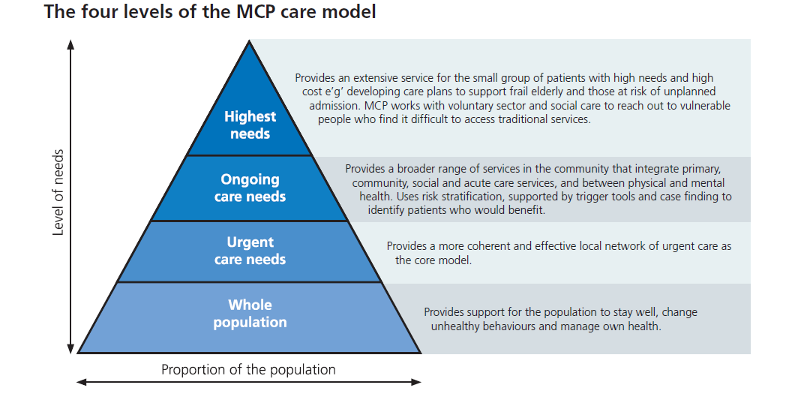

Appendix B
MCP Contractual Models
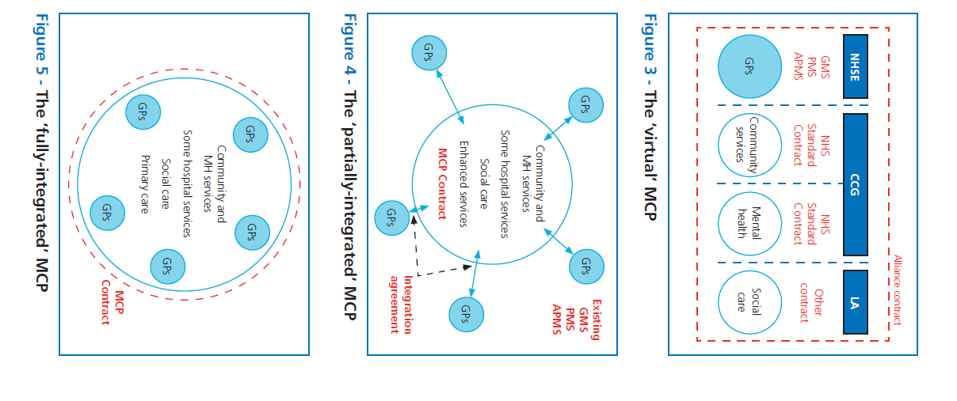
Appendix C
High impact actions for general practice

10 High Impact Actions

High Impact Action | Definition
1. Active signposting | Provides patients with a first point of contact which directs them to the most appropriate source of help. Web and app-based portals can provide self-help and self-management resources as well as signposting to the most appropriate professional.
2. New consultation types | Introduce new communication methods for some consultations, such as phone and email, improving continuity and convenience for the patient, and reducing clinical contact time
3. Reduce Did Not Attend (DNAs) | Maximise the use of appointment slots and improve continuity by reducing DNAs. Changes may include redesigning the appointment system, encouraging patients to write appointment cards themselves, issuing appointment reminders by text message, and making it quick for patients to cancel or rearrange an appointment.
4. Develop the team | Broaden the workforce in order to reduce demand for GP time and connect the patient directly with the most appropriate professional.
5. Productive work flows | Introduce new ways of working which enable staff to work smarter, not harder.
6. Personal productivity | Support staff to develop their personal resilience and learn specific skills that enable them to work in the most efficient way possible.
7. Partnership working | Create partnerships and collaborations with other practices and providers in the local health and social care system.
8. Social prescribing | Use referral and signposting to non-medical services in the community that increase wellbeing and independence.
9. Support self care | Take every opportunity to support people to play a greater role in their own health and care with methods of signposting patients to sources of information, advice and support in the community.
10. Develop QI expertise | Develop a specialist team of facilitators to support service redesign and continuous quality improvement.

