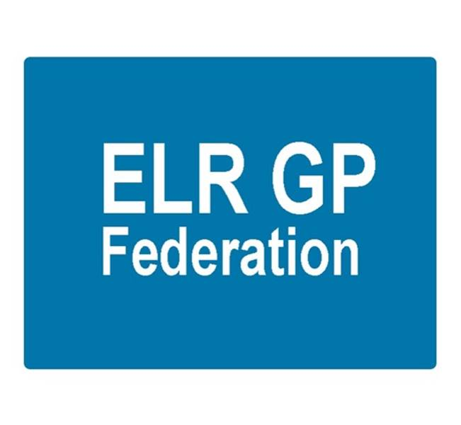
ELR GP Federation Ltd – Update

- Introduction

This paper provides an update on the progress of ELR GP Federation Ltd in support of its Business Plan and the SLA with ELR CCG which was approved in June 2016.

- ELR GP Federation activities

A work plan has been developed to support the vision and objectives outlined in the business plan, including ideas raised by members. The plan has been organised into the four categories;

- Scale efficiencies;
- Business development;
- Primary care innovation / transformation;
- Federation matters.
This work plan is attached in a separate spread sheet but the main areas of progress are summarized below.

- Back office / scale efficiencies;

  - Purchase Direct – A Federation offer is in place to work with practices to realise the scale economies in purchasing non-clinical supplies and over two thirds of practices have expressed interest. This project is in its early phase but already over £50K of savings have been identified for the 11 practices where work has started; which represents a saving of 26% of the current spend in the areas analysed so far. This will also provide the Federation with a small income from practices (@5% of savings implemented over an agreed level).

  - Pharmacy Support – Prescribing Support Services offer in place to support practices to engage pharmacists to work within practices. Two practices have signed up and are sharing a pharmacist and they report that the scheme is working very well.

  - Flu vaccines – GSK Fed offer circulated. We made clear that this is not a Federation ‘endorsed’ offer. Sanofi also approached us.

  - Buildings management (incl Health & Safety) – prompted by a suggestion from a practice – we are working with Estates Strategy Group to develop a Federation buildings management offer that realizes the potential benefits of working at scale.

  - Indemnity / insurance – this is one area that has been identified where savings could be made. An initial meeting has been held with Locktons who have an interesting Federation offer that could improve this area. Other options to be considered.

- Locum service – we are working to develop the website to provide a platform to connect staff with 'spare' sessions to be connected with practices who require additional sessions.

  - Other areas being explored include; contact centre, HR / payroll, telecoms, finance, medicines procurement, CRB checks.

- Business development / service improvement;

- Improving Access to General Practice scheme – the Federation has been awarded a contract to manage the process for this NHS England scheme to provide additional urgent on the day appointments over the winter period (with no reduction in other appointments or activity). We are working with practices to implement this additional capacity.

- Urgent Care Tender (City, West & Home Visiting service) – the Federation was part of a consortium bid with the other LLR Feds & DHU. We are working with DHU to support the Home Visiting service.

- Urgent Care Tender (East) – This represents a key opportunity for the Federation and we are actively preparing for the Federation to be a key partner in the procurement for the Urgent Care Centres in ELR.

- Public Health Community Based Services (Health Checks, contraception, alcohol reduction) – the Federation has submitted a bid on behalf of 12 practices. A further 7 practices are named as sub-contractors (in addition to the 12) to participate in an inter-practice referral scheme for contraception (IUD/IUS & implants).

- Oadby care homes – the four Oadby practices are working to improve the way that they provide GP support to the care homes. The Federation is working with the practices to consider an option whereby pooling resources could enable a joint bespoke care home service to be delivered.

- ELR GP Federation Teaching Academy – seven practices have joined to form this academy and made an application to Leicester University to provide placements for third year medical students. Whilst the Academy has not been selected to take provide third year student placements; this provided a valuable opportunity for practices to work together. Furthermore, the University has invited us to consider involvement in other schemes as below;

- Very Early Clinical Experience (VECE) for first year students – 2 week practice placement
- Compassionate, Holistic Diagnostic Detective (CHDD) course – seminar teaching at the medical school
- Fifth year apprenticeship – 6 week practice placement for senior students
- Student Selected Components and electives
- Mentoring
- Examining

- Clinical Pharmacists in General Practice – a number of practices have asked the Federation to support a combined application to this scheme. UHL have also approached us regarding the possibility of combining in a bid.

- GP SIP – we have engaged with the planning process with made a proposal to support the management of the demand management stream.

- Research - CK Aspire have approached the Federation with a model for member practices to support reesarch projects and provide an income stream.

- Primary care innovation / transformation;

- Integrated Locality Teams – a key area for the Federation to work with / support practices in the development of the ‘leadership teams’ in the four ELR localities (B&L, Melton/Syston, Market Harborough, O&W) to work towards developing ‘wrap around community services’. Effective ‘federated working’ between primary care providers will be a key element in the success of these teams. The Federation is working with the Out of Hospital Board and is part of the Integration Executive. The Federation is also part of the B&L and O&W leadership teams. This is an area for further development.

- Primary Care Home – Rutland have been successful in their bid and is a key opportunity for developing new models of working.

- STP - GP Programme Board – Fed are an active part of this Board (Rysz & James) to develop improved approaches to the delivery of primary care and improve services for high comlex patients etc. COO has supported Tim in developing an overview of MCP approaches – which links with the Integrated Locality Team working.

- Learning from other areas – COO has made contact with Federations in other areas to learn / acquire ideas including; West Leics, Leicester City, Birmingham / Sandwell (Modality), Northants (Three Sixty Federation), Essex, Staffs, The Practice Group. In addition, our Chair has connected with other GP Federation Chairs in the region.

- Engagement and communications;

- COO has connected with / visited practices and key stakeholders to listen.
- COO is an active member of the Practice Managers Forum and is developing effective working relationships with Practice Managers.
- Connection has been made with the Locality Meetings, but this is an area for further development.
- The website (www.elrgpfed.com) has been developed to include updates, news, online listening form, health news ticker, LLR health window on the world, ‘give us your ideas’ campaign, community hospital waiting times, LLR STP. The site is now used for all Federation Board papers.
- A discussion forum has been created (at the request of Practice Managers) and the web site will be used to host the Practice Managers’ Forum papers and, hopefully, a locum support service.
- Regular newsletters are circulated.
- LPT have approached us to assist in communications with regarding changes in their services, including Health Visiting and School Nursing.

- Budget

- Expenditure in FY16/17 will be below £175K due to the COO taking up post in mid-September 2016. The ‘underspend’ will be greater than the £50K projected in October 2016 and this will be finalized with the CCG team.

- Other Federation matters;

- Dr Louise Ryan (Oadby Central) has joined the Board, representing the Oadby & Wigston locality.
- A part time staff member (Hina Patel) has been appointed to manage the Federation administration and accounts.
- Joe McCrea has been appointed to provide to support the Federation’s engagement, communication and marketing activity
- Company policies have been developed and require finalizing.

- Strategic issues

Progress in the areas outlined in the work plan has been and will be important but the Federation Board is committed to developing a clear, compelling vision and plan that is owned by its members that positions the Federation to play its key role in the development of sustainable integrated primary/community care in ELR.

In particular, we need to determine the Federation’s role in the development of MCPs / Integrated Locality Teams and Primary Care Homes in ELR. This may need to include formal alliances and partnerships. It is interesting to note that the 3Sixty GP Federation in North Northants (who have been established for approx. 3 years) have merged with their local Community Care / Mental Health NHS Trust in preparation for new models of working. This may not be appropriate in ELR but we are pursuing discussions with LPT to identify effective ways of joint working.

Some thoughts and observations;

- Locality meetings are / could be ‘ready made’ forums to facilitate federated working between practices. At the moment the Federation is regarded as an external organization that is invited into these sessions on an occasional basis.

- The Federation IS the shareholder members and success will be when the Federation agenda is a key element of the agenda for ‘Federated Locality Meetings’. The CCG has agreed that this is an area to follow up.

- The CCG Locality Managers currently support ‘federated working’ and are well respected by their Localities. The Federation needs to determine the most effective way of engaging with these key staff in the pursuit of effective federated working between practices.

- The CCG has a range of ‘levers’ that could help the development of federated working. For example, ‘formalising’ projects that require the Federation to work with its shareholders; as the CCG has done by awarding the Federation a contract to manage extended access to primary care over the winter period.

- Whilst back office / economies of scale projects are important, the key way that the Federation will achieve sustainability will be through winning new business and this needs to be a key area for discussion with the CCG.

- The Federation should have a key role in the development of MCPs / Integrated Locality Teams and Primary Care Homes in ELR. This may need to include formal alliances and partnerships.

- We will be invest time in March for ‘Board development’ to work on the purpose and vision and team working arrangements. This will inform an update to the Federation’s Business Plan.

