Proposal for Federations to support the development of the diagnostic hubs and spokes model
- Background
Diagnostic activity has increased over the past three years beyond that of population growth, with the exception of 24 hour ECG monitoring in WLCCG. UHL is unable to absorb this growth year on year as it detracts from the specialist work that only they can deliver. Hence an alternative solution is required.
A diagnostic hubs and spokes model is therefore being developed to support the delivery of the LLR STP which is sustainable in supporting transformational change to Planned Care pathways and reduces the referrals to secondary services as GPs have the information required to make an informed decision regarding the need for ongoing care. This will also be supported by tools such PRISM and Advice and Guidance to assist in deciding who and when to refer.
The focus of the diagnostics project is on GP initiated Direct Access diagnostic activity, which has been divided into three groups.
- Imaging
  - X-ray
  - Ultrasound
  - MRI
  - Echocardiogram (ECHO)
- Non Imaging
  - 12 Lead ECG
  - Ambulatory BP Monitoring (ABPM)
  - Spirometry
  - Ambulatory ECG Monitoring – 24hr/ 48hr/ 72hr (AMECG)
- Pathology
From the initial discussions with GPs regarding the model, there is a strong need to provide specific near patient testing within the hubs and spokes.
There are a number of GP practices within the three CCGs that provide 12 Lead ECG and Spirometry but very few providing Ambulatory BP Monitoring. The number of GPs providing these investigations across LLR has reduced over the last 12 months as a growing number feel that this activity is not “core contract”.
The following table shows activity data for 2015/16 and forecasted activity for 2016/17 at month 10 for UHL GP Direct Access contract only by CCG. There are no specific payments attached to these investigations within Primary Care so no data is collected to indicate how many investigations are being done.
 | 12 Lead |  | Variance | AMBP |  | Variance | Spirometry |  | Variance
 | 15/16 | 16/17 |  | 15/16 | 16/17 |  | 15/16 | 16/17
ELRCCG | 1246 | 1295 | +49 | 107 | 137 | +30 | 2 | 5 | +3
LCCCG | 4385 | 5161 | +776 | 101 | 110 | +9 | 167 | 130 | -37
WLCCG | 520 | 565 | +45 | 66 | 61 | -5 | 9 | 38 | +29

 | 24hr ECG |  | Variance | 48hr ECG |  | Variance | 72hr ECG |  | Variance
 | 15/16 | 16/17 |  | 15/16 | 16/17 |  | 15/16 | 16/17
ELRCCG | 986 | 1111 | +125 | 50 | 77 | +27 | 5 | 8 | +3
LCCCG | 908 | 1096 | +188 | 31 | 50 | +19 | 1 | 6 | +5
WLCCG | 1026 | 722* | -304 | 31 | 38 | +7 | 3 | 4 | +1
*The drop in 24hr ECG monitoring in WLCCG in 2016/17 has been driven by the EPatch pilot in one of the WLCCG’s Federations. The pilot ran for a year and WLCCG is awaiting an evaluation report before considering
 | TOTAL SPEND |  | Variance  (£)
 | 2015/16 (£) | 2016/17 (£)
ELRCCG | 194,926 | 223,844 | +28,918
LCCCG | 331,525 | 401,126 | +69,601
WLCCG | 157,809 | 128,432 | -29,386

- Proposed Future Model
The proposed model, shown in the diagramme below, will enable;
- A hub and spoke model
- Investigations that require more specialist equipment e.g. x-ray or AMECG to take place in hubs,
- Larger volumes / low complexity investigations to take place in the spokes.
- Greater access to GP DA diagnostics closer to the patient, in a more timely fashion so enabling the GP to avoid unnecessary urgent or elective referrals to secondary care
- Development of hubs to provide support for other activities such as the development of community cardiac hubs and other activity being moved out of the acute hospitals.
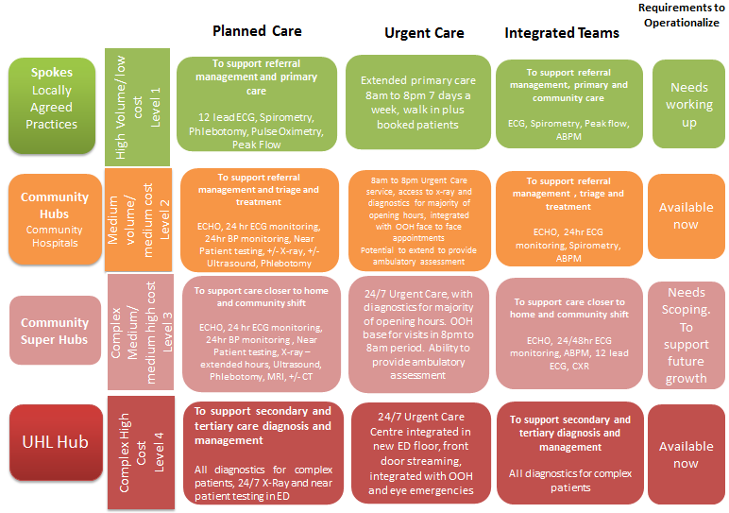
- Development of the spokes and nubs
3.1 Spokes (Locally Agreed Practices) – Imaging
- There are no GP practices with X ray facilities and there is no intention for this to occur.
- ECHO will continue to be provided within GP practices, in the short to medium term by the current private providers, due to the large number being provided – 50% of adult ECHOs across LLR. As part of the providers’ current contract they provide the staff and equipment. There would need to be significant investment if UHL were to take on this activity in the future.
- Further discussion is required regarding the provision of ultrasound in GP Practices. The current issue is the lack of connectivity between images taken in primary care and the EMRAD system, which results in duplication of scans.
3.2 Spokes (Locally Agreed Practices) - Non Imaging
The intention is that a number of practices within every locality are able to provide a range of diagnostic tests, during practice hours. These tests include;
- 12 Lead ECG
- Spirometry
- Ambulatory Blood Pressure Monitoring
- Phlebotomy
- Pulse Oximetry
- Peak Flow
Many GPs already provide this range of testing but this varies across LLR.
3.3 Actions to operationalize the spokes
- Agree the configuration of service availability within each area with Localities / Federations
- Stock take of equipment to ensure identified practices have the appropriate equipment and enough equipment to deliver service
- Agree with UHL that current GP direct access activity is transferred to practice localities
- Agree payment for practices delivering these investigation
- Identify managerial and clinical leads to champion and support the implementation of the model
- Education and training for those that undertake the investigations and those that will be responsible for interpreting the results.
3.4 Community Hubs (Community Hospitals) - Non Imaging Diagnostics
The Community Hospitals will provide diagnostic investigations for both GP initiated activity and to support secondary care services outpatient activity. The range of investigations includes
- 12 Lead ECG
- Spirometry
- Ambulatory Blood Pressure Monitoring
- Phlebotomy
- Pulse Oximetry
- Peak Flow
- Ambulatory ECG Monitoring (24hr, 48hr and 72hr)
The Community Hubs will provide support for the locality spokes and their locations may also influence the formation of the spokes.
The map below shows the Community Hub non imaging diagnostic provision.
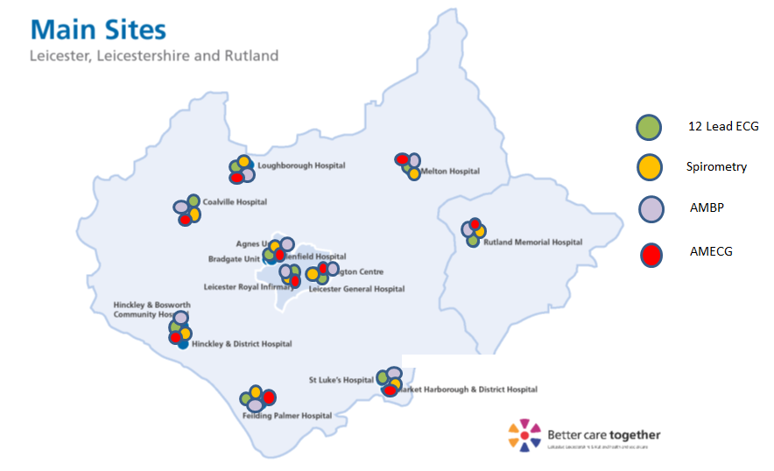
3.5 Community Super Hubs
The super hubs will be community facilities that are able to provide a range of cross-sectional imaging – CT and MRI. This will enable more complex imaging to take place outside of the acute hospitals. The development of Super Hubs will need to be fully scoped and will require a system wide review that considers the planned capital investment in equipment and the most appropriate locations for the equipment. This is not anticipated to occur till 2019/20.
3.6 UHL Hub
UHL will continue to support the diagnosis and ongoing management of complex secondary care and tertiary care patients across all patient pathways. Whilst the intent is to move the GP DA activity in to the Hubs and Spokes, it is likely that UHL will remain a Hub for the Leicester City population in the short term.
- Next steps
ELR GP Federation has been asked by the Alliance to work with its members to develop a proposal for the spokes in ELR (3.2 and 3.3 above).

