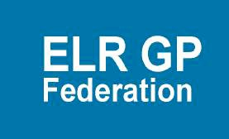

PPaper J

ELR GP Federation
Annual Report 2016/17

ELR GP Federation Annual Report 2016/17
Contents

Introduction from our Chair
Page

Local Context
Our Mission, Vision and Values
Our Business Plan Priorities
Our First Year
Engagement and Communication

Legal Form and Governance

Introduction from our Chair, Dr Rysz Bietzk

Welcome to this first Annual Report from the ELR GP Federation Ltd. We are delighted to be able to report on a busy first year of development and achievement.

Our GP Federation was created after extensive engagement with local GP practices and wider stakeholders to explore how we might best support them to deliver sustainable primary care in East Leicestershire and Rutland (ELR) in the future.

All GP practices across ELR committed to being part of ELR GP Federation, creating a solid foundation from which to build an effective organisation to address the challenges that lay ahead.

Throughout our first year, we continued that process of engagement and listening, through visiting practice teams, meetings in our localities and by harnessing web, social and digital forms of communication.

As is the case across the UK, primary care services in ELR need to evolve to meet the increasing healthcare needs and expectations of the people they serve and to address current service pressures.

The pressure on general practice services is set to continue to increase as we live longer with more complex needs. ELR GP Federation will support our practices to meet local challenges across primary care and the wider healthcare system and to respond to the vision laid out in the Leicester, Leicestershire & Rutland (LLR) Blueprint for General Practices to meet patient’s needs at scale.
Increasingly, it is becoming apparent that the traditional model of general practice will not be sustainable. Consequently, we need to work together to provide services ‘at scale’, as appropriate to the problem that needs solving, thereby realising the benefits of economies of scale, improve opportunities for career structures and professional support and deliver a wider range of services.

Our Business Plan was developed to meet these challenges in our localities and in conjunction and consultation with our members.
Our Federation is committed to facilitating and enabling joint working between practices where it makes sense to do so. Our priorities include:

  - Supporting primary care sustainability and resilience
  - Providing more care locally for patients
  - Leading innovation in primary care delivery
  - Delivering more integrated primary and community care
  - Influencing improvements in health outcomes
Our first Annual Report outlines the positive start that has been made in addressing these priorities over the last year as our GP Federation has been developed and projects and initiatives have been ‘kicked off’ in partnership with our members.

As the Federation’s elected Board, we are committed to supporting our members to deliver sustainable primary care, bringing services closer to patients and providing a clear voice for GPs locally. We have recruited a Chief Operating Officer who is leading the delivery of this exciting agenda.

As well as developing services for members and taking on new service contracts on behalf of our practices, we have provided free online services through our website, www.elrgpfed.com - including Windows on the World and Right Now in Health.

You can also create a free myFed account via the website, which will enable you to subscribe for automatic updates when new items appear on the site. You can also sign up to receive our regular e-newsletter or you can keep in touch and engage with us via our social media channels.
As we enter our second year of operation, our ambition and determination to innovate and deliver new ways of working is set to increase, with further new services and support for our members and our local communities.

We look forward to submitting proposals to develop new services and being a key partner in developing and providing urgent care services across ELR.

I have enjoyed enormously the challenge of being the Federation’s first Chair and look forward to continuing to drive its vision forward and support our members in the coming year.

Dr Ryszard Bietzk
Chair

Local context

All ELR GP practices serving a registered population of around 325,000 patients are part of the ELR GP Federation. The practices fall onto three locality areas:
  - Melton Mowbray, Rutland and Market Harborough
  - Oadby and Wigston
  - Blaby and Lutterworth
Within each of the localities, a number of hubs are emerging with GP Practices coming together to provide more care locally.

Four Integrated Locality Teams are being formed within ELR to improve the delivery of integrated community and primary care services to patients.

The health of the local population is generally better than the overall population of England. However, there are a significant number of people affected by ill health, including:
  - Coronary heart disease
  - Hypertension
  - Diabetes
Over 70% of all deaths in ELR are from three major diseases:
  - Cardiovascular disease
  - Respiratory disease
  - Cancer
Prevalence of long-term diseases in ELR is increasing, particularly amongst the older age groups.

The population of ELR is estimated to increase to 350,000 by 2025 with a significant increase in the older population.
Each health system in the UK has produced its Sustainability and Transformation Plan (STP) to outline how services will evolve to become sustainable. LLR’s STP sets out a range of proposals to meet its healthcare challenges, including;
  - A new emergency department – now opened
  - Increasing services delivered in the community by specialised clinical teams;
  - Encouraging more people to live healthily and avoid illness;
- A shift of services to the community, based on a ‘home first’ principle
To support this STP, LLR has developed its ‘blueprint for General Practice’ which sets out the vision to deliver the General Practice 5 Year Forward View. This blueprint places General Practice with registered lists at the heart of a comprehensive service to patients that caters for their differential needs according to condition and complexity.

The plan articulates how practices will need to come together either formally or informally to meet patients’ needs at scale. By working together practices will deliver improved efficiency and make more effective use of existing resources to ensure that practices are sustainable in the long term. It is intended that the ELR GP Federation will be at the heart of delivering a new model of sustainable General Practice in ELR.

By working together more effectively, practices will be able to contribute to the provision of place-based integrated community and primary care.

ELR GP Federation is committed to supporting our member practices to deliver this vision for transformed healthcare across our region and ensure the delivery of excellent, sustainable primary care services.

Our Mission, Vision and Values

It is against this background that we have set our mission to “To champion through GPs and their practices, investment and delivery of healthcare services at scale for patients across East Leicestershire and Rutland”

To support this mission our vision is To remain a GP-led, patient centred organisation, working collaboratively with our partners across health, social and community care to facilitate an enhanced delivery of high quality, innovative and responsive services across East Leicestershire and Rutland”

ELR GP Federation is committed to the core values, outlined below, which guide the way that we work - placing patients are at the heart of everything we do.

- Patient Centred – ensuring that the needs of patients are at the heart of everything that we do
- Local and Accessible – striving to deliver our services where and when our patients need them
- Efficient and Effective – providing high quality healthcare
- Open and Transparent – in all everything that we do
- Collaborative and Accountable – working effectively with all stakeholders to meet the needs of our members and their patients
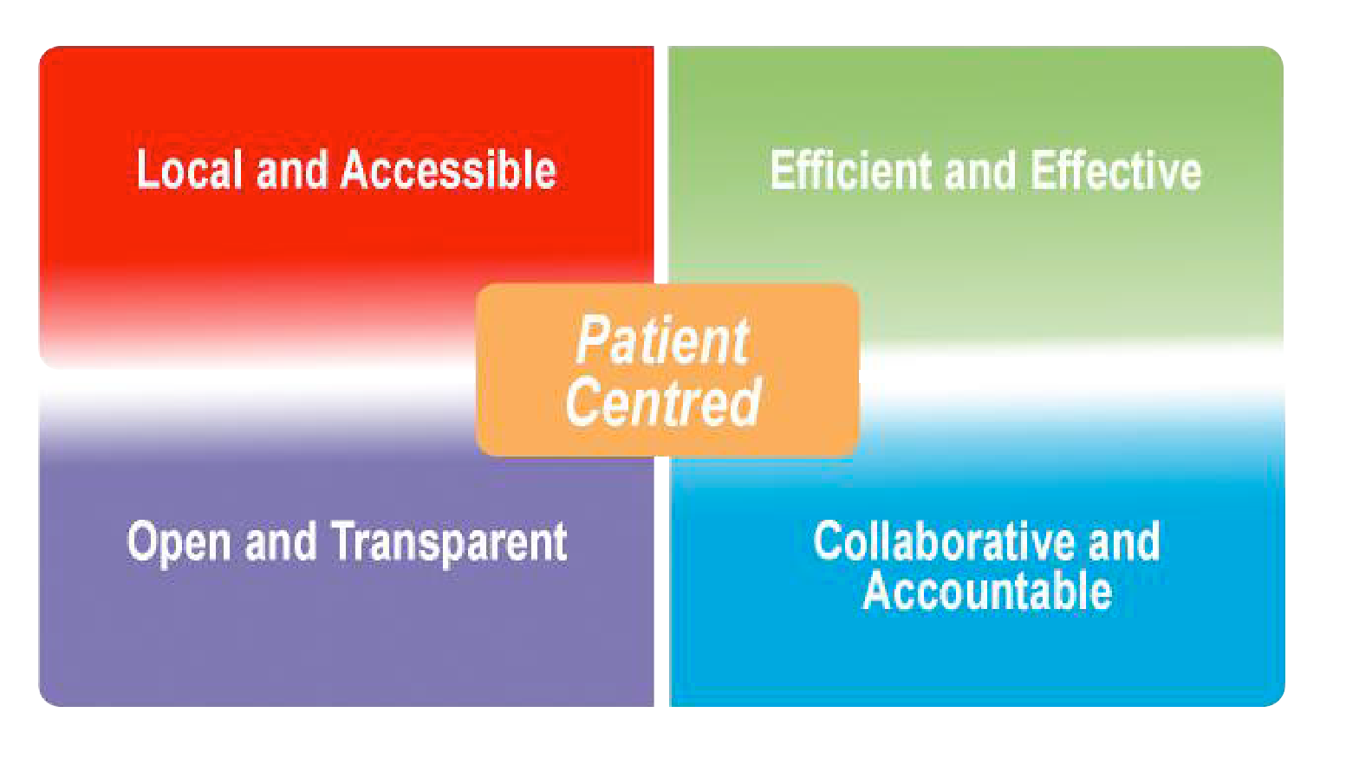

Our Priorities

We have reviewed our business priorities to ensure that they are aligned with meeting the challenges that our member practices are facing. These priorities are outlined below.

Priority 1 – Local service delivery
- Facilitating the delivery of more services locally by expanding non-core primary care services to make them more accessible to our patients.
- Be an effective health service provider; collectively bidding for services that individual practices are too small to provide, collaborating with other healthcare partners, thereby bringing new business to practices.

Priority 2 – Support sustainable primary healthcare
- Support GP members enhance the resilience of their practices to deliver sustainable primary care services. This might include the sharing of best practice and the harmonisation and adoption of common practices and processes e.g. CQC audits, assisting practices to meet external or internally determined KPIs.
- Working with our GP members to improve the way that services are delivered to address the pressures currently faced in the local health care system, delivering at scale where it is helpful to do so.
- Drive forward efficiencies in primary care and within budget seek opportunities to transform the delivery of effective and focused healthcare, where appropriate redesigning pathways.
- Collaborate with other providers, key health and social care partners and commissioners to deliver more planned care locally at scale;

Priority 3 – 5 Year Forward View
- Advance the ambitions set out in the LLR Blueprint for General Practice to improve the way that services are delivered to address the challenges that primary care is currently facing.
- Be a key enabler in the integration of care pathways across health and social care boundaries;
- Drive forward quality in primary care through rigorous and effective governance; and
- Work collaboratively with Commissioners to
influence health outcomes.

Priority 4 – Effective voice

- Be an effective voice for our members across ELR when negotiating with CCGs, Trusts, social care, and voluntary sector. Empowered by its GP members to make the case of the GP role within the future health and social care system.
- It is our aim that the Federation works with commissioners to influence better health outcomes. Local Commissioners have the opportunity to engage the expertise of ELR GP Federation to achieve key commissioning objectives.

Our First Year
We have been working on a number of projects that across our priority areas to deliver on the Federation’s vision.

Local Service Delivery and Business development

Improving Access to General Practice scheme - the Federation was awarded a contract to manage the process for the NHS England scheme to provide additional urgent on the day appointments over the winter period. Two thirds of our practices took part in this scheme which delivered over 5,000 additional appointments.

Urgent Care & Home Visiting services – along with the other LLR GP Federations, ELR GP Federation participated in the consortium bid for the urgent care service in West Leicestershire and the Home Visiting service that was led by DHU.

ELR Urgent Care Centres tender - this represents a key opportunity for the Federation and we are actively preparing to be a key partner in the procurement for the Urgent Care Centres in ELR. The Federation will work closely with its members and partners to ensure that these services are embedded in the ELR primary care system to effectively support general practice to enhance the offer to our patients.

Public Health Community Based Services (Health Checks, contraception, alcohol reduction) – the Federation submitted a bid on behalf of 12 practices to deliver these services and was successfully awarded the contract. Two further practices have subsequently been added to this contract. A further 7 practices were named as sub-contractors to participate in an inter- practice referral scheme for contraception services (IUD/IUS & sub-dermal implants fitting and removal).

Teaching Academy – seven practices joined to make an application to Leicester University to form an academy to provide placements for third year medical students. Whilst we were not selected to provide third year student placements, the University indicated that our bid was strong and invited us to consider involvement in a range of other student teaching schemes. This also provided a valuable opportunity for practices to work together.

Clinical Pharmacists in General Practice – the Federation is working with a number of practices to develop a combined application to the NHS England scheme to support clinical pharmacists working in general practice in patient facing roles.

GP SIP 2017/18 – the Federation engaged with the planning process and made a proposal to support the management of the demand management stream.

LLR Provider Company (LLR PCL) – the Federation has been working closely with LLR PCL to ensure that its members are fairly represented as services are moved out of UHL into the community. LLR PCL has indicated their intention to commission H Pylori services via the Federation in 2017/18.

Alliance – the Federation has been asked to work with its members to bring forward proposals for the development of some diagnostic services to support the transfer of services out of hospital into the community.
Supporting sustainable primary healthcare

We have been working in a number of areas to support our practices to deliver ‘back office offers’ which realise the benefit of scale.

Purchase Direct – A Federation offer has been developed to work with practices to realise the scale economies in purchasing non-clinical supplies. Many of our member practices have joined this scheme and over £90K of savings have been identified so far.
Pharmacy Support – A Prescribing Support Services offer is in place to support practices to engage pharmacists to work within practices. Two practices have signed up and are sharing a pharmacist and they report that the scheme is working very well.

Buildings management (including Health & Safety) – prompted by a suggestion from a practice – we have worked with the Estates Strategy Group to develop a buildings management offer for members.

Indemnity / insurance – this is one area that was identified where savings could be made and we have held exploratory discussions with a potential partner to
investigate how to bring this forward.

Locum service – we are working to develop a platform to connect staff with ‘spare’ sessions with practices who require additional sessions.

Supporting practices – the Federation has been working a number of practices on specific projects to support their sustainability and facilitate joint working between members that are seeking to develop new ways of working to ensure future sustainability.
Back office – a number of other areas are being considered where the development of services at scale could support improved efficiency within practices. These include, HR, payroll, finance support, telecoms, web / intranet, CRB checks.

Five Year Forward View – transforming primary care

GP Five Year Forward View – The Federation is an active member of the GP Five Year Forward View Programme Board which is overseeing the implementation of the LLR ‘Blueprint for General Practice’ which sets out a 5 year vision for General Practice in LLR.

The Federation is working with colleagues across LLR to develop an effective model of sustainable General Practices and facilitate joint working between practices to meet patients’ needs. We have been instrumental in collating learning from local and national projects to provide tools that will support practices to work together where it makes sense to do so, to make more effective use of existing resources to ensure that practices are sustainable in the long term.

Integrated Locality Teams – A key element of the LLR Blueprint for General Practice vision is for practices to work together more effectively with community health and social care providers to develop place-based integrated community and primary care services for local populations.

Four Integrated Locality Teams are being established across ELR to lead this work. Effective ‘federated working’ between primary care providers will be key to the success of this work and, as such, the Federation is actively supporting the development of these ‘leadership teams’ to deliver ‘wrap around community services’. We are also a key member of the ‘Out of Hospital Board’ which is overseeing the development of integrated community and primary care working across ELR to represent the voice of our members.

Engagement and Communication

Effective engagement and communication with our members, commissioners and the wider health community is an essential factor in the Federation supporting its shareholding practices to deliver excellent and sustainable health care. We are committed to communicating and engaging with our stakeholders in an open, trustworthy, accessible and responsive manner to support the delivery of comprehensive primary healthcare services that are available to all and accountable to the communities that we serve. We strive to listen to as many voices as possible throughout our stakeholders.

The Federation has been working with local commissioners on behalf of our members, to support the development of sustainable General Practice across ELR. By drawing on the experience and expertise of our members, we proactively support our commissioners and partner organisations to deliver effective primary care services by calling upon an innovative GP network that is committed to creating an effective and sustainable primary care service with improved health outcomes for the residents of ELR.

We will continue to work collaboratively with commissioners - representing our members’ interests to help create new pathways and innovative services that will be key to improving clinical outcomes for our patients in line with the vision set out in the LLR Blueprint for General Practice.

We constantly seek new ways of obtaining feedback about the services that we and our member Practices provide for local people, stakeholders, patients and their families.
The Federation has and will actively work with our health and social care partners to achieve this, including Leicestershire County Council, Rutland County Council, Healthwatch, patient groups, the voluntary sector and other partner organisations.

We have also been engaging with the wider healthcare economy and other GP Federations within Leicestershire and the Midlands to gather learning and draw on the evidence base for innovating and developing healthcare systems and practice to enhance services. As part of this process, we have linked with a Midlands based GP Federation network group.

Harnessing social, web and digital technology

In addition to traditional paper based communication and engagement methods, we have introduced a host of new and innovative digital tools, techniques and channels. These have improved the ways in which we are able to reach out to our communities, keeping them informed about what we are doing, and bringing them together with each other and us.

We have developed a modern and engaging web presence - www.elrgpfed.com – where people can register online with ‘myFed’ to be part of a Federation membership scheme to;
- Receive updates, notifications and breaking news about the topics and issues of most interest and relevance to them,
- Subscribe to a regular e-newsletter,
- Access background documents and other materials
- Engage with us through a range of social media channels including Twitter and Facebook.

Our website also features free online services that make it attractive for our members and stakeholders to visit and return regularly, including;

- The healthcare news ticker – providing the breaking national healthcare news;
- Window on the World –bringing together live social media feeds from the three LLR Clinical Commisioning Groups, University Hospitals Leicester, Leicester Partnership Trust, LLR Alliance, ELR GP Federation, the 2 LLR Healthwatch organisations, Voluntary Action Leicestershire and the Better Care Together Programme;
- Community Hospital Waiting Times - a free downloadable resource.

We are also working to use social media to give frontline staff, carers, patients and families their voice and their spaces to interact with us and each other. We use a specialist NHS Social Media tool called Find SoMeone in Health to engage with audiences who would not naturally work with the Federation or whom may not be aware of what we do.

Whilst the ELR GP Federation is not a public authority we nevertheless champion equality and human rights in all that we do. This is especially important for communication and engagement activities.

Legal form and Governance

The Federation comprises all GP practices within the ELR area from its three Localities;

Melton, Rutland and Harborough
County Practice
Empingham Medical Centre Kibworth Health Centre
Latham House Medical Practice
Market Harborough Medical Centre Market Overton & Somerby Surgeries Oakham Medical Practice
The Jubilee Medical Practice The Billesdon Surgery
The Husbands Bosworth Surgery Two Shires Medical Practice
Long Clawson Medical Practice The Uppingham Surgery

Blaby and Lutterworth
Enderby Medical Centre
Forest House Medical Centre
The Glenfield Surgery
Countesthorpe Health Centre
Hazelmere Medical Centre
Kingsway Surgery
Narborough Health Centre
Northfield Medical Centre
The Limes Medical Centre
The Masharani Practice
The Wycliffe Medical Practice

Oadby and Wigston Bushloe Surgery Rosemead Drive Surgery Severn Surgery
South Wigston Health Centre The Central Surgery
The Croft Medical Centre Wigston Central Surgery

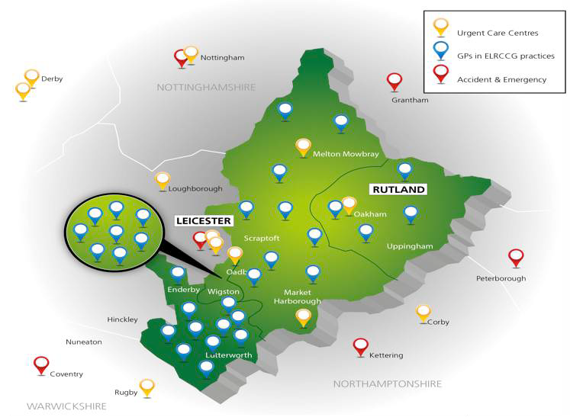

Legal Form

ELR GP Federation Ltd is a company limited by shares which;
- Is registered at Companies House;
- Is owned by its shareholders, who are the Practices, and run by an elected Executive Board;
- Each practice has nominated a GP to hold its shares on the practice’s behalf;
- Is governed by its Articles of Association and a Shareholders’ Agreement between its members;
- Offers limited liability;
- Allowed Practices to buy shares at a value and limit of £1 per 1000 population with the retention of a defined number of shares for later issue if required.
Our Shareholders’ Agreement:
- States how the Board of Directors will be elected;
- Sets out the shareholders’ rights and obligations;
- Regulates the sale of shares in the company;
- Describes how the company is going to be run;
- Describes what will happen if a shareholder wishes to leave the company;
- Provides an element of protection for minority shareholders and the company; and
- Defines how important decisions are to be
Made
- Provides guidance in relation to tendering for services

The Board
The Board is accountable to shareholders on an on-going basis for the effective management of the Federation.

The Board comprises six members who carry the confidence of the voting shareholders from the three Localities:

- Melton, Rutland and Market Harborough;
- Oadby and Wigston;
- Blaby and Lutterworth.

One of the Directors is elected as Chair of the Board. The Board can also co-opt further Directors, if necessary.

Each Board member serves for an initial period of three years.

A Chief Operating Officer serves for an unlimited period subject to performance and is a non- voting member of the Board.

Management Structures

The Federation will play a key role in the delivery of services that move from and acute to community setting, either itself or by sub-contracting this to member Practices.

Many of the members of the Federation are also shareholders of the
LLR Provider Company Ltd (part of the Alliance Partnership). Any consequential conflicts of interest are managed by the Federation and the LLR Provider Company Ltd in accordance with their respective policies and procedures.

A clear management structure aids the smooth and efficient running of operations, and ensures that each member Practice is aware of its obligations and commitments in terms of any service it provides on behalf of the Federation.

The three Localities are key in enabling the Federation to ensure that the member GP Practices are able to influence decisions made by the Federation and ensure that local health needs are addressed where appropriate through pan Federation initiatives.

If the Federation directly provides clinical services, it will implement the requisite clinical indemnity insurance in place to cover against claims for negligence.

Our Board

.
James Watkins

James is the Chief Operating Officer for ELR GP Federation.

James started his career in healthcare nearly
25 years ago when he joined the NHS Graduate Management Training scheme based at Leicester General Hospital. Since then he has worked across the country in a number of operational, strategic and development roles within the NHS, Charity and Social

Dr Ryszard Geraint Bietzk

Rysz is the Chair of the
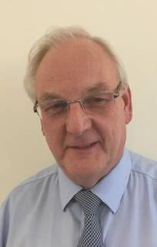

ELR GP Federation

He has been a GP in Oakham since 2012, more recently moving to be based at the allied practices at Market Overton and Somerby.
Prior to moving to Rutland,
Rysz has spent many years in general practice both in Bedfordshire and Essex and been active
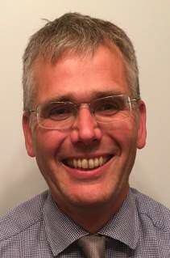

Enterprise healthcare sectors.

James recognises this is a challenging time to be working within the NHS to ensure that we deliver high quality healthcare to the people that use our services. He believes it is very exciting that all practices in ELR have agreed to come together to create a new GP Federation to help rise to that challenge.

His commitment is to work with all Federation members to determine how the Federation can effectively engage with practices and add value to the delivery of primary care – recognising the local variations across ELR.
development over that time from total purchasing and fundholding through to practice based commissioning and the formation of CCGs. He also took time away from primary care to be medical director of a hospice

Anuj Chahal

Anuj Chahal is Board Member for Harborough.

Anuj Chahal is a GP partner at the Two Shires Medical Practice with sites at Kibworth, Fleckney and Market Harborough. He completed his medical training in London and general practice training in Leicestershire.

He has worked on initiatives with the NHS Leadership Academy and is a board director for the Leicester, Leicestershire and Rutland Provider

Gareth Chidlow

Gareth Chidlow is Board Member for Melton.

Gareth Chidlow works at Syston, where he was instrumental in the building of their new Health Centre and bringing many services into Primary Care from

Nainesh Chotai

Nainesh Chotai is Board Member for Blaby and Lutterworth.
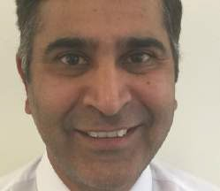

Nainesh Chotai has been a GP at the Glenfield Surgery since 1995. He is an LMC committee member and a GP trainer. He was on the

Company Limited (LLR PCL) - a clinical services organisation established in 2011 by 90 GP Practices.

His hope is that the ELR GP Federation will allow practices to share services, resources and expertise. This will encourage better local integration with improved quality and safety for overall patient care.
Secondary Care. These have included ultrasound scanning, hand surgery, hernia repairs and MRI. He has used his experience in leading on procurement for LLR Provider Company, where he has been successful with several tenders including the Alliance contract for Elective Care.

Gareth sits on the Alliance Leadership and Management Boards as well as the Clinical Reference Group.
working group that founded the ELR GP Federation.

He is an active participant in the locality meetings and is committed to ensuring GPs are appropriately resourced for the increasing burdens placed on them.

Louise Ryan

Louise Ryan is Board Member for Oadby and Wigston

Louise has lived and worked in Leicester and Leicestershire since 1999, when she commenced medical training at Leicester Medical School.
She trained as a GP at the

Simon Vincent

Simon Vincent is Board Member for Blaby and Lutterworth
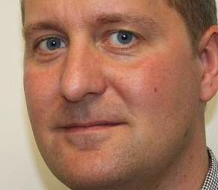

Dr Simon Vincent worked for 12 years as a GP at Burbage Surgery before joining the partnership at The Limes Medical

Joe McCrea

Joe McCrea is Head of Communications and Engagement.
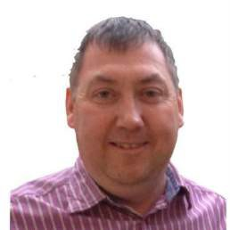

Joe has been involved with the Federation since its inception
- both in shadow form and once fully operational.
He attends Board

Glenfield Surgery and,
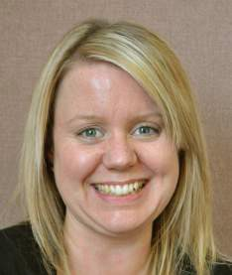

following four years as a GP at Hazlemere Medical Centre in Blaby, she joined Central Surgery in Oadby, where she works a a GP Partner and GP Trainer.
Speaking of her reasons for wanting to join the ELR
Centre, Narborough in April 2015.

He has been a GP Trainer since 2008. In 2014 he joined the West Leicestershire CCG Quality &
Performance Group and became a Director of the newly formed Hinckley & Bosworth GP Federation in the summer of 2015.

Dr Vincent had to leave both of these posts with moving to to The Limes, which is part of East Leicestershire & Rutland CCG.

His main interest in becoming a Director of ELR GP Federation lies in the opportunities that exist to develop new services that our surgeries can deliver. Outside of medicine he loves cycling and his kept very busy with his family.
meetings in a non-voting capacity to give advice and support in respect of all aspects of communications and engagement.

He has a strong communications background with wide experience over more than 20 years at a senior level developing and delivering in-house
assignments, marketing, comms, PR and campaign initiatives in health, public health, local government, education and environment spheres.

