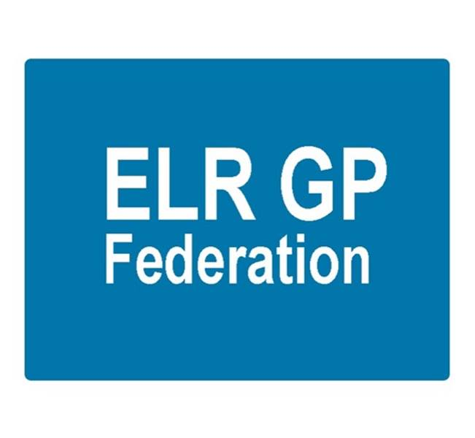

Board meeting
7pm 21st September 2017 @ Syston Medical Centre
AGENDA

 |  | Paper
 | Urgent care procurement – Paula Vaughan
 | Apologies
 | Review of Minutes of the Meeting held on 17th August 2017 | A
 | Matters arising
 | NHS England Clinical Pharmacists scheme | B
 | Report from the COO | C, D, E, F
 | Financial update  - FY17/18 update  - 3 year forecast | Tabled  G
 | Shareholders meeting – 28th September 2017 | H  Outline presentation to be tabled
 | STP GP Five Year Forward View update  - Toolkit | C
 | Localities update | C
 | PCL update  - H Pylori  - Diagnostics Hubs and Spokes | C
 | Communications update
 | Conflicts of Interest register
 | AOB
 | Date & venue of next meeting

