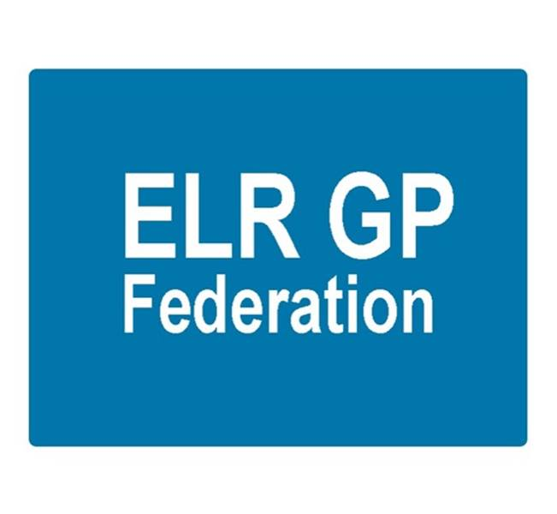

ELR GP Federation Ltd
Minutes of the meeting of The Board of Directors
Tuesday 13th June 2017 – Syston Medical Centre

Present: Dr R Bietzk (RB); Dr G Chidlow (GC); Dr N Chotai (NC); Dr A Chahal (AC); J Watkins (JW); H Patel (HP), J McCrea (JM)

In the Chair: Dr R Bietzk

- Apologies
Dr S Vincent, Dr L Ryan

- To confirm the minutes of the meeting held on 4th May 2017.
The minutes were confirmed as an accurate record.

- Matters arising
- JW to review the Articles of Association & policies for approval. Action, JW – 6 weeks.
- Demand Management proposal – awaiting feedback from CCG. Action, JW.
- Comms circulation – JM to advise on management of circulation lists. Action JM.
- LPT – suggested that it would be useful to hold a Board to Board event. Action JW/RB.

- Clare Sherman – Interim Head of Primary Care

Clare updated on the key areas that she is working on;
- GP IT
- Primary care contracting
- Business continuity plans update
- Demand management plans – see below.
- International recruitment
- SystmOne migration
- Shift to N4 – further to question from NC; Clare confirmed that they are working to implement performance standards
- Clare and JW to review the SLA reporting and arrange the next Board to Board session. Action JW.

- Demand management

- Clare Sherman confirmed that she is leading on demand management
- RB summarized the Federation’s proposal to lead on the production of the demand metrics on a quarterly basis which would include a commentary on variances and facilitation of the debate at Locality meetings to ensure that the information is used to encourage peer review and improved learning and performance across all practices.
- Clare Sherman reported that there are some challenges with the data coming from the new Mids & Lancs CSU.

- Away Day Outcome

The updated outcomes paper summarizing the Board’s vision for the Federation and the key relationships, roles and responsibilities of Board members was accepted.

Next steps;

- Board members to be clear and confident in their role as Locality leads
- Recalibrate the way that we work with Localities – agreed with the CCG
- Agree a common narrative with the CCG to use in our communications and engagement with the Localities and wider healthcare economy
- Provider development – needs to be led by the Federation

- COO Report

  - Pharmacy project – The Federation continues to provide a service to two Oadby practices - via Prescribing Support Services - which is going well.

Tim Sacks has indicated that the CCG will undertake a procurement process for PSS/MMS type services. Existing arrangements will continue until at least the end of September 2017. JW to work with the new Head of Medicines, John Nicholls, regarding managing this process. Action JW.

  - NHS England; Clinical pharmacists in general practice – JW to progress, in conjunction with John Nicholls, with interested practices targeting the September 2017 cohort. Action, JW.

  - Purchase Direct scheme – 16 practices signed up. Over £100K of savings identified.

  - Community Based Services procurement –The Federation bid for the Leicestershire County Council community based services, including health checks and contraception was successful.

We have now received the contract document from LCC. We have been supported by LMC Law to produce a sub-contract which will be issued to our 13 sub-contracting practices (including two who did not bid for the contract initially).

We will also now work to put in place a process to facilitate inter-practice referrals for IUD/IUS/SDI services.

We are required to hold medical malpractice insurance up to £2M for this contract. As discussed as the last Board meeting, LCC are content to rely upon the individual practitioners and practices indemnity arrangements. As directed by the Board, the sub-contracts state that our sub-contracting practices must hold this insurance.

  - GP SIP – see demand management section above.

  - Locality updates

Oadby & Wigston; Louise is a member of the Leadership Team that is looking at improved working arrangements with Care Homes.

JW has been working with two practices in O&W to facilitate joint working between the practices as they consider forming a new partnership. Action JW.

Blaby & Lutterworth; James is a member of the Leadership Team. The group is working on a number of initiatives, including;

- MDT teleconferencing / Skype
- MDT care homes / ward round
- UTI project with UHL Geriatrician
- Blaby DC disease prevention project
- Active Blaby

Melton, Syston and Rutland; Initiatives include;
- Rutland experience / wellbeing workers / primary care home
- Melton DC workers embedded in the practice

Harborough; Anuj has agreed to help set up a Leadership Team and we are working with the CCG accordingly.

  - STP GP Five Year Forward View - The Blueprint for General Practice document has been launched to guide the delivery of the GP Five Year Forward View agenda in LLR. ELR GP Federation is stated as being a key element in the delivery of the vision and plan to support practices coming together to meet patients’ needs at scale.

JW is working with Julia Cory, new Head of Primary Care for Leicester City CCG, to produce a guidance / tool kit document to assist practices who wish to work at scale. Action JW

The PLT on 20th June 2017 will focus on supporting practices to implement the GP Five Year Forward View agenda. The Federation (JW) has been asked to do a 10 minute presentation at this event on how the Federation has / will support this work. Slides were tabled and approved. Action JW.

  - Kingsway ‘clinical top up service’ – The Federation have continued to work successfully with the Kingsway surgery team to provide GP, ANP, nurse support in line with our four months clinical top-up service SLA. There are now two partners in place.

  - Buildings management offer - We have developed a buildings management offer with the Estates Strategy Group. JW has spoken with a number of practices about piloting the Beacon assessment. Action JW.

  - Primary Care Exchange - Social Enterprise who provide the Locum exchange service that Anuj used whilst in Bristol. A presentation is being arranged. Action JW.

  - Insurance - Working with Locktons on an insurance offer for consideration. Action JW.

  - LLR PCL

H Pylori – ELR GP Federation has been offered a contract with LLR PCL to provide H Pylori breath tests in ELR from July 2017 on the basis of taking a 5% administration fee. The Board decided that the Federation should pursue this opportunity.

Diagnostic Hubs and Spokes – ELR GP Federation has been asked by the Alliance to work with its members to develop a proposal for diagnostic spokes in ELR. The Board decided that the Federation should pursue this opportunity.

  - Other back office projects

JW / AC to investigate the options for shared intranet (options include IntraDoc and Clarity) and digital dictation services (Lexicom). Action JW, AC, JM

Anuj also advised the Board on the helpful ‘Practice Index’ web site.

- Urgent Care Procurement

- The procurement process is likely to be delayed to allow for public consultation on the proposed specification. Start date could be October 2018 but we should continue to plan on the basis of an April 2018 start.
- RB & JW had a positive meeting with Vocare who will be bidding for this contract. We agreed that we should work together ahead of the procurement process on the basis that Vocare are the incumbent provider and we could pilot new ways of working. It was agreed to follow up with Vocare after the PLT meeting on 20th June 2017. Action RB / JW.
- Gareth and James will arrange a follow up session with DHUwho are keen to partner with the Federation on a similar basis to that employed in the West Leics urgent care centres. Action JW/GC.
- The Board decided to suspend a decision regarding the possibility of selecting one partner to work with on an exclusive basis.

- Financial update

  - VAT - Income generated by the Federation may be standard rated VATable income. A paper was tabled outlining the advice from the Federation’s accountants.

We are advised that the contracts with the Practices should be 'back-to-back', with the full 100% being remitted to the Practices, and a separate invoice issued for any administration charges. In this way, only the administration charge would form part of the potential VATable element.

  - IR35 – our accountants have confirmed that IR35 does not apply to GP Federations.

  - Directors costs – It is suggested that directors should be paid through the payroll for their regular attendance at Board meetings. Any other work claimed could potentially be billed by the Board member's Practice. Post meeting note; JW/HP to check this proposal.

  - FY17/18 update – the Board reviewed the financial update for the year to date.

- Communications update

- Annual report – see below.
- JM has configured Campaign Monitor to communicate with patient group – including the PPG Chairs. Liaise with Healthwatch. Action, JM.
- JW/JM have met with North Staffs GP Federation. Suggestion to invite NHS E lead to meet with the Board. Action JW / JM.
- JM to update the GP lists. Action JM.
- JM to advise on process in relation to circulating future comms with GPs. Action JM.
- JM to add the Conflicts of Interest register to the website. Action JM.

- Annual report and AGM

Annual report drafted and was included in the Board pack. Board members to review and feedback any comments to JW/JM Action, All.

AGM to be scheduled for September 2017. Action JW.

- AOB

The Board approved that the Federation should join the East Midlands GP Federation Network at a cost of £1K. Action JW.

- Date & venue of next meetings

Thursday 6th July 2017 @ 7pm – Board meeting at Syston Health Centre.

