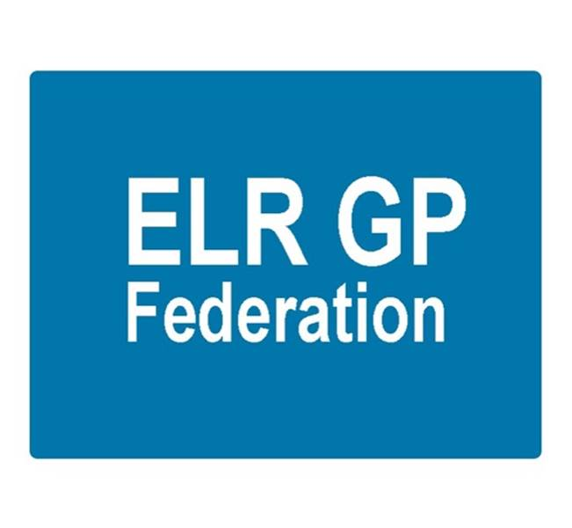

ELR GP Federation Ltd
Minutes of the meeting of The Board of Directors
Tuesday 17th August 2017 – Syston Medical Centre

Present: Dr R Bietzk (RB); Dr S Vincent; Dr G Chidlow (GC); Dr N Chotai (NC); J Watkins (JW); H Patel (HP)

In the Chair: Dr R Bietzk

- Apologies - Dr L Ryan; J McCrea; Dr A Chahal

- To confirm the minutes of the meeting held on 6th July 2017.
The minutes were confirmed as an accurate record.

- Matters arising
- JW has made contact with the solicitor who prepared the Articles of Association and confirmed that a formal AGM is not required unless a formal resolution is required.
- Policies to be removed for approval. Action, JW
- Demand Management proposal – C Sharman / T Sacks have indicated that the Federation will be asked to assist with peer review. Action, JW.
- LPT – Meeting arranged with Peter Cooke and Rachel Bilsborough on 11th September 2017. RB/JW to attend. Action RB/JW.

- Feedback from PLT / CCG feedback

- The Board discussed the update following JW’s meeting with Tim Sacks. Key points and actions;
- Develop joint strategy with the CCG that clarifies the expectations for the Federation and the respective roles of the CCG and Federation - building on the work that we have done to date. Action JW/RB
- A key role for the Federation must be as the facilitator / fixer - bringing practices together to develop new ways of working to enhance sustainability - as we are doing with the practices in Oadby/Wigston.
- The transformation fund is a key opportunity to enable new ways of working and we need to be at the forefront of helping practices to come together to grasp this opportunity.
- To support this, a key priority is completing the 'tool kit' to provide practices with the 'how to' guides to work together. Action JW
- We need to establish a greater presence with our members and a 'louder voice'
- We have been successful in being awarded contracts (CBS, winter access) and have developed a sub-contracting process with our members that works. There will be further opportunities that we need to grasp. A key opportunity is the urgent primary care / 7 day access service that we are working on.
- We will facilitate an application to the NHS E Pharmacists in practice scheme.
- We will work with the CCG on how we support demand management.
- We will provide a regular report to the CCG and produce a financial plan for future years.
- We need to ‘recalibrate the way that we work with Localities
- A North Blaby Hub is developing. JW to attend to see how the Federation could support this work. Action SV/JW

- Urgent Care Procurement

- The timetable for procurement process is likely to be put back so that the new ‘extended primary care’ service would start in October 2018.
- Clarification is needed regarding the extent of the proposed specification and the interface with minor injuries and extended hours services. Paula Vaughan to be invited to the next meeting to provide an update. Action JW
- This is an important opportunity for the Federation to work on behalf of its members with the potential of a useful income stream.
- RB/JW and Dan Marchovic held a follow up meetings with Vocare to discuss opportunities for joint working on the basis that they are the incumbent. RB/JW to review how we could potentially develop a bookable 6.30 to 8 service on a pilot basis. Action RB
- Vocare also stated that they are seeking to work with the Federation on an exclusive basis to prepare for the forthcoming tender for extended primary care.
- JW/GC are arranging a follow up session with DHU who are also seeking to work with the Federation on an exclusive basis to prepare for the forthcoming tender for extended primary care. Action GC/JW
- The Board will either need to determine to work on an exclusive basis with either Vocare or DHU or offer support to bidders on a non-exclusive basis. The Board decided to suspend a decision pending further information.

- COO Report

(a) Pharmacy Project - Following CCG guidance, we have now served notice on the contract with PSS which will come to an end on 31st October 2017. The CCG will be undertaking a procurement process for third party pharmacy organisations to join an accredited list. The new arrangements will commence on 1st November 2017.

(b) NHS England; Clinical pharmacists in general practice - NHS England has launched a further scheme to support the development of clinical pharmacists in general practice. The deadline for the next phase of applications is 29th September 2017.

JW/RB are preparing an application on behalf of interested practices (15 to date). Action JW/RB

The Board considered the Soar Beyond offer which provides a hub/spoke ‘at scale’ model to enable practices to collaborate as the scheme requires. They have been successful with two NHS England schemes applications and could assist with the bid. JW/RB to meet with Soar Beyond to progress. Action JW/RB

(e) Purchase Direct - 17 practices now signed up. Over £100K of savings have been identified.

(f) Community Based Services - Signed the contract in place and sub-contracting agreements with our 13 sub-contracting practices.

JW attended the first contract review meeting in July and will follow up with practices on the points raised. Action JW.

The West Federations inter-practice referrals process for IUD/IUS/SDI services has been adapted and will be circulated for comment. Action JW.

(g) Demand management - the CCG has indicated that it would like the Federation to assist with this element of the GP SIP but we still await confirmation regarding next steps. Action JW.

(h) Locality updates

Oadby & Wigston; LR / JW met with Vivec on 14th August 2017. Key points; support practices with back office and workload demands. JW / LR to attend the September 2017 Locality meeting. Action JW/LR.

JW continues to facilitate joint working between the Oadby Central and South Wigston practices as they work towards new partnership working.

Blaby & Lutterworth; JW met with Nick Glover to discuss how the Federation can best support practices. Key point for the Federation to support practices with ‘how to’ guides to support joint working and accessing the transformation funds.

Melton, Syston and Rutland; Initiatives include;
- Rutland experience / wellbeing workers / primary care home
- Melton DC workers embedded in the practice

Harborough; Working with Paula Vaughan / Anuj to set up a Leadership Team. Action JW/AC

(i) STP GP Five Year Forward View

JW is working with Julia Cory, new Head of Primary Care for Leicester City CCG, to produce a guidance / tool kit document to assist practices who wish to work at scale. Three key steps;

- Identify opportunities for practices to work together
- Provide guidance and practical tools to enable practices to implement these joining working schemes
- Promote the toolkit and fulfil the Federation’s facilitation role to support joint working and accessing Transformation Funding where it makes sense to do so.

This is a key role for the Federation and also provides an opportunity to provide it with funding streams where it provides support to practices to come together. Action JW / all.

(k) Kingsway ‘clinical top up service’

This scheme has now been concluded. The practice is now in a better position with two partners in place. The scheme’s financial summary is shown below.

 | £ | Comment
Scheme budget | £ 106,000.00 | £101,520 invoiced and paid to date.
Costs
Staffing costs @ 11th July 2017 | £ 97,288.95 | Per weekly activity report.
Fed admin @ 5% | £ 4,864.45
Total costs | £ 102,153.40
Surplus / deficit | £ 3,846.60

(l) Buildings management offer - We have developed a buildings management offer with the Estates Strategy Group. Latham House will pilot the Beacon diagnostic assessment tool.
(m) Primary Care Exchange – a social enterprise that provides a Locum exchange service. A presentation took place in July and JW will now prepare a paper / business case to progress this opportunity. Action JW
(n) Insurance - met with Locktons regarding an insurance offer for consideration – no further update.
(o) LLR PCL

H Pylori – we have now advised all practices that the Federation has been offered a contract with LLR PCL to provide H Pylori breath tests in ELR based on a 5% administration fee. Approximately half have now indicated that they wish to sub-contract to the Federation. Existing AQP arrangements have been extended for a further two months and new arrangements will not start until September 2017 at the earliest.

Diagnostic Hubs and Spokes – JW is working with the Alliance to support the scheme to develop a proposal for diagnostic spokes in ELR. Questionnaires have been circulated to practices and many have now been returned.
(p) Dispensing practices procurement - Kibworth practice has approached the Federation to assist with procuring medicines on behalf of dispensing practices.

(q) HR - HR support is an area where a Federation wide approach could improve the level of service and cost effectiveness to practices. JW will be meeting with the LPT HR Director along with one of the Practice Managers to discuss what could be possible. Action JW

(r) GP TeamNet - a demonstration of this system is being arranged. Action JW

(s) Cleaning – the Board suggested that we investigate procuring cleaning services on behalf of practices. Action JW

- Financial update

  - Financial accounts for the year ending 31st Match 2017

The financial statements of the company for the year ended 31 March 2017 and the letter of representation to the reporting accountants, circulated with the Board papers, were considered. It was resolved:
- That the financial statements as produced are hereby approved and that they be signed on behalf of the board by Dr R Bietzk

- That the report of the directors as produced is hereby approved and that it be signed on behalf of the board by Dr R Bietzk
(c) That the letter of representation to the reporting accountants, Ballard Dale Syree Watson LLP, be hereby approved and that it be signed on behalf of the board.
(d) That no dividend would be paid in respect of the year ended 31 March 2017
HP will arrange with Ballards for the accounts to be filed prior to the deadline of 23rd September 2017. Action HP.

7.2 3 year forecast – the Board considered the forecast and noted the assumptions made. JW/HP to keep this updated. Action JW/HP

- Communications update

- Annual report – final draft included in the Board pack. JW/JM to finalise and print for the shareholders’ meeting.
- Shareholders’ meeting – 28th September 2017 at College Court - include items on accessing transformation funding and urgent care / extended GP access.

- Conflicts of interest register - the register has been updated and added to the website.

- Directors’ costs – The Board confirmed that directors will be paid through the payroll for their Federation work. All Directors are now set up on the payroll.

- Date & venue of next meetings

Thursday 21st September 2017 @ 7pm – Board meeting at Syston Health Centre.

