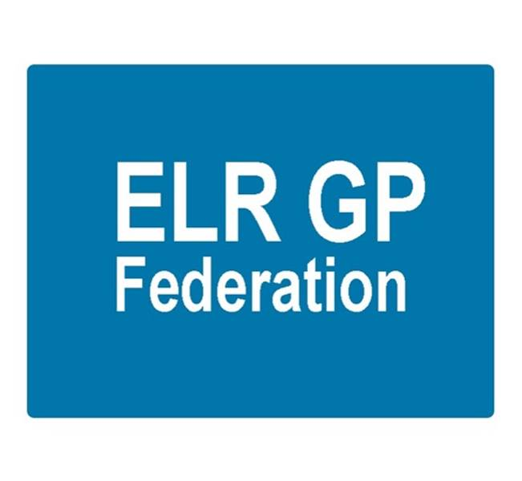

Board meeting
7pm 14th December 2017 @ Syston Medical Centre
AGENDA

 |  | Paper
 | Apologies
 | Review of Minutes of the Meeting held on 16th November 2017 | A
 | Matters arising
 | Report from the COO | B, C, D, E, F
 | Financial update  - FY17/18 update  - FY18/19 forecast | G  G
 | Board changes
 | STP GP Five Year Forward View update | B
 | Localities update | B
 | Service contracts  - H Pylori  - ECG  - Demand management | B
 | Communications update
 | Conflicts of Interest register
 | AOB
 | Date & venue of next meeting

