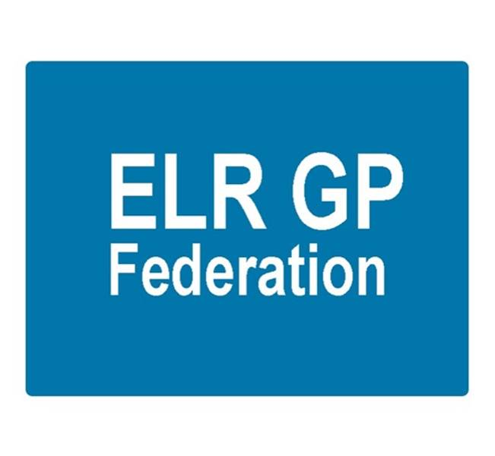

ELR GP Federation Ltd
Minutes of the meeting of The Board of Directors
Tuesday 16th November 2017 – Syston Medical Centre

- Present: Dr R Bietzk; Dr G Chidlow; Dr N Chotai; J Watkins; J McCrea, Dr L Ryan, Dr A Chahal; H Patel; Dr S Vincent

In the Chair: Dr R Bietzk

- Apologies - None

- To confirm the minutes of the meeting held on 21st September 2017.
The minutes were confirmed as an accurate record.

- Matters arising
- Policies to be updated for approval. Action, JW
- Joint strategy with the CCG - that clarifies the role and expectations of the Federation, including as facilitator to bring practices together to develop new ways of working, and the respective role of the CCG – including budget forecast. Action JW / RB.
- Winter access – no further news regarding FY17/18.

- COO Report

- Joint strategy with the CCG / future funding - JW will draft a joint strategy that clarifies the expectations for the Federation, including as facilitator and ‘honest broker’ in supporting practices to develop the new Localities and develop new ways of working and outline the funding requirements for the Federation in FY18/19. JW will arrange to meet with Tim Sacks. Action JW.

- Localities and transformation fund update - The emerging six localities are at different stages of development but are all starting to develop plans for joint working between the practices and integrating more effectively with community, mental health and social care services in their respective areas.

The CCG will be supporting this development of integrated place based working with the transformation fund over the next 18 months. This is additional to the funding that will be made available to support the development of acute on the day ‘in hours’ provision for patients.

The CCG plans to release resource to fund additional GP capacity to support this work. The Federation has been asked by all six emerging localities to assist with the development of their joint working initiatives and transformation fund applications.

The Board agreed that the Federation should support the development of the Locality development and transformation fund applications within its existing resources during FY17/18. Further resources will need to be sought for FY18/19. Action JW

JW continues to support South Wigston and Central Surgery as they work towards a new partnership. Action JW

- LLR STP GP FYFV Programme Board and tool kit - The tool kit work has been well received. This will be updated following consultation. The toolkit will be used to assist with joint working between practices in the emerging six localities. Action JW

- LPT - RB/JW met with Peter Miller (CEO) and Rachel Bilsborough (Director) on 11th September. This was a positive first meeting, focusing on how we could collaborate to improve integrated working between primary, community and mental health services in the localities across ELR.

GC suggested that we should set up a meeting with Will Monahan, UHL. Action JW

- Extended primary care / urgent care - The timetable for the procurement process will result in the new ‘extended primary care’ service would starting in October 2018, and possibly April 2019.

Vocare has been acquired by Totally Plc, an out-of-hospital care provider, who will use this acquisition to develop their presence in the urgent care sector. RB has contacted Vocare since this announcement and they remain keen to work with the Federation on the forthcoming tender.

GC/JW will be meeting with DHU on 17th November 2017, who remain keen to work with the Federation on an ‘exclusive basis’.

- Pharmacy Project – The Federation’s arrangement with PSS, on behalf of two Oadby practices, ended on 31st October 2017. The CCG has completed a procurement process for third party pharmacy support organisations to join an accredited list. The new arrangements commenced on 1st November 2017.

- NHS England; Clinical pharmacists in general practice – the application for 1 senior pharmacist and 2 pharmacists to support 11 practices (93,000) was submitted on 29th September 2017. Subsequently;
- NHS E asked us to adjust the application to 3 pharmacists. We did this on the basis that the senior support would be provided from the specialist partner and/or a neighbouring scheme.
- This will have a cost implication.
- The plan is to dovetail the 3 NHS E pharmacists with the approx. 3 that are funded by the ELR CCG scheme.
- Soar Beyond are not on the CCG accredited list which will make the melding of the two schemes more challenging. The Soar Beyond cost will increase if they do not employ all 6 pharmacists. The implications are being worked through.

- Community Based Services and inter-practice referral process – JW/HP attended the Q2 contract review meeting on 3rd November 2017. Key points;
- Overall happy with performance
- Asked the Federation to follow up on areas of variation
- General reduction in IUD/S fittings and asked if we knew why?
- Encourage the use of the Quest browser (TCR software), which will become mandatory

The inter-practice referrals process for IUD/IUS/SDI services has been adapted has been circulated for comment. Action JW

- Demand management – A plan has been submitted to the CCG to propose how the scheme would be implemented. JW, RB to meet with the CCG to review the information that is available and advise on what further information would be required. Action RB, JW.

- Correspondence management – The Federation successfully applied on behalf of seven practices for £33K to be a pilot site. Awaiting detail to implement. Action JW

- Active signposting – JW to follow-up. Action JW

- Buildings management offer – Latham House piloted the Estates Strategy Group Beacon assessment tool in October 2017. They report that the assessment was helpful. Once we have the full report, we will determine the best approach to offering this wider and further developing a buildings management offer.

- Primary Care Exchange – JW to follow-up. Action JW

- Service contracts – H Pylori and CCG – JW/GC to follow-up. Action JW/GC

GC update the Board on developments with Diagnostic World.

- Dispensing practices procurement – JW/RB to pursue Action JW/RB

- GP TeamNet –a demonstration of this system has been held (owned by Clarity). This is an option for sharing of information / policies between practices. JW to develop a proposal. Action JW

- Flu vaccines – meeting held with Sanofi Pasteur

- HR – JW met with the LPT HR Director along with one of the Practice Managers in August and we will scope out an indicative specification and cost for consideration. Action JW.

- Cleaning - JW to follow this up. Action JW.

- Web site – Footfall - Oakham MC have suggested that JW investigate the FootFall product. Action JW

- Nurse training – Ann Scott (CCG) has asked the Federation to consider how it could support nurse training.

- Financial update

- Forecast for FY17/18 - The Board reviewed the updated budget forecast.

- FY18/19 budget – a draft budget for FY18/19 had been prepared. The key issue relates to the income assumptions, which will require CCG support and a significant contribution from the urgent care contract, which is yet to be procured. A meeting with Tim Sacks is being arranged to determine a way forward to fund the Federation in FY18/19. Action JW

- Board issues

- Anuj Chahal will be joining the ELR CCG Governing Body in December 2017 and has consequently had to resign from the Federation Board.
- The Board thanked Anuj for his contribution and wished him well with his CCG role.
- JW/JM to invited applications for the vacant Harborough Director role and arrange for a ballot. Action JW/JM
- Louise Ryan confirmed that she will remain a Director following her maternity leave. Louise will speak with Ursula Montgomery about providing cover during her maternity leave. Action LR
- The Board suggested opening the meeting to a wider attendance, including Practice Managers, on a quarterly basis to gain input from members. Action JW/RB
- The Board also suggested inviting CCG members on an occasional basis. Action JW/RB

- Communications update
- GC reported that he and JW had met with Ed DeClovely, CEO of Melton Borough Council to introduce the Federation following his recent appointment.

- Conflicts of interest register - added to the website.

- Date & venue of next meetings

Thursday 14th December 2017 @ 7pm – Board meeting at Syston Health Centre.

