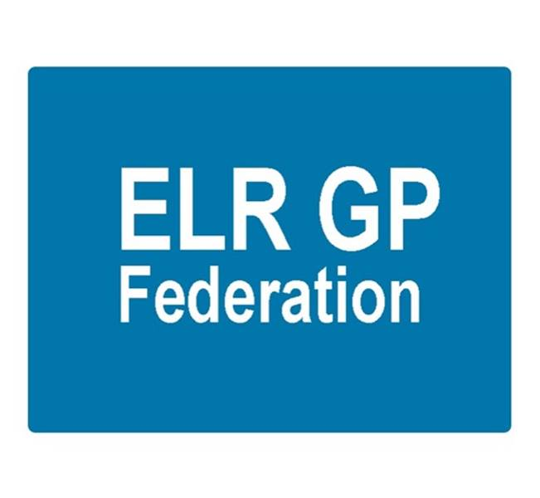

ELR GP Federation Ltd
Minutes of the meeting of The Board of Directors
Tuesday 21st September 2017 – Syston Medical Centre

Present: Dr R Bietzk (RB); Dr G Chidlow (GC); Dr N Chotai (NC); J Watkins (JW); J McCrea

In the Chair: Dr R Bietzk

- Apologies - Dr L Ryan; Dr A Chahal; H Patel; Dr S Vincent

Note; as only three directors were present, the meeting was not technically quorate.

- Urgent care procurement

Paula Vaughan (Deputy COO, ELR CCG) updated the board on the plans to develop ‘Community Based Urgent Primary Care’ in ELR. Key points;
- Easy to understand and access for patients
- Standardised offer
- ‘Binary’ model – see Annex A
  - ‘in hours’ (0800-1830) = practice led
  - ‘out of hours’ – separate provider across 5 sites
- Integrates with the wider LLR UC system, 111 & clinical navigation hub
- Supports practices & long-term stability
- Additional resources (GPFYFV & minor injuries CBS) for practices to deliver in hours extended primary care, including acute access – to also include joint working (eg, Oadby?)
- Out of hours procurement – likely to start in April 2018 for an Oct 18 start
- Extended access DES will remain

- To confirm the minutes of the meeting held on 17th August 2017.
The minutes were confirmed as an accurate record.

- Matters arising
- Policies to be updated for approval. Action, JW
- LPT - RB/JW met with Peter Miller (CEO) and Rachel Bilsborough (Director) on 11th September. This was a positive first meeting. Focus on how we could collaborate to improve integrated working between primary, community and mental health services in the localities across ELR. We discussed the attached the paper Moving Towards an Accountable Care System in LLR. We agreed to consider joint bidding where appropriate.
- Inter-practice referral process – JW to progress. Action, JW
- Joint strategy with the CCG - that clarifies the role and expectations of the Federation, including as facilitator to bring practices together to develop new ways of working, and the respective role of the CCG – including budget forecast. Action JW / RB.
- Winter access – CCG have advised that there are no additional resources at the moment. However, if funds become available we can run a scheme similar to last year.

- Urgent Care Procurement

- See update above.
- The Board will either need to determine to work on an exclusive basis with either Vocare or DHU or offer support to bidders on a non-exclusive basis.
- Follow up discussions / meetings to be arranged with DHU and Vocare. Action JW, GC, RB

- COO Report

(a) Pharmacy Project - In line with the CCG guidance, we have served notice on the contract with PSS which will come to an end on 31st October 2017. The CCG is undertaking a procurement process for third party pharmacy support organisations to join an accredited list. The new arrangements will commence on 1st November 2017.

(b) NHS England; Clinical pharmacists in general practice - NHS England has launched a further scheme to support the development of clinical pharmacists in general practice. The scheme is open for 18 months with applications being assessed every couple of months. The deadline for the next phase of applications is 29th September 2017.

In line with the Board’s decision at the August 2017 meeting to progress an application in conjunction with Soar Beyond, it was agreed to submit an application as outlined in Paper B, working with the specialist partner, Soar Beyond, who would employ the pharmacists. NHS E have agreed to review the application ahead of the 29th September 2017 deadline. Action JW/RB

Post meeting note; NHS England indicated that an application for part time workers did not meet the scheme criteria. As such, the final application was adjusted to exclude practices who had expressed an interest on the basis of using part time staff. Melton decided to apply separately. The final application was therefore for 1 senior and 2 pharmacists on behalf of 11 practices (93,000).

(c) Purchase Direct - 17 practices now signed up. Over £100K of savings have been identified.

(d) Community Based Services

JW has followed up the points raised at the first contract review meeting in July 2017 with the relevant practices.

The inter-practice referrals process for IUD/IUS/SDI services has been adapted has been circulated to two practices for comment. JW to incorporate the comments and circulated wider.

(e) Demand management

A plan has been submitted to the CCG to propose how the scheme would be implemented – as per paper F. JW, RB to meet with the CCG to review the information that is available and advise on what further information would be required. Action RB, JW.

(f) Locality updates

There is a proposal to move to six Localities that are more manageable and reflect the groupings that are emerging naturally (see below). These groupings will provide the basis for effective integration with community / mental healthcare and social care services in the respective areas. They will also facilitate joint / federated working between practices

- North Blaby
- South Blaby and Lutterworth
- Oadby and Wigston
- Rutland
- SLAM
- Harborough

Oadby & Wigston; LR / JW met will attend the September Locality meeting.

JW continues to facilitate joint working between the Oadby Central and South Wigston practices as they work towards a new partnership.

Blaby & Lutterworth; emerging hubs in north and south Blaby. JW working with SV to see how the Federation could support the North Blaby hub.

Melton, Syston and Rutland; Initiatives include;
- Rutland experience / wellbeing workers / primary care home
- Melton DC workers embedded in the practice

Harborough; Working with Paula Vaughan and Anuj to establish the Harborough ILT. Focus on how to reduce the demand on district nurses.

(g) STP GP Five Year Forward View

The LLR Blueprint for general practice lays out the vision for the development of General Practice over the next five years and supporting practices coming together to meet patients’ needs at scale.

JW is working with Julia Cory, Head of Primary Care for Leicester City CCG, to produce a guidance / tool kit document to assist practices who wish to work at scale. Next version will be presented to the September 2017 Programme Board.

(h) Transformation fund

The transformation fund is intended to enable new ways of working between practices and the Federation will be at the forefront of helping practices to grasp this opportunity – as we have done in the case of South Wigston and Oadby Central. The Board suggested that the Federation could be funded to coordinate the joint working initiative / applications to support practices and ensure consistency. Action JW
(i) Buildings management offer - We have developed a buildings management offer with the Estates Strategy Group. Latham House will pilot the Beacon assessment tool in October 2017.
(j) Primary Care Exchange - Primary Care Exchange provide the Locum exchange service that Anuj used whilst in Bristol. A presentation took place in July and JW will now prepare a paper / business case to progress this opportunity.
(k) Insurance - Working with Locktons on an insurance offer for consideration – no further update.
(l) LLR PCL

H Pylori – we have now advised all practices that the Federation has been offered a contract with LLR PCL to provide H Pylori breath tests in ELR based on a 5% administration fee. Existing AQP arrangements have been extended and we await further guidance. GC / JW to approach the CCG. Action JW / GC.

Diagnostic Hubs and Spokes – GC / JW to develop a proposal for ECGs. Action JW/GC
(o) Dispensing practices procurement - JW/RB to pursue.
(p) Flu vaccines – JW to investigate options for Federation support for next year. Action JW

(q) HR - HR support is an area where a Federation wide approach could improve the level of service and cost effectiveness to practices. JW met with the LPT HR Director along with one of the Practice Managers in August and we will scope out an indicative specification and cost for consideration. Action JW

(r) GP TeamNet - JW has had a demonstration of this system.

(s) Cleaning – JW to follow this up. Action JW.

(t) Web site – Footfall – Oakham MC have suggested that JW investigate the FootFall product. Action JW

- Financial update

7.1 Forecast for FY17/18 - The Board reviewed the forecast and approved it to be sent to the CCG.

7.2 FY18/19 budget – a draft budget for FY18/19 had been prepared. The key issue relates to the income assumptions, which will require CCG support and a significant contribution from the urgent care contract, which is yet to be procured. An early version had shared with Tim Sacks who is aware that the sustainability of the Federation after March 2018 will require CCG funding. An updated version should be included in an updated strategy / business plan. Action JW/HP

- Communications update

- Annual report – completed, printed and tabled.
- Shareholders’ meeting – 28th September 2017 at College Court - agenda approved; JW/RB to lead the event.

- Conflicts of interest register - added to the website.

- Date & venue of next meetings

Thursday 16th November 2017 @ 7pm – Board meeting at Syston Health Centre.

Annex A – Proposed Urgent Care / 7 Day Access Model

