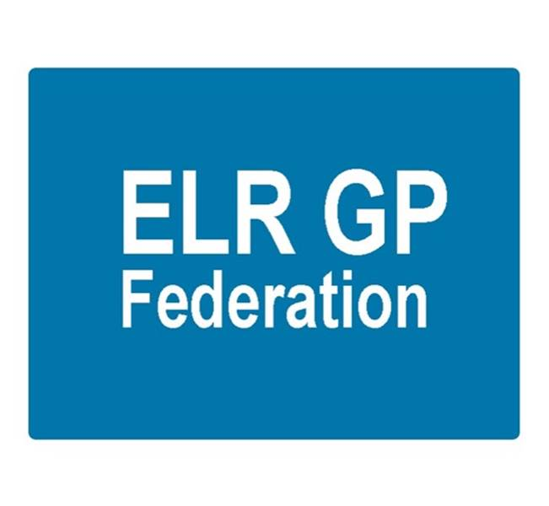ELR GP Federation Ltd

Minutes of the meeting of The Board of Directors

Thursday 14th December 2017 – Syston Medical Centre

1. Present: Dr R Bietzk;; Dr N Chotai; J Watkins; J McCrea; Dr S Vincent; Dr G Chidlow (second part from 8.35pm)

In the Chair: Dr R Bietzk

1. **Apologies -** Dr L Ryan, H Patel
2. **To confirm the minutes of the meeting held on 16th November 2017.**

The minutes were confirmed as an accurate record.

1. **Matters arising**

* Policies to be updated for approval. **Action, JW**
* **Winter access –** no further news regarding FY17/18.
* JW/GC to contact Will Monahan after Christmas. **Action JW. GC**

1. **COO Report**
2. **Joint strategy with the CCG and funding for FY18/19 –**

Rysz and James met with Tim Sacks on 8th December 2017 and determined a way to fund the Federation during FY18/19 based on the CCG honouring their commitment to pay the full £350K originally committed to the Federation and utilizing the transformation fund. T Sacks will seek approval and advise. **Action JW**



**The Board noted the progress that the Federation has made** over the last 15 months securing income streams on behalf of its member practices @ >£800K across FY17/18 and FY18/19 and identified savings @ >£200K for the same two year period through its purchasing scheme.

1. **Localities and transformation fund update**

* The emerging six localities are all developing plans for joint working between the practices and integrating more effectively with community, mental health and social care services.
* We await guidance from the CCG relating to the transformation fund and Locality Plan templates. The Federation will review this guidance and develop a proposal for supporting the locality groups. **Action JW**
* Additional funding (5YGPFV monies) will also be made available to support the development of acute on the day ‘in hours’ provision for patients. This will be delivered through practices working together, where practical.
* The six Localities are likely to merge with the ILTs.
* The localities have asked the Federation to support this work and the transformation fund application process.

**Oadby & Wigston** (Wigston Central, Bushloe, South Wigston, Central, Croft, Severn, Rosemead)

* Acute on the day access; reviewing the best options for joint working.
* Continuing to facilitate joint working between the Oadby Central and South Wigston practices as they work towards a new partnership.

**North Blaby** (Kingsway, Glenfield, Limes. Forest House, Enderby)

* MSK, mental health practitioners – identify the best mechanism to employ staff on behalf of the hub and associated NHS pension implications **Action JW**
* Urgent care service

**South Blaby & Lutterworth** (Northfield, Wycliffe, Masharani, Hazelmere, Countesthorpe)

* Utilise social media to improve communications with patients. JM/JW facilitating a workshop to determine the best way forward. **Action JW/JM**
* JW is the Federation representative on this Hub, as there is no Federation Board Director.

**SLAM** (Melton, County, Jubilee, Long Clawson)

* Joint buildings maintenance service
* Intranet for information / policy sharing
* Dementia MDT
* Inter-practice referrals for coils / minor surgery **Action JW**

**Rutland** (Uppingham, Oakham, Market Overton & Somerby, Empingham)

* Primary care home
* Vitrucare app to enable holistic consultation. Rutland CC funding.
* **The Board approved that Federation should hold the contract with VitruCare and Rutland County Council to enable the practices to develop this app and that JW should project manage.** **Action JW**
* Suggestion that the Federation might hold the transformation fund on behalf of the practices, depending on the scheme.

**Harborough** (Billesdon, Kibworth, Two Shires, Husbands Bosworth, Market Harborough)

* Joint working is in development.

1. **LLR STP GP FYFV Programme Board and tool kit -**  The tool kit work has been well received. This will be updated following consultation. The toolkit will be used to assist with joint working between practices in the emerging six localities. This work will also identify where there are gaps in the guidance and we will update the tool kit accordingly.  **Action JW**
2. **Extended primary care / urgent care -**  The timetable for the procurement process will result in the new ‘extended primary care’ service starting in April 2019.

* Vocare (recently been acquired by Totally Plc) remain keen to work with the Federation on the forthcoming tender process.
* GC/JW met with DHU on 17th November 2017, who remain keen to work with the Federation on an ‘exclusive basis’
* Progress discussions in the new year. **Action JW, GC, RB**
* JW to liaise with City & West Leics Feds to update on their progress. **Action JW**

1. **NHS England; Clinical pharmacists in general practice**

* NHS E have advised that they intend to support the application. No detail yet.
* Application for 11 practices (93,000)
* NHS E asked us to adjust the application to 3 pharmacists. We did this on the basis that the senior support would be provided from Soar Beyond and/or a neighbouring scheme but this will have a cost.
* The plan is to dovetail the 3 NHS E pharmacists with the approx. 3 that are funded by the ELR CCG scheme.
* However, Soar Beyond are not on the CCG accredited list – which will make the melding of the two schemes more challenging. The Soar Beyond cost will increase if they do not employ all 6 pharmacists.
* The implications are being worked through and alternative options considered. **Action JW**

1. **Community Based Services and inter-practice referral process** –

Following up the points raised in the November contract meeting, including;

* General reduction in IUD/S fittings and asked if we knew why?
* Encourage the use of the Quest browser (TCR software), which will become mandatory

The inter-practice referrals process for IUD/IUS/SDI services has been adapted has been circulated for comment. The Board suggested that we should identify one provider per Locality. **Action JW**

1. **Demand management**

The CCG has confirmed that it would like the Federation to support demand management in ELR.

This project will be led by Rysz. Start-up costs will be met within existing resources. The CCG have indicated that they will pay 10p per patient (£33K) in FY18/19. This is to be confirmed. **Action JW**

1. **Correspondence management**  –

The Federation successfully applied on behalf of seven practices. The funding is being hosted by West Leicestershire CCG and equates to £33K for the Federation scheme. This project is likely to start in March 2018.

**The Board approved that the Federation should proceed with this project and hold the contract on behalf of the seven practices. The Board also directed that the Federation should negotiate a fee for coordinating this work. Action JW.**

1. **Active signposting**  – JW to follow-up. **Action JW**
2. **Buildings management offer**

We are working with the Estates Strategy Group to support practices with building management. Latham House piloted the Beacon assessment tool in October 2017. We are now developing a buildings management offer for them to consider. Once we have tested this with LH, we will determine the best approach to offering this wider. **Action JW**

1. **Diabetes nurse specialists –** We applied with Latham House to host the LLR 1.8WTE Diabetes Nurse specialists and have been offered the contract. This is NHS E funding that West Leics CCG are hosting. We are working with Latham House and WL CCG to agree the details. Funding (approx. £80K) will run to March 2019.

**The Board approved that the Federation should support this project and work with Latham House to host this initiative, subject to contract. Action JW.**

GC suggested that we contact the Diabetes Centre (Prof Melanie Woods / Dr Khunti) to see if there could be any secondment opportunities. **Action JW**

1. **Primary Care Exchange** – JW to follow-up. **Action JW**
2. **Service contracts** – H Pylori and CCG – JW/GC to follow-up. **Action JW/GC**

Home Phlebotomy Service – this is an opportunity that would be procured via the Alliance. JW to follow up. **Action JW**

1. **Dispensing practices procurement** – JW/RB to pursue **Action JW/RB**
2. **GP TeamNet** – JW to develop a proposal. **Action JW**
3. **HR** – JW met with the LPT HR Director along with one of the Practice Managers in August – JW to scope out an indicative specification and cost for consideration. **Action JW.**
4. **Cleaning -** JW to follow this up. **Action JW.**
5. **Nurse training –** Ann Scott (CCG) has asked the Federation to consider how it could support nurse training.
6. **Financial update**

* **Forecast for FY17/18 -** The Board reviewed the updated budget forecast.
* **FY18/19 budget –** the Board reviewed the draft budget forFY18/19 that had been updated following the discussion with Tim Sacks. Assuming that the CCG confirm approval of the proposal that was discussed on 8th December 2018, there will be sufficient funding for the Federation to operate during FY18/19. The key challenge will be to identify funding streams from April 2019. **Action JW.**

1. **Board changes**

* Following Anuj Chahal’s resignation, JW/JM to organize a ballot for the Harborough Locality vacancy. **Action JM/JW**
* **The Board agreed that Dr Ursula Montgomery should be co-opted onto the Board to cover Louise Ryan’s maternity leave. RB to contact Ursula. Action RB**
* The Board suggested opening the meeting to a wider attendance, including Practice Managers and CCG members on an occasional basis. To be discussed further. **Action JW/RB**

1. **Communications update**

* JW / JM to complete Christmas newsletter. **Action JW / JM**
* JM updated on the Simon Stevens’ recent visit to Staffs and the importance of developing a business model that is scaleable.

1. **Conflicts of interest register –** GC has updated his conflicts.
2. **Date & venue of next meetings**

Thursday 25th January 2018 @ 7pm – Board meeting at Syston Health Centre.