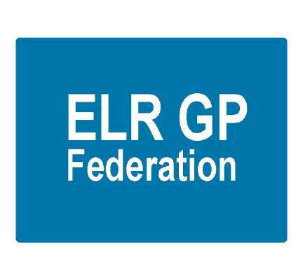

**ELR GP Federation Strategy 2017 - 2020**

**“*Championing through GPs and their practices, investment and delivery of healthcare services at scale for patients across East Leicestershire and Rutland”***

# Contents

|  |  |  |
| --- | --- | --- |
|  |  | **Page** |
|  |  |  |
| 1 | Executive Summary | 3 |
| 2 | Introduction | 4 |
| 3 | Background and context | 4 |
| 4 | Partnership working | 5 |
| 5 | New ways of working in the Hubs & Transformation Fund | 7 |
| 6 | ELR GP Federation Mission, Vision, Values & strategic priorities | 9 |
| 7 | ELR GP Federation work plan | 11 |
| 8 | Finance and resources | 12 |

# Executive Summary

Rapidly rising pressure on general practice services is set to continue and escalate as the ageing population lives longer with more complex needs. The LLR Blueprint for General Practice sets out a 5 year vision where General Practice with registered lists is at the heart of a comprehensive service to patients that caters for their differential needs according to condition and complexity.

To achieve this practices will come together either formally or informally to meet patients’ needs at scale. By working together practices will deliver improved efficiency and make more effective use of existing resources to ensure that practices are sustainable in the long term. The ELR GP Federation will be at the heart of delivering a new model of sustainable General Practice.

It is against this background that the six locality hubs are emerging in ELR with GP Practices coming together to explore how they could work together more effectively and provide more care locally; engaging with ELR GP Federation to support and facilitate this work, using the newly developed toolkit, where useful. The CCG is supporting this work through the Transformation Fund.

The Federation’s mission, vision and values echo the LLR Blueprint for General Practice document and specifically support the development of the Locality Hubs to create sustainable primary care services across the ELR CCG area. It is also a key player & partner in shaping place based integrated working in developing an accountable care system.

The Federation will continue to act as a key **‘change agent’; enabling and facilitating** joint working, innovation and transformation where it makes sense to do so to address the sustainability and resilience challenges that its members face.

It has four strategic priority areas;

1. **Local service delivery & business development -** facilitating the delivery of more services locally by expanding non-core primary care services to make them more accessible to our patients, bidding collectively and / or holding contracts where it is helpful to do so
2. **Resilience and sustainability in primary healthcare -** working with our GP members to improve the way that services are delivered to address the pressures currently faced in the local health care system, providing clinical and back office services at scale where it is helpful to do so
3. **Transformation and Innovation -** advancing the ambitions set out in the LLR Blueprint for General Practice to improve the way that services are delivered to address the challenges that primary care is currently facing
4. **Effective voice -** for our members across ELR when engaging with CCGs, Trusts, social care, and the voluntary sector

The Federation has funding secured for FY18/19. During 2018 the Federation will identify funding streams to secure its operation beyond April 2019.

**2.** **Introduction**

This joint strategy document has been prepared to;

* Provide an overview of the joint approach that ELR CCG and ELR GP Federation are taking to support our 31 GP Practices to address the sustainability challenges that they face;
* Outline the role of the GP Federation in developing and supporting partnership between practices, working to fully realise the benefits of working at scale across its member practices;
* Outline ELR GP Federation’s strategic priorities, work plan and financial resources to deliver this agenda.

# 3. Background and context

The LLR Blueprint for General Practice sets out a 5 year vision where General Practice with registered lists is at the heart of a comprehensive service to patients that caters for their differential needs according to condition and complexity.

To achieve this practices will come together either formally or informally to meet patients’ needs at scale. By working together practices will deliver improved efficiency and make more effective use of existing resources to ensure that practices are sustainable in the long term. The ELR GP Federation will be at the heart of delivering a new model of sustainable General Practice.

By working together more effectively, practices will be able to contribute to the provision of place-based integrated community and primary care in line with the model outlined in the Blueprint for General Practice as illustrated in the model below.

**Figure 1 – LLR Blueprint for General Practice - model for healthcare**

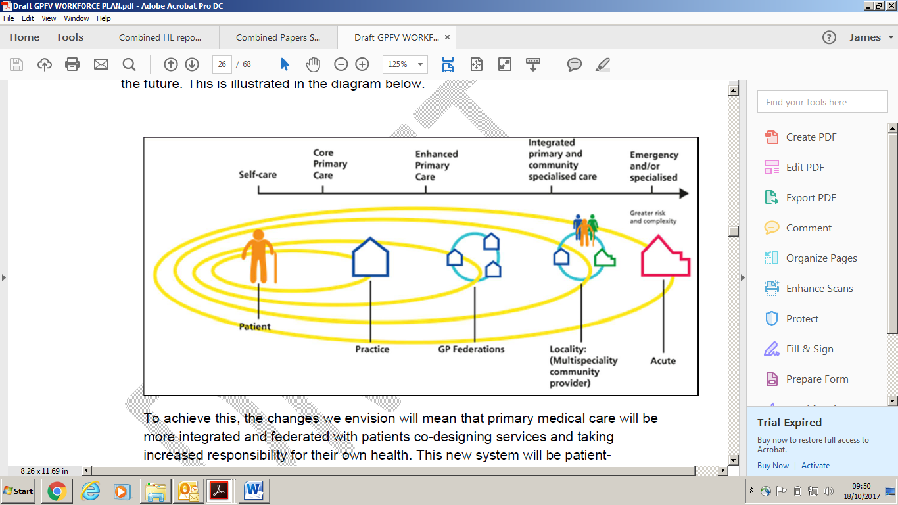

It is against this background that the six locality hubs are emerging in ELR with GP Practices coming together to explore how they could work together more effectively and provide more care locally; engaging with ELR GP Federation to support and facilitate this work.

All 31 practices face sustainability challenges, as they seek to provide excellent NHS primary care services for their communities in an increasingly difficult operating environment. The practices are therefore working pro-actively together to find new ways of working that will make them stronger together.

**4. Partnership working**

The emerging six locality hubs (listed below) are at different stages of development but are all starting to develop plans for joint working between the practices and integrating more effectively with community, mental health and social care services in their respective areas.

* 1. **Oadby & Wigston** (Wigston Central, Bushloe, South Wigston, Central, Croft, Severn, Rosemead)
  2. **North Blaby** (Kingsway, Glenfield, Limes. Forest House, Enderby, Narborough)
  3. **South Blaby & Lutterworth** (Northfield, Wycliffe, Masharani, Hazelmere, Countesthorpe)
  4. **SLAM** (Melton, County, Jubilee, Long Clawson)
  5. **Rutland** (Uppingham, Oakham, Market Overton & Somerby, Empingham)
  6. **Harborough** (Billesdon, Kibworth, Two Shires, Husbands Bosworth, Market Harborough)

To address the challenges that the practices face, the hubs have a number of joint working options;

1. Informal networking and joint hub working
2. Joint working through a contract mechanism
3. Vertical integration with an NHS Trust
4. ‘Soft merger’ of the practices
5. ‘Hard merger’ of the practices

The practices have decided to form informal networks and joint working hubs to help address the challenges that they face.

These Hubs represent between 35,000 to 60,000 patients and therefore are ideal sizes to develop the benefits of the home first place based holistic care model through integrated working with community and social care services. The intention is for these Locality structures to support integrated locality working as part of an emerging accountable care system approach within the LLR STP.

The **key benefits** of developing Partnership Hub working include;

* Greater sustainability; securing the services for patients in the respective geographies.
* Potential to offer a wider range of services and greater specialization.
* Benefit of sharing staff and expertise and building the MDT.
* Ability to create more attractive, flexible and diverse career, training and employment options and greater flexibility in succession planning.
* Potential to standardise administration processes and improve the efficiency and skills of the workforce.
* Ability to respond to the challenges arising from the Blueprint for General Practice and look towards developing new models of care to provide closer integration between community and primary healthcare providers.
* Potential to streamline back office support functions to gain the benefits of greater economies of scale, including; HR, quality, health & safety, finance, IT and comms.
* Create a larger organisation that has more influence in the local healthcare economy and can take on additional services, including out of hospital care, joint ventures with other GP or NHS organisations.
* Create a more secure platform to support extended primary care, improving in-hours access to general practice and out of hours working, as appropriate.
* Develop and pilot new ways of working that respond to new models of primary care outlined in the Blueprint for General Practice.

The **key risks** of Hub working and the mitigating measures are outlined in the risk analysis below.

|  |  |  |  |
| --- | --- | --- | --- |
| **Id** | **Risk** | **Likelihood** | **Mitigation** |
| 1 | Lack of openness, transparency and trust | L | * Parties have invested time to develop jointly owned vision / mission and values |
| 2 | Lack of management capacity to manage the Hub’s work programme | M | * Utilising the Federation to provide project management support. * Submitting a proposal plan for Transformation Funding |
| 3 | Parties fail to work together effectively | M | * Jointly owned vision and values agreed * Federation supporting the change process |
| 4 | Poor project management | M | * Robust project management put in place * Transformation Funding application |

**5. New ways of working in the Hubs & Transformation Fund**

The Hub practices are committed to developing new ways of working together to improve the sustainability of the practices and services for patients in line with the model in Figure 2 below which is outlined in the LLR Blueprint for general practice.

The key priority is to create additional capacity in the practices to respond to the growing demand and provide longer appointments for patients with complex needs. An important element of delivering these improvements is developing effective multi-disciplinary teams to reduce GP workload and improve patient access to relevant services and consequently patient satisfaction.

The CCG will be supporting this development of integrated place based services with the £800K transformation fund over the next 18 months (50p per patient in FY17/18 and £2/patient in FY18/19).

Additional funding (5YGPFV monies) will also be made available to support the development of primary care – especially acute on the day ‘in hours’ provision for patients. This will be delivered through practices working together, where practical.

Each locality will develop a **‘Locality Plan’** which will detail its approach to place based integrated services (primary, community & social care).

The CCG will support the development of the six Localities with 4 PLT events each year, align the Locality Managers with the Localities and provide additional operational management resource.

**ELR GP Federation is working with all six emerging localities to assist with the development of their joint working initiatives and Locality development.**

**Figure 2 – A Blueprint for General Practice**

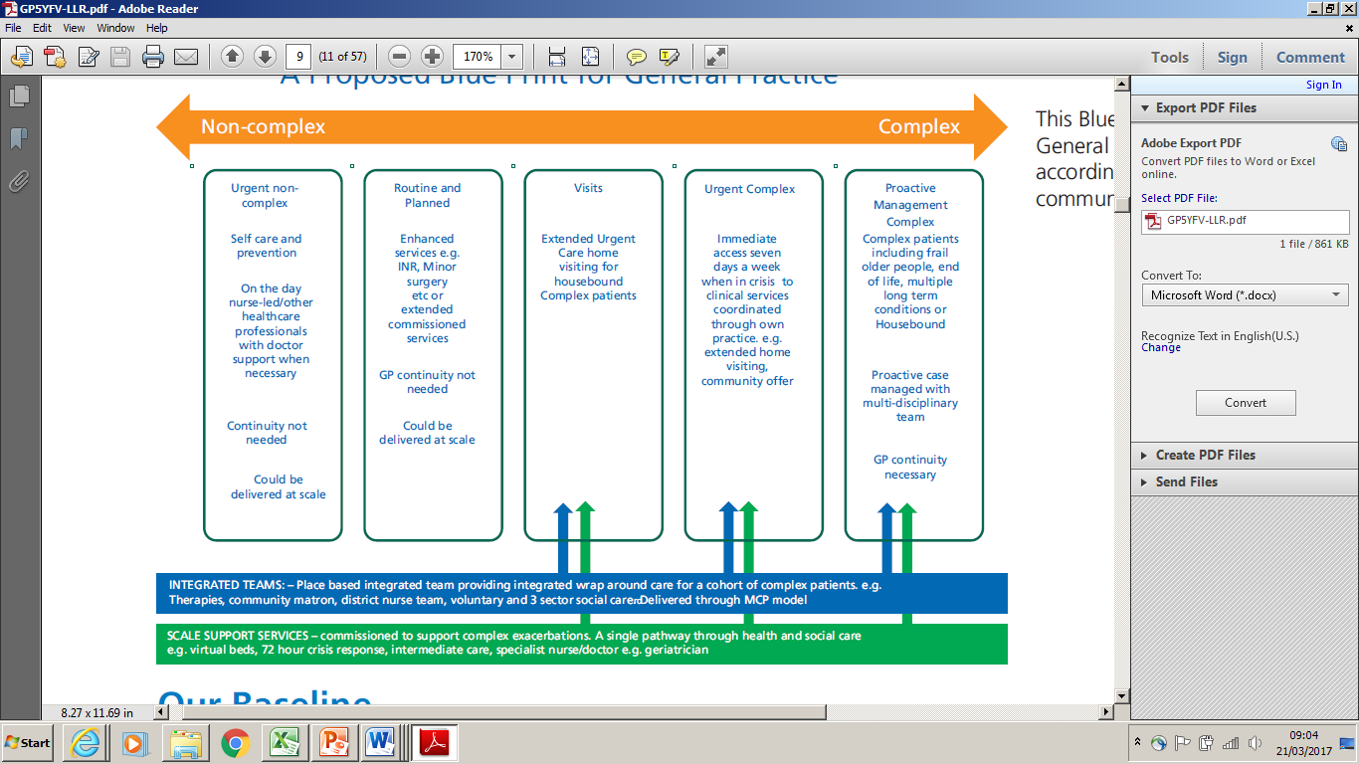

**The six hubs are in the process of developing their plans for collaborative working and have outlined the following potential areas;**

* Improved acute on the day GP access
* Out of hours GP / urgent care services
* Visiting service
* Closer working / integration with LPT & Local Councils – community health teams around GP practices
* Use social media to develop an effective patient information portal
* Standardised protocols / consistency of approach
* 24 hour BP and ambulatory ECG services
* Inter-practice referrals for minor surgery, IUD/S, GPSI services (hub & spoke working)
* Primary care home
* New technology to improve patient care, eg, self care app (Vitrucare)
* Specialist nurses, eg, chronic disease nurses
* MSK, mental health practitioners, health & wellbeing co-ordinators / advisors
* MDT, eg, pharmacists
* Nursing home support
* Patient education
* PPG support
* Sub-specialisation; determine which services to provide at locality, sub-locality and practice level
* Back office / admin services
* Improving access to diagnostics

# 6. ELR GP Federation Mission, Vision, Values & Strategic Priorities

The Federation’s mission, vision and values echo the LLR Blueprint for General Practice document and specifically support the development of the six Locality Hubs to create sustainable primary care services across the ELR CCG area.

**Key principles;**

* *The extent to which working at scale is sensible depends on the problem or challenge that needs addressing, and so;*
* *The Federation has and will continue to enable and facilitate joint working, as appropriate, to address the sustainability and resilience challenges that members face.*

**Mission**

*“To champion through GPs and their practices, investment and delivery of healthcare services at scale for patients across East Leicestershire and Rutland”*

**Vision**

*“To remain a GP-led, patient centred organisation, working collaboratively with our partners across health, social and community care to facilitate an enhanced delivery of high quality, innovative and responsive services across East Leicestershire and Rutland”*

**Values**

* ***Patient Centred*** *– ensuring that the needs of patients are at the heart of everything we do*
* ***Local and Accessible*** *– striving to deliver our services where and when our patients need the service*
* ***Efficient and Effective*** *– providing high quality healthcare*
* ***Open and Transparent*** *– in all that we do*
* ***Collaborative and Accountable*** *– working effectively with all stakeholders to meet the needs of our members and their patients*

**Strategic Priority areas**

**Priority 1 – Local service delivery & business development**

* Facilitate the delivery of more services locally by expanding non-core primary care services to make them more accessible to our patients
* Be an effective health service provider, collectively bidding for services that individual practices are too small to provide, collaborating with other healthcare partners, thereby bringing new business to practices
* Collaborate with other providers, key health and social care partners and commissioners to deliver more planned care locally at scale

**Priority 2 – Resilience and sustainability in primary healthcare**

* Support GP members enhance the resilience of their practices to deliver sustainable primary care services. This will include the sharing of best practice and the harmonisation and adoption of common practices and processes e.g. supporting with CQC compliance, assisting practices to meet external or internally determined KPIs
* Work with our GP members to improve the way that clinical and back office services are delivered to address the pressures currently faced in the local health care system, delivering at scale where it is helpful to do so
* Drive forward efficiencies in primary care and seek opportunities to transform the delivery of effective and focused healthcare and, where appropriate, redesigning pathways
* Collaborate with other providers, key health and social care partners and commissioners to deliver more planned care locally at scale

**Priority 3 – Transformation and Innovation**

* + Advance the ambitions set out in the LLR Blueprint for General Practice to improve the way that services are delivered to address the challenges that primary care is currently facing
  + Support the development of the six locality hubs across ELR
  + Provide the tools to enable collaborative working between practices and be a key facilitator in promoting and supporting joint working initiatives
  + Be a key enabler in the integration of care pathways across health and social care boundaries
  + Drive forward quality in primary care through rigorous and effective governance; and
  + Work collaboratively with Commissioners to influence health outcomes

**Priority 4 – Effective voice**

* Be an effective voice for our members across ELR when negotiating with CCGs, Trusts, social care, and voluntary sector
* Empowered by its GP members to make the case of the GP role within the future health and social care system
* Work collaboratively with commissioners to influence better health outcomes.
* Ensure that local commissioners have the opportunity to engage with the expertise of ELR GP Federation and its members to achieve key commissioning objectives

**Federation structure and approach**

ELR GP Federation Ltd is a company limited by shares, with each of ELR’s 31 GP practices being its shareholders who elect the company’s Board of Directors. This legal form and scale enables the Federation to support wide scale service transformation and bid for and hold contracts for clinical services.

To deliver its strategic objectives in supporting member practices to work together to ensure future sustainability, the Federation will adopt the structure and approach outlined below;

* Act as a ‘change agent’, enabling and facilitating Locality Hub joint working, innovation and transformation
* Support doing things differently where it makes sense to do so
* Be a strengthened locality based federation with central support
* Adopt a hybrid Federation structure (see Figure 3 below), to support the 6 locality hubs
* Maximum flexibility for locality hubs to advance their collaboration ambitions
* Support the locality hub based clusters of GPs who share services
* Bid for and hold contracts for services, where helpful
* Be a key player / partner in mutually shaping the place based agenda (Integrated Locality Teams / Primary Care Home / Multi Speciality Community Providers / Accountable Care System)
* Provide an integrated role in supporting GP resilience / back office support and facilitating joint working

**Figure 3 – ELR GP Federation’s proposed operating structure**

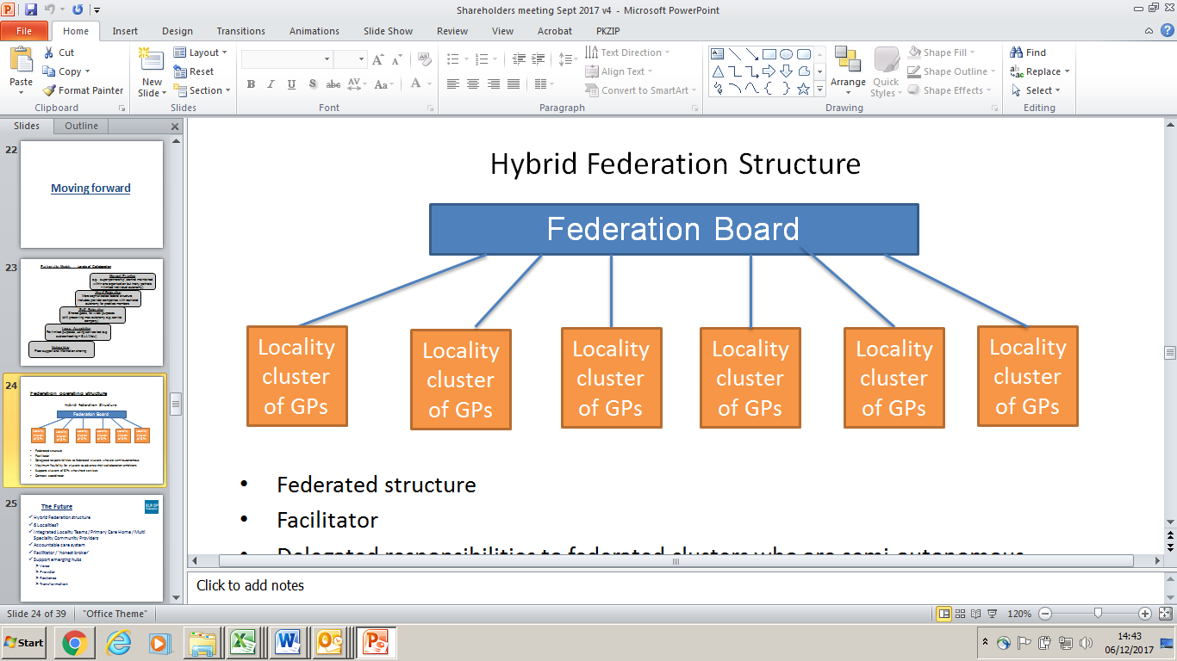

## 7. GP Federation work plan

## The detailed work plan to support this vision and strategic objectives is attached in the spreadsheet inserted below. This plan outlines the work streams that have been completed and those planned.

## The work plan is organized into sections that reflect the Federation’s strategic priorities;

## Local service delivery and business development

## GP resilience

## Primary care innovation and transformation

## Communications and engagement

## Federation strategy

## 

## 8. Finance and resources

The Federation has secured income to cover overhead operating costs @ £136K for FY18/19. There is the potential for a further £33K to administer the demand management process in FY18/19. An outline of the Federation’s financial position and proposed action plan to secure income to cover its operating costs for the full year (FY18/19) are outlined below.

* The Federation has made significant progress over the last 15 months securing income streams on behalf of its member practices @ >£800K across FY17/18 and FY18/19 and identified savings @ >£200K for the same two year period through its purchasing scheme **(see Table 1)**.
* Some of the material income assumptions in the original business plan have yet to materialize, including;
  + The urgent care re-tender has been deferred until FY19/20
  + A significant proportion of the potential ‘left-shift’ work is carried out through LLR PCL Ltd / Alliance
* FY18/19 will be a ‘break through’ year as the six Localities bed down and the transformation schemes are implemented.
  + The Federation and CCG finalize additional contracts, including demand management and H Pylori. Other options include the Federation having a role in prescribing.
  + Continued scrutiny the Federation’s running costs
* During FY18/19 the Federation will work with its members to secure further income streams through new business and back office schemes to cover its running costs. A key element of this will be to play a key role in the future urgent care arrangements from April 2019.

**Table 1 – ELR GP Federation income and costs saving scheme for FY17/18 to FY19/20**



**Table 2 – Income and expenditure forecast for FY2018/19**

## 