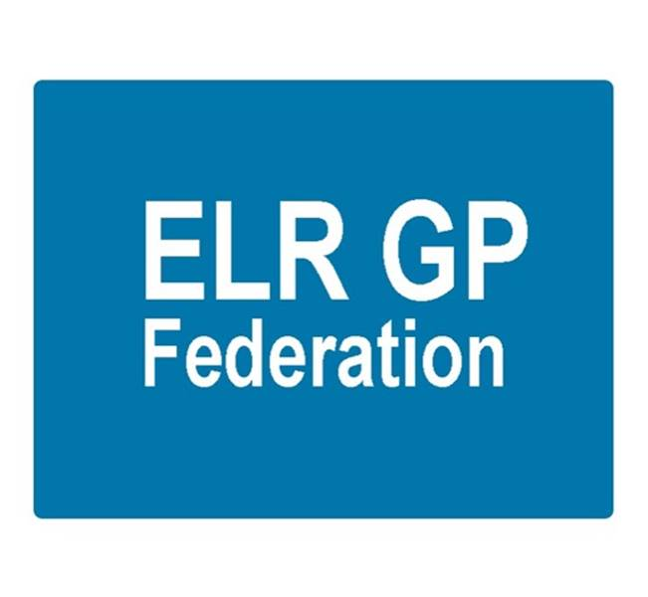
ELR GP Federation Ltd
Minutes of the meeting of The Board of Directors
Thursday 25th January 2018 – Syston Medical Centre

- Present: Dr R Bietzk; J Watkins; J McCrea; Dr S Vincent; Dr G Chidlow; Dr U Montgomery, K Whawell, H Patel

In the Chair: Dr R Bietzk

- Apologies - Dr L Ryan, Dr N Chotai

- To confirm the minutes of the meeting held on 14th December 2017.
The minutes were confirmed as an accurate record.

- Matters arising
- Policies to be updated for approval. Action, JW
- JW/GC to contact Mark Wightman (UHL) – to link with the Primary Care Board. Action JW / GC

- Welcome
- Kirsty was welcomed to the Board as the Director representing the Harborough Locality.
- Ursula was welcomed to the Board as the Director co-opted to cover for L Ryan’s maternity leave.

- COO Report

- Joint strategy with the CCG and funding for FY18/19

Tim Sacks has indicated that the CCG will pay the balance of £350K that was committed to the Federation in FY18/19. However, this is subject to the support of the PCCC and CCG Governing Board approval. JW will present to the PCCC on 6th February 2018. Action JW

We await confirmation on the demand management funding @ 10 pence per patient for FY18/19. JW to follow-up. Action JW

- Localities and transformation fund update

- JW is working with the six locality groups to develop their bids for transformational joint working projects; this is a considerable commitment at the moment but a key area for the Federation to facilitate.
- Some locality hubs are considering transformation projects that could link with the recurrent funding stream for acute on the day access.
- Localities are also considering joint working arrangements with LPT, social services, local councils and third sector, as appropriate – as they are likely to merge with the Integrated Locality Teams in FY18/19.
- JW to provide an update on the Locality applications. Action JW.

- LLR STP GP FYFV Programme Board and tool kit - JW will be incorporating comments to produce a final draft of the tool kit in conjunction with Julia Cory (City CCG). This will then be circulated to practices to assist with joint working between practices. Action JW

- Extended primary care / urgent care
- The timetable for the procurement process will result in a new contract to start in April 2019.
- The Board will review the CCG paper, when available. Action JW
- RB to follow-up with Vocare. Action RB
- GC to follow-up with DHU. Action GC.
- The Federation Board will need to determine its strategy once further information is known.
- JW has spoken with West Feds and will liaise with City Fed to update on their progress. Action JW

- Winter Access Scheme
- The Federation has been commissioned to provide 5,100 additional urgent, bookable appointments over an 8 week period.
- The budget is @ £71K + Federation admin fee.
- 28 practices have indicated their intention to take part in the scheme.
- Whilst it is positive that our practices have mobilized very well in response to the short notice of this additional money, the Board discussed that allocating appointments on a proportional basis by patient numbers may not make best use of the limited resource. It was agreed that we should prepare a more pro-active plan – possibly on a Locality basis for future years. Action JW.
- JM to prepare a communication piece regarding the current scheme. Action JM

- NHS England; Clinical pharmacists in general practice
- NHS E have confirmed that the Federation’s application was successful and forwarded contract information for 3 Pharmacists to support 11 practices (93,000).
- Soar Beyond (SB) are not on the CCG accredited list and the CCG have advised that they will not re-open the application window. Consequently, SB are unable to employ ELR CCG funded pharmacists which will make the melding of the two schemes more challenging.
- We have approached Prescribing Support Services (PSS) who would be able to ‘step in’. PSS delivered the Federation scheme until October 2017 and are an accredited ELR CCG supplier.
- The Board considered the four options outlined in the COO paper and approved that we should proceed on the basis of ‘Option D’ and work with PSS to deliver this project. Action JW..

- Community Based Services and inter-practice referral process

- LCC have asked;
- Why has there been a general reduction in IUD/S fittings
- Encourage the use of the Quest browser (TCR software), which will become mandatory in April 2018
- LCC have confirmed that the contract will be extended for a further year.
- JW/HP to arrange for practices to provide up to date evidence of their clinical indemnity arrangements in line with the sub-contracting agreement. Action JW/HP
- Bushloe and Wigston Central surgeries will trial the inter-practice referrals process for IUD/IUS/SDI services. Action JW
- UM noted that David Sheppard’s practice has a well-established inter-practice referral process with the Shack service.
- GC noted that the sexual health tender is due.

- Demand management
- The Federation will be facilitating the peer review sessions at the Locality meetings in January 2018. Action RB
- Following the January 2018 Locality meetings, RB will prepare a report to summarise the learning and develop a reporting template for the future. Action RB
- The peer review process will be reviewed and updated for March and the new financial year.
- Consideration needs to be given to Board members assisting with future facilitation.

- Correspondence management
- We have received a start date for 6th March 2018.
- LMC Law have reviewed the contract. JW to follow up. Action JW
- The programme will span FY17/18 and FY18/19; West Leicestershire CCG have confirmed that this is acceptable.

- Diabetes nurse specialists
- Scheme to provide DSN support to 29 LLR practices identified with needing assistance with diabetes management.
- This is NHS E funding that West Leics CCG are hosting @ approx. £80K.
- JW to work with Latham House and WL CCG to finalise the details / recruitment process. Action JW
- JW to meet with Carmel O’Brien’s team (ELR CCG) to assist with designing and implementing a clinical governance process to assure this scheme. Action JW
- JW / GC to review clinical governance arrangements to support this and further Federation projects. Action JW / GC

- Buildings management offer
- JW is working with the Estates Strategy Group to develop a buildings management offer for Latham House in the first instance. Action JW
- There is the potential for this to be part of a transformation fund application, if there is interest from practices.

- Primary Care Exchange – JW to follow-up. Action JW

- Service contracts – H Pylori, CCG, home phlebotomy service – JW/GC to follow-up. Action JW/GC

- Dispensing practices procurement – JW/RB to pursue Action JW/RB

- GP TeamNet – The Harborough Locality has expressed an interest in developing this to assist with sharing of information / policies between practices. JW to progress. Action JW

- HR – JW to follow up. Action JW.

- Board and corporate governance issues
- The process of filing our annual return highlighted that two of the shareholders have left;
  - Dr Pemberton; Latham House
  - Dr Gordon; Kingsway
- JW/HP to arrange to remove these shareholders and institute their replacements. Action HP/JW

- Following the recent ballot, Kirsty Whawell has been elected as the Board member for the Harborough Locality.

- Consideration needs to be given to opening the meeting to a wider attendance, including Practice Managers and CCG members on an occasional basis. To be discussed further. Action JW/RB

- Financial update

- Forecast for FY17/18 - The Board reviewed the updated budget forecast.

- FY18/19 budget – the Board reviewed the updated draft budget for FY18/19 that had been updated following the discussion with Tim Sacks. Assuming that the CCG Governing Body approve the proposal outlined in 6 (a) above, there will be sufficient funding for the Federation to operate during FY18/19.

- However, the key challenge will be to identify funding streams from April 2019. JW to prepare a business plan to support this. Action JW.

- Communications update
- Christmas newsletter completed.
- Communication on winter appointments. Action JM / JW
- JM updated that he ran a workshop, on behalf of the Federation, with the South Blaby & Lutterworth Partnership Hub to explore how they could develop a collaborative approach to harnessing the use of digital communications technologies.

- Conflicts of interest register – GC has updated his conflicts.

- Date & venue of next meetings

Thursday 22nd February 2018 @ 7pm – Board meeting at Syston Health Centre.

