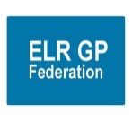

**ELR GP Federation’s strategic priorities for FY2018/19 – Discussion Paper**

1. **Where are we now?**

* 17 months of testing various schemes and approaches with the 'willing'.- now need to focus
* Significant work facilitating joint working between practices
* Developed tool kit to support joint working

## Secured income streams @ >£1M over the period FY16/17 to FY19/20

## Savings identified @ >£300K (April 2016 to March 2019) through Purchase Direct scheme.



* Good progress against our ‘From – To’ objectives;

|  |  |  |
| --- | --- | --- |
| **ELR GP Federation**  **Where are we now (From)** | **New operating structure where do we want to be? (To)** | **Progress (0-3)** |
| Few contracts | Significant contractor / service provider on behalf of members | 1 |
| Partner with limited influence on Integrated Locality Teams (ILT)/ STP | Federation as enablers of ILT/ STP (active partnership engagement) | 2.5 |
| Loose Federation | More clustered Federation with central support | 2 |
| Limited impact on the local agenda | A key player / partner in mutual shaping the place based agenda | 2.5 |
| Evolving clarity on Federation purpose | Key voice / provider and facilitator of cluster working | 2 |
| Evolving relationship between CCG and Federation | Clear strategy and identified roles between CGG and Federation | 2 |
| Limited offer to members | More integrated role in supporting GP resilience / back office support and facilitating joint working – both clinical & administrative. | 1 |

* **Locality working** - The emerging six locality hubs (listed below) are all develop plans for joint working between and integrating with community, mental health and social care services in their respective areas. The Federation is playing a key role in supporting and facilitating this work.

1. **Oadby & Wigston** (Wigston Central, Bushloe, South Wigston, Central, Croft, Severn, Rosemead)
2. **North Blaby** (Kingsway, Glenfield, Limes. Forest House, Enderby, Narborough)
3. **South Blaby & Lutterworth** (Northfield, Wycliffe, Masharani, Hazelmere, Countesthorpe)
4. **SLAM** (Melton, County, Jubilee, Long Clawson)
5. **Rutland** (Uppingham, Oakham, Market Overton & Somerby, Empingham)
6. **Harborough** (Billesdon, Kibworth, Two Shires, Husbands Bosworth, Market Harborough)

To address the challenges that the practices face, the hubs have a number of joint working options;

1. Informal networking and joint hub working
2. Joint working through a contract mechanism
3. Vertical integration with an NHS Trust
4. ‘Soft merger’ of the practices
5. ‘Hard merger’ of the practices

The practices have decided to form informal networks and joint working hubs to help address the challenges that they face.

These Hubs represent between 35,000 to 60,000 patients and therefore are ideal sizes to develop the benefits of the home first place based holistic care model through integrated working with community and social care services. The intention is for these Locality structures to support integrated locality working as part of an emerging accountable care system approach.

The **key benefits** of developing Partnership Hub working include;

* Greater sustainability; securing the services for patients in the respective geographies.
* Potential to offer a wider range of services and greater specialization.
* Benefit of sharing staff and expertise and building the MDT.
* Ability to create more attractive, flexible and diverse career, training and employment options and greater flexibility in succession planning.
* Potential to standardise administration processes and improve the efficiency and skills of the workforce.
* Ability to develop new models of care / closer integration between community and primary healthcare providers.
* Potential to streamline back office support functions to gain the benefits of greater economies of scale, including; HR, quality, health & safety, finance, IT and comms.
* Create a larger organisation that has more influence in the local healthcare economy and can take on additional services, including out of hospital care, joint ventures with other GP or NHS organisations.
* Create a more secure platform to support extended primary care, improving in-hours access to general practice and out of hours working, as appropriate.
* Form the basis of the Locality Leadership Teams

1. **Where do we want to be?**

**“*Championing through GPs and their practices, investment and delivery of healthcare services at scale for patients across East Leicestershire and Rutland”***

**Stream line the strategic goals / purpose;**

1. **Local service delivery & business development -** facilitating the delivery of more services locally by expanding non-core primary care services to make them more accessible to our patients, bidding collectively and / or holding contracts where it is helpful to do so. [**SERVICE CONTRACTS]**
2. **Resilience and sustainability in primary healthcare -** working with our GP members to **innovate and transform** the way that services are delivered to address the pressures currently faced in the local health care system, providing clinical and back office services at scale where it is helpful to do so. **[FACILITATION / CONSULTANCY]**
3. **Effective voice -** for our members across ELR when engaging with CCGs, Trusts, social care, and the voluntary sector

**Key elements;**

* Win contracts – especially Urgent Care
* Support the development of the six Locality Hubs to create sustainable primary care services across the ELR CCG area.
* Key player in shaping place based integrated working in developing an accountable care system.

## ‘Change agent’; facilitating joint working, innovation and transformation between practices

## Develop products / solutions to support practices working together, eg, employ specialist / back office staff

## Options beyond April 2019

## Support the development of the six Localities and then ‘shut up shop’

## Continue to support Localities and deliver a turnover @ £200K through two main streams;

## Contracts and secured income @ £2M-£3M to deliver a contribution to the Federation @ £150K

## Facilitation / consultancy fees @ £50K

1. **How are we going to get there?**

**Operating structure**

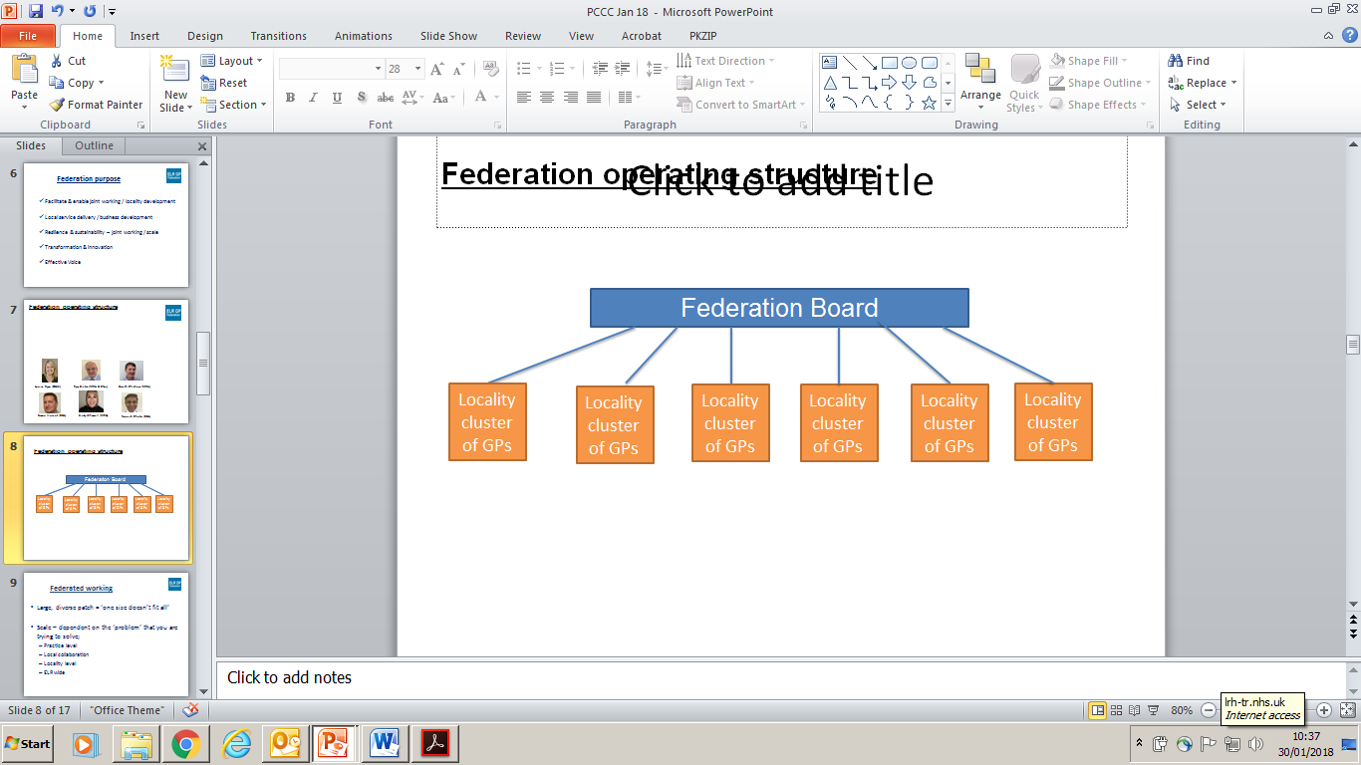

* Federated structure with delegated responsibilities to clusters who are semi-autonomous
* Maximum flexibility for clusters to advance their collaboration ambitions
* Contract coordinators

Prioritise the work plan against the strategic priorities to identify the ‘golden ticket’ projects that must be delivered to achieve the preferred option and achieve an income stream @ circa £200K;

* Net contract income @ £150K
* Consultancy fee income @ £50K

Early consultation with CCG (Tim Sacks) to include consideration of an element of ‘top slicing’ to support on-going Locality development.

Produce an I&E forecast for FY19/20 (updating the profile below) that will allow for some growth in Federation team to deliver an expanding work load.



**Key relationships, roles and responsibilities**

|  |  |  |
| --- | --- | --- |
| **Stakeholder** | **Lead** | **Relationship with ELR GP Federation** |
| Localities | NB; SV, NC  SBL: JW  O&W; LR (UM)  SLAM; GC  Harb; KW  Rutland; RB | * Leads to support the development of joint working in each Locality * Locality Leadership Team meetings to become the key meetings which are supported / driven by the Federation * Establish a ELR GP Fed/CCG Managers ‘one team’ approach to support Locality development * Lead the Transformation agenda |
| CCG | JW / RB | * Establish joint strategy with the CCG Board * Establish mutual understanding between the Federation board members and CCG Board Members on how best they work together to support localities |
| LMC | NC | * Mutual roles and responsibilities between LMC and ELR GP Federation.  |  |  | | --- | --- | | **ELR GP federation** | **LMC** | | Focus on practice | Focus on individual | | Engagement | Representation | | Service Delivery | Challenge | |
| LLR Provider Company | GC (?) / JW | * Maintain strong ELR GP Federation representation on the LLR PCL and its representation on the Alliance board * Influence the health care system transformation agenda as it relates to primary care and integrated care in places/localities * LLR PCL scope is elective care not primary care development |
| LPT/UHL/PH | LPT; RB  UHL;  LCC; ??  Rut C; RB | * Leicestershire Partnership Trust: ELR GP Federation Board member to take on lead role in coordinating LPT with Locality Clusters * UHL: ELR GP Federation Board member to take on a similar role as the one with LPT * Public Health (Leicestershire County Council) – replicate the arrangements with LPT and UHL |
| Patient groups | ?? | * Patient Groups will be involved at locality Level |