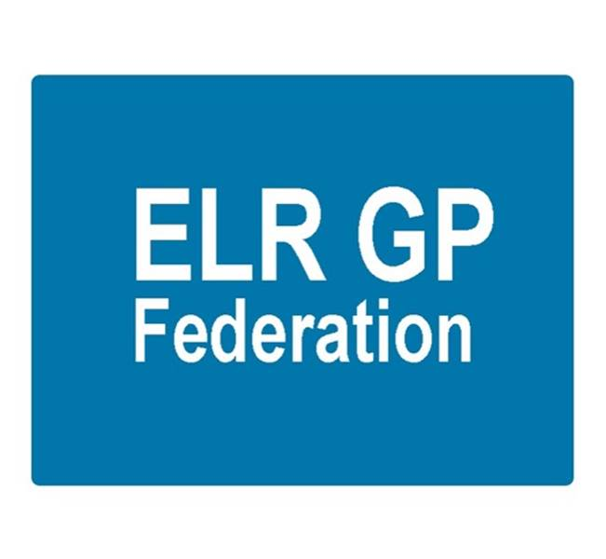
ELR GP Federation Ltd
Minutes of the meeting of The Board of Directors
Thursday 22nd February 2018 – Syston Medical Centre

Present: Dr R Bietzk; J Watkins; J McCrea; Dr S Vincent; Dr G Chidlow; Dr U Montgomery, K Whawell, H Patel, Dr N Chotai

In the Chair: Dr R Bietzk

- Apologies - Dr L Ryan

- To confirm the minutes of the meeting held on 25th January 2018.
The minutes were confirmed as an accurate record.

- Matters arising
- Contact has been made with Mark Wightman @ UHL – meeting TBA. Action, JW
- Rysz to contact Vocare. Action RB

- COO Report

- Joint strategy with the CCG and funding for FY18/19

Following JW’s presentation to the PCCC on 6th February 2018, Tim Sacks has confirmed that the ELR CCG Governing Body has approved that the CCG will pay the balance of the £350K that it committed to the Federation in FY18/19. The CCG has decided to utilize the Transformation Fund @ 75 pence per patient to fund this commitment. This may raise concerns amongst some practices and will need careful communication.

We await confirmation on the demand management funding @ 10 pence per patient.

We will construct a budget for FY18/19 and importantly develop a budget for April 2019 onwards. Key elements of income are likely to relate to service contracts (especially urgent care) and fees for services provided to practices. Action JW / HP

HP outlined that there will be VAT implications that need to be accounted for going forward. Further advice to be sought. Action JW/HP

- Localities and transformation fund update

JW has been working with the six Localities to develop their transformation applications. An overview of the areas that the Localities are planning to develop is included in the COO report.

There are a number of potential roles that the Federation will play to support the implementation of the transformation schemes going forward including;

- Administrating the Locality transformation funds
- Employing staff
- Project management support for the implementation of the Locality cross-practice projects

The Board agreed that the Federation should support the projects in this way, assuming that it was recompensed appropriately.

- Extended primary care / urgent care
- The timetable for the procurement process will result in a new contract to start in April 2019.
- KW attended a DHU/4 Fed Joint Venture meeting on 20th February 2018; DHU remain keen to partner with the Federation.
- The Federations in the West have suggested that we consider how the LLR Federations collaborate to ensure an effective GP Voice as the three CCGs move to closer working / joint management structures etc.
- RB to follow-up with Vocare. Action RB
- GC to follow-up with DHU. Action GC.
- The Federation Board will need to determine its strategy once further information is known.

- Winter Access Scheme
- Practices have engaged well with the Federation scheme to provide an additional 5,000 urgent, bookable appointments over an 8 week period, with 28 practices indicating that they will take part. An update was provided in the COO report.
- As previously discussed, allocating appointments on a proportional basis by patient numbers may not make best use of the limited resource and we will prepare a more pro-active plan – possibly on a Locality basis for future years. Action JW.

- NHS England; Clinical pharmacists in general practice
- Soar Beyond (SB) are not on the CCG accredited list and the CCG have advised that they will not re-open the application window.
- We have approached Prescribing Support Services (PSS) who would be able to ‘step in’. PSS delivered the Federation scheme until October 2017 and are an accredited ELR CCG supplier.
- NHS England have acknowledged this change in plan.
- JW will now summarise the changes for circulation to the 11 participating practices. Action JW

- Community Based Services and inter-practice referral process
- JW/HP to arrange for practices to provide up to date evidence of their clinical indemnity arrangements in line with the sub-contracting agreement. Action JW/HP
- Bushloe / Wigston are starting inter-practice referral for IUD/IUS/SDI services
- Notes of the performance review meeting that took place on 25th January 2018 were attached to the COO report.
- LCC will conduct a quality review of Latham House.

- Correspondence management
- Start date @ 6th March 2018.
- GP workshop now scheduled for March 2018 as well.
- Contract almost finalized. Final issue relating to confining indemnity to the actions of the Federation, rather than all practices. The alternative is that we put a sub-contract in place with the practices to provide a suitable indemnity. Action JW

- Demand management
- The Federation facilitated the peer review sessions at the Locality meetings in January 2018.
- Report is being drafted. Action RB
- The peer review process will be reviewed and updated for March and the new financial year.
- Review meeting with CCG on 2nd March 2018 – postponed. Action JW/RB
- Awaiting confirmation of funding @ 10p/patient for FY18/19.
- Consideration needs to be given to Board members assisting with future facilitation.

- Diabetes nurse specialists
- Scheme to provide DSN support to 29 LLR practices identified with needing assistance with diabetes management. Budget @ approx. £80K for FY18/19.
- Implementing with Latham House, with support from Diabetes Centre (Laura Willcocks)
- Anne Scott (ELR CCG) is assisting with implementing a clinical governance process to assure this scheme.
- JW / GC to review clinical governance arrangements to support this and further Federation projects. Action JW / GC

- Buildings management offer
- JW is working with the Estates Strategy Group to develop a buildings management offer for Latham House in the first instance. Action JW
- There is the potential for this to be part of a transformation fund application, if there is interest from practices.

- Rutland Patient App project (VitruCare)
- Contract agreed with Dynamic Health Systems Services
- Grant agreement with RCC is in its final draft. RCC require a clause that requires funding to be returned, if practices do not participate in the scheme and we are finding an appropriate mechanism to deal with this unlikely scenario. Action JW
- Workshop held on 20th February – all practices confirmed their commitment to the project.

- Primary Care Exchange – JW to follow-up. Action JW

- GP TeamNet – The Harborough Locality has expressed an interest in developing this to assist with sharing of information / policies between practices. JW to progress. Action JW

- Service contracts – H Pylori, CCG, home phlebotomy service – JW/GC to follow-up. Action JW/GC

- Dispensing practices procurement – JW/RB to pursue Action JW/RB

- Strategy update

The Board discussed the strategic priorities paper that the COO had prepared and approved the key priority areas, as follows;

Vision
“Championing through GPs and their practices, investment and delivery of healthcare services at scale for patients across East Leicestershire and Rutland”
Stream line the strategic goals / purpose;

Priority areas
- Local service delivery & business development - facilitating the delivery of more services locally by expanding non-core primary care services to make them more accessible to our patients, bidding collectively and / or holding contracts where it is helpful to do so. [SERVICE CONTRACTS]

- Resilience and sustainability in primary healthcare - working with our GP members to innovate and transform the way that services are delivered to address the pressures currently faced in the local health care system, providing clinical and back office services at scale where it is helpful to do so. [FACILITATION / CONSULTANCY]

- Effective voice - for our members across ELR when engaging with CCGs, Trusts, social care, and the voluntary sector

Key elements;
- Win contracts – especially Urgent Care
- Support the development of the six Locality Hubs to create sustainable primary care services across the ELR CCG area.
- Key player in shaping place based integrated working in developing an accountable care system.

‘Change agent’; facilitating joint working, innovation and transformation between practices

Develop products / solutions to support practices working together, eg, employ specialist / back office staff

The Board considered the options presented for the Federation beyond April 2019 and determined to proceed with Option 2

Support the development of the six Localities and then ‘shut up shop’

Continue to support Localities and deliver a turnover @ £200K through two main streams;

Contracts and secured income @ £2M-£3M to deliver a contribution to the Federation @ £150K

Facilitation / consultancy fees @ £50K

The Board Directors agreed that they should take key areas of responsibility as outlined in the paper.

The Board also made the following observations / suggestions;
- The Federation should move towards CQC accreditation Action JW
- The Federation should obtain and independent provider status to enable it to employ staff with NHS pensions. Action JW.
- Future project support work should be fully costed and charged on a fee for service basis. Action JW
- We should review the Locality transformation plans and create offers to solve practices’ problems and challenges. For example, assisting practices with their GDPR obligations Action JW / all.
- Actively contribute and support the emerging Localities and their structures. Action JW / all
- Consider working with local GP Federations, where sensible. Action JW

- Service contracts
  - H Pylori is with ELR CCG to consider and determine their approach
  - ECG – depends on whether money could be released from UHL.
  - Diagnostic Hubs – no further update

- Financial update
- Forecast for FY17/18 - The Board reviewed the updated budget forecast.
- FY18/19 budget forecast – the Board reviewed the updated forecast for FY18/19 that had been updated following the discussion with Tim Sacks and provided in the COO update.
- The key challenge will be to identify funding streams from April 2019. JW to prepare a business plan to support this. Action JW.

- Communications update
- Announcement re Kirsty joining the Board has been completed.
- JM has drafted a newsletter.
- JM ran a workshop with the South Blaby and Lutterworth Partnership Hub to help them consider how to make effective use of digital comms in communicating with their patients. This area will form part of their Transformation Fund application.
- JM to advise on how the Federation meets its GDPR obligations. Action JM

- Any other business
- Consider offering Catmose College, Oakham a service in respect of flu jabs. Action GC/JW
- We will keep Board member roles and responsibilities on the agenda for future meetings. Action JW
- Further consideration needs to be given to how we engage others in the work of the Federation. Action all.

- Date & venue of next meetings
The March meeting was postponed to Thursday 26th April 2018 @ 7pm @ Syston Health Centre.

