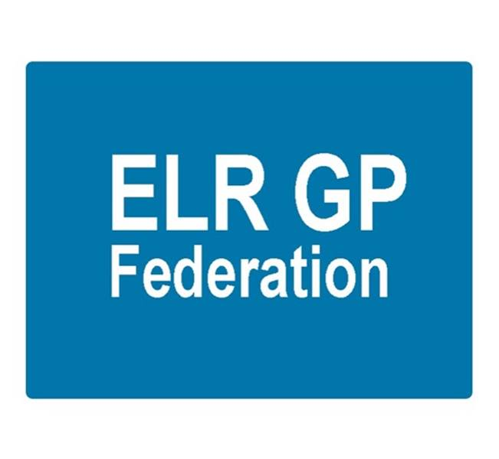

Board meeting
7pm 30th August 2018 @ Syston Medical Centre
AGENDA

 |  | Paper
 | Apologies
 | Review of Minutes of the Meeting held on 5th July 2018 | A
 | Matters arising
 | Report from the COO | B, C
 | Localities update
Service contracts
- H Pylori
- Demand management
 | Financial update  - FY17/18 accounts  - FY18/19 forecast | D  Tabled
Board issues
- South Blaby & Lutterworth
- Removing shareholders
 | Communications update
 | Shareholders meeting
 | Conflicts of Interest register
 | AOB
 | Date & venue of next meeting

