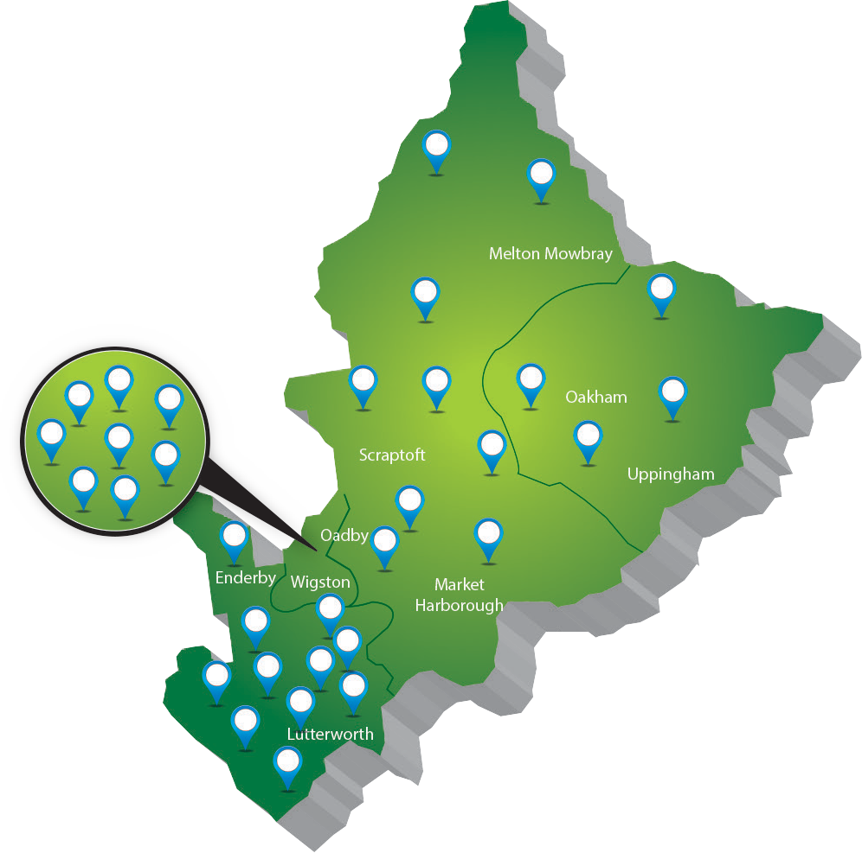

**East Leicestershire and Rutland**

**GP Federation**

**Annual Report 2017/18**

**ELR GP Federation Annual Report 2017/18**

**Contents**

Page

1

2

3

4

5

Introduction from our Chair

Our Context

Our Mission and Values Our Priorities

Our Second Year - maturing and delivering

Engagement and Communication Legal Form and Governance

Our Board

10

11

13

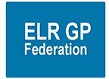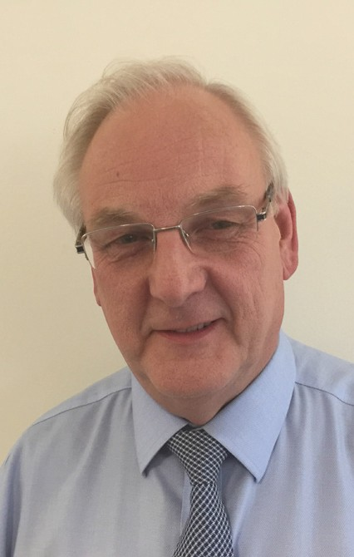

**Introduction from our Chair**

Welcome to this second Annual Report from the ELR GP Federation.

Last year, we said it was becoming apparent that the traditional model of general practice will not be

sustainable. Consequently, we needed to work together to provide services ‘at scale’, as appropriate to the problem that needs solving, thereby realising the benefits of economies of scale, improving opportunities for career structures and professional support and delivering a wider range of services.

Over the course of the year, the Board said goodbye and thank you to Dr Anuj Cahal and Dr Simon Vincent. It has been a pleasure to have worked with them as fellow Board members and they can be proud of what they

achieved. I am delighted that they continue to play active roles in the local health economy and we look forward to continuing to work with them as colleagues and partners.

In the introduction to our first Report last year, I said that we were delighted to be able to report on a busy first year of development and achievement. I am even more delighted this year to be able to report on an even busier year of maturing and delivering.

Of course, this meant we have been able to welcome a new colleague to the Board - Kirsty Whawell, whose experience as a Practice Manager further enriches

our insight, diversity and hands-on knowledge of the challenges our members and their staff face.

That means delivering for our member practices, for the local health and care economy and - most importantly - supporting our members’ delivery for our patients, their families and carers and the communities they serve.

I am proud that this year’s Annual Report is full of examples of how we have risen to that challenge, for example through developing and supporting services such as Clinical Pharmacists in General Practice, the Improving Access to General Practice Winter Scheme or Diabetes Nurses.

We never forget that we were created after extensive engagement with local GP practices and wider stakeholders with the explicit aim of supporting them to deliver sustainable primary care in East Leicestershire and Rutland (ELR) in the future.

One again, the whole Board is indebted to our fantastic Chief Operating Officer, James Watkins for his ceaseless work and continuing dedication since his appointment. The Federation could not be in safer or more excellent hands.

We are also introducing innovative services ourselves, such as the GDPR Data Protection Officer Service and harnessing web, digital and social channels to improve communications and engagement with patients and the wider community via Rutland Healthcare.

That was our purpose at the time of our creation and it remains our purpose today.

**Dr Ryszard Bietzk Chair**

This year we celebrated the 70th Anniversary of the creation of the NHS - the single most successful and popular act of innovation and transformation ever undertaken by a British Government. And delivered in the depths of austerity.

The Federation represents a diversity of practices and to achieve maximum effect the Board constantly reviews the way it works to ensure local needs and opportunities for innovation are supported, balancing this with opportunities to work at a larger scale.

70 years on, it is clear that the future of the NHS remains in continued innovation and transformation. That is why I am particularly proud that a bedrock of our work this year has been supporting our member practices in developing and delivering their local Transformation Fund applications and plans.

This means being flexible and responsive as our members continue to develop and explore different modes of locality working and organisation.

The pressure on general practice services is set to continue to increase as we live longer with more complex needs.

ELR GP Federation continues to support our practices to meet local challenges across primary care and the wider healthcare system and to respond to the vision laid out in the Leicester, Leicestershire & Rutland (LLR) Blueprint for General Practices to meet patients’ needs at scale.

Being the Chair of the Federation is both a pleasure and a privilege. And it is made all the easier by being surrounded by a fantastic team of Board Members.

IELR GP Federation Annual Report 2017/18 - Page 1

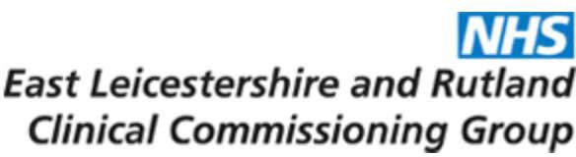

**Our context**

All ELR GP practices - serving a registered population of around 325,000 patients - are part of the ELR GP Federation.

The plan articulates how practices will need to come together either formally or informally to meet patients’ needs at scale. By working

together practices will deliver improved efficiency and make more effective use of existing resources to ensure that practices are sustainable in the long term. The ELR GP Federation is

at the heart of delivering a new model of sustainable General Practice in ELR. By working together more effectively, practices will be able to contribute to the provision of place-based integrated community and primary care.

But despite this pressure, treatment outcomes are far better - and public satisfaction higher - than ten or twenty years ago.

Over the course of 2017-18, these practices moved from being based in three locality areas to six. These now are:

To address the challenges, NHS England has produced its Five Year Forward View. In relation to primary care and general practice, this states:

* Oadby & Wigston;
* North Blaby;

“Most NHS care is provided by general practice. One of the public’s top priorities is to know that they can get a convenient and timely appointment with a GP when they need one. That means having enough GPs, backed up by the resources, support and other professionals required to enable them to deliver the quality of care they want to provide.

* South Blaby & Lutterworth;
* SLAM;
* Rutland; and
* Harborough.

The health of the local population is generally better than the overall population of England. However, there are a significant number of people affected by

ELR GP Federation is committed to supporting our member practices to deliver this vision for transformed healthcare across our region and ensuring the delivery of excellent, sustainable primary care services.

“As people live longer lives the NHS needs to adapt to their needs, helping frail and older people stay healthy and independent, avoiding hospital stays where possible. To improve prevention and care

for patients, as well as to place the NHS on a more sustainable footing, the NHS Five Year Forward View called for better integration of GP, community health, mental health and hospital services, as well as more joined up working with home care and care homes.”

ill health, including:

* Coronary heart disease
* Hypertension
* Diabetes

Over 70% of all deaths in ELR are from three major diseases:

* Cardiovascular disease
* Respiratory disease
* Cancer

Prevalence of long-term diseases in ELR is increasing, particularly amongst the older age groups.

To support this vision, the healthcare system across Leicester, Leicestershire and Rutland developed its ‘blueprint for General Practice’ which sets out the vision to deliver the General Practice 5 Year Forward View. This blueprint places General Practice with registered lists at the heart of a comprehensive service to patients that caters for their differential needs according to condition and complexity.

The population of ELR is estimated to increase to 350,000 by 2025 with a significant increase in the older population.

New treatments for a growing and aging population mean that pressures on the NHS are greater than they have ever been. And this is nowhere more true than in primary care and general practice.

Page 2 - IELR GP Federation Annual Report 2017/18

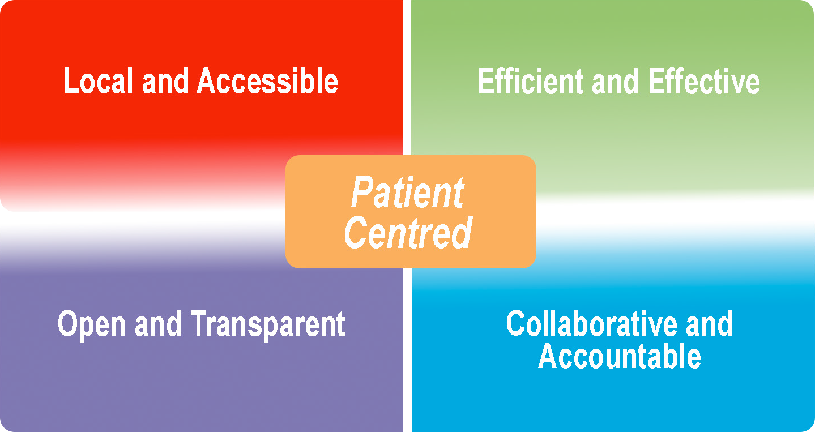

**Our Mission, Vision and Values**

During 2017-18, we confirmed our mission as being:

**“To champion through GPs and their practices, investment and delivery of healthcare services at scale for patients across East Leicestershire and Rutland”**

To support this mission our vision is “to remain a GP-led, patient centred organisation, working collaboratively with our partners across health, social and community care to facilitate an enhanced delivery of high quality, innovative and responsive services across East Leicestershire and Rutland”

ELR GP Federation is committed to the core values, outlined below, which guide the way that we work:

* Patient Centred – ensuring that the needs of patients are at the heart of everything that we do
* Local and Accessible – striving to deliver our services where and when our patients need them
* Efficient and Effective – providing high quality healthcare
* Open and Transparent – in all that we do
* Collaborative and Accountable – working effectively with all stakeholders to meet the needs of our members and their patients

IELR GP Federation Annual Report 2017/18 - Page 3



**Our Priorities**

Our business priorities ensure we help our member practices meet the challenges that they are facing. These priorities are outlined below.

* Collaborate with other providers, key health and social care partners and commissioners to deliver more planned care locally at scale

Priority 4 – Effective voice

•

Be an effective voice for our members across ELR when negotiating with CCGs, Trusts, social care, and voluntary sector

Empowered by its GP members to make the case of the GP role within the future health and social care system

Work with commissioners to influence better health outcomes. Ensure that local

commissioners have the opportunity to engage with the expertise of ELR GP Federation and

its members to achieve key commissioning objectives

Priority 1 – Local service delivery

Priority 3 – Transformation and Innovation

•

* Facilitate the delivery of more services locally by expanding non-core primary care services to make them more accessible to our patients
* Be an effective health service provider, collectively bidding for services that individual practices are too small to provide, collaborating with other healthcare partners, thereby bringing new business to practices

•

Advance the ambitions set out in the LLR Blueprint for General Practice to improve the way that services are delivered to address the challenges that primary care is currently facing

Provide the tools to enable collaborative working between practices and be a key facilitator in promoting and supporting joint working initiatives

Be a key enabler in the integration of care pathways across health and social care boundaries

Drive forward quality in primary care through rigorous and effective governance; and

Work collaboratively with Commissioners to influence health outcomes

•

•

•

Priority 2 – Resiliance and sustainability in primary healthcare

•

* Support GP members enhance the resilience of their practices to deliver sustainable primary care services. This will include the sharing

of best practice and the harmonisation and adoption of common practices and processes

e.g. supporting with CQC compliance, assisting practices to meet external or internally determined KPIs

* Work with our GP members to improve the way that services are delivered to address the pressures currently faced in the local health care system, delivering at scale where it is helpful to do so

Drive forward efficiencies in primary care and seek opportunities to transform the delivery of effective and focused healthcare and, where appropriate, redesigning pathways

•

•

Page 4 - IELR GP Federation Annual Report 2017/18



**Our Second Year - maturing and delivering**

*South Blaby & Lutterworth (Northfield, Wycliffe, Masharani, Hazelmere, Countesthorpe)*

* quality improvement and sharing of specialist skills – build on collaborative peer review work to effectively utilise ‘intelligence packs’ information to identify learning needs and share best practice on key topics to improve the quality of patient care and outcomes;
* investigating how to transform the approach to Acute on the Day access for patients in South Blaby and Lutterworth;
* care navigation and integration with community based services to support disease prevention;
* collaborating with Blaby District and Harborough Councils, LPT, Social Care and Voluntary Sector teams to develop a Locality Plan to deliver an integrated primary and community care offer for the residents of South Blaby & Lutterworth; and
* ensuring that community assets’ are effectively used through effective care navigation, social prescribing and use of First Contact Plus.

As the Federation has grown and matured over its second year of operation, we have been able to develop our role, influence and capacity on behalf of our members.

Amongst the projects being brought forward under the Transformation Fund are:

*Oadby & Wigston (Wigston Central, Bushloe, South Wigston, Central, Croft, Severn, Rosemead)*

* extending the locality para-medical team and sharing local expertise;
* reviewing the approach to Acute on the Day access for patients in Oadby and Wigston and trialing new approaches;
* demonstrating GPs at scale through formal changes to working arrangements in two practices; and
* social prescribing and integrating with community-based services to support disease prevention.

*North Blaby (Kingsway, Glenfield, Limes. Forest House, Enderby)*

* transforming and re-designing the use of para-medical staff to improve access for patients and reduce the demands on GPs;
* ensuring that the primary and community care offer to North Blaby residents is streamlined and integrated and that ‘community assets’ are effectively used through social prescribing;
* developing closer back office links between practices with an emphasis of harmonising processes, where appropriate and possible, to greater enable integrated working;
* investigating the potential of developing a Locality Visiting Service to meet the needs of housebound patients who do not meet the LLR Acute Visiting Service criteria; and
* looking at ways of delivering in-hours urgent care collaboratively.

Increasingly, we are becoming the default ‘go to’ place for supporting, promoting and delivering innovation - at individual Practice, Locality and ELR- wide levels.

We have also continued to develop our role as an effectice voice for our practices with commissioners and decision-makers.

Supporting Transformation Fund innovation

Amongst our most significant successes has been our work supporting our members across localities by helping them develop their local Transformation Fund applications and plans. All six Localities which we supported had their plans approved by the ELR CCG.

We have also developed a Project Management structure to assist the Locality teams to implement their plans and have been supporting the implementation of these plans in most cases.

We have worked with the CCG to develop reporting templates which will be used as the basis to update the CCG on progress and release the funds to the Localities.

We now attend quarterly CCG Transformation Fund panels to advise on and review progress and support the release of transformation funds to the localities.

IELR GP Federation Annual Report 2017/18 - Page 5



*SLAM (Melton, County, Jubilee, Long Clawson)*

* implementing a programme of improvement support to practices including Dementia MDT and integrating with community based services;
* utilising recognised data sources to benchmark and identify areas of strength and weakness to allow a collaborative approach to

utilising and sharing the practices’ specialist knowledge when considering both demand management and driving up clinical quality. Two areas highlighted identified as national and local priority areas include Dementia and Cardiovascular Disease;

* jointly developing and aligning governance, workforce development and communications strategies across practices to meet the service framework expected for the ELR CCG Acute Access specification. This will enable practices to offer services jointly when and if appropriate;
* developing the primary care estate and investing in better technology to improve back office resilience – including investigating extending GPTeamNet/Intradoc (or similar)

via a secure network to allow access from all practices within the locality. This will allow sharing of policies, procedures, protocols and best practice relating to clinical care and CQC requirements; and

* developing GPs and wider primary care workforce to meet the growing demands on urgent access.

*Rutland (Uppingham, Oakham, Market Overton & Somerby, Empingham)*

* developing a collaborative locality approach to the management of diabetes;
* ensuring effective collaboration with Rutland County Council, LPT, Social Care and Voluntary Sector teams in trialling a care navigation hub to enable patients to take responsibility for their health and wellbeing;
* developing a collaborative approach to harness web, digital and social channels to improve communications and engagement with patients and the wider community, including supporting the active signposting agenda;
* implementing measures to improve back office and workforce resilience; including the implementation of an information sharing tool

such as GPTeamNet to enable sharing of policies, procedures, protocols and best practice relating to clinical care and CQC requirements; and

* developing integrated primary and community nursing and the ‘Rutland bank’ to enable clinical and administrative staff to be utilised efficiently to provide cover across Hub practices, including strengthening joint educational arrangements;

*Harborough (Billesdon, Kibworth, Two Shires, Husbands Bosworth, Market Harborough)*

* Collaborating with Harborough Council, LPT, Social Care and Voluntary Sector teams to develop an integrated prevention services offer for the Harborough residents and ensure that its ‘community assets’ are effectively used through social prescribing; and
* developing the approach to acute on the day access, including;
  + using para-medical staff
  + reviewing use of buildings
  + home visiting service
  + Locality triage service
  + Policy / information sharing – GPTeamNet

Page 6 - IELR GP Federation Annual Report 2017/18



Clinical Pharmacists in General Practice

ELR Teaching Academy

Improving Access to General Practice Winter scheme

The Federation worked with a number of practices to secure agreement from the NHS England “Clinical Pharmacists in General Practice” scheme to support the recruitment of 3 clinical pharmacists to work in general practice in patient facing roles.

We were successful in securing support for an ELR Teaching Academy, supporting seven teaching academy GP practices across East Leicestershire and Rutland. Teaching support has been offered by the medical school at masterclasses at the school or on location to team members involved in teaching.

The Federation was awarded a contract to manage the process for the NHS England scheme to provide additional urgent on the day appointments over the winter period.

Our scheme covers more than 90,000 patients across East Leicestershire and Rutland. We are working with Prescribing Support Services (PSS) to:

* provide Senior Pharmacist cover;
* provide an all-inclusive service in relation to the 3 Pharmacists, including;
  + Recruitment;
  + Employment inc. all checks, HR, professional registration, DBS;
  + Mandatory NHS training – safeguarding, IG;
  + Pension;
  + Indemnity;
  + Parental leave, long-term sick;
  + On-going professional development & training; and
  + End of 4 years – retain the employment responsibility of the pharmacists.

Two thirds of our practices took part in this scheme which delivered over 5,000 additional appointments - almost 1,000 of which were additional nurse appointments.

This will involve teaching Year 3 students starting in January 2019 and year 5 students in February 2019.

Each Year 3 student will have a named mentor in their allocated GP practice. Teaching will be

undertaken by several members of the practice team including Healthcare Assistants, Advance Nurse Practitioners, practice and district nurses. They will also be encouraged to work with the HCA and undertake practical procedures such as phlebotomy and spirometry.

The additional appointments delivered across the whole range of our localities, with particular

success in Latham House Medical Centre (over 500 additional appointments) and Market Harborough Medical Centre (over 380 additional appointments).

Some sessions will take place in urgent care/care homes to undertake for instance medication and or care plan reviews. Students will be encouraged to undertake audit activities.

The benefits for our member practices through involvment in the scheme include;

* taking the recruitment and management burden;
* removing the risk of employment;
* providing effective cross cover, as necessary; and
* flexibility for moving pharmacists around, as necessary.

There will be face-to-face teaching by a GP, some observed, some with supervision available. There will also be one group/locality teaching session per week which will be rotated amongst the academy practices. These could be video consultation analysis and be tripartite with FY1 doctors and registrars.

The 3 pharmacists are augmented by the existing pharmacists employed by practices.

IELR GP Federation Annual Report 2017/18 - Page 7

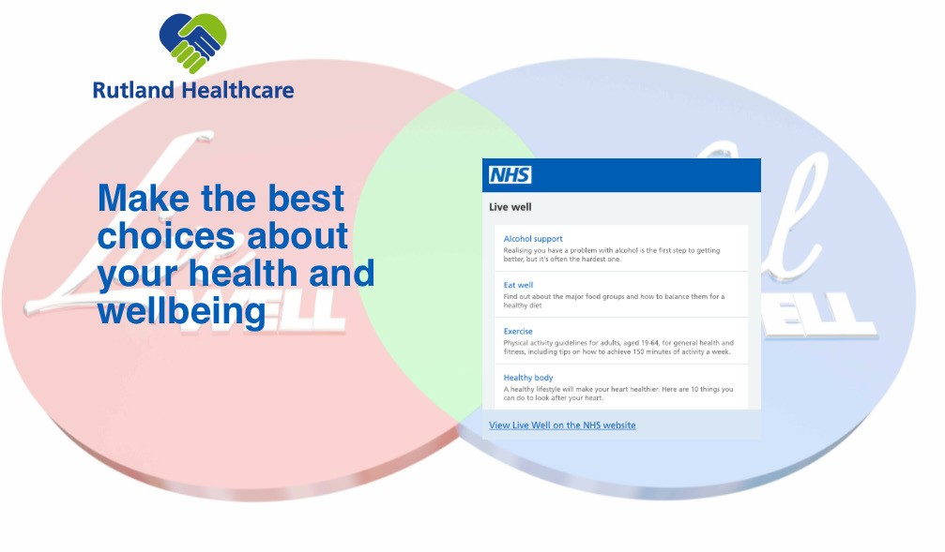

GDPR Data Protection Officer Service

Harnessing web, digital and social channels to improve communications and engagement with patients and the wider community

Public Health Community Based Services (Health Checks, contraception, alcohol reduction)

One of the major challenges facing our members during 2017/18 was preparing for the introduction of the Generak Data Protection Regulations (GDPR).

The Federation provided this service throughout the year through 13 sub-contracting member practices.

We have begun work with Rutland Healthcare in a highly innovative project to harness web, digital and social channels across 5 practices to improve communications and engagement with patients

and the wider community, including supporting the active signposting agenda.

In response to requests from our member practices, we successfully established the ELR GDPR DPO Service, providing:

* the DPO function from an experienced and suitable qualified expert;
* access to a self-assessment toolkit to enable self- assessment and review by the DPO of current level of GDPR readiness;
* initial review by the DPO of that self assessment with comments or advice;
* an e-mail first point of contact for data protection issues questions – (dpo@elrgpfed. com);
* Ask the DPO question and comment form;
* GDPR FAQs;
* sample html code to use as a GDPR page for practice websites; and
* a library of GDPR Further Reading resources.

Further practices participated as sub-contractors in an inter-practice referral scheme for contraception services (IUD/IUS & sub-dermal implants fitting and removal).

The aim is to transform patient and carer access to health and care information, services, self-help and guidance. From one ‘Hub’ website, they will be able to see national and regional healthcare information

- updated directly by NHS England and Public Health England, latest news, guidance and advice in one convenient place, plus information and assistance relevant to their own local practice area.

Diabetes Nurses

The Federation worked with Latham House Medical Practice with support from the Diabetes Centre to introduce a Diabetes Nurses scheme to support 29 LLR practices identified with needing assistance with diabetes management. We worked with the Clinical Commissioning Group to implement a clinical governance process to assure this scheme.

They will be able to contact their local GP Practice, see details of local services, opening times and contacts. The practices will benefit from not having to duplicate effort in providing national and core healthcare information and advice.

The DPO service has been a significant success with, to date, more than 4 out of 5 ELR practices signed up to the service.

Users will be able to use a range of tools to understand symptoms and get advice on the best course of action to take. They will also be able to tap into and interact with live conversations taking place across local social media

We have also received interest from GP practices and other health bodies outside ELR, interested in signing up to the service.

The Hub will also act as a gateway to research and thought leadership from leading think tanks and research institutions

Page 8 - IELR GP Federation Annual Report 2017/18



Correspondence management

Several practices attended a LLR workshop in April 2018 and follow-up session in May 2018 to understand how to improve the correspondence management process. We held a project management workship in June 2018 to support the practices in implementing the correspondence management process

H Pylori

add stuff in here

IELR GP Federation Annual Report 2017/18 - Page 9

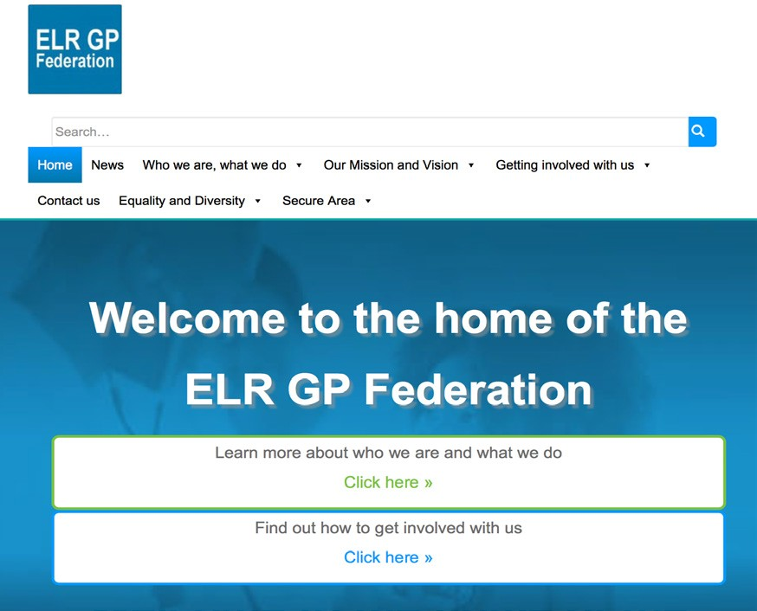

**Engagement and Communication**

Effective engagement and communication with our members, commissioners and the wider health

community is an essential element in the Federation supporting its shareholding practices to deliver excellent and sustainable health care.

The Federation has and will actively work with our health and social care partners to achieve this, including Leicestershire County Council, Rutland County Council, Healthwatch, patient groups, the voluntary sector and other partner organisations.

Our website also features free online services that make it attractive for our members and

stakeholders to visit and return regularly, including:

•

The healthcare news ticker – providing the breaking national healthcare news

Window on the World –bringing together live social media feeds from the three LLR Clinical Commisioning Groups, University

Hospitals Leicester, Leicester Partnership Trust, LLR Alliance, ELR GP Federation, the 2 LLR Healthwatch organisations, Voluntary Action Leicestershire and the Better Care Together Programme

Community Hospital Waiting Times - a free downloadable resource.

•

We are committed to communicating and engaging with our stakeholders in an open, trustworthy, accessible and responsive manner to support the delivery of comprehensive primary healthcare services that are available to all and accountable

to the communities that we serve. We strive to listen to as many voices as possible across our stakeholders.

We also seek to engage with the wider healthcare economy and other GP Federations within Leicestershire and the Midlands to gather learning and draw on the evidence base for innovating and developing healthcare systems and practice to enhance services. As part of this process, we have

linked with a Midlands based GP Federation network group.

•

The Federation has been working with local commissioners on behalf of our members, to support the development of sustainable General Practice across ELR. By drawing on the experience and expertise of our members, we proactively support our commissioners and partner organisations to deliver effective primary care services by calling

upon an innovative GP network that is committed to creating an effective and sustainable primary care service with improved health outcomes for the residents of ELR.

Harnessing social, web and digital technology

ELR GP Federation champions equality and human rights in all that we do. This is especially important for communication and engagement activities.

In addition to traditional paper based communication and engagement methods, we have introduced a host of new and innovative digital tools, techniques and channels. These have

improved the ways in which we are able to reach out to our communities, keeping them informed about what we are doing, and bringing them together with each other and us.

We have developed a modern and engaging web presence - [www.elrgpfed.com](http://www.elrgpfed.com/) – where people can register online with ‘myFed’ to be part of a Federation membership scheme to:

We will continue to work collaboratively with commissioners - representing our members’ interests to help create new pathways and innovative services that will be key to improving clinical outcomes for our patients in line with the vision set out in the LLR Blueprint for General Practice.

•

Receive updates, notifications and breaking news about the topics and issues of most interest and relevance to them,

Subscribe to a regular e-newsletter,

Access background documents and other materials

Engage with us through a range of social media channels including Twitter and Facebook.

•

•

We constantly seek new ways of obtaining feedback about the services that we and our member Practices provide for local people, stakeholders, patients and their families.

•

Page 10 - IELR GP Federation Annual Report 2017/18

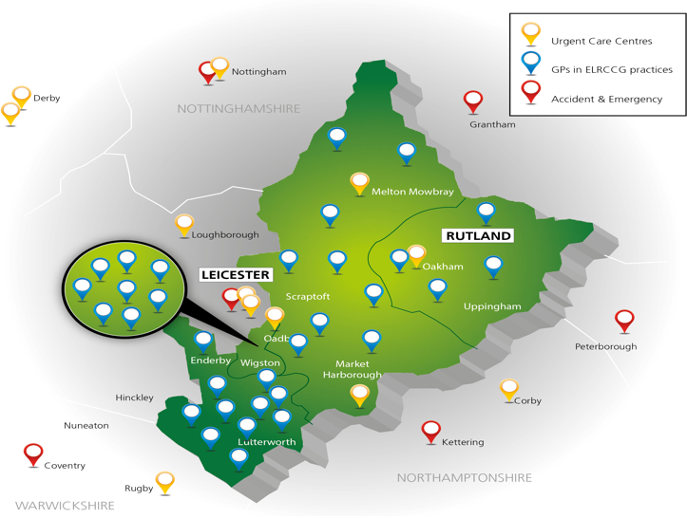

**Legal form and Governance**

The Federation comprises all GP practices within the ELR area from its six localities.

South Blaby and Lutterworth Countesthorpe Health Centre Hazelmere Medical Centre Narborough Health Centre Northfield Medical Centre The Masharani Practice

The Wycliffe Medical Practice

* Describes how the company is going to be run
* Describes what will happen if a shareholder wishes to leave the company
* Provides an element of protection for minority shareholders and the company
* Defines how important decisions are to be made
* Provides guidance in relation to tendering for services

Harborough

The Billesdon Surgery Kibworth Health Centre Two Shires Medical Practice

The Husbands Bosworth Surgery Market Harborough Medical Centre

Legal Form

North Blaby

Enderby Medical Centre Forest House Medical Centre Kingsway Surgery

The Glenfield Surgery The Limes Medical Centre

ELR GP Fed Ltd is a company limited by shares which:

* Is registered at Companies House
* Is owned by its shareholders, who are the Practices, and run by an elected Executive Board;
* Each practice has nominated a GP to hold its shares on the practice’s behalf
* Is governed by its Articles of Association and a Shareholders’ Agreement between its members
* Offers limited liability;
* Allowed Practices to buy shares at a value and limit of £1 per 1,000 population with the retention of a defined number of shares for later issue if required.

Oadby and Wigston Bushloe Surgery Rosemead Drive Surgery Severn Surgery

South Wigston Health Centre The Central Surgery

The Croft Medical Centre Wigston Central Surgery

Rutland

Empingham Medical Centre

Market Overton & Somerby Surgeries Oakham Medical Practice

The Uppingham Surgery

SLAM

The County Practice

The Jubilee Medical Practice Latham House Medical Practice Long Clawson Medical Practice

Our Shareholders’ Agreement:

* States how the Board of Directors will be elected
* Sets out the shareholders’ rights and obligations
* Regulates the sale of shares in the company

IELR GP Federation Annual Report 2017/18 - Page 11



The Board

A clear management structure aids the smooth and efficient running of operations, and ensures that each member Practice is aware of its obligations and commitments in terms of any service it provides on behalf of the Federation.

The Board is accountable to shareholders on an

on-going basis for the effective management of the Federation.

The Board comprises six members who carry the confidence of the voting shareholders from our Localities:

* Melton, Rutland and Market Harborough (3 Board members);
* Oadby and Wigston (1 Board member);
* Blaby and Lutterworth (2 Board members).

The Localities are key in enabling the Federation to ensure that the member GP Practices are able to influence decisions made by the Federation and

ensure that local health needs are addressed where appropriate through pan- Federation initiatives.

One of the Directors is elected as Chair of the Board. The Board can also co-opt further Directors, if necessary.

Each Board member serves for an initial period of three years.

A Chief Operating Officer serves for an unlimited period subject to performance and is a non- voting member of the Board.

Management Structures

The Federation plays a key role in the delivery of services that move from an acute to community setting, either by itself or by sub-contracting this to member Practices.

Many of the members of the Federation are also shareholders of the LLR Provider Company (part of the Alliance Partnership). Any consequential

conflicts of interest are managed by the Federation and the LLR Provider Company in accordance with their respective policies and procedures.

Page 12 - IELR GP Federation Annual Report 2017/18

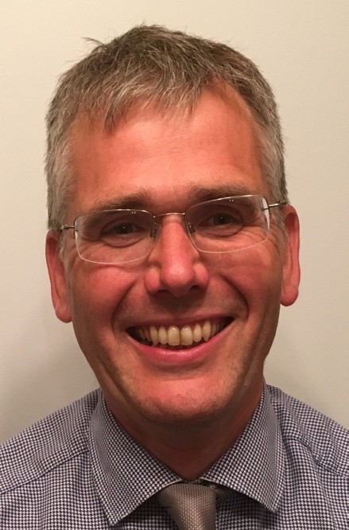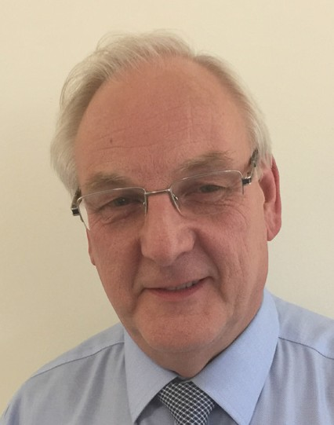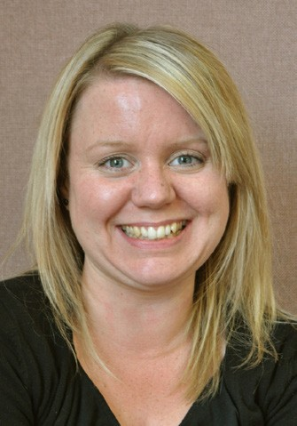

**Our Board**

James Watkins

**James is the Chief Operating Officer for ELR GP Federation.**

Dr Gareth Chidlow

**Gareth Chidlow is Board Member for Melton.**

Dr Ryszard Geraint Bietzk

**Rysz is the Chair of the ELR GP Federation**

Rysz has been a GP in Oakham since 2012, more recently moving to be based at the allied practices at Market Overton and Somerby.

James started his career in healthcare 25 years ago when he joined the NHS Graduate Management Training scheme based

at Leicester General Hospital. Since then he has worked across the country in a number of operational, strategic and development roles within the NHS, Charity and Social

Enterprise healthcare sectors.

Gareth Chidlow works at Syston, where he was instrumental in the building of their new Health Centre and bringing many services

into Primary Care from Secondary Care. These have included ultrasound scanning, hand surgery, hernia repairs and MRI. He has used his experience in leading on procurement for LLR Provider Company, where he has been successful with several tenders including the Alliance contract for Elective Care.

Prior to moving to Rutland, Rysz has spent many years in general practice both in Bedfordshire and Essex.

He has been actively involved in primary care development over that time from total purchasing and fundholding through to practice based commissioning and the formation of CCGs. He also took time away from primary care to be medical director of a hospice.

Gareth sits on the Alliance Leadership and Management Boards as well as the Clinical Reference Group.

Dr Louise Ryan

**Louise Ryan is Board Member for Oadby and Wigston**

James recognises this is a challenging time to be working within the NHS to ensure that we deliver high quality healthcare to the people that use our services. He believes it is very exciting that all practices in ELR have agreed to come together to create a new GP Federation to help rise to that challenge.

His commitment is to work with all Federation members to determine how the Federation can effectively engage with practices and add value to the delivery of primary care, whilst recognising the local variations across ELR.

Louise has lived and worked in Leicester and Leicestershire since 1999, when she commenced medical training at Leicester Medical School.

She trained as a GP at the Glenfield Surgery and, following four years as a GP at Hazlemere

Medical Centre in Blaby, she joined Central Surgery in Oadby, where she works a a GP Partner and GP Trainer

IELR GP Federation Annual Report 2017/18 - Page 13

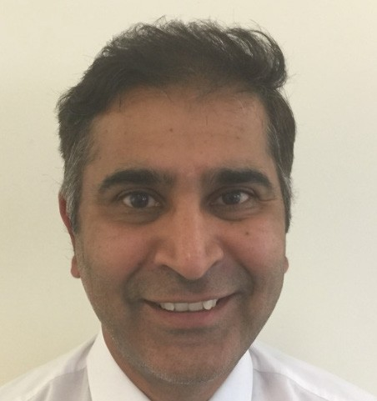

Kirsty Whawell

**Kirsty Whawell is Board Member for Harborough.**

Joe McCrea

**Joe McCrea is Head of Communications and Engagement.**

In addition, over the period covered by this Annual Report, the following served as Board Members..

Dr Anuj Chahal

**Anuj Chahal was Board Member for Harborough.**

Kirsty has lived and worked in Kibworth for the last 8 years and is the Practice Manager at Kibworth Medical Centre where she has been in post for the last 4 years.

Joe has been involved with the Federation since its inception – both in shadow form and once fully operational.

Anuj Chahal is a GP partner at the Two Shires Medical Practice with sites at Kibworth, Fleckney and Market Harborough. He completed his medical training in London and general practice training in Leicestershire.

Dr Simon Vincent

**Simon Vincent was Board Member for Blaby and Lutterworth**

He attends Board meetings in a non- voting capacity to

give advice and support in respect of all aspects of communications and engagement.

From 2013, Kirsty managed the development and construction of the new medical centre which opened to patients in July 2017.

Dr Nainesh Chotai

**Nainesh Chotai is Board Member for Blaby and Lutterworth.**

He has a strong communications background with wide experience over more than 20 years at a senior level developing and delivering in-house

assignments, marketing, comms, PR and campaign initiatives in health, public health, local government, education and environment spheres.

Simon worked for 12 years as a GP at Burbage Surgery before joining the partnership at The Limes Medical Centre, Narborough in April 2015.

**\**ainesh Chotai has been GP at the Glenfield Surgery since 1995. He is an LMC

committee member and a GP trainer. He was on the working

group that founded the ELR GP Federation.

a

He has been a GP Trainer since 2008. In 2014 he joined the West Leicestershire CCG Quality &

Performance Group and became a Director of the newly formed Hinckley & Bosworth GP Federation in the summer of 2015.

He is an active participant in the locality meetings and is committed to ensuring GPs are appropriately resourced for the increasing burdens placed on them.

Page 14 - IELR GP Federation Annual Report 2017/18

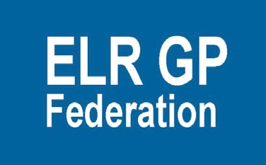

ELR GP Federation 111 Station Road, Glenfield,

Leicester LE3 8GS

[email: communications@elrgpfed.com](mailto:communications@elrgpfed.com) [www.elrgpfed.com](http://www.elrgpfed.com/)

@elrgpfed

ELR GP Fed is a private limited company registered at Companies House under Company Number 9927787