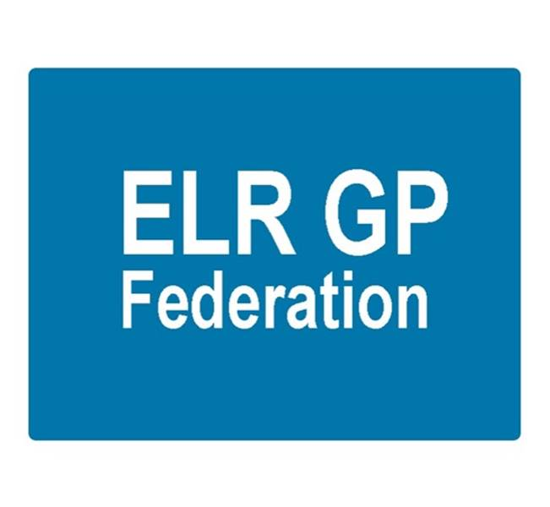

Board meeting
7pm 22nd November 2018 @ Syston Medical Centre
AGENDA

 |  | Paper
 | Apologies
 | Urgent Care tender update & next steps – Simon Harris
 | Review of Minutes of the Meeting held on 4th October 2018 | A
 | Matters arising
 | Report from the COO | B, C, D, E, F
 | Localities update
Service contracts
- H Pylori
- Demand management
 | Financial update  - FY18/19 forecast  - Forward cash flow  - VAT | Paper G  To be tabled
Board issues
- South Blaby & Lutterworth
- Removing shareholders
 | Communications update
 | Fracture Liaison Service – Gareth Chidlow
 | Referral Support Service – Helen Mather
 | Conflicts of Interest register
 | AOB
 | Date & venue of next meeting

