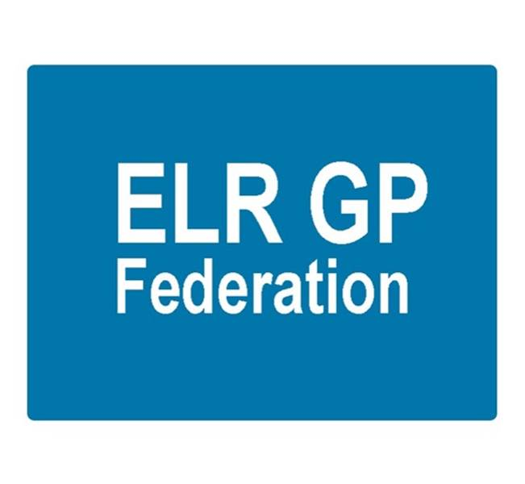

Board meeting
7pm 10th January 2019 @ Syston Medical Centre
AGENDA

 |  | Paper
 | Apologies
 | Review of Minutes of the Meeting held on 22nd November 2018 | A
 | Matters arising
 | Report from the COO | B
 | Localities update
 | Financial update  - FY18/19 forecast  - Forward cash flow  - VAT | Paper  To be tabled
Board issues
- South Blaby & Lutterworth
- Oadby & Wigston
- Removing shareholders
 | Communications update
 | Conflicts of Interest register
 | AOB
 | Date & venue of next meeting

