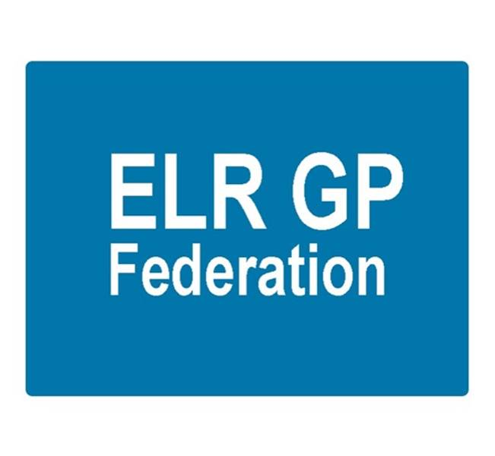
ELR GP Federation Ltd
Minutes of the meeting of The Board of Directors
Thursday 22nd November 2018 – Syston Medical Centre

Present: Dr R Bietzk (chair), Dr L Ryan, Dr G Chidlow, K Whawell, J McCrea, J Watkins, Dr N Chotai, H Patel

- Apologies - none

- Urgent Care Bid

Simon Harris (DHU) (SH) joined to discuss the successful tender and the next steps. Key points;
- We have been advised that our partnership bid has been successful
- We are currently in the standstill period; with the intention that the contract is finalised on 28th November 2018.
- JV Board needs to be set up with 2 or 3 reps from the Federation and the same number from DHU. An independent chair will be appointed.
- Mobilisation meetings will be set up. Post meeting note; first meeting scheduled for 8th January 2019, and weekly thereafter until mid-April 2019.
- The TUPE consultation process will be started with the existing Vocare employees.
- Initial focus is on recruiting ANPs and GPs.
- The North Blaby site is still to be finalized but is likely to be Enderby Leisure Centre.
- JW will follow-up with the six Localities to establish the level of interest in providing part of the service. (O&W, and Rutland Localities; LHMP and MHMP have expressed an interest in contributing to the delivery of the service). Action JW
- DHU have advised that the Federation’s fixed fee will be @ £48K and that there will be a profit share above a capped level; so that the Federation is not exposed to the risk of sharing a negative surplus. Details to be finalized. Action JW

- Minutes of the meeting held on 4th October 2018.
The minutes were confirmed as an accurate record.

- Matters arising – covered in the agenda.

- COO Report

- LLR Federations joint working
- A positive joint Coolaborative LLR Federations meeting was held on 16th November 2018;
  - Topics of discussion included Community Based Services, Diagnostic Hubs, RSS, Alliance Opportunities and GPFV implementation
  - It was agreed to work together on projects, as appropriate
  - Integrated Community Board papers were shared
  - Next meeting to be held on 20th December 2019

- Business plan for FY19/20
- An updated income and expenditure forecast for FY18/19 and draft budget for FY19/20 were reviewed. Key points;
    - A healthy surplus @ c.£40K will be generated in FY18/19 due to the support that the Federation is providing for the implementation of the Transformation Projects. This is important, as the income streams for FY19/20 are not as secure at the moment.
    - The draft budget for FY19/20 is currently showing a deficit. Key income streams in FY19/20 include;
      - Demand management @ c£25K (TBC)
      - Urgent Care (DHU) @ c£41K (net of VAT)
      - Locality Support (£ TBD)
      - RSS / FLS (£ TBD)
      - H Pylori, CBS, GDPR (£10-15K)
      - Other CCG projects (£ TBD)
- After discussion, the Board decided not to ask Practices to support the Federation with a proportion of their LMC rebate.
- The Federation will register for VAT during 18/19 which will have an impact on future income streams
- JW to meet with CCG (Tim Sacks) to update on the Federation’s position and ascertain options for projects and funding in FY19/20. Action JW.

- Localities & transformation fund update
- The Federation is providing support to Localities in implementing their transformation fund projects.
- Funding arrangements for the Federation’s work are being finalised with the Localities; using the Board approved pricing model as a guide. Action JW.
- The contract with Jamie Bell Physiotherapy Ltd and Market Harborough Medical Practice for a six month First Contact Physiotherapy pilot in the Harborough Locality is progressing well. Early indications are that GP time is being saved.
- Similar arrangements are being established as follows;
  - 6 month First Contact Physiotherapy contract for the Oadby and Wigston Locality with Jamie Bell Physiotherapy Ltd; starting in December 2018.
  - 6 month ECP/Visiting contract for three SLAM Locality practices with DHU; starting in December 2018.
  - 3 month ECP visiting contract for Rutland practices with DHU; starting in January 2019.
- 12 month contract with Clarity Informatics to enable all ELR member practices to have access to the GPTeamNet tool starting in November 2018.

- Community services re-design
- Rutland are the ELR pilot site.

- Winter Access scheme
  - Balance of funds to be distributed. Action HP

- NHS England; Clinical pharmacists in general practice Project
- Rosemead have agreed to join the scheme.
- Enderby have withdrawn.
- Due to the passage of time; practices have been asked to confirm that they wish to proceed.
- NHS E have confirmed that we can proceed with two pharmacists in the first instance.
- LMC Law will then be asked to review the PSS contracts; costs to be shared.
- Start date to be asap after contracts have been agreed. Action JW

- Community Based Services
- HP has contacted our sub-contracting practices to update the schedule of fitters and their evidence to practice and indemnity certificates. Action HP
- It is important that practices use Quest going forward; which will be the basis for future payments.

- Correspondence management
- A positive review took place at the LLR workshop on 24th October 2018.
- Our contract provides a further 15 months of support from Practice Unbound. We will arrange quarterly support / review sessions with our participating practices. Action JW.

- Demand Management
- RB/JW have circulated the report to all six Localities with guidance on the top 4 specialties to focus on and the actions required.
- Practices have returned referral information for the month of October 2018 for the specialties identified; which will be discussed at the November Locality meetings. Action RB / JW.

- Referral Support Service (RSS)
- Helen Mather, Sue Sutton and Simon Carr joined the Board to update on the RSS.
- ELR and City CCGs have agreed to work with the Alliance to develop a model (see diagramme below) to shift more activity into the community in the following specialties;
- ENT
- Dermatology
- General Surgery
- Orthopaedics
- Rheumatology
- A commissioner service specification was issued in November 2018.
- An Alliance implementation group has been meeting which includes patient representation, primary and secondary care clinical representation as well as finance, operational and contracting teams.
- The group has been working through the processes, financial model, contracting requirements and capacity and demand implications associated with providing triage and treatment services.

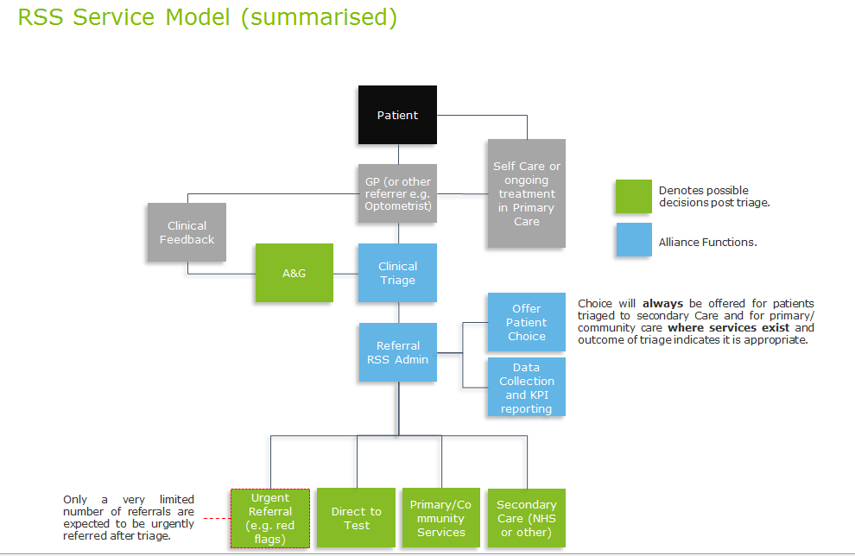

- This is an opportunity for ELR GP Federation to manage the provision of both the triage and treatment elements of the model.
- The Alliance will hold the contract; who could sub-contract to PCL / Federations.

- Next steps;
- Engagement with all key stakeholders, in particular GPs, to develop an efficient process.
- Finalise capacity plan for provision of triage and treatment in primary care.
- Implement Standard Operating Procedures and IM&T solutions.
- Finalise the financial model to ensure the service can:
- Adequately remunerate clinicians (GPSIs etc.) for providing triage and treat services.
- Ensure the Alliance is able to cover the overheads for the administration of the service.
- Ensure commissioners pay less than they would have done had patients been treated in secondary care.
- JW/RB to meet with Helen Mather to update on Demand Management work in ELRE and discuss next steps for RSS in ELR. Action JW / RB.
- JW to establish what skills / GPSIs there are in ELR. Action JW

- Diabetes nurse specialists
- The service is being Implemented with Latham House, with support from Diabetes Centre (Laura Willcocks)
- Three DSNs have been recruited; who continue to provide a valuable support to identified LLR practices.
- GC/JW to develop a clinical governance process to assure this scheme. Action JW / GC

- Rutland Patient App project (VitruCare)
- Three care homes and >90 patients have signed up to trial / use the product
- There has been a glitch with the system which has been resolved and will result in an extension to the contract. Action JW

- GP TeamNet
- All six Localities have agreed to join the GPTeamNet project utilizing Transformation Funds.
- The Federation has agreed a contract with Clarity Informatics on behalf of member practices.
- A project implementation team has been put in place which includes a lead from each Locality, JW and Kati Makepeace from Clarity Informatics
- 5 introductory workshops have been organized.

- H Pylori
- The majority of Practices have decided to provide an H Pylori service as a sub-contractor to the Federation.
- 13 practices submitted returns in Q2.

- Locum service
At the annual shareholders meeting it was suggested that a ‘Locum Agency’ solution would be well received by practices and could generate useful revenue for the Federation. Options include; Primary Care Exchange and GPTeamNet - JW will progress this. Action JW

- Teaching Academy
- Oakham, MOSS, Uppingham and Billesdon practices have decided not to proceed at this time
- The Federation is supporting the remaining practices to liaise with the Jubilee and South Leics Academies
- We will maintain contact with the Jubilee and South Leics Academy Leads to explore options for joint working. Action JW

- GDPR – DPO service
  - Some practices now need chasing to complete the self-survey. Action JW / JM
  - We held a workshop for all members in October 2018.

- Fracture Liaison Service (FLS) project
  - The proposal is to trial a locality based ‘fracture liaison service’ to help prevent further fractures in the identified risk group.
  - A draft business case was attached in the Board papers.
  - The Board confirmed that the business case should be submitted to the CCG for its consideration. Action GC / JW.

- Communications update
The Transformation Fund pilot scheme to develop hub level web portal, integrated with social media and e-marketing approaches with Rutland Healthcare is progressing well.

- Financial update

- FY18/19 budget forecast & draft budget for FY19/20– the Board reviewed the updated schedules – see Business Plan section of COO report above.

- Board issues
- Louise Ryan will be standing down from the Board but has agreed to serve a notice period to allow a replacement to be appointed.
- JM to publish an advert for Louise’s replacement. Action JM
- No applications have been received for the vacancy in the Blaby & Lutterworth Locality. A direct approach will be made to practices. If unsuccessful, the Board will consider co-opting someone onto the Board. Action JW / all.
- HP/JW are arranging for the shareholders who have left (Latham House, Kingsway, S Wigston & Oadby Central) to be removed. Action HP/JW
- HP to check the arrangements for removing Narborough Health Centre. Action HP

- Date & venue of next meetings
Thursday 10th January 2018 @ 7pm @ Syston Health Centre.
Action Log
Id | Detail | Who | Update | Status
1 | CQC registration | JW | JW spoken to CQC. We need a contract to trigger an application. | A
2 | Business Plan for FY19/20 | JW | To be drafted in Q4 | A
3 | Meet with Tim Sacks re projects / funding options | JW | Complete | G
4 | Fracture Liaison Service Biz Case | GC/JW | In hand | G
5 | Winter scheme returns / payments | HP | Completed | G
6 | Clarify £2/patient scheme with Tim Sacks | RB/JW | Completed | G
7 | NHSE Pharmacists scheme implementation | JW | Finalised the practices will take part. Portal updated, subject to PSS confirmation. Emailed NHS E to confirm next steps. | A
8 | Physio contracts | JW | Harborough and O&W complete. | G
 | Finalise Federation TF fee arrangements | JW | Complete | G
9 | Urgent care tender; complete with DHU | JW/GC/RB | Contract awarded. Implementation phase. | G
10 | Urgent Care;  - Follow up Localities / Practices  - Finalise sub-contract | JW  JW | In hand  In hand | G
11 | CBS contract – update accreditation and indemnity details | HP | In process | A
12 | Correspondence management implementation | JW | Review report complete. Next quarterly reviews scheduled. | G
13 | Clinical governance process for DSN project | GC/JW | Meeting held with Anne Scott. To be completed. | A
14 | GPTeamNet | JW | Contract signed. | G
15 | H Pylori contract | JW/GC | Implementation of sub-contracts | G
16 | Blaby & Lutterworth Board Director vacancy | JW | No response to the advert | R
17 | O&W Director recruitment | JW/JM | Advert placed. Two EOI. | G
18 | Meet with Helen Mather re RSS next steps | JW / RB | Complete | G
19 | Establish skills / GPSIs in LLR for RSS | JW | In hand | G
20 | DPO; chase practices to complete self-assessment & hold workshop | JM/JW | To be completed | A
21 | Wider involvement of practices | RB | Plan to be developed | A
22 | Complete Board / shareholder removals | HP | Complete | G
23 | Policy development | JW | To be developed | A
24 | VAT advice implementation | HP | Complete. | G
25 | Demand management identify Localities’ priority areas and feedback | RB/JW | Complete | G
26 | File 17/18 accounts | HP | In hand | G
27 | Locum service next steps | JW | TBC | A
28 | Complete FLS Business Case | JW / GC | In hand | G
29 | Determine approach for Narborough shares | HP/JW | TBD | A

