**Paper C**

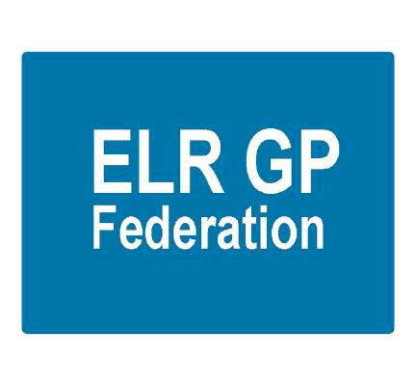

**ELR GP Federation Update**

**Primary Care Commissioning Committee**

**January 2019**

**“*Championing through GPs and their practices, investment and delivery of healthcare services at scale for patients across East Leicestershire and Rutland”***

# Contents

|  |  |  |
| --- | --- | --- |
|  |  | **Page** |
|  |  |  |
| 1 | Executive Summary | 3 |
| 2 | Introduction | 4 |
| 3 | Background and context | 4 |
| 4  4.1  4.2  4.3 | Progress update  Locality partnership working & transformation fund  Resilience & sustainability projects  Service delivery & business development projects | 5  5  7  9 |
| 5 | Mission, Vision, Values & strategic priorities | 10 |
| 6 | Finance & resources | 13 |

# Executive Summary

The pressure on general practice services is set to continue to increase as we live longer with more complex needs. With the support of ELR CCG, led by Tim Sacks, ELR GP Federation was created after extensive engagement with local GP practices and wider stakeholders with the explicit aim of supporting them to deliver sustainable primary care in East Leicestershire and Rutland (ELR) in the future.

Against this background the six Localities in ELR have developed during the last year; with Practices coming together to explore how they can work together more effectively, provide more care locally and find new ways of working that will make them stronger together; engaging with the Federation to support and facilitate this work. The Transformation Fund has been a key enabler in the Localities development; providing >£700K funding to support joint working schemes. The Federation has been instrumental in writing the funding applications and managing the implementation of many of the projects.

The recently published **NHS 10 Year Plan** emphasizes the development of Primary Care Networks (PCN) of local GP practices and community teams covering areas of 30-50,000 people and indicates new investment to fund expanded community multidisciplinary teams. The six Localities that the Federation has been helping to develop over the last year, provide the ideal foundation for the development of PCNs in ELR and this will be a key focus going forward.

FY18/19 has been a significant ‘break through’ year of progress and achievement for the Federation during which it has identified where best to add value; acting as a ‘change agent’; enabling and facilitating joint working, innovation and transformation between practices to address their sustainability and resilience challenges.

## There has been positive engagement with member practices who have increasingly sought help and support for their Federation. This has included securing income streams to support primary care development @ >£2M over the period FY16/17 to FY19/20 and identifying savings @ >£300K for the three year period April 2016 to March 2019 through its purchasing scheme.

A key success has been forming a Joint Venture (JV) with DHU and successfully bidding for the ELR Urgent Care Centres contract which starts in April 2019. We will build on this success and seek to secure further contracts using the JV vehicle.

The Federation’s strategic priority areas remain;

1. Supporting practices to achieve resilience and sustainability - specifically through PCN development;
2. Service delivery and business development - securing new contracts;
3. Being an effective voice for member practices.

Funding received during FY18/19 and the Urgent Care contract will sustain the Federation’s operations into the first part of FY19/20. However, further income is required and discussions are ongoing with the CCG to identify work streams that could bring further funding. The Federation will work to identify further funding streams to secure its ongoing operation.

**2.** **Introduction**

The pressure on general practice services is set to continue to increase as we live longer with more complex needs. All 30 practices in ELR continue to face sustainability challenges, as they seek to provide excellent NHS primary care services for their communities in an increasingly difficult operating environment.

Consequently, practices need to work together to provide services ‘at scale’, as appropriate to the problem that needs solving, to realise the benefits of economies of scale, improve opportunities for career structures and professional support and deliver a wider range of services.

With the support of ELR CCG, led by Tim Sacks, ELR GP Federation (hereafter ‘the Federation’) was created after extensive engagement with local GP practices and wider stakeholders with the explicit aim of supporting them to deliver sustainable primary care in East Leicestershire and Rutland (ELR) in the future.

This document has been prepared to provide the PCCC with;

1. An update on the progress of the Federation in developing and supporting its member practices to realise the benefits of working at scale
2. Outline the Federation’s strategic priorities for the future and financial resource requirements to deliver this agenda

# 3. Background and context

The LLR Blueprint for General Practice set out a vision for practices to come together either formally or informally to meet patients’ needs at scale. By working together practices will deliver improved efficiency and make more effective use of existing resources to ensure that practices are sustainable in the long term. The Federation has been and will continue to be instrumental in supporting the development and delivery of new joint working models to enable sustainable General Practice in ELR.

By working together more effectively, practices are able to transform the way primary care is delivered, test new models with new roles and contribute to the provision of place-based integrated community and primary care.

Against this background the six Localities in ELR have developed during the last year; with Practices coming together to explore how they can work together more effectively, provide more care locally and find new ways of working that will make them stronger together; engaging with the Federation to support and facilitate this work.

The recently published **NHS 10 Year Plan** emphasizes the development of Primary Care Networks (PCN) of local GP practices and community teams and indicates new investment to fund expanded community multidisciplinary teams aligned with new PCNs based on neighbouring GP practices working together typically covering 30-50,000 people. This will include developing network contracts for specific services, as an extension of current GP contracts. There is also the potential for ‘shared savings’ schemes which would enable PCNs to benefit from actions to reduce avoidable A&E attendances, admissions and delayed discharge, streamlining patient pathways to reduce avoidable outpatient visits and overmedication through pharmacist review.

The six Localities that the Federation has been helping to develop over the last year, provide the ideal foundation for the development of PCNs in ELR.

**4. Progress update**

The Federation has made significant progress over the last year, establishing itself as;

* A ‘change agent’; facilitating and leading joint working, innovation and transformation
* Supporting the development of the six Locality Hubs
* A key player / partner in mutual shaping the place based agenda
* A service provider on behalf of its members; Increasing number of contracts it holds
* A key voice / provider and facilitator of Locality partnership working
* Providing a more integrated role in supporting GP resilience
* Securing funding / savings for primary care projects @ **>£2 million** (see table 1 below)

**4.1 Locality partnership working & Transformation Fund projects**

A key achievement of the Federation over the last year has been its work to support the development of the six Locality hubs and facilitate and support the development and implementation of their transformation projects.

As part of its commitment to strengthening general practice and supporting the sustainable transformation of primary care, NHS E provided a fund to support the development of transformation plans. ELR CCG therefore invited applications from its six Locality groupings for joint working transformation proposals between practices.

The Federation worked with practices in each of the six Localities who decided to form informal networks, Partnership Hubs, to help address the challenges that they face and realise the potential benefits of joint working which include;

* Greater sustainability; securing the services for patients in the respective geographies
* Ability to offer a wider range of services and greater specialization
* Sharing staff and expertise and building the MDT
* Creating attractive, flexible and diverse career, training and employment opportunities
* Standardising administration processes & streamline back office support functions
* Develop / pilot new models of care to provide closer integration between community and primary healthcare providers.
* Create a larger organisation with influence in the local healthcare economy
* Create a more secure platform to support extended primary care / in-hours access

The Federation worked with each of the Locality Partnership Hubs to develop their Transformation Fund plans and applications which were all successfully approved; securing **>£700K of additional funding** to invest in the development of primary care in ELR. The projects have had a range of positive benefits, including;

* + Improving access for patients
  + Reduce GP workload
  + Wider range of services and greater specialization
  + Flexible career, training and employment options
  + Improved care navigation
  + New merged practices – creating more sustainable primary care organisations
  + Integration with community services
  + Streamlining back office functions

The Federation was asked by all Localities to support the implementation of their Transformation Plans, to a greater or lesser extent. Key involvement and successes are outlined below;

1. Project managed the implementation of two 6 month First Contact Physiotherapist pilots in Harborough and Oadby & Wigston; providing Band 7 Physiotherapists to improve access for patients with MSK related conditions and releasing GP time in all 12 practices across these two Localities. The Federation has organized the contracts with a specialist provider which it holds on behalf of the practices.

The two Localities decided on different approaches to sharing the Physiotherapy resources. The Federation is working closely with both Localities to ensure the optimum approach, sharing the learning between the two schemes.

1. Project managed the implementation of a six month pilot Emergency Care Practitioner service between three practices in SLAM to improve access for patients and release GP time; organizing and holding the contract with the provider.
2. The Federation was asked by the South Wigston and Oadby Central practices to facilitate the merger of their respective practices to form Washbrook Medial Group. This has created a new partnership of 17,000 patients which is a more sustainable primary care organization in the Locality.
3. The Federation was asked by the Two Shires and Kibworth practices to facilitate and advise on their merger which is due to complete in April 2019. We have worked closely with the respective teams to develop a robust project plan to ensure effective delivery of the wide ranging issues that need addressing to complete a successful merger.
4. Managed a MDT team in Oadby & Wigston to develop an Active Signposting training event that was attended by all practices and representatives from social care and First Contact Plus to provide the teams with the information and tools to signpost patients to the most appropriate service and release the GPs time to care.
5. Providing programme management support to the Rutland Transformation Steering Group to implement its transformation fund projects. These projects are being dovetailed with the Locality’s other transformation activity and Primary Care Home development.

The Federation is also providing programme management support to four other Locality Hubs (Harborough, O&W, North Blaby and SLAM) to ensure delivery of their respective transformation fund projects.

1. Identified a tool, GPTeamNet, to facilitate joint working between practices and Localities and enable the sharing of information between stakeholders in the ELR health community. All 30 practices decided to join the GPTeamNet trial; the Federation has organized the contract on behalf of all of its member practices. This also provides effective tools to help practices manage their services, linking to CQC standards and enabling GPs to manage their personal portfolios effectively.
2. Project managing the development of a joint frailty service in the North Blaby hub; building on the success of the Locality’s para-medical model.

**4.2 Resilience and sustainability projects**

* **Tool kit for Practices wishing to work at scale** - led a project that produced a toolkit for practices who wish to look further at working at scale, providing practical tools to implement joint working schemes in the following areas;
  + - Joint working between practices
    - Hub development
    - Mergers between practices
    - Opportunities for working with Federations
    - Multispecialty Community Provider (MCP) new care model
    - Primary Care Home model
* **Diabetes transformation project** - The LLR STP was awarded transformation funding for Diabetes treatment and prevention; helping Practices to improve the achievement of the NICE recommended treatment targets, and to help reduce the variation in achievement across general practice in LLR.

In partnership with Latham House Medical Practice, the Federation was awarded the contract to work with the Leicester Diabetes Centre to introduce a Diabetes Specialist Nurses scheme to support LLR practices identified as needing assistance with diabetes and blood pressure management. Three DSNs have been recruited who are making a positive impact in the practices that they are supporting.

* **Correspondence management** – secured NHS E funding to support seven practices to form one of the LLR pilot sites to develop a safe and effective approach to managing correspondence and reduce the workload for GPs. Good progress has been made, releasing >500 hours of GP time.
* **Demand management** – the Federation is working with its Localities and practices to review performance data on a regular basis, indentify key areas of variation and focus on key areas for further investigation. Performance monitoring reports have been developed for all 6 Localities which enable comparison between practices and identify key themes for discussion and further investigation to improve referrals performance. These reports have been well received and will be produced on a regular basis to facilitate ongoing joint working to share best practice, identify training needs and service development opportunities, which will have a positive impact on referrals.

Using these reports some practices have made local changes that have made observable improvements in referral performance. Furthermore, the indications are that referrals increase will be in line with the CCG ‘target’ @ 1% for FY18/19.

* **Patient self-care app** – secured Better Care Funding in Rutland to develop a patient care app (VitruCare) to support patients to take control of their own health and wellbeing. The Federation is holding the contract on behalf of the four practices.
* **Data Protection Officer service** – in response to requests from our member practices, we established the ELR GDPR DPO Service, providing:
* the DPO function from an experienced and suitable qualified expert;
* access to a self-assessment toolkit to enable self- assessment and review by the DPO of current level of GDPR readiness;
* initial review by the DPO of that self-assessment with comments or advice;
* an e-mail first point of contact for data protection issues questions – (dpo@elrgpfed. com);
* Ask the DPO question and comment form;
* GDPR FAQs;
* sample html code to use as a GDPR page for practice websites; and
* a library of GDPR Further Reading resources.
* **Purchase Direct** – a purchasing scheme that achieves savings for practices (> £300K identified over a three year period).

## The Rutland Health and Care Portal has now been completed – this has created a live HUB - delivering live information / advice created by national, NHS, GP Practices, Federation, RCC, and voluntary sector all in one place. This also provides the infrastructure to support Self-care and Active Signposting - supporting key Campaigns and Initiatives.

**4.3 Service delivery and business development projects**

* **Clinical Pharmacists in General Practice -** The Federation worked with a number of practices to secure agreement from the NHS England “Clinical Pharmacists in General Practice” scheme to support the recruitment of 3 clinical pharmacists to work in general practice in patient facing roles.
* **Community Based Services –** awarded a contract by Leicestershire County Council to provide public health community based services (Health Checks, contraception and alcohol reduction). These services are being provided through sub-contracting member practices.
* **Improving Access to General Practice** – awarded a contract to deliver additional urgent on the day appointments over the winter period. The majority of our practices took part; delivering over 5,000 additional appointments.
* **H Pylori breath test –** awarded a contract to deliver the H-Pylori breath test service in ELR. The majority of our practices have agreed to provide this on a sub-contract basis.
* **Urgent Care Centres –** the DHU / ELR GP Federation Joint Venture was recently awarded the contract to provide six out-of-hours urgent care centres in ELR from April 2019.

In summary, over the period between FY16/17 to FY19/20 these various projects and schemes have secured funding / savings @ >£ 2 million as outlined in Table 1 below.

**Table 1 – ELR GP Federation income and costs saving scheme for FY16/17 to FY19/20**



# 5. Mission, Vision, Values & Strategic Priorities

The Federation’s mission, vision and values echo the LLR Blueprint for General Practice document and specifically support the development of the six Locality Hubs to create sustainable Primary Care Networks (PCNs) and primary care services across the ELR CCG area.

**Key principles;**

* *The extent to which working at scale is sensible depends on the problem or challenge that needs addressing, and so;*
* *The Federation has and will continue to enable and facilitate joint working, as appropriate, to address the sustainability and resilience challenges that members face.*

**Mission**

*“To champion through GPs and their practices, investment and delivery of healthcare services at scale for patients across East Leicestershire and Rutland”*

**Vision**

*“To remain a GP-led, patient centred organisation, working collaboratively with our partners across health, social and community care to facilitate an enhanced delivery of high quality, innovative and responsive services across East Leicestershire and Rutland”*

**Values**

* ***Patient Centred*** *– ensuring that the needs of patients are at the heart of everything we do*
* ***Local and Accessible*** *– striving to deliver our services where and when our patients need the service*
* ***Efficient and Effective*** *– providing high quality healthcare*
* ***Open and Transparent*** *– in all that we do*
* ***Collaborative and Accountable*** *– working effectively with all stakeholders to meet the needs of our members and their patients*

**Strategic Priority areas**

1. **Service delivery & business development;** [**SERVICE CONTRACTS]**

* Facilitate the delivery of more services locally
* Expanding non-core primary care services
* Bid collectively and / or hold contracts
* Build on Joint Venture with DHU
* Collaborate with health and social care partners and commissioners to deliver more planned care locally at scale

1. **Resilience and sustainability; [FACILITATION / CONSULTANCY]**

* Key ‘change agent’; supporting / leading the development of Primary Care Networks
* Provide the tools to enable collaborative working between practices
* Key enabler in the integration of care pathways across health and social care boundaries
* Support members to enhance the resilience of their practices to deliver sustainable primary care services.
* Share best practice and harmonise policies and processes
* Work with members to **innovate and transform** the way that services are delivered to address challenges
* Seek opportunities to transform the delivery of effective and focused healthcare and, where appropriate, redesign pathways
* Provide clinical and back office services at scale

1. **Effective voice -** for our members across ELR when engaging with CCGs, Trusts, social care, and the voluntary sector

**Federation structure and approach**

ELR GP Federation Ltd is a company limited by shares, with each of ELR’s 30 GP practices being its shareholders who elect the company’s Board of Directors. This legal form and scale enables the Federation to support wide scale service transformation and bid for and hold contracts for clinical services.

There are six Directors on the Board who represent the Locality structure;

* Dr Rysz Bietzk (Chair), MRH Locality
* Dr Gareth Chidlow, MRH Locality
* Ms Kirsty Whawell, MRH Locality
* Dr Nainesh Chotai, B&L Locality
* Dr Louise Ryan, O&W Locality (due to be replaced by Mr Robert Whitehead)
* Vacancy, B&L Locality

To deliver its strategic objectives in supporting member practices to work together to ensure future sustainability, the Federation has adopted the structure and approach outlined below;

**ELR GP Federation’s operating structure**

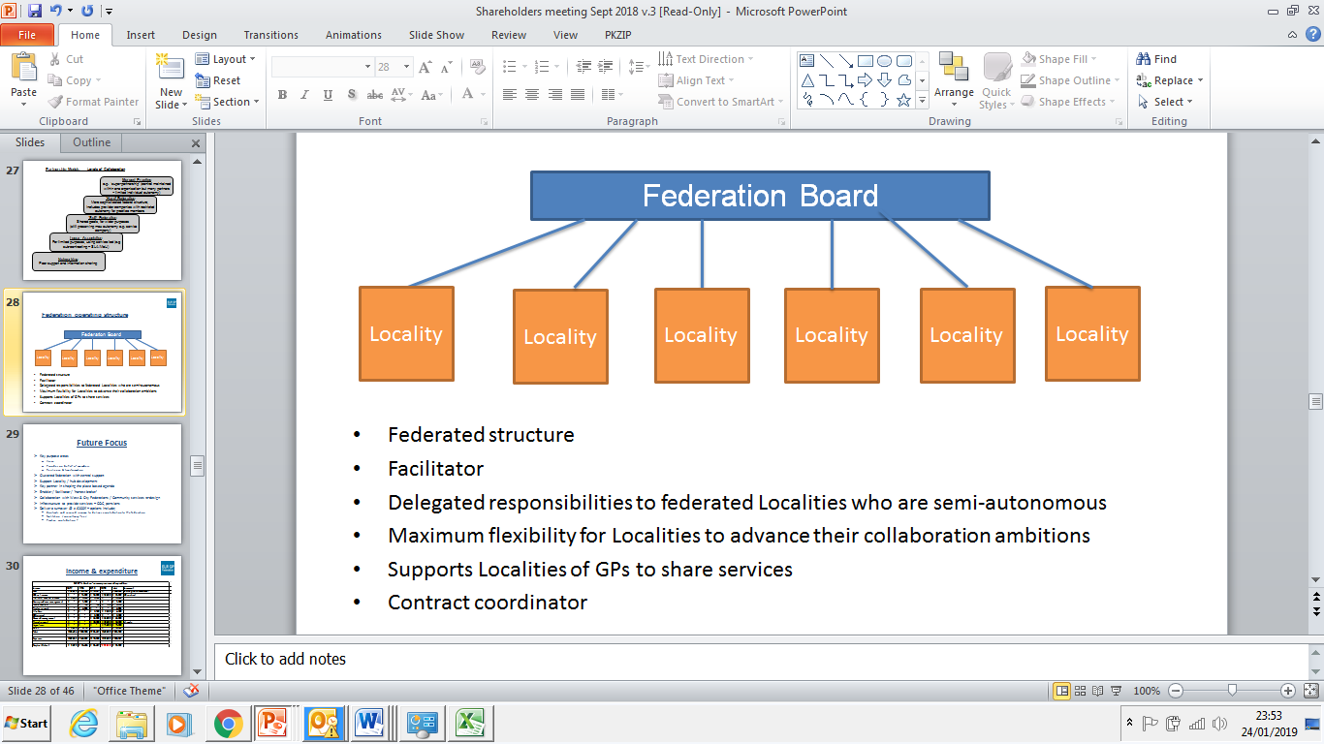

* Act as a ‘change agent’, enabling and facilitating Locality Hub (PCN) joint working, innovation and transformation
* Support doing things differently where it makes sense to do so
* Locality based federation with central support
* Hybrid Federation structure (see figure below), to support the 6 locality hubs
* Maximum flexibility for locality hubs to advance their collaboration ambitions
* Support the locality hub based clusters of GPs who share services
* Bid for and hold contracts for services, where helpful
  + Be a key player / partner in mutually shaping the PCN agenda

**Future Focus**

* Support PCN development
* Key partner in shaping the place based agenda

## ‘Change agent’ - facilitating joint working, innovation and transformation between practices

## Develop products / solutions to support practices working together, eg, buildings management, Locum service, HR, employ specialist / back office staff

* Develop the Federation’s infrastructure to provide services – CQC, pensions
* Secure further contracts and associated income, including engaging with the Alliance to support the emerging ‘Referral Support Service’
* Work with the CCG to provide services, including Demand Management
* Support practices in procuring services, eg ,INR support

## 6. Finance and resources

The Federation’s income and expenditure profile for the four year period April 2016 to March 2020 is summarized in table 2 below.

**Table 2 – Income and expenditure summary**



## Notes;

## The profile for FY18/19 is a forecast position, which may be improved upon

## The profile for FY19/20 is an estimated forecast

## The Federation will register for VAT, which will impact future projections

## The CCG projects income requires further discussion and agreement with the CCG

## We will continue to work to improve this forecast position

FY18/19 was a key year as the six Localities bedded down and the transformation schemes were implemented.

Securing the Urgent Care contract in partnership with DHU will provide an important income stream in FY19/20 and the potential to add further contracts.

The Federation has been able to build a small reserve in FY18/19 by supporting the implementation of Transformation Fund projects which will help to sustain the Federation.

However, there remains a projected shortfall in income for the FY19/20. The Federation is talking to the CCG about potential projects / service provision for the forthcoming financial year. The indications are that the Demand Management scheme has had a positive impact on referral performance in FY18/19 and we hope that this scheme will be extended into FY19/20.

The Federation will continue to play a key role in supporting and facilitating transformation activity and securing further income streams. Areas of focus will include;

* Further ‘left-shift’ work in conjunction with LLR PCL Ltd / Alliance
* Taking a lead in the demand management work in conjunction with Localities
* Securing ongoing delivery of Community Based Services public health contracts
* Implementing ongoing transformation schemes, where appropriate
* Work with the CCG to identify further contracts
* Development of ‘back office’ schemes with members, eg, buildings management
* Seek further opportunities for the JV with DHU
* Continued scrutiny the Federation’s running costs