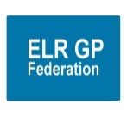
NOTICE OF A GENERAL MEETING

The general meeting of ELR GP Fed Ltd, its offices registered at 111 Station Road, Glenfield, LE3 8GS, with registered company number 09927787 shall take place on:-
Wednesday 22nd May 2019 at 7pm at Syston Health Centre, Melton Road, Syston, LE7 2EQ

ORDINARY BUSINESS
1. Plan to defer the election of Directors

SPECIAL RESOLUTIONS
1. Approve the resolution for ELR GP Fed Ltd to form a Joint Venture with DHU, as outlined in the attached paper.

By order of the Board
…………………………………………………….
Secretary
17th April 2019
……………………………………………………
Date

