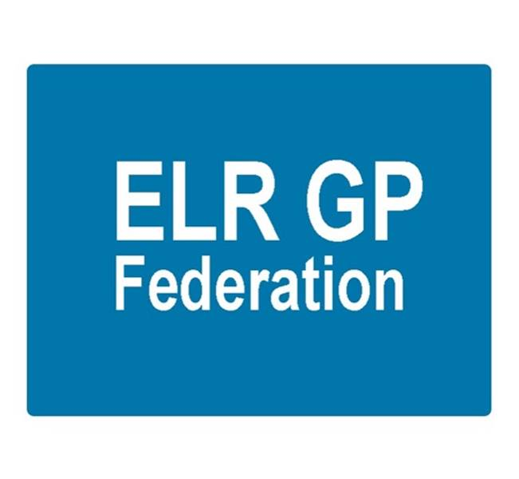

Board meeting
7.30pm 22nd May 2019 @ Syston Medical Centre
AGENDA

 |  | Paper
 | Apologies
 | Review of Minutes of the Meeting held on 24th April 2019 | A
 | Matters arising
 | Report from the COO  - PCN development | B
 | Localities update
 | Financial update  - FY18/19  - FY 19/20 Forward cash flow  - VAT | To be tabled  To be tabled  C
Board issues
- Removing shareholders / Narborough
- Deferring election
 | Communications update
 | Conflicts of Interest register
 | AOB
 | Date & venue of next meeting

