ELR GP Federation Ltd

Minutes of the meeting of The Board of Directors

Wednesday 24th April 2019 – Syston Medical Centre

**Present**: Dr R Bietzk (chair), Dr G Chidlow, J McCrea, J Watkins, Dr N Chotai, R Whitehead, Dr L Ryan, H Patel

1. **Apologies** – K Whawell
2. **Declarations of interest**

Robert Whitehead – along with The Croft Medical Centre; Bushloe Surgery have been awarded a contract to provide the GPs for Oadby Urgent Care Centre during core hours, Monday to Friday.

1. **Urgent Care / extended primary care**

* Simon Harris introduced Steve Atkinson who will be the Independent Chair of the Joint Venture Board.
* It was confirmed that there will be three Directors from DHU and three from the Federation. One Director from each organization will need to be present for the Board meetings to be quorate.
* JW, Peter Quinn, Simon Harris and LMC Law will meet to finalise the JV agreement. ***Action JW***
* A Federation General Meeting will be held on 22nd May 2019 to secure the agreement of Shareholders to form a Joint Venture with DHU. JW will coordinate the completion of Proxy voting arrangements, where necessary. ***Action JW***
* Bushloe & Croft Practices have finalized an agreement to act as sub-contractors to provide the GPs in core hours at the Oadby UCC.
* The pilot to implement the ‘UCC booking pathway’; whereby Practices will make slots available for UCC to book directly into has started.
* Simon Harris updated on progress in the first three weeks;
  + 3,000 patients
  + 50/50 walk-in to pre-booked
  + Enderby IT connection needs improving
  + There has been some misunderstanding / suggestion from patients that they have not been able to walk-in, where they have been asked to book-in.
  + The contract is yet to be signed – Simon Harris is working with the CCG to resolve the outstanding issues that relate to a minor spec change and finalizing FMT issues

1. **Minutes of the meeting held on 21st March 2019**

Approved as an accurate record.

1. **Matters arising** – dealt with under the agenda headings.
2. **COO Report**
3. **Localities & transformation fund update**

* The Federation has organised the following contracts on behalf of practices to support the transformation projects utilising the funds that have been granted by ELR CCG.

|  |  |  |  |
| --- | --- | --- | --- |
| **Locality** | **Contractor** | **Project** | **Duration** |
| Harborough | Jamie Bell Physiotherapy Ltd | First Contact Physio | 7 months |
| O&W | Jamie Bell Physiotherapy Ltd | First Contact Physio | 6 months |
| SLAM | DHU | ECP | 6 months |
| All | Clarity Informatics | GPTeamNet | 12 months |
| Rutland | DHU | ECP (to be finalised) | 3 months |

* Harborough have decided to extend their pilot until March 2020. The Federation is coordinating the setting up of a new contract that will be held by the Practices.
* OWI are reviewing their options and will decide on next steps at their April Locality meeting.
* The Rutland ECP pilot has started and will run for three months during Q1.
* LHMP are considering joining the SLAM pilot in Q1.
* The Federation will coordinate the Q4 update reports which will be reviewed at the final CCG panel in May 2019. This will include an overall summary of the achievements of the TF projects and a comparison of similar projects, as appropriate.

1. **Primary Care Networks**

* The Federation has developed a proposal to support the Localities to develop as PCNs – see **appendix 1.**
* JW to develop a fee structure to support this proposal. ***Action JW***
* The proposal that the new ACDs should be co-opted onto the Board to provide a forum for collaboration and driving the agenda of the Federation was endorsed by the Board.
* The Federation is running the OWI ACD recruitment process; fee @ £500 – which will be absorbed into the overall support fee if they decide to opt for a more extensive support package.
* The Federation will also be supporting the North Blaby and Rutland ACD recruitment processes.
* The Board agreed that Dr Noel O’Kelly (Clinical Director, LPT) and Jude Smith will be invited to attend a future Federation Board meeting. ***Action JW***

1. **Business plan for FY19/20**

* JW presented a business plan summary – **see appendix 2**
* A key challenge will be to agree with the PCNs to utilise a proportion of their budget to fund Federation support.
* The plan for long term sustainability beyond the end of FY19/20 needs to be developed.

1. **NHS England; Clinical pharmacists in general practice Project**

* We are working with LMC Law to finalise a contract/SLA between PSS and the Practices. ***Action JW***
* PSS have advised a start date in June 2019.
* We are arranging for the Lead Practices to complete the Enhanced Service Agreement with NHS E. ***Action JW***

1. **Community Based Services**

* Leicestershire CC has written to confirm that our contract will be extended into the third year; JW to confirm with the sub-contracting Practices. ***Action JW***
* LMC Law have provided advice regarding the new indemnity arrangements – see below;

*Dear James,  
  
Apologies for the delay.  
  
I have looked at the guidance and the scheme details and the advice contained within your email.  
  
As far as the guidance goes relating to the CNSGP - organisations are covered if they provide primary medical services where those have been commissioned by a provider whose main function is to provide/commission those services.  
  
My reading of this is that as a federation, if you are commissioned to provide primary medical services under a core contract then you are covered. If you are commissioned by a local authority for the provision of public health services, then you are also covered. If you fall into those categories you are treated as a part 4 contractor and therefore, the GPs you sub-contract to are also covered.  
  
Not all federations will fall under a Part 4 contractor so that may mean any sub-contractors are not covered under the CNSGP.  
  
The same rules would apply I believe in terms of a federation holding a Network DES - as long as they are providing in hours primary care services then they are entitled to hold the DES.  
  
The rules are still a little unclear, but with all guidance and information out there at present, this seems to be the clearest scenario.  
  
Shanee*

* HP is confirming with our sub-contracting practices their schedule of fitters and their evidence to practice and indemnity certificates. ***Action HP***

1. **Correspondence management**

* We will arrange a workshop for both the admin staff and GPs for Practices to provide an update on their progress and enable the sharing of best practice. ***Action JW***

1. **Demand Management**

* Rysz has met with Mids & Lancs CSU to review the Intelligence packs
* RB will develop reports for each Locality – identifying key trends and areas for further investigation / training / service development.
* Funding needs to be identified from PCNs.  ***Action JW***

1. **Referral support service (RSS)**

* Expressions of interest have been sought for MSK Triage & ENT.
* Meeting arranged with Danah Cadman to progress. ***Action JW***

1. **Diabetes nurse specialists**

* Additional funding has been identified to extend the project into FY19/20.
* A planning session will take place in May 2019 to determine how this project will be extended.
* We need to agree an extension with LHMP. ***Action JW***
* JW needs to write up a clinical governance process to assure this scheme for Board consideration. ***Action JW***

1. **Rutland Patient App project (VitruCare)**

* JW / RB have advised Dynamic Healthcare Systems that the Federation will not renew the contract for a second year when it comes up for renewal at the end of April 2019.

1. **GP TeamNet**

* Implementation is progressing well overall.
* The majority of Practices have started to implement the tool within their Practices.
* Each Locality has a portal which will help with PCN development.
* ‘Hot topic’ webinars and support workshops have been held to help Practices implement the system.
* The two-factor login arrangements are being developed which will enable the CCG to use the tool.
* A webinar has been held with LCC Public Health.
* DHU have bought licenses. JW to follow up how this could be used. ***Action JW***
* The order has been raised for Year 2 for Five Localities plus SLMG.

1. **H Pylori**

* All bar three Practices have decided to provide an H Pylori service as a sub-contractor to the Federation.
* We have received verbal confirmation that the contract will be rolled forward into FY19/20; we await written confirmation. ***Action JW***

1. **Locum service**

* GP TeamNet has functionality that could support internal ‘bank’ working; which will be investigated further.

1. **GDPR – DPO service**

* JW to follow up the potential role of the CCG with Sharon Rose. ***Action JW***
* JW to liaise with JM to put arrangements in place to roll forward the DPO service, subject to consulting with the CCG. ***Action JW/JM***

1. **Fracture Liaison Service (FLS) project**

* Public Health and the Alliance Leadership Board have supported the proposal
* GC / JW to follow up questions/issues raised by the CCG and update the Business Case accordingly. ***Action GC/JW***

1. **INR STAR**

* The contract with LumiraDX on behalf of all, bar one, of the member Practices has been finalised.
* The CCG will pay for the final two weeks on March 2019.

1. **Second blood collection**

* The three CCGs are considering whether to institute a second blood collection – we await an update.

1. **Active signposting**

* ELR CCG has asked the Federation to coordinate a pilot within 1/2 Localities to support practices with Active Signposting
* The first session with the OWI and Rutland Practices will took place on 20th March 2019 and was successful.
* A further two sessions will be planned over the next six months.  ***Action JW***

1. **Diagnostic hubs**

* JW met with Helen Mather and Simon Carr who are developing a Business Case to develop diagnostic hubs in primary care.
* JW will work with Simon Carr to develop the ELR element of this proposal for consideration by PCNs / Practices. ***Action JW***
* LR will follow up with Sarah Smith. ***Action LR***

1. **Finance**

* The budget forecast reports (**Appendices 3 & 4**) were reviewed by the Board – the key issue is ensuring that we agree with the PCNs to allocate some of their PCN budget in return for Federation set-up support.
* HP has registered the Federation for VAT and a formal response is awaited. ***Action HP***
* The Board confirmed its approval that JW receive the budgeted pension allocation as additional salary – adjusted to ensure that the overall cost to the Federation is within the allocated budget.
* JW/HP requested that Robert Whitehead review the Federation’s financial management arrangements and make recommendations, as appropriate. RW has agreed to conduct this review and the Board approved this approach. ***Action RW***

1. **Board issues**

* HP to check the arrangements for removing Narborough Health Centre. ***Action HP*/JW**
* The Board resolved that the election of the Directors who are due to retire by rotation in May 2019 should be deferred until the autumn of 2019 to enable the appointment of the PCN ACDs to be completed and pursue the option of them becoming Federation Board Directors. This resolution would be put to the Shareholders at the General Meeting on 22nd May 2019. ***Action JW***
* This was Nainesh Chotai’s last meeting and the Board sincerely thanked Nainesh for his service to the Board. Nainesh offered to attend Board meetings at the invitation of the Board during the period of transition.
* Re-constituting the Federation as a CIC will not change the VAT position. This idea will be put on hold.

1. **Date & venue of next meeting**

Wednesday 22nd May 2019 @ 7pm @ Syston Health Centre – to include a General Meeting to deal with the DHU Joint Venture formation and the proposal to defer the retirement of Directors.

**Action Log**

|  |  |  |  |  |
| --- | --- | --- | --- | --- |
| **Id** | **Detail** | **Who** | **Update** | **Status** |
| 1 | CQC registration | JW | JW spoken to CQC. We need a contract to trigger an application. | G |
| 2 | Business Plan for FY19/20 | JW | Summary complete | G |
| 3 | Fracture Liaison Service Biz Case | GC/JW | Follow-up information requests following CCG meeting | G |
| 4 | NHSE Pharmacists scheme implementation | JW | Finalised the practices will take part. Portal updated. NHS E have confirmed funding. 2WTE pharmacists recruited to start in June 19. SLA/ contract prepared. | G |
| 5 | Finalise Federation TF fee arrangements | JW | In hand | G |
| 6 | Urgent Care;   * Follow up Localities / Practices * Finalise JV legals * Organise for resolution of shareholders | JW  JW  JW | Complete  In hand  In hand | G |
| 7 | CBS contract –   * Update accreditation and indemnity details * Comms to Practices * Indemnity arrangements | HP  JW  JW | In process  To complete  Complete | A |
| 8 | Correspondence management workshop | JW | In hand. | G |
| 9 | Clinical governance process for DSN project | GC/JW | Gareth advised on the approach. To be completed. | A |
| 10 | GPTeamNet – Y2 quote / implementation | JW | Contract signed. Quote obtained for Y2. | G |
| 11 | H Pylori contract – check FY19/20 | JW/GC | Verbal confirmation that the contract will be rolled forward. | G |
| 12 | Establish skills / GPSIs in LLR for RSS | JW | In hand | G |
| 13 | DPO; chase practices and determine the approach for FY19/20 | JM/JW | In hand | G |
| 14 | Wider involvement of practices | RB | Plan to involve / co-opt the ACDs | A |
| 15 | Complete Board / shareholder removals | HP | Uppingham/Kingsway/Severn/MHMP to be completed. | A |
| 16 | Investigate the option of becoming a CIC | JW | In hand | G |
| 17 | Policy development | JW | To be developed, as required. | A |
| 18 | VAT registration | HP | Registration submitted. | G |
| 19 | Demand management identify next steps and funding for FY19/20 | RB/JW | In hand | G |
| 20 | Locum service next steps | JW | Lantum demo. Investigating GPTeamNet | A |
| 21 | Diagnostic hubs proposal | JW / LR | Follow up with Simon Carr / Sarah Smith | A |
| 22 | Determine approach for Narborough shares | HP/JW | TBD | A |
| 23 | Rutland ECP pilot | RB / JW | Q1 pilot commenced | G |
| 24 | RSS – preparations | JW | Meeting arranged with Danah Cadman – complete. | G |
| 25 | INR – obtain quotes & implement | JW / KW |  | G |
| 26 | PCN development – proposal to support Localities | JW | In hand | G |
| 27 | Invite Noel O’Kelly and Jude Smith | JW | In hand | G |
| 28 | Organise follow-up Active Signposting workshops | JW | In hand | G |
| 29 | Review financial management | RW | List to be developed | A |
|  |  |  |  |  |
|  | **Archived Actions** |  |  |  |
|  | Follow-up meeting with Tim Sacks re projects / funding options | JW / RB | Complete | G |
|  | Blaby & Lutterworth Board Director vacancy | JW | No response to the advert. Dr Louise Ryan co-opted. | G |
|  | O&W Director recruitment | JW/JM | Robert Whitehead appointed. | G |
|  | Cancel VitruCare contract | JW/RB | Complete | G |
|  | Physio contracts | JW | Harborough and O&W complete. | G |

**Appendix 1 – ELR GP Federation Business Plan Summary**

**Where are we now?**

* ‘Change agent’; Practices have been grateful for the objective facilitation support that has been provided for joint working / Transformation Fund projects
* Project management / management consultancy type support
* Hold a number of contracts on behalf of Practices
* Urgent care provider, in partnership with DHU
* We are a ‘dot joiner’
* A key player & partner in shaping place based integrated working

**Where do we want to be?**

* **Local service delivery & business development -** facilitating the delivery of more services locally; bidding collectively and / or holding contracts where it is helpful to do so
* **Resilience and sustainability –** innovating and transforming the way that services are delivered to address the pressures currently faced in the local health care system
* **Effective voice -** for our members across ELR

**Figure 1 – Structure of PCNs and Federation**

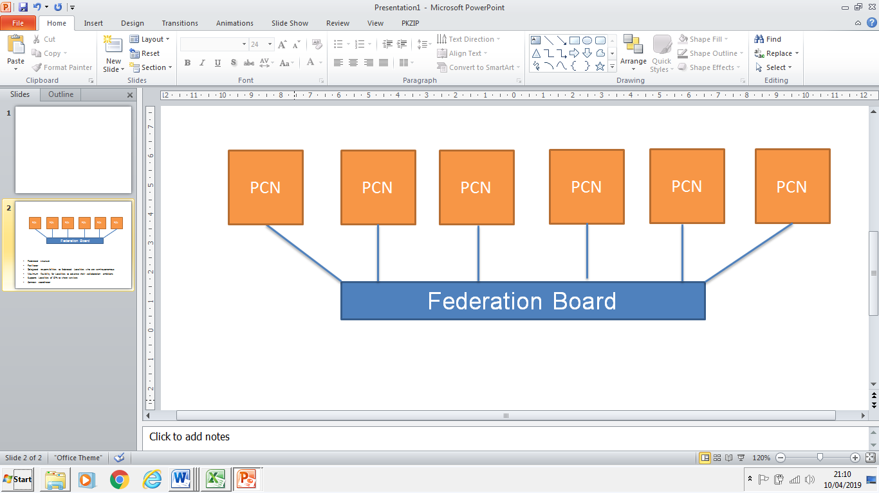

* Locality / PCN development
* Merger support
* Demand management
* Referral hubs
* ELR wide project support – bids & implementation
* Urgent care provider
* Back office support provider

**How do we get there / funding?**

* Key income streams will be;
* PCN development (incl demand management) @ c£60K to 80K **(TBC/negotiated with PCNs)**
* Urgent Care (DHU) @ c£50K
* H Pylori, CBS, GDPR @ £10-£15K
* TF funds c/fwd @ £40 - 50K (TBC)

***Note;*** *all these numbers are quoted before the impact of VAT*

**Appendix 2**

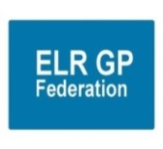**ELR Primary Care Networks – ELR GP Federation role and support – a proposal / ‘think piece’**

1. **The context**
2. Practices in ELR are in the process of forming Primary Care Networks (PCN), in line with the National Network Contract DES.
3. Whilst PCNs will have the freedom to organise themselves in line with their local context; there will be a range of areas where it will make sense for PCNs to operate within a sensible, strategic framework; providing consistency between PCNs and avoid ‘inventing the wheel’ several times.
4. It is important that the voice of primary care is clearly articulated at the CCG and wider LLR STP level. For this to be effective there will need to be a level of consistency with PCNs ‘pulling in the same direction’.
5. Local NHS organisations will increasingly focus on population health and local partnerships with local authority-funded services through development of Integrated Care Systems (ICS). PCNs will be a key part in the formation and delivery of these services and, as such, ‘integrated PCNs’ will be stronger and provide a more coherent voice within this system.
6. There will continue to be a range of issues where it makes sense to organise and/or hold contracts at the ‘30 practice level’.
7. As such, it will be important that PCNs within ELR have a forum to ‘compare notes’ and organise at a ’30 practice level’ where it makes sense to do so.
8. Managing a network does not necessarily require forming a new legal entity.
9. **A proposal**
10. Utilise ELR GP Federation, an organisation that the 30 Practices have created and remain as shareholders, to support PCN development and provide a forum for them to work together **(see Figure 1)**; building on the Federation’s 'transformation' and 'sustainability' strategic priorities.

* **Local service delivery & business development -** facilitating the delivery of more services locally; bidding collectively and / or holding contracts where it is helpful to do so
* **Resilience and sustainability –** innovating and transforming the way that services are delivered to address the pressures currently faced in the local health care system
* **Effective voice -** for our members across ELR

**Figure 1 – suggested structure of PCNs and Federation**



1. Co-opt the 6 ACDs onto the Federation Board (if they are not already a Director) to shape and focus the Federation business on activity that supports PCNs to operate effectively; providing a forum for debate at the ‘30 practice level’.
2. The Federation will tailor its work programme to support the direction provided by the expanded Board, which would include a range of the following options;

* Supporting the development of the PCNs; clarifying vision, strategic objectives and action plans (using business plan template – Appendix 1)
* Draw together various advice and guidance from national and local sources into one place to inform decision making for the development of PCNs
* Provide objective facilitation and project management from an informed, objective & trusted partner
* Share knowledge, best practice and learning across the Localities; avoiding the need for Localities to ‘invent the wheel’ six times (whilst bearing in mind that ‘one size might not fit all’)
* Support the ACDs and ongoing running of the PCNs, as required
* Be a key ‘change agent’; enabling and facilitating joint working, innovation and transformation
* Use the ELR GP Federation company, possibly create trading divisions within the Federation, for activities that require a separate legal entity, rather than creating a number of separate legal entities with associated costs
* Provide a governance structure
* Coordinate / manage the recruitment processes for *Social Prescribers & Pharmacists* at the ‘30 practice level’ – rather than running six separate campaigns
* Provide demand management support
* Urgent care – manage the current partnership with DHU & support future developments
* Back office support
* Referral hubs
* ELR wide project support
* Hold budgets, if helpful
* Employment where helpful / possible
* Provide a clear primary care voice and influence in the local healthcare economy / STP

1. **Resources** – to support Federation work to be drawn from the PCN’s Network DES budget – **TBC.**

**Appendix A**

**Business Plan framework**

**Purpose** – to clearly articulate the PCN’s agreed vision, objectives and action plan, including;

* Background and context
* Assessment of the PCNs current status, utilising and developing the maturity matrix **(Appendix B)**
* PCN’s mission and vision, options include;
  1. Left shift the focus to primary and community care, improving prevention
  2. Greater sustainability
  3. Offer a wider range of services and greater specialization.
  4. Benefit of sharing staff and expertise and building the MDT.
  5. Create more attractive, flexible and diverse career, training and employment options
  6. Standardise administration processes
  7. Developing new models of care / integration with community providers.
* Strategic objectives
* Option appraisal on the PCN operating model & organisational structure

*(Options incl; Flat practice network, Lead provider, Federation, Provider entity (eg, CIC), Super-practice)*

* PCN internal governance and decision making arrangements
* PCN workforce and employment plan
* PCN Financial plan & budget management arrangements
* Terms of Reference for the PCN
* Action plan
* Risk register & mitigations

**Appendix B – Maturity Matrix**

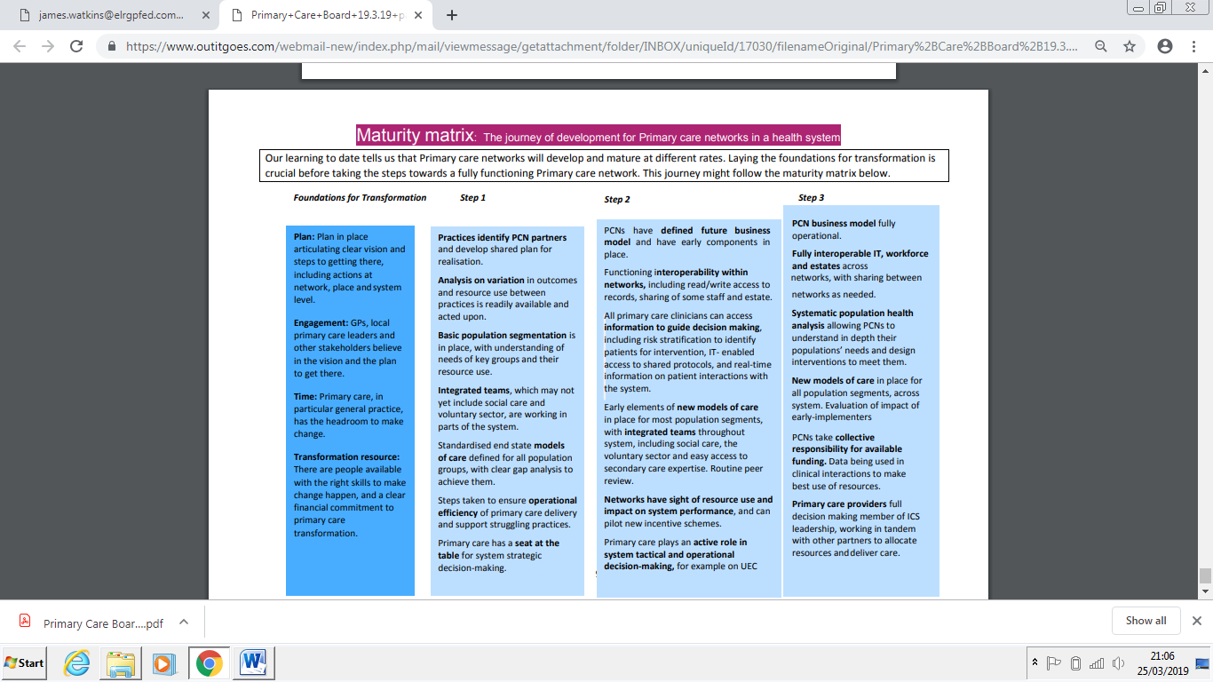

**Appendix 3 – Cashflow forecast FY18/19**



**Appendix 4 – Budget forecast for FY19/20**