**Paper C**

**VAT advice from Ballards @ May 2019 – in response to issues raised @ Appendix 1 (original VAT advice [March 2017] is @ Appendix 2)**

James Watkins has sent through a number of documents to consider further following a conversation earlier in the week.

1. The main issues surround the **Transformation Funds Project Support**.

Our comments are as follows:

* The money has been received from the CCG. The amount received is based upon the budget to spend, and it is fully anticipated that the money will be used in full as per the budgeted spend.
* As the services are delivered, these are paid for by ELR out of this money received. The contracts are typically a tripartite agreement between ELR, the provider, and the medical centres at which the services are to be provided. We have been supplied with an example of this contract with First Contact Physiotherapists (‘FCP’), and we note that the first paragraph includes reference to the fact that the CCG has provided funding to ELR to enable the work to be undertaken at the individual surgeries.
* As the work is undertaken, invoices are raised by FCP to ELR and an authorisation process has been put in place so that these invoices are only paid by ELR upon the approval of the surgery where the work was undertaken. The money spent is then tracked within ELR’s Sage accounting system so that at any one time an amount of unspent funds relating to a particular site held by ELR can be established.
* We understand that the intention has always been that ELR will hold the money on trust. We further understand that there is a separate client account set in Sage for each practice and income and expenses relating to that site is booked to this account.
* ELR receive an administration fee for operating the service, and raise invoices to the practice as appropriate. These invoices would be subject to VAT. ELR then request authorisation for the payment of these invoices to the practices to whom they have been raised. Once approval has been received, the money is moved out of the separated client account within the Sage accounting system, into ELR’s own funds.
* We therefore believe that this arrangement exhibits a number of features which supports management's assertion that this is essentially a process of holding money on behalf of the practices, and operating their accounts on their behalf. It does not therefore seem appropriate that VAT on the main services would come into play, although clearly the administration service charge would be VAT able.
* We note that a key feature of this arrangement is the fact that separate accounts are held within Sage relating to amounts which are not yet spent on the project. We recommend this approach is continued going forward.
* We further understand there has been some discussion with certain practices to extend this programme whereby additional physiotherapy services would be provided, which would be paid for by practice funds (ie, not from funds supplied by the CCG).
* The situation here is less clear, however there may be an opportunity to treat these costs as the disbursement, which is essentially a pass-through treatment which attracts no VAT.
* For example, if physiotherapy services of £100 are supplied and invoiced to ELR, ELR could then invoice to the practice £110, being the £100 for physiotherapy services, plus a £10 admin fee. Crucially, any paperwork would need to identify that the £100 for physiotherapy service was merely a disbursement, and the amount recharged would have to match the amount incurred. This would need to be separated clearly on the invoice and would in this instance not attract VAT.

1. **PCNs**

* We understand that some PCNs are considering using the Federation to hold their money on trust.
* Where money is held on trust under arrangements such as this, this has no VAT impact.
* We strongly recommend however that a separate bank account is used to hold the funds relating to the PCNs. This would benefit the Federation in supporting the assertion that these are not funds belonging to the Federation, and would equally make any audit trail relating to the expenditure from the PCN funds considerably clearer.

1. **INR licences**

* We understand the Federation has arranged to acquire an INR software license on behalf of the practices, and has incurred VAT on the acquisition of this license. These licenses will then be recharged to the practices plus an administration charge.
* This is clearly a service which is subject to VAT. However, we understand that the Federation is registering for VAT, and when registered the treatment would be as follows:
* A licence £100 would be acquired which would attract VAT of £20. Therefore a cost in total of £120, but the VAT of £20 would be recoverable so the net cost to ELR would be only £100.
* ELR would then charge £100 for that licence plus £10 for a mark-up = £110 plus VAT of £22, a total of £132. There is no need to split the cost of the licence and the mark-up on the invoice, and the arrangement is much the same as any reseller arrangement where a profit is made on distribution.

**Mark Skellum**BSc (Hons) FCA

Partner

Ballards LLP

 M: +44 (0) 7917 517 579

 T:   +44 (0) 1905 794 504 (Switchboard)

T:   +44 (0) 1905 783 354 (Direct Dial)

E:   [mark.skellum@ballardsllp.com](mailto:mark.skellum@ballardsllp.com)

**Appendix 1** - **ELR GP Federation – VAT issues**

1. **Transformation Fund Projects Support**
2. The CCG had a ‘Transformation Fund’ and asked for Practices in six Localities to bid for a proportion of the Fund to pilot new ways of working collaboratively at scale (? akin to a grant). The CCG provided the funds for these projects for which it received no benefit.
3. ELR GP Federation provided administration and project management support to the Practices to implement various joint working projects.
4. In conjunction with the Practices, the Federation calculated the budget required to fund the projects and, based on these schedules, the CCG transferred some of the funds directly to the Practices and some to the Federation, as necessary **(typical schedule @ Appendix A)**.
5. Where funds were passed to the Federation, the intention was to effectively hold the money ‘on trust’ and expend it on projects as directed by the Practices.
6. In a number of cases, the Federation organised (and, with Practices, was party to) contracts with third parties to deliver the projects (eg, physiotherapy service shared by Practices in a Locality). However, the Federation did not buy the service and sell it on – it was funded by the CCG Transformation Fund for which the CCG received no benefit and was not a party to the contract. Consequently, the practices did not buy the service from the Federation, rather they were provided with a free service. The contracts made clear in the Introduction that the CCG had granted funding for the provision of the services. **(Appendix B provides a breakdown of these projects)**. **An authorisation process was set up; whereby the Localities approved all invoices.**
7. The 3 Practices in the Harborough Locality intend to extend the contract with the third party Physiotherapy provider (using Practice funds) and therefore we need to be clear on any VAT implications – which potentially will arise in the scenario where the Practices pay directly for the service.
8. The Federation charged the Localities contract administration and project management fees – **ALL ASSUMED TO BE VATable. Hina set up** **an authorisation process whereby the Localities approved these fees.**
9. **Other issues**
10. Some PCNs are considering using the Fed to hold its monies ‘on trust’ – we assume that this does not attract VAT?
11. We have organised to hold an INR licence on behalf of Practices (VAT charged by the company). We have invoiced the Practices to cover this cost plus a contract administration charge. Is this correct?

**Appendix A – example schedule provided to CCG and Practices**



**Appendix B**

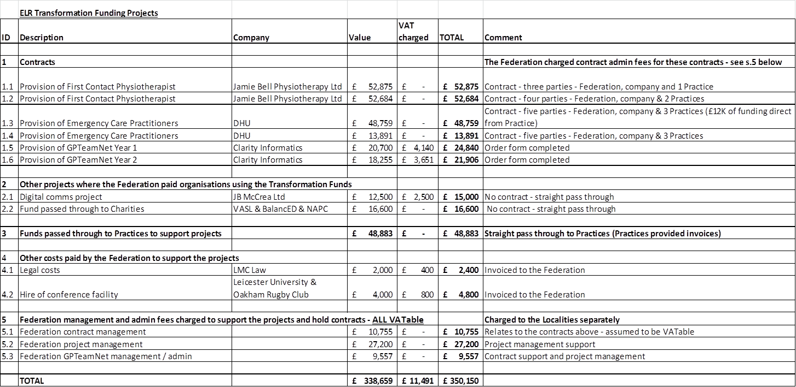

**Appendix 2 - Ballards advice to ELR GP Fed @ March 2017**

James

Apologies for the delay on this. I have put a few comments below as discussed

**VAT**

We have had lots of discussions internally with our VAT specialists and I think it is fair to say it is not a clear cut example. I should note it is rare for a federation to receive funding direct form the CCG in this form, so well done on securing this !

Our initial thoughts are that this is a taxable supply as the service would appear to be primarily related to a structural change rather than clinical delivery by ELR although there are some clinical elements such as supporting GP delivery. However, those elements appear to be relatively minor and the funding is not allocated against each element but is a “block” payment which means the type of service is determined by the “overriding nature” of what is being done.

It is possible that we could treat this as a grant though as some aspects are of a grant based nature. The grant argument would clearly be much stronger if the funding were for Capital expenditure rather than service delivery.

The existence of the items in the balance of the document which suggests there are specific direct benefits received by the CCG in return for the funding is not helpful in the argument that the funding would be a grant.

Therefore, there are arguments both ways, but given that it is the CCG’s intention to spend this money to support the development of the business and establish new business for the GPs, and that any direct benefits to the CCG are likely to be intangible and not initially directly linked to this money, we believe an argument can be made that the income is akin to a grant, and therefore not subject to VAT.

As we discussed, I would recommend letting us know of any new services as they develop so that we can ensure the VAT treatment is appropriate as soon as possible.