ELR GP Federation Ltd

Minutes of the meeting of The Board of Directors

Wednesday 22nd May 2019 – Syston Medical Centre

**Present**: Dr R Bietzk (chair), Dr G Chidlow, J McCrea, J Watkins, R Whitehead, Dr L Ryan, H Patel

1. **Apologies** – Dr N Chotai
2. **Minutes of the meeting held on 24th April 2019**

Joe McCrea was not present at the meeting.

1. **Matters arising** – DSN project governance arrangements to be completed. ***Action JW***.
2. **COO Report**
3. **Primary Care Networks**

JW updated on the development of Primary Care Networks in ELR and the support that the Federation is providing;

|  |  |  |
| --- | --- | --- |
| **PCN** | **ACD** | **Federation support** |
| SLAM (Jubilee, County, LH, LC) | Dr Fahreen Dhanji | Attending the May Locality to discuss how the Federation will support. |
| North Blaby (FH, Limes, Glenfield, Enderby, Kingsway) | Dr Simon Vincent (The Limes) | Managed ACD recruitment @ £200. This fee will be absorbed into a wider support package, should this be approved.  The Fed is leading the development of the Schedules to the Mandatory Agreement. SV has indicated interest in ongoing Fed support. |
| South Blaby (Countesthorpe, Northfield, Masharani, Wycliffe, Hazelmere) | Dr Rachel Omand, (Northfield) | Met Nick Glover who has indicated that Fed support could be helpful. Nick will arrange for JW to meet with the new ACD.  Nick supports the proposal for the Fed Board to provide a forum for the ACDs to meet and direct the business of the Fed. |
| Rutland (Oakham, MOSS, Empingham, Uppingham) | Dr Hilary Fox, (MOSS) | The Fed managed the ACD recruitment process. The PCN has agreed for the Fed to support the development of the PCN @ 20p per patient, to include demand management. |
| OWI (Severn, Wigston Central, Bushloe, Washbrook, Rosemead) | Dr Richard Palin (Bushloe) | The Fed managed the ACD recruitment process @ £500. This fee would be absorbed into a wider support package, should this be approved.  JW met with Richard Palin who has indicated that it will be helpful for the Fed to support the development of the PCN, subject to the approval of the PCN Practices. |
| Harborough (SLMG, Billesdon, Croft) | Dr Anuj Chahal, (SLMG) | Anuj Chahal has indicated that it will be helpful for the Fed to support the PCN development, subject to agreeing costs. |
| Market Harborough / Husbands Bosworth | Dr Hamant Mistry | The Federation has not provided any support, so far. |

**Potential fees** – The table below outlines a methodology for charging the Localities for Federation support. This includes Demand Management Support.

Rutland have indicated that they are happy to proceed on the basis of 20p per patient. However, other PCNs have asked `for a price for the Federation to support the development of the DES Agreement and a Business Plan, in the first instance up until July 2019; ongoing support would be reviewed at this point. Consequently, JW needs to adjust the charging methodology accordingly. ***Action JW.***



1. **Localities & transformation fund update**

* The various projects are nearing their end; the Federation is continuing to provide support to Localities in completing their transformation fund projects.
* Harborough have decided to extend their FCP pilot until March 2020; OWI will not be extending its pilot.
* The Rutland ECP pilot has started and will run for three months (Jan to March 2029).
* LHMP are also utilising ECPs in Q1.
* The Federation will coordinate the Q4 update reports which will be reviewed at the final CCG panel on 28th May 2019. This will include an overall summary of the achievements of the TF projects and a comparison of similar projects, as appropriate. ***Action JW***

1. **Urgent Care / extended primary care**

DHU’s (Simon Harris) update outlined the progress following the start of the contract in April 2019 as follows;

* *SH met with Tim Sacks and the finance lead from ELRCCG along with colleagues from WLCCG, WLCCG agree with our position; Tim was non-committal. ELRCCG finance have made errors in the FMT which they are trying to resolve. No further communication but M1 invoice has been paid albeit 2 weeks late.*
* *4,569 attended during the month of April*
* *111% of contracted capacity provided April 19 (5813 slots)*
* *3.3% DNA rate, 149 appointments*
* *54% Walked In, 35% booked via NHS111/CNH, 11% were booked by ELR GP Practices.*
* *Oadby 68% Walk In has the greatest percentage of walk in patients*
* *58% of activity ELRCCG patients, 28% LCCCG patients, WLCCG 5%, OOA 9%*
* *Oadby seeing more patients from LCCCG area (44%) than from ELRCCG area (43%)*
* *Performance exceptionally good 4hrs 99.9% ; 1hr 98%+*
* *To mitigate short 2.5hr shifts in the evening – creative thinking to combine and extend resource used in other services*
* *Fragility in the resilience of provision - single clinician manned locations as Commissioned.*
* *The CCG have stopped sending questions; so there seems to be less confusion from patients but ‘walk-in’ is available at all sites as you can see by the above, the ‘walk-in’ patients are the majority.*
* *Activity reports are generally received in first draft on about the 10th of the month with finance a couple of days afterwards and these along with the quality reports are key for the JV Board meetings.  We meet the other two Federations during the same week, City is the last Thursday at 12pm and 4Fed are the last Tuesday at 12pm.*

The Board agreed that the Federation Directors on the JV Board would be **Robert Whitehead, Rysz Bietzk and Gareth Chidlow.** Wednesday lunchtimes would be the preferred meeting time. JW to advise DHU / Simon Harris. ***Action JW.***

The Board discussed the ‘bad press’ that had been received in relation to a perception that patients can no longer ‘walk-in’ and one evening when the Oakham service did not open. There has clearly been some confusion created the DHU Standard Operating Procedure (SOP) whereby patients who present with a non-urgent issue are offered an appointment at a later time. This issue will be kept under review with the DHU team. ***Action JW / Board.***

1. **NHS England; Clinical pharmacists in general practice Project**

* LMC Law have drafted a contract which has been circulated to Practices and PSS have confirmed is satisfactory.
* PSS have advised a start date @ June 2019.
* We are arranging for the Lead Practices to complete the Enhanced Service Agreement with NHS E. NHS E have asked that we wait for the updated agreement to be finalised. ***Action JW.***

1. **Community Based Services**

* Leicestershire CC has written to confirm that our contract will be extended into the third year; JW to confirm with the sub-contracting Practices. ***Action JW***
* LMC Law have provided advice regarding the new indemnity arrangements.
* HP is confirming with our sub-contracting practices their schedule of fitters and their evidence to practice and indemnity certificates. ***Action HP***

1. **Correspondence management**

* A workshop for both the admin staff and GPs will be organized for Practices to provide an update on their progress and enable the sharing of best practice.  ***Action JW***

1. **Demand Management**

* RB will develop reports for each Locality – identifying key trends and areas for further investigation / training / service development.
* RB is working with the CCG / East Mids / Lancs CSU review of demand management information.
* However, we need to confirm with the PCNs what level of service they require and agree the funding to support this work. ***Action JW***

1. **Referral support service (RSS)**

* JW met with Danah Cadman (CEO, PCL) who is keen that the Federation becomes a contractor for the provision of RSS services.

1. **Diabetes nurse specialists**

* Additional funding has been identified to extend the project into FY19/20.
* A planning session will took place in May 2019 to determine how this project will be extended.
* LHMP have agreed to employ the DSNs until March 2020.
* JW needs to write up a clinical governance process to assure this scheme for Board consideration. ***Action JW.***

1. **GP TeamNet**

* Implementation is progressing well overall.
* Each Locality has a portal which will help with PCN development.
* Further workshops will be arranged to support PCN development.
* The two-factor login arrangements are being developed which will enable the CCG to use the tool.
* The order has been raised for Year 2 for Five Localities plus SLMG.

1. **H Pylori**

* We have received verbal confirmation that the contract will be rolled forward into FY19/20; we await written confirmation. ***Action JW***

1. **Locum service**

* GP TeamNet has functionality that could support internal ‘bank’ working; which will be investigated further.  ***Action JW***

1. **GDPR – DPO service**

* We await the CCG / Sharon Rose’s feedback regarding the CCG’s plans to provide a DPO service foe Practices.
* In the meantime, we will put an offer to Practices to renew the DPO service for a further year. ***Action JW***

1. **Fracture Liaison Service (FLS) project**

* Public Health and the Alliance Leadership Board have supported the proposal.
* Tim Jones (Osteoporosis Society) has updated the Business Case to respond to CCG comments – which will be reviewed by GC / JW and a further meeting will be arranged to review this. ***Action JW/GC.***

1. **INR STAR**

* The contract with LumiraDX on behalf of all, bar one, of the member Practices has been finalised.
* The CCG will pay for the final two weeks on March 2019.

1. **Second blood collection**

* Yasmin Sidyot (Deputy Director of Urgent and Emergency Care) has advised that paper went to the CCG Joint Management Team. Further information has been requested to strengthen the case. We await further feedback.

1. **Active signposting**

* ELR CCG has asked the Federation to coordinate a pilot within 1/2 Localities to support practices with Active Signposting.
* The first session with the OWI and Rutland Practices will took place on 20th March 2019 and was successful; a further two sessions will take place over the next six months. ***Action JW***

1. **Diagnostic hubs** - Simon Carr (Helen Mather’s team) had provided the following update on progress;

*·****Communication:****Recognising that we need to progress this work across all 3 CCGs in Leicestershire, we have identified yourselves as the key points of contact for discussing some of the scoping. We appreciate much wider engagement will need to take place across all stakeholders, particularly as PCNs take shape. However, in the first instance we want to ensure there is a core of people from all key stakeholders aware of what is happening. DD will continue to liaise with colleagues at UHL given his close links with the diagnostics services there.*

***Scoping Demand:****there are several aspects to establishing what demand for Direct Access Diagnostics (Non-Imaging) is likely to be, and we need to collate a view on each of them before we can start to articulate the scale of the services that may need to be commissioned.*

*o****Existing Direct Access demand at UHL:****This is more readily identified by practice and thereby by CCG – and indeed future PCN.*

*o****Existing Direct Access demand at other secondary care providers:****This will be identifiable, but could be more limited that than granularity we can readily access from UHL.*

*o****Discretionary demand:****the availability of activity data on activity taking place a discretionary service will be very varied and from early conversations, I think we will have to establish a proxy for understanding demand associated with discretionary services.*

*o****Future demand:****We need to reflect how services and patient care is evolving such that we can apply the right assumptions to growth and anticipate future demand. This will need to link closely with any work being undertaken by the likes of LPT. DD will be able to help with this.*

*Recognising that it will not be possible to establish a single, comprehensive dataset which estimates demand for every footprint, we are first exploring the potential to identify this for a smaller footprint and extrapolate by weighted population for a more robust estimation of demand across practices. ·*

***Finances:****in addition to the establishing of demand, initial scoping will need to reflect some consideration of the financial implications of establishing diagnostic hubs, and reflect at high level how this might compare to the existing cost. Undertaking the demand exercise will allow us to begin this work.*

The Federation will support this scoping exercise and assist with coordinating information from Practices, as required.  ***Action JW.***

1. **Finance**

* JW updated the Board that the Financial Profile included in the minutes of the meeting of April 2019 (see Annexes 1 & 2) provides the current financial overview. Key points to note;
  1. A good surplus will be achieved in FY18/19. This is due to the fact that a number of Localities asked the Federation to support the implementation of their Transformation Projects.
  2. This will result in a reserve being carried forward to FY19/20; which was a deliberate plan to help cover the Federation’s operating costs during FY19/20 which will be a period where the CCG start-up fund / ‘grant’ ceases and PCNs are being developed.
  3. The main elements of future cash-flow will be the DHU JV payment and income from the PCNs for their development and operation. The working arrangements with the PCNs are being developed and consequently, the key action is to finalise the scope of the future Federation support to the PCNs and the associated fee arrangements. ***Action JW***
* HP has registered the Federation for VAT and a formal response is awaited. ***Action HP***
* The recent VAT advice from Ballards in relation to the various schemes to support Practices (attached at Annexe 3), including the Transformation Fund projects was reviewed by the Board who noted that they were happy with this advice. This included the original Ballards advice that the start-up fund received from the CCG could reasonably be treated as a grant and therefore not subject to VAT.
* Robert Whitehead will review the Federation’s financial management arrangements and make recommendations, as appropriate. ***Action RW***

1. **Board issues**

* Further to the agreement at the Extra-ordinary meeting on 22nd May 2019, JW will arrange for a letter to be sent to Kirsty Whawell advising that the Federation will take the necessary steps to remove her as a Director as she is no longer an employee of a Sharholder Practice. ***Action JW***
* Further to the agreement at the Extra-ordinary meeting on 22nd May 2019, the election of the Directors who are due to retire by rotation in May 2019 will be deferred until the end of October 2019 during which time a discussion will take place with the PCN ACDs regarding the future scope of the Federation and the option of them becoming Federation Board Directors.
* HP to review the patient numbers and the associated impact on Practices’ shareholoding, which will include arrangements for removing Narborough Health Centre. ***Action HP***
* HP will arrange for Kirsty Whawell and Nainesh Chotai to be removed as Directors. ***Action HP***
* The Annual Shareholders meeting will take place on **12th September at College Court.**

1. **Communications**

* The Rutland Hub will be provide the Rutland PCN with a useful tool for developing joint working. JM/JW to consider how this web hub tool could be rolled out in other Localities / PCNs. ***Action JM/JW***
* RB noted that the Leicester City Head of Comms will be taking the lead on comms in relation to the development of PCNs in LLR.

1. **Date & venue of next meeting**

Tuesday 9th July 2019 @ 7pm @ Syston Health Centre.

**Action Log**

|  |  |  |  |  |
| --- | --- | --- | --- | --- |
| **Id** | **Detail** | **Who** | **Update** | **Status** |
| 1 | CQC registration | JW | JW spoken to CQC. We need a contract to trigger an application. | G |
| 2 | Business Plan for FY19/20 | JW | Summary complete | G |
| 3 | Fracture Liaison Service Biz Case | GC/JW | Follow-up information requests following CCG meeting | A |
| 4 | NHSE Pharmacists scheme implementation | JW | Finalised the practices will take part. Portal updated. NHS E have confirmed funding. 2WTE pharmacists recruited. SLA/ contract prepared. | G |
| 5 | Finalise Federation TF fee arrangements | JW | Complete | G |
| 6 | Urgent Care;   * Follow up Localities / Practices * Finalise JV legals * Organise for resolution of shareholders | JW  JW  JW | Complete  In hand  Complete | G |
| 7 | CBS contract –   * Update accreditation and indemnity details * Comms to Practices * Indemnity arrangements | HP  JW  JW | In process  Complete  Complete | A |
| 8 | Correspondence management workshop | JW | In hand. | G |
| 9 | Clinical governance process for DSN project | GC/JW | Gareth advised on the approach. To be completed. | A |
| 10 | GPTeamNet – Y2 quote / implementation | JW | Contract signed. | G |
| 11 | H Pylori contract – check FY19/20 | JW/GC | Verbal confirmation that the contract will be rolled forward. | G |
| 12 | Establish skills / GPSIs in LLR for RSS | JW | In hand | G |
| 13 | DPO | JM/JW | Offer for contract extension circulated to Practices but we are waiting for the CCG to confirm their position. | A |
| 14 | PCN ACDs to become Federation Board Directors / future involvement of the Federation with PCN management and associated budget considerations | RB | Plan to involve / co-opt the ACDs – in hand. | G |
| 15 | Complete Board / shareholder removals | HP | Uppingham/Kingsway/Severn/MHMP to be completed. | A |
| 16 | Investigate the option of becoming a CIC | JW | In hand | G |
| 17 | Policy development | JW | To be developed, as required. | A |
| 18 | VAT registration | HP | Complete | G |
| 19 | Demand management identify next steps and funding for FY19/20 | RB/JW | In hand | G |
| 20 | Locum service next steps | JW | Investigating GPTeamNet potential. | G |
| 21 | Diagnostic hubs proposal | JW / LR | Follow up with Simon Carr / Sarah Smith | A |
| 22 | Review share allocations in light of updated list sizes and determine approach for Narborough shares. | HP/JW | TBD | A |
| 23 | Rutland ECP pilot | RB / JW | Q1 pilot commenced | G |
| 24 | RSS – preparations | JW | Meeting arranged with Danah Cadman – complete. | G |
| 25 | INR – obtain quotes & implement | JW / KW | Complete | G |
| 26 | PCN development – proposal to support Localities | JW | In hand | G |
| 27 | Invite Noel O’Kelly and Jude Smith | JW | In hand | G |
| 28 | Organise follow-up Active Signposting workshops | JW | In hand | G |
| 29 | Review financial management | RW | List to be developed | A |
| 30 | Transformation Fund review report | JW | In hand | G |
|  |  |  |  |  |
|  | **Archived Actions** |  |  |  |
|  | Follow-up meeting with Tim Sacks re projects / funding options | JW / RB | Complete | G |
|  | Blaby & Lutterworth Board Director vacancy | JW | No response to the advert. Dr Louise Ryan co-opted. | G |
|  | O&W Director recruitment | JW/JM | Robert Whitehead appointed. | G |
|  | Cancel VitruCare contract | JW/RB | Complete | G |
|  | Physio contracts | JW | Harborough and O&W complete. | G |

**Annex 1 – ELR GP Federation Budget Report for FY18/19**

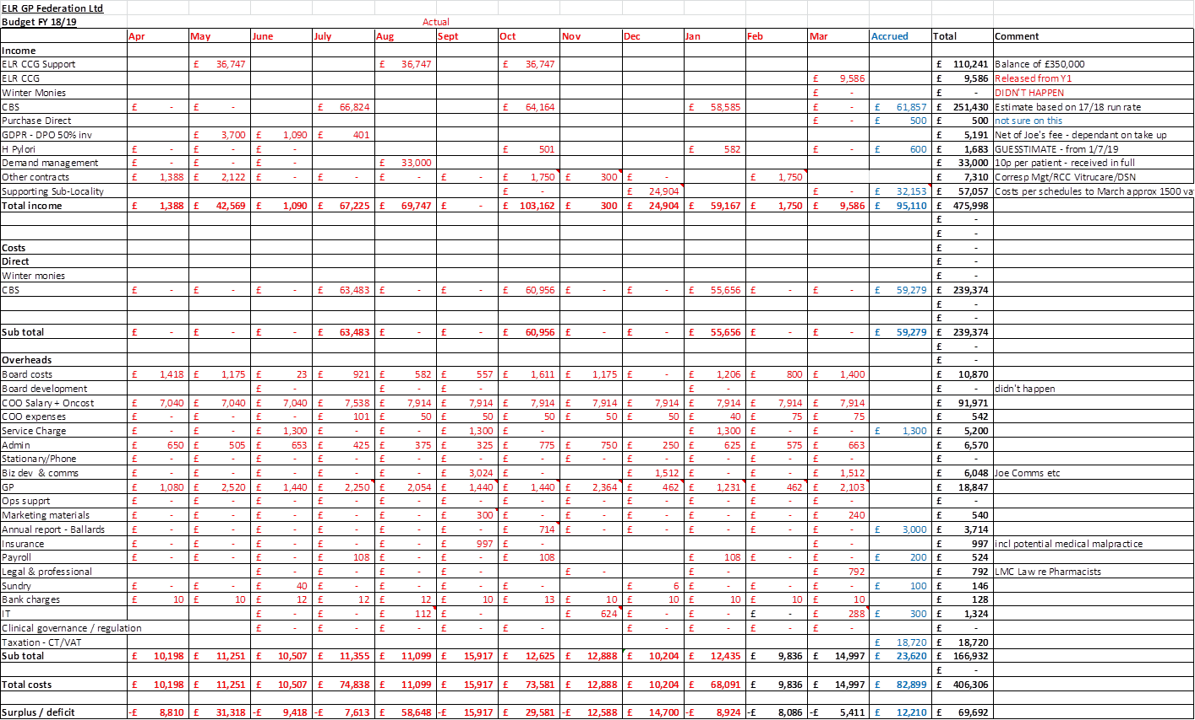

**Annex 2 – ELR GP Federation Budget Forecast for FY19/20**



**Annexe 3**

**VAT advice from Ballards @ May 2019 – in response to issues raised @ Appendix 1 (original VAT advice [March 2017] is @ Appendix 2)**

James Watkins has sent through a number of documents to consider further following a conversation earlier in the week.

1. The main issues surround the **Transformation Funds Project Support**.

Our comments are as follows:

* The money has been received from the CCG. The amount received is based upon the budget to spend, and it is fully anticipated that the money will be used in full as per the budgeted spend.
* As the services are delivered, these are paid for by ELR out of this money received. The contracts are typically a tripartite agreement between ELR, the provider, and the medical centres at which the services are to be provided. We have been supplied with an example of this contract with First Contact Physiotherapists (‘FCP’), and we note that the first paragraph includes reference to the fact that the CCG has provided funding to ELR to enable the work to be undertaken at the individual surgeries.
* As the work is undertaken, invoices are raised by FCP to ELR and an authorisation process has been put in place so that these invoices are only paid by ELR upon the approval of the surgery where the work was undertaken. The money spent is then tracked within ELR’s Sage accounting system so that at any one time an amount of unspent funds relating to a particular site held by ELR can be established.
* We understand that the intention has always been that ELR will hold the money on trust. We further understand that there is a separate client account set in Sage for each practice and income and expenses relating to that site is booked to this account.
* ELR receive an administration fee for operating the service, and raise invoices to the practice as appropriate. These invoices would be subject to VAT. ELR then request authorisation for the payment of these invoices to the practices to whom they have been raised. Once approval has been received, the money is moved out of the separated client account within the Sage accounting system, into ELR’s own funds.
* We therefore believe that this arrangement exhibits a number of features which supports management's assertion that this is essentially a process of holding money on behalf of the practices, and operating their accounts on their behalf. It does not therefore seem appropriate that VAT on the main services would come into play, although clearly the administration service charge would be VAT able.
* We note that a key feature of this arrangement is the fact that separate accounts are held within Sage relating to amounts which are not yet spent on the project. We recommend this approach is continued going forward.
* We further understand there has been some discussion with certain practices to extend this programme whereby additional physiotherapy services would be provided, which would be paid for by practice funds (ie, not from funds supplied by the CCG).
* The situation here is less clear, however there may be an opportunity to treat these costs as the disbursement, which is essentially a pass-through treatment which attracts no VAT.
* For example, if physiotherapy services of £100 are supplied and invoiced to ELR, ELR could then invoice to the practice £110, being the £100 for physiotherapy services, plus a £10 admin fee. Crucially, any paperwork would need to identify that the £100 for physiotherapy service was merely a disbursement, and the amount recharged would have to match the amount incurred. This would need to be separated clearly on the invoice and would in this instance not attract VAT.

1. **PCNs**

* We understand that some PCNs are considering using the Federation to hold their money on trust.
* Where money is held on trust under arrangements such as this, this has no VAT impact.
* We strongly recommend however that a separate bank account is used to hold the funds relating to the PCNs. This would benefit the Federation in supporting the assertion that these are not funds belonging to the Federation, and would equally make any audit trail relating to the expenditure from the PCN funds considerably clearer.

1. **INR licences**

* We understand the Federation has arranged to acquire an INR software license on behalf of the practices, and has incurred VAT on the acquisition of this license. These licenses will then be recharged to the practices plus an administration charge.
* This is clearly a service which is subject to VAT. However, we understand that the Federation is registering for VAT, and when registered the treatment would be as follows:
* A licence £100 would be acquired which would attract VAT of £20. Therefore a cost in total of £120, but the VAT of £20 would be recoverable so the net cost to ELR would be only £100.
* ELR would then charge £100 for that licence plus £10 for a mark-up = £110 plus VAT of £22, a total of £132. There is no need to split the cost of the licence and the mark-up on the invoice, and the arrangement is much the same as any reseller arrangement where a profit is made on distribution.

**Mark Skellum**BSc (Hons) FCA

Partner

Ballards LLP

 M: +44 (0) 7917 517 579

 T:   +44 (0) 1905 794 504 (Switchboard)

T:   +44 (0) 1905 783 354 (Direct Dial)

E:   [mark.skellum@ballardsllp.com](mailto:mark.skellum@ballardsllp.com)

**Appendix 1** - **ELR GP Federation – VAT issues**

1. **Transformation Fund Projects Support**
2. The CCG had a ‘Transformation Fund’ and asked for Practices in six Localities to bid for a proportion of the Fund to pilot new ways of working collaboratively at scale (? akin to a grant). The CCG provided the funds for these projects for which it received no benefit.
3. ELR GP Federation provided administration and project management support to the Practices to implement various joint working projects.
4. In conjunction with the Practices, the Federation calculated the budget required to fund the projects and, based on these schedules, the CCG transferred some of the funds directly to the Practices and some to the Federation, as necessary **(typical schedule @ Appendix A)**.
5. Where funds were passed to the Federation, the intention was to effectively hold the money ‘on trust’ and expend it on projects as directed by the Practices.
6. In a number of cases, the Federation organised (and, with Practices, was party to) contracts with third parties to deliver the projects (eg, physiotherapy service shared by Practices in a Locality). However, the Federation did not buy the service and sell it on – it was funded by the CCG Transformation Fund for which the CCG received no benefit and was not a party to the contract. Consequently, the practices did not buy the service from the Federation, rather they were provided with a free service. The contracts made clear in the Introduction that the CCG had granted funding for the provision of the services. **(Appendix B provides a breakdown of these projects)**. **An authorisation process was set up; whereby the Localities approved all invoices.**
7. The 3 Practices in the Harborough Locality intend to extend the contract with the third party Physiotherapy provider (using Practice funds) and therefore we need to be clear on any VAT implications – which potentially will arise in the scenario where the Practices pay directly for the service.
8. The Federation charged the Localities contract administration and project management fees – **ALL ASSUMED TO BE VATable. Hina set up** **an authorisation process whereby the Localities approved these fees.**
9. **Other issues**
10. Some PCNs are considering using the Fed to hold its monies ‘on trust’ – we assume that this does not attract VAT?
11. We have organised to hold an INR licence on behalf of Practices (VAT charged by the company). We have invoiced the Practices to cover this cost plus a contract administration charge. Is this correct?

**Appendix A – example schedule provided to CCG and Practices**



**Appendix B**

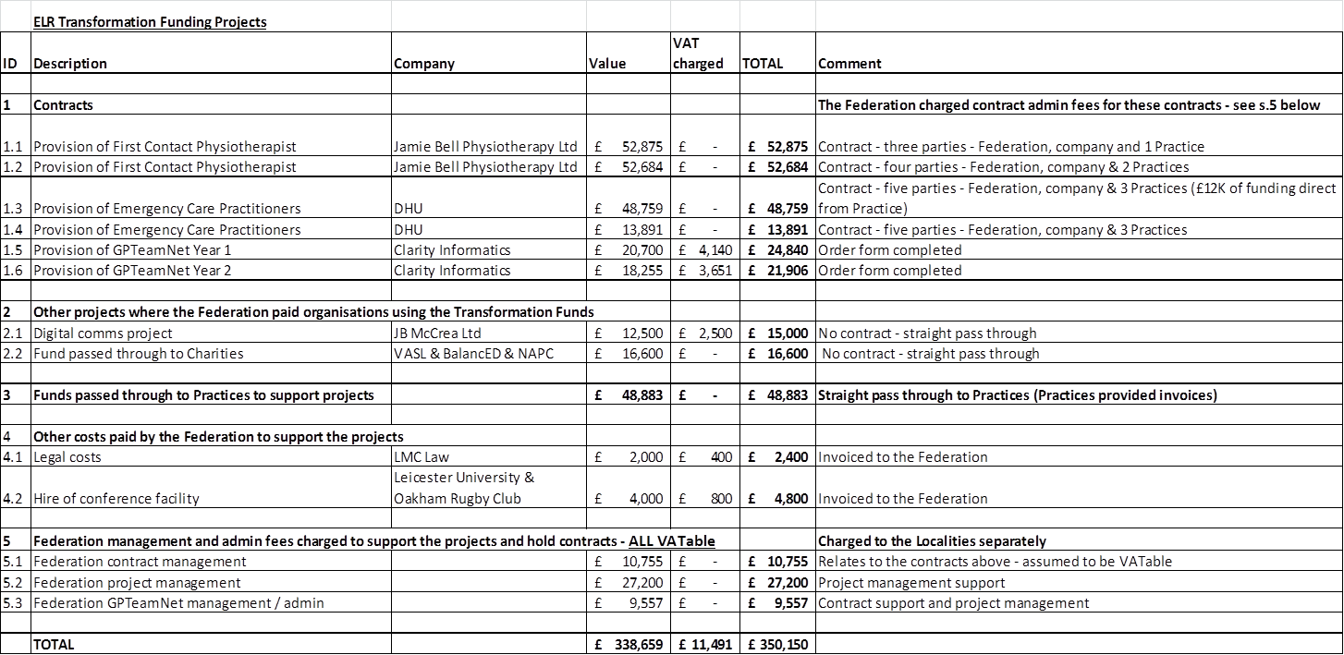

**Appendix 2 - Ballards advice to ELR GP Fed @ March 2017**

James

Apologies for the delay on this. I have put a few comments below as discussed

**VAT**

We have had lots of discussions internally with our VAT specialists and I think it is fair to say it is not a clear cut example. I should note it is rare for a federation to receive funding direct form the CCG in this form, so well done on securing this !

Our initial thoughts are that this is a taxable supply as the service would appear to be primarily related to a structural change rather than clinical delivery by ELR although there are some clinical elements such as supporting GP delivery. However, those elements appear to be relatively minor and the funding is not allocated against each element but is a “block” payment which means the type of service is determined by the “overriding nature” of what is being done.

It is possible that we could treat this as a grant though as some aspects are of a grant based nature. The grant argument would clearly be much stronger if the funding were for Capital expenditure rather than service delivery.

The existence of the items in the balance of the document which suggests there are specific direct benefits received by the CCG in return for the funding is not helpful in the argument that the funding would be a grant.

Therefore, there are arguments both ways, but given that it is the CCG’s intention to spend this money to support the development of the business and establish new business for the GPs, and that any direct benefits to the CCG are likely to be intangible and not initially directly linked to this money, we believe an argument can be made that the income is akin to a grant, and therefore not subject to VAT.

As we discussed, I would recommend letting us know of any new services as they develop so that we can ensure the VAT treatment is appropriate as soon as possible.