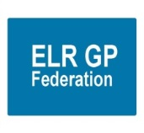**ELR GP Federation Ltd**

**Chief Operating Officer Report – April 2019**

1. **Localities & transformation fund update**

* We continue to provide support to Localities in implementing their transformation fund projects
* The Federation is now holding the following contracts on behalf of practices.

|  |  |  |  |
| --- | --- | --- | --- |
| **Locality** | **Contractor** | **Project** | **Duration** |
| Harborough | Jamie Bell Physiotherapy Ltd | First Contact Physio | 7 months |
| O&W | Jamie Bell Physiotherapy Ltd | First Contact Physio | 6 months |
| SLAM | DHU | ECP | 6 months |
| All | Clarity Informatics | GPTeamNet | 12 months |
| Rutland | DHU | ECP (to be finalised) | 3 months |

* The First Contact Physio and ECP contracts are progressing well and GP time is being saved.
* Harborough have decided to extend their pilot until March 2020.
* OWI are reviewing their options and will decide on next steps at their April Locality meeting.
* The Rutland ECP pilot has started and will run for three months.
* LHMP are considering joining the SLAM pilot in Q1.
* The Federation will coordinate the Q4 update reports which will be reviewed at the final CCG panel in May 2019. This will include an overall summary of the achievements of the TF projects and a comparison of similar projects, as appropriate.

1. **Primary Care Networks**

* PCNs are being established in the six ELR Localities.
* The Federation has developed a proposal to support the Localities to develop as PCNs – see **appendix 1.**
* Localities have asked the Federation to provide a fee structure that includes a breakdown of costs.
* The Federation is running the OWI ACD recruitment process; fee @ £500 – which will be absorbed into the overall support fee if they decide to opt for a more extensive support package **(see ACD spec @ Appendix 2)**.
* JW / RB spoke with Peter Miller (CEO, LPT) regarding the development of PCNs and the idea of ‘freedom within a framework’; that there would be a level of consistency of approach and that the Federations could play an important role in facilitating this.
* JW has spoken with Dr Noel O’Kelly (Clinical Director, LPT) and agreed that it is important to have a strategic conversation between primary and community care providers. We will invite Noel and Jude Smith to the June 2019 Federation Board meeting.

1. **Business plan for FY19/20**

**Where are we now?**

* ‘Change agent’; Practices have been grateful for the objective facilitation support that has been provided for joint working / Transformation Fund projects
* Project management / management consultancy type support
* Hold a number of contracts on behalf of Practices
* Urgent care provider, in partnership with DHU
* We are a ‘dot joiner’
* A key player & partner in shaping place based integrated working

**Where do we want to be?**

* **Local service delivery & business development -** facilitating the delivery of more services locally; bidding collectively and / or holding contracts where it is helpful to do so
* **Resilience and sustainability –** innovating and transforming the way that services are delivered to address the pressures currently faced in the local health care system
* **Effective voice -** for our members across ELR

**Figure 1 – Structure of PCNs and Federation**

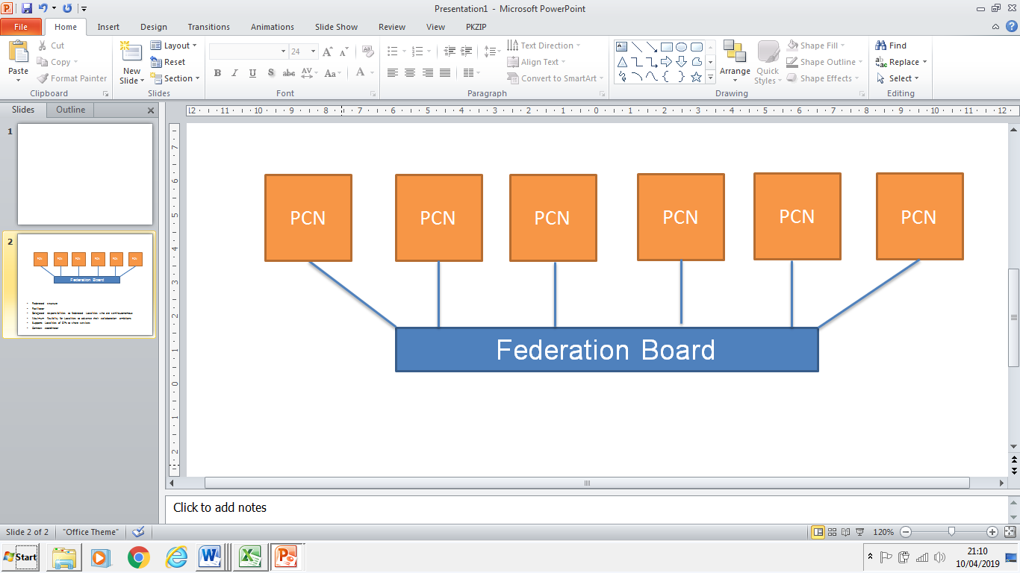

* Locality / PCN development
* Merger support
* Demand management
* Referral hubs
* ELR wide project support – bids & implementation
* Urgent care provider
* Back office support provider

**How do we get there / funding?**

* Key income streams will be;
* PCN development (incl demand management) @ c£60K to 80K **(TBC/negotiated with PCNs)**
* Urgent Care (DHU) @ c£50K
* H Pylori, CBS, GDPR @ £10-£15K
* TF funds c/fwd @ £40 - 50K (TBC)

***Note;*** *all these numbers are quoted before the impact of VAT*

1. **Urgent Care / extended primary care**

* Bushloe & Croft Practices have finalized an agreement to act as sub-contractors to provide the GPs in core hours at the Oadby UCC.
* The pilot to implement the ‘UCC booking pathway’; whereby Practices will make slots available for UCC to book directly into has started.
* A General Meeting will take place on 22nd May 2019 to confirm a resolution of Shareholders to enter into a Joint Venture with DHU – **see paper @ Appendix 3**.
* From 2021 PCNs will be responsible for Extended Care which may impact on the contract

1. **NHS England; Clinical pharmacists in general practice Project**

* LMC Law have drafted a contract which has been circulated to Practices and PSS have confirmed is satisfactory.
* PSS have advised a start date @ 1st June 2019.
* We are arranging for the Lead Practices to complete the Enhanced Service Agreement with NHS E.

1. **Community Based Services**

* Leicestershire CC has written to confirm that our contract will be extended into the third year; JW to confirm with the sub-contracting Practices.
* LMC Law have provided advice regarding the new indemnity arrangements – see below;

*Dear James,  
  
Apologies for the delay.  
  
I have looked at the guidance and the scheme details and the advice contained within your email.  
  
As far as the guidance goes relating to the CNSGP - organisations are covered if they provide primary medical services where those have been commissioned by a provider whose main function is to provide/commission those services.  
  
My reading of this is that as a federation, if you are commissioned to provide primary medical services under a core contract then you are covered. If you are commissioned by a local authority for the provision of public health services, then you are also covered. If you fall into those categories you are treated as a part 4 contractor and therefore, the GPs you sub-contract to are also covered.  
  
Not all federations will fall under a Part 4 contractor so that may mean any sub-contractors are not covered under the CNSGP.  
  
The same rules would apply I believe in terms of a federation holding a Network DES - as long as they are providing in hours primary care services then they are entitled to hold the DES.  
  
The rules are still a little unclear, but with all guidance and information out there at present, this seems to be the clearest scenario.  
  
Shanee*

* HP is confirming with our sub-contracting practices their schedule of fitters and their evidence to practice and indemnity certificates.

1. **Correspondence management**

* We will arrange a workshop for both the admin staff and GPs after Easter; for Practices to provide an update on their progress and enable the sharing of best practice etc

1. **Demand Management**

* RB will develop reports for each Locality – identifying key trends and areas for further investigation / training / service development.
* RB is working with the CCG / East Mids / Lancs CSU review of demand management information.
* Funding needs to be identified from PCNs.

1. **Referral support service (RSS)**

* Expressions of interest have been sought for MSK Triage & ENT.
* Meeting arranged with Danah Cadman to progress.

1. **Diabetes nurse specialists**

* West Leicestershire CCG , who commission the service on behalf of NHS E, are pleased with the progress that has been made.
* Additional funding has been identified to extend the project into FY19/20.
* A planning session will take place in May 2019 to determine how this project will be extended.
* We need to agree an extension with LHMP.
* JW needs to write up a clinical governance process to assure this scheme for Board consideration.

1. **Rutland Patient App project (VitruCare)**

* JW / RB have advised Dynamic Healthcare Systems that the Federation will not renew the contract for a second year when it comes up for renewal at the end of April 2019.

1. **GP TeamNet**

* Implementation is progressing well overall.
* The majority of Practices have started to implement the tool within their Practices.
* Each Locality has a portal which will help with PCN development.
* ‘Hot topic’ webinars and support workshops have been held to help Practices implement the system.
* The two-factor login arrangements are being developed which will enable the CCG to use the tool.
* A webinar has been held with LCC Public Health.
* DHU have bought licenses. JW to follow up how this could be used.
* The order has been raised for Year 2 for Five Localities plus SLMG.

1. **H Pylori**

* All bar three Practices have decided to provide an H Pylori service as a sub-contractor to the Federation.
* We have received verbal confirmation that the contract will be rolled forward into FY19/20; we await written confirmation.

1. **Locum service**

* JW has had a demonstration from Lantum.
* GP TeamNet has functionality that could support internal ‘bank’ working; which will be investigated further.

1. **GDPR – DPO service**
   * Tim Sacks has advised that the CCG will not be paying for Practice DPOs but requested that JW follows this up with Sharon Rose.
2. **Fracture Liaison Service (FLS) project**
   * The proposal is to trial a locality based ‘fracture liaison service’ to help prevent further fractures in the identified risk group.
   * Public Health and the Alliance Leadership Board have supported the proposal
   * GC / JW have met with LLR commissioners who have raised a number of questions. We have agreed to address these questions and update the Business Case to fit with their format to assist further review .
3. **INR STAR**

* The contract with LumiraDX on behalf of all, bar one, of the member Practices has been finalised.
* The CCG will pay for the final two weeks on March 2019.

1. **Second blood collection**

* 19 practices have indicated that they wish to procure a second blood collection
* The three CCGs are considering whether to institute a second blood collection – we await an update.

1. **Active signposting**

* ELR CCG has asked the Federation to coordinate a pilot within 1/2 Localities to support practices with Active Signposting
* The first session with the OWI and Rutland Practices will took place on 20th March 2019 and was successful.
* A further two sessions will be planned over the next six months.

1. **Diagnostic hubs** (ref Louise’s **paper C**)

* JW met with Helen Mather and Simon Carr who are developing a Business Case to develop diagnostic hubs in primary care.
* JW will work with Simon Carr to develop the ELR element of this proposal for consideration by PCNs / Practices.

**Appendix 1**

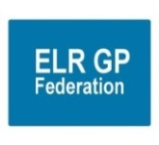**ELR Primary Care Networks – ELR GP Federation role and support – a proposal / ‘think piece’**

1. **The context**
2. Practices in ELR are in the process of forming Primary Care Networks (PCN), in line with the National Network Contract DES.
3. Whilst PCNs will have the freedom to organise themselves in line with their local context; there will be a range of areas where it will make sense for PCNs to operate within a sensible, strategic framework; providing consistency between PCNs and avoid ‘inventing the wheel’ several times.
4. It is important that the voice of primary care is clearly articulated at the CCG and wider LLR STP level. For this to be effective there will need to be a level of consistency with PCNs ‘pulling in the same direction’.
5. Local NHS organisations will increasingly focus on population health and local partnerships with local authority-funded services through development of Integrated Care Systems (ICS). PCNs will be a key part in the formation and delivery of these services and, as such, ‘integrated PCNs’ will be stronger and provide a more coherent voice within this system.
6. There will continue to be a range of issues where it makes sense to organise and/or hold contracts at the ‘30 practice level’.
7. As such, it will be important that PCNs within ELR have a forum to ‘compare notes’ and organise at a ’30 practice level’ where it makes sense to do so.
8. Managing a network does not necessarily require forming a new legal entity.
9. **A proposal**
10. Utilise ELR GP Federation, an organisation that the 30 Practices have created and remain as shareholders, to support PCN development and provide a forum for them to work together **(see Figure 1)**; building on the Federation’s 'transformation' and 'sustainability' strategic priorities.

* **Local service delivery & business development -** facilitating the delivery of more services locally; bidding collectively and / or holding contracts where it is helpful to do so
* **Resilience and sustainability –** innovating and transforming the way that services are delivered to address the pressures currently faced in the local health care system
* **Effective voice -** for our members across ELR

**Figure 1 – suggested structure of PCNs and Federation**



1. Co-opt the 6 ACDs onto the Federation Board (if they are not already a Director) to shape and focus the Federation business on activity that supports PCNs to operate effectively; providing a forum for debate at the ‘30 practice level’.
2. The Federation will tailor its work programme to support the direction provided by the expanded Board, which would include a range of the following options;

* Supporting the development of the PCNs; clarifying vision, strategic objectives and action plans (using business plan template – Appendix 1)
* Draw together various advice and guidance from national and local sources into one place to inform decision making for the development of PCNs
* Provide objective facilitation and project management from an informed, objective & trusted partner
* Share knowledge, best practice and learning across the Localities; avoiding the need for Localities to ‘invent the wheel’ six times (whilst bearing in mind that ‘one size might not fit all’)
* Support the ACDs and ongoing running of the PCNs, as required
* Be a key ‘change agent’; enabling and facilitating joint working, innovation and transformation
* Use the ELR GP Federation company, possibly create trading divisions within the Federation, for activities that require a separate legal entity, rather than creating a number of separate legal entities with associated costs
* Provide a governance structure
* Coordinate / manage the recruitment processes for *Social Prescribers & Pharmacists* at the ‘30 practice level’ – rather than running six separate campaigns
* Provide demand management support
* Urgent care – manage the current partnership with DHU & support future developments
* Back office support
* Referral hubs
* ELR wide project support
* Hold budgets, if helpful
* Employment where helpful / possible
* Provide a clear primary care voice and influence in the local healthcare economy / STP

1. **Resources** – to support Federation work to be drawn from the PCN’s Network DES budget – **TBC.**

**Appendix A**

**Business Plan framework**

**Purpose** – to clearly articulate the PCN’s agreed vision, objectives and action plan, including;

* Background and context
* Assessment of the PCNs current status, utilising and developing the maturity matrix **(Appendix B)**
* PCN’s mission and vision, options include;
  1. Left shift the focus to primary and community care, improving prevention
  2. Greater sustainability
  3. Offer a wider range of services and greater specialization.
  4. Benefit of sharing staff and expertise and building the MDT.
  5. Create more attractive, flexible and diverse career, training and employment options
  6. Standardise administration processes
  7. Developing new models of care / integration with community providers.
* Strategic objectives
* Option appraisal on the PCN operating model & organisational structure

*(Options incl; Flat practice network, Lead provider, Federation, Provider entity (eg, CIC), Super-practice)*

* PCN internal governance and decision making arrangements
* PCN workforce and employment plan
* PCN Financial plan & budget management arrangements
* Terms of Reference for the PCN
* Action plan
* Risk register & mitigations

**Appendix B – Maturity Matrix**

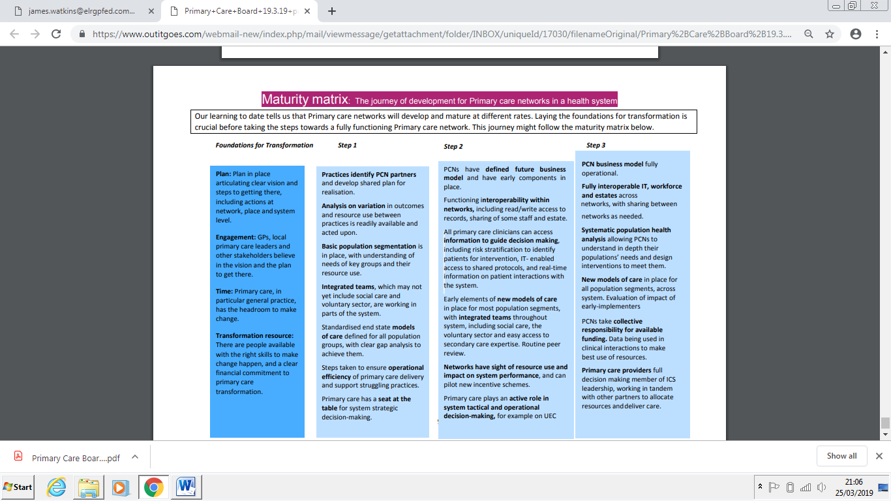

**Appendix 2 - Primary Care Network Accountable Clinical Director**

1. **Time commitment;** Minimum two sessions per week – actual to be confirmed with PCN members to account for local requirements and financing.
2. **Reimbursement;** In line with the CCG GP Board posts – to be confirmed with PCN members.
3. **Term;** Circa two years – to be confirmed with PCN members.
4. **Role summary**

The Accountable Clinical Director (ACD) will be accountable to the Primary Care Network (PCN) members and provide leadership for the PCN’s strategic plans, working with members to improve the quality, cost and effectiveness of the services it offers. This will include professional leadership of the Quality and Outcomes Framework Quality Improvement activity across the PCN.

The ACD will be a practicing clinician from within the PCN member practices able to undertake the responsibilities of the role and represent the PCN’s collective interests. It is most likely this role will be fulfilled by a GP but this is not an absolute requirement.

The ACD will work collaboratively with ACDs from other PCNs within the STP area, playing a critical role in shaping and supporting the STP, helping to ensure full engagement of primary care in developing and implementing local system plans.

1. **Key responsibilities**
2. Provide strategic and clinical leadership to the PCN, developing and implementing strategic plans, leading and supporting quality improvement and performance across member practices.
3. Support implementation of agreed service changes and pathways across the PCN.
4. Work closely with member practices and the commissioner and other networks to develop, support and deliver local improvement programmes aligned to national priorities.
5. Develop local initiatives that enable delivery of the PCN’s agenda by working with commissioners and other networks to meet local needs and ensure comprehensive coordination.
6. Provide strategic leadership for workforce development, through assessment of clinical skill-mix and development of a PCN workforce strategy.
7. Develop relationships and work closely with other ACDs, clinical leaders of other primary care, health and social care providers, local commissioners and LMCs.
8. Play a key role in helping to ensure full engagement of primary care in developing and implementing local system plans.
9. Facilitate participation by practices within the PCN in research studies and act as a link between the PCN and local primary care research networks and research institutions.
10. Represent the PCN at CCG-level and STP-level clinical meetings, contributing to the strategy and wider work of the STP.
11. Take a lead role in developing a PCN’s conflict of interest arrangements, taking account of what is in the best interests of the PCN and their patients.

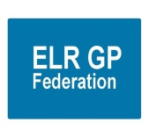**Appendix 3 - Proposal to form a Joint Venture with DHU**

1. **Introduction**

Shareholders will be aware that, in partnership with DHU, ELR GP Federation bid successfully for the contract to manage the ELR Integrated Urgent Care Centres (see configuration below).



**The Federation is now in the process of formalising the Joint Venture Agreement with DHU and requires a resolution from Shareholders to establish this agreement, in accordance with the Articles of Association of ELR GP Fed Ltd.**

1. **Overview of DHU Health Care CIC**
2. DHU Health Care CIC is a social enterprise and a not for profit company, known locally as DHU.
3. The company was established in April 2007 as a result of a merger between two Derbyshire based companies that were set up by local general practitioners. DHU is now officially classified as a medium sized organisation under The Companies Acts definition and are consequently large enough to be operationally robust but small enough to care and to be flexible in meeting commissioners’ requirements.
4. DHU secured the contracts for GP Out of Hours Services for LLR and the Loughborough Urgent Care Centre on 13th May 2016, stepping in on a caretaking basis following the financial collapse of the previous provider, CNCS.
5. In Autumn 2016, the process for re-procurement of the new service models for urgent care commenced. DHU Health Care CIC has secured the first two contracts that were let by competitive tender. This includes;

* Integrated Primary and Community Urgent Care Service in West Leicestershire in partnership with 4FED (the combined West Leicestershire GP Federations)
* LLR Urgent Care Home Visiting Service which is a 24 hour a day, 7 day a week service spanning a population of 1.1 million

1. In addition DHU is continuing to provide Out of Hours services to East Leicestershire and Leicester Royal Infirmary, pending re-letting of the primary and urgent care contracts for East Leicestershire, the City Hubs and the LRI Front Door and is continuing to provide and develop the Clinical Navigation Hub.
2. DHU’s ambition was to provide urgent care services across LLR recognising both the clinical benefits and economies of scale that a single provider can bring to LLR by managing capacity and demand across the patch in partnership with local GPs and their Federations.
3. DHU have invested heavily in LLR with the creation of an LLR Divisional Management and Governance Structure which includes an independent Chair, Managing Director, Clinical Director, senior operational and clinical leads along with dedicate support staff. The current structure has been developed to support further expansion.
4. **Benefits of partnering with DHU Health Care CIC**
5. **Tender Process** - ELR Federation would not have qualified to bid alone due to limited trading history and track record of mobilisation and delivery of large services. A Dun & Bradstreet score, which is based on financial strength (such as tangible net worth based on financial accounts) and risk indicators (such as minimum data to identify trading activity) is generally undertaken.

DHU Health Care CIC has significant trading history, having traded for the last 10 years, achieving profitable growth which has enabled it to invest, as a social enterprise, its surplus in expansion.

The process of submitting a tender is complex, time consuming and requires significant investment in both time and money. Bidders are required to pass a preliminary compliance review, evaluation of qualification and an evaluation of a technical envelop.

1. **Capacity and Capability** - DHU has capacity and capability to invest in a large competitive tender with dedicated programme management, service model development, bid writing, financial modelling through to mobilisation of new contract. Furthermore it can deliver a commercially viable bid by delivering greater efficiencies for commissioners operating at scale, in partnership and where mutually beneficial.
2. **Set up** – DHU can provide the working capital / early stage funding requirements for pay roll costs, overheads and back office infrastructure such as payroll, governance and financial accounting
3. **Reputation and Track record** - DHU has a good local reputation and track record of delivery. In addition to mobilising NHS 111 contracts and the recent LLR contracts, DHU have continued to develop the Clinical Navigation Hub and has provided additional support to UHL front door due to staffing difficulties in LRI and the City Hubs.
4. **Arrangements with 4FED** - DHU has an existing joint venture for the delivery of West Leicestershire Integrated Primary and Urgent Care services in conjunction with 4 FED, (the combined West Leicestershire Federations).
5. **Future opportunities –** the creation of a Joint Venture with DHU will provide a vehicle that could bid for future opportunities.
6. **Basis of Proposed Agreement with ELR GP Federation**

It is proposed that the Joint Venture be structured in the following way from an organisational lead and delivery perspective:

1. **DHU expertise with in the Joint Venture:**

* Management control in the day to day delivery of the services responsible to the Board
* Clinical and non-clinical staff as required for the delivery of services within the Tier 1 and Tier 2/3 services
* Clinical Leadership for both strategic and operational elements of integrated urgent care across East Leicestershire within the Tier 2/3 service
* Back office support services required to, e.g. Clinical governance, Human Resources, Analytics, Facilities, Finance, Governance, Health & Safety, Insurance, IT and Business Continuity Provision of data aspiring towards better integrated IT systems to support modelling and inform future service delivery through improved and integrated patient journey
* Engagement in wider system changes (e.g. MCP development), as appropriate within LLR

1. **ELR Federation expertise with in the Joint Venture**

* Practice engagement & collaborative working with Primary Care (sub-contract arrangements have been put in place with The Croft Medical Centre and Bushloe Surgery to provide the GPs required at Oadby UCC during ‘core hours’, Monday to Friday.
* Primary Care pathway interactions and streamlining of clinical pathways in turn improving patient experience in to and out of both the Tier 1 and Tier 2/3 services
* Provision of data aspiring towards better integrated IT systems, including risk stratification software to support modelling and inform future service delivery
* Clinical Leadership for both strategic and operational elements of integrated urgent care across West Leicestershire within the Tier 1 services
* Engagement in wider system changes (e.g. PCN development), as appropriate within ELR

1. **Governance**

* The Joint Venture will be supported by a robust governance structure.
* A joint strategic Board will be formed to manage the strategic direction of the services with equal representation and voting rights for both parties and the appointment of an Independent Chair.
* The Federation will receive reimbursement for its contribution @ £48K (inc VAT) per annum
* In return for the Federation not being exposed in the event of a deficit; surplus will be retained by DHU up to a cap (TBA), beyond which it will be shared on a 50:50 basis.
* The draft Articles of Association and Shareholders Agreement for the JV are inserted below.

 

1. **Resolution**

**The Directors propose that a special resolution of the shareholders of ELR GP Fed Ltd is made to approve the formation of a Joint Venture with DHU at its General Meeting on 24th April 2019 @ 7pm @ Syston Health Centre.**