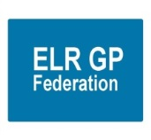
ELR GP Federation Ltd

Chief Operating Officer Report – July 2019

- Primary Care Networks

An update on the PCNs is shown in the table below;

PCN | ACD | Federation support
MSV (Melton, Syston, Vale) | Dr Fahreen Dhanji | - Led the development of the Mandatory Agreement Schedules and will develop a Business Plan for the PCN.  - Agreed an initial fee @ £3,350 +VAT for this work (final amount TBC).  - On-going support TBC.
North Blaby (FH, Limes, Glenfield, Enderby, Kingsway) | Dr Simon Vincent (The Limes) | - Managed ACD recruitment process.  - Led the development of the Mandatory Agreement Schedules and will develop a Business Plan for the PCN.  - Agreed an initial fee @ £3,850 +VAT for this work.  - Non-voting member of the PCN Board.  - On-going support TBC.
South Blaby (Countesthorpe, Northfield, Masharani, Wycliffe, Hazelmere) | Dr Rachel Omand, (Northfield) | - Nick Glover indicated that Fed support could be helpful and he supports the proposal for the Fed Board to provide a forum for the ACDs to meet and direct the business of the Fed.  - Meeting with Rachel Omand (ACD) TBC.  - JW provided a draft set of Mandatory Agreement Schedules.
Rutland (Oakham, MOSS, Empingham, Uppingham) | Dr Hilary Fox, (MOSS) | - The Fed managed the ACD recruitment process.  - The PCN has agreed for the Fed to support the development of the PCN @ 20p per patient, to include demand management.
OWI (Severn, Wigston Central, Bushloe, Washbrook, Rosemead) | Dr Richard Palin (Bushloe) | - The Fed managed the ACD recruitment process.  - Led the development of the Mandatory Agreement Schedules and will develop a Business Plan for the PCN.  - Agreed an initial fee @ £3,850 +VAT for this work.  - Non-voting member of the PCN Board.  - On-going support TBC.
Harborough (SLMG, Billesdon, Croft) | Dr Anuj Chahal, (SLMG) | - Anuj Chahal has indicated that it will be helpful for the Fed to support the PCN development, subject to agreeing costs.  - JW provided advice on the Mandatory Agreement Schedules.
Market Harborough / Husbands Bosworth | Dr Hamant Mistry | - No support agreed.

- ACDs update
- A key next step for the Federation is to determine the future role of the PCN Accountable Clinical Directors (ACD) on the Federation Board and the scope of the Federation’s future role in supporting the Practices in ELR.
- Rysz met with ACDs in June 2019 to start this conversation. The ACDs are broadly supportive about working with the Federation and have requested further information on costs – see email exchange below;

Dear Simon,

Thank you for the update. The summary provided for yesterday's meeting was trying to give an overview rather than the full detail that we review at the board meetings, but we will revise and expand the detail for further discussion.

My summary points for your consideration would be to:
- ​Emphasise the quantity of work that will be expected, and as Richard identified it would be very easy to get dragged into providing a presence at a variety of meetings taking you away from the core work that you want to do, and having an additional resource to assist with this via the Federation can help with this.
- Public Health, secondary care, and other organisations are already indicating their intent and desire to be involved with PCNs but at scale, and across LLR not just ELR.
- There is no doubt that the reporting back that will be required will increase, and doing this across all PCNs allows economies of scale.
- The opportunities to use your Federation for a key role over the next years is there to be developed
- Other Federations locally have all by one means or another had and continue to have a levy from practices to support their running. We had tried to avoid doing this for as long as possible, but this is a point where supporting the organisation has to be considered in terms of the opportunities and support that it can bring, which will then enable greater savings in the future. The Federation is there to work for our practices and PCNs and, as in other Feds there has to be investment in that. Ensure value for money without doubt, do not try to prune the costings to such an extent as Paula indicated to make the Federation unable to be effective, and please consider the shorter and longer term benefits that a relatively small investment of non practice monies can make to enable works to be developed as indicated, free up ACDs and practice staff to get on with their core functions, and reduce the risks that practices might otherwise be facing particularly in the next 2-3 years.
Kind regards,
Rysz

From: Simon.Vincent@GP-C82055.secure.nhs.uk <Simon.Vincent@GP-C82055.secure.nhs.uk>
Sent: 19 June 2019 14:38
To: james.watkins@elrgpfed.com; Ryszard.Bietzk@GP-C82010.nhs.uk; BIETZK, Ryszard (NHS EAST LEICESTERSHIRE AND RUTLAND CCG)
Cc: FOX, Hilary (NHS EAST LEICESTERSHIRE AND RUTLAND CCG); Anuj.Chahal@GP-C82001.nhs.uk; fahreen.dhanji@GP-C82038.nhs.uk; Rachel.Omand@GP-C82068.nhs.uk; Simon.Vincent@GP-C82055.nhs.uk; HK.Mistry@GP-C82009.nhs.uk; r.palin@gp-c82013.nhs.uk
Subject: ELR GP Federation

Dear Rysz & James

First of all, thank you Rysz for coming to our meeting last night, much appreciated.

We had a good discussion after you left Rysz. Whilst all around the table agreed that we need a group that we represent ELR PCNs at scale to provide influence and the ability to bid for bigger projects there was considerable concern regarding the extent of the projected shortfall for 2019/20 which appeared to amount to approximately £100k without PCN support. The figures and what they related to were however rather vague and unclear (eg General Admin £30k).

James, would it be possible in the next couple of weeks to develop a spread sheet that precisely details income and expenditure along with an analysis of cost savings that could be implemented and rescue plan?
Our next meeting is scheduled for Tuesday 9th July at 17:30 to be held at Kibworth Health Centre. Would it be possible for you to attend for the first part of the meeting?

Simon, on behalf of ELR ACD's

- JW has circulate the budget update information – see Appendix 1 – and will be meeting with the ACDs on Tuesday 9th July 2019 to progress the discussion regarding the future role of ELR GP Federation.

- Localities & transformation fund update
- The various projects have now mainly completed.
- We are in the process of reconciling the project budgets in order to arrange final payments, as appropriate.
- Harborough have decided to extend their FCP pilot until March 2020 and we have assisted the Practices to put a contract in place with Jamie Bell Physiotherapy Ltd.
- We will support the SLAM Locality to review its ECP Project.
- The Federation coordinated the Q4 reports which were reviewed at the final CCG panel on 28th May 2019. We have been asked to prepare an overall summary report of the achievements of the TF projects, comparison between projects where appropriate, lessons learnt and recommendations.

- Urgent Care / extended primary care

Report on progress as included in the Board Pack as Paper C. The key points listed in the Executive Summary are shown below;

- 111% of contracted capacity provided April 19 (5813 slots)
- 3.3% DNA rate , 149 appointments
- 54% Walked In; 35% booked via NHS111/CNH; 11% were booked by ELR GP Practices.
- Oadby 68% Walk In
- 58% of activity ELRCCG patients ; 28% LCCCG patients
- Oadby seeing more patients from LCCCG area (44%) than from ELRCCG area (43%)
- Performance exceptionally good 4hrs 99.9% ; 1hr 98%+
- To mitigate short 2.5hr shifts in the evening – creative thinking required to combine and extend resource used in other services
- Fragility in the resilience of provision - single clinician manned locations as Commissioned.
- To mitigate short 2.5hr shifts in the evening – creative thinking to combine and extend resource used in other services

- NHS England; Clinical pharmacists in general practice Project
- The contract between the Practices and PSS has been finalised.
- The first Pharmacist started at the beginning of June 2019.
- The second Pharmacist decided not to join the scheme, however PSS have recruited a replacement who started at the beginning of July 2019.
- We are arranging for the Lead Practices to complete the Enhanced Service Agreement with NHS E. NHS E have now advised that we should use their original template; having asked us to wait for their update which has not been issued.
- The Federation will invoice the Practices for their share of its admin fee (@ £5K); which was included in the proposal.

- Community Based Services
- Further to Leicestershire CC written confirmation that our contract will be extended into the third year; JW has emailed the sub-contracting Practices to update them.
- HP is confirming with our sub-contracting practices their schedule of fitters and their evidence to practice and indemnity certificates.

- Correspondence management
- A workshop will be organized for the autumn of 2019 for admin staff and GPs from the participating Practices to update on their progress and share best practice.

- Demand Management
- RB is working with the CCG / East Mids / Lancs CSU review of demand management information.
- The future scope of the Federation’s input will be determined as part of the discussions with the PCN ACDs.

- Referral support service (RSS)
- Danah Cadman (CEO, PCL) has indicated that PCL is keen for the Federation becomes a contractor for the provision of RSS services.
- This will be considered as part of the review of the Federation’s future role with the PCN ACDs.

- Diabetes nurse specialists
- Additional funding has been identified to extend the project into FY19/20 and LHMP have agreed to employ the DSNs until March 2020.
- One DSN has resigned from the project.
- Arrangements are being put in pace with the other two DSNs and a DSN, who we originally appointed but was initially unable to provide any sessions to the project, to provide support to the Practices during FY19/20.
- JW will write up a clinical governance process to assure this scheme for Board consideration.

- GP TeamNet
- The tool is being used by Practices and Localities to varying degrees.
- Each Locality has a portal which will help with PCN development.
- Further workshops will be arranged to support PCN development.
- The two-factor login arrangements are being developed which will enable the CCG to use the tool. This needs to be finalized.
- The order has been raised for Year 2 for Five Localities plus SLMG. Hina is collecting the outstanding funds in order to pay the invoice.
- GP TeamNet has functionality that could support internal ‘bank’ working; which will be investigated further.

- H Pylori
- We have received verbal confirmation that the contract will be rolled forward into FY19/20; but still await written confirmation.

- GDPR – DPO service
- An offer was circulated to Practices to renew the DPO service for a further year.
- Some Practices have indicated their wish to continue the service.
- However, we are waiting for clarification on the CCG’s position in light of the national guidance that indicates that they may be responsible for providing this service to Practices.
- The BMA have recently issued guidance – see Appendix 2.

- Fracture Liaison Service (FLS) project
- Tim Jones (Osteoporosis Society) has updated the Business Case to respond to CCG comments – which need to be reviewed by GC / JW.

- INR STAR
- The contract with LumiraDX on behalf of member Practices has been finalised.
- The CCG will pay for the final two weeks on March 2019 – which still needs to be finalised.

- Second blood collection
- We await further information from the CCG Joint Management Team.

- Active signposting
- ELR CCG has asked the Federation to coordinate a pilot within 1/2 Localities to support practices with Active Signposting
- Two sessions with the OWI and Rutland Practices have now taken place (March and July 2019).
- A final session will be scheduled for the autumn 2019.

- Diagnostic hubs
- No further progress – we will follow-up with Helen Mather’s team.

·
- Finance
- Draft schedules for the FY18/19 accounts will be tabled at the meeting.
- The Federation is now registered for VAT.
- The Federation has been receiving a rebate from HMRC on the basis that it is a small company. JW has questioned whether the Federation is eligible for this rebate and we await advice from Ballards.

Appendix 1 – ELR GP Federation Budget Update

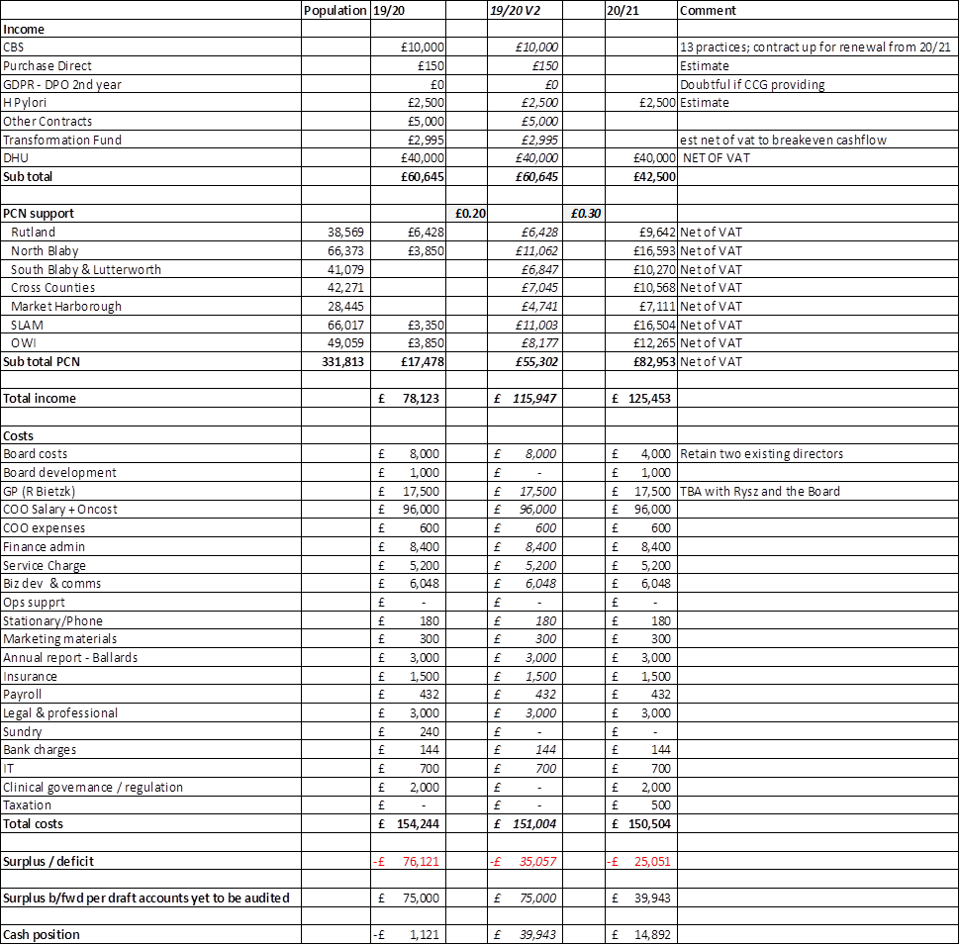

Appendix 2 – DPO guidance from the BMA

From: GPC Local Medical Committees discussion list <LMC-L@LISTSERV.BMA.ORG.UK> On Behalf Of Daniel Hodgson
Sent: 04 July 2019 17:10
To: LMC-L@LISTSERV.BMA.ORG.UK
Subject: DPO statement from NHS England
Hi all,
Following significant engagement from GPC over the last few weeks, and in response to several LMCs and practices which are experiencing issues on this matter, please see below message that has gone out to CCGs today from NHS England:
GP Practice and CCG Responsibilities for Data Protection Officers (DPO)
Since April 2018, CCGs have been required to provide IG advice and DPO support to practices. The new GP contract announced that this mandatory requirement would be extended. In 2019, CCGs are required to offer a Data Protection Officer (DPO) function to practices in addition to their existing DPO support services. This DPO function can be provided by the CCG direct or through its commissioning support service. Funding has been made available in CCGs’ baseline to support this requirement. The new Primary Care (GP) Digital Services Operating Model, due to be published in July, includes detail about CCGs’ responsibilities. The requirements are as follows:
Mandatory Requirements for CCGs
IG advice and Data Protection Officer (DPO) Support:
- Provision of advice, guidance and support on IG related issues including existing operational processes and procedures or new business initiatives to support practice designated Data Protection Officers including existing operational processes and procedures or new business initiatives. This includes:
· Access for practices during normal service hours to specialist qualified advice on GDPR matters;
· Advice on compliance with GDPR obligations;
· Advice reflecting national guidance on GDPR compliance as it is published;
· A review at least annually to identify and improve processes which have caused breaches or near misses, or which force practice staff to use workarounds which compromise data security. This may for example be a facilitated workshop at CCG level which would encourage shared learning;
· Advice to support practices develop and maintain best practice processes that comply with national guidance on citizen identity verification;
· Advice to support practices achieve mandatory compliance with the National Data Opt-Out policy by March 2020.
- DPO Function (New requirement from April 2019):
- As data controllers and “public authorities” general practices are legally required to designate a DPO.
- CCGs are now required to provide a named DPO for practices to designate as their Data Protection Officer. The named DPO could be shared between practices.
- Practices may choose to make their own DPO arrangements. CCGs are not expected to fund alternative arrangements, if a DPO service has already been offered by the CCG. However a CCG may at its discretion offer to fund these alternative arrangements.

Best wishes,
Dan
Daniel Hodgson
Head of Independent Contractors
Pay and Contracts
Policy Directorate
British Medical Association
T: 020 7383 6735 | E: dhodgson@bma.org.uk

