Communications Update
August 2019

Annual Report 2018/19

Work is well underway on the Annual Report 2018/19.

Last year’s title was “Our Second year – maturing and delivering”. This year, the title will be “Our Third year – supporting transformation”

The Report will focus on four main themes:
- Confirmation and details of our delivery supporting Transformation Fund projects – with details of outcomes;
- Our success in securing and delivering contracts – including the Urgent Care Centres contract and our partnership with DHU;
- Developments in primary care in line with the NHS Five Year Forward View – in particular, the creation of Primary Care Networks; and
- Our support for the creation of PCNs.

Looking forward, the Annual Report will contain details of our thinking around the future of the Federation in the light of creation of Primary Care Networks, to position the Federation strongly at the heart of the emerging agenda. A draft will be produced and circulated during September.

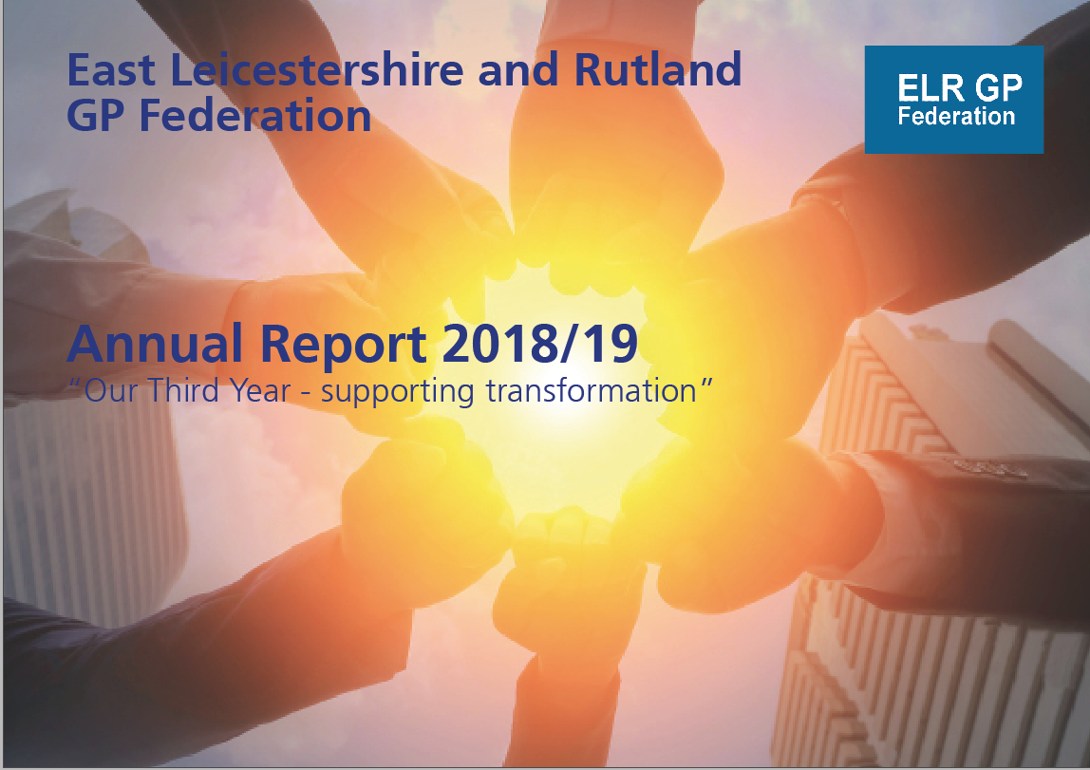

Opportunities for the Rutland Hub

The creation of the Rutland Hub and associated practice websites has been a considerable success. The Hub website is totally unique in the NHS and has received praise nationally from NHS Digital and national NHS England and NHSI Communications leaders.

With the creation of the Rutland Primary Care Network, we now have the opportunity to continue its development and further enhance the reputation of the Rutland practices as a seedbed of innovation. We have replaced the Rutland Health logo with a new Rutland Primary Care logo and changed the description text on the opening page as well.

We have been asked by Hilary Fox whether it would be possible to have a blog on the Rutland Health website which could be pushed out to each of the individual practice websites. We have told Hilary that the simple answer is “yes’. This is exactly what the Rutland Hub website was designed to do.
On the one hand, it can and does aggregate material from each of the practice websites and bring it into the Hub. Material such as news announcements and opening times are the main content that uses this function. On the other, it has the ability to create once at the Hub and send it out to any number of practice websites. We haven’t used that facility until now, because the steering group decided they would prefer Hub-wide material to stay only on the Hub site. But we could create a blog for Hilary and have it farmed out to the practice sites.
We also have welcomed an idea from Hilary for a short video promoting the PCN and Hub is excellent and can easily be done.

We also continue to have discussions around an exciting idea for social prescribing support via the Hub.
Communications support for PCNs

The communications support we have provided for the Federation since its inception has been highly successful in establishing its brand and reputation, as well as projecting the Federation as credible, professional and innovative.

We strongly believe that we can and should offer a similar service to individual PCNs. This could be done as a menu of options from which they could choose, including:
- Standalone website;
- Hub and Spoke websites between a central reworked “ELR GP Federation” website and individual PCN websites;
- Hub and Spoke websites between the PCN and member practices – along the Rutland PCN model;
- Social Media;
- Production of Annual Reports;
- Design and production of promotional materials (e.g. leaflets, posters, banners, Annual Report; and
- Promotional videos, blogs.

We would be keen for the Federation to facilitate conversations with the PCNs around these opportunities as part of its package of back office support.

GDPR DPO Service

In the light of the decision by the CCG to award a contract to the CSU to provide a DPO service to ELR practices, the Federation DPO Service has now ceased.

We have created the following automated message which will be received in future by anyone e-mailing dpo@elrgpfed.com

"Since May 2018, we have been pleased and proud to provide a high class 24 hour Data Protection Officer service for all practices across East Leicestershire and Rutland.
This has involved us providing:
- The DPO function;
- Access to a self-assessment toolkit to enable self- assessment and review by the DPO of current level of GDPR readiness;
- Initial review by the DPO of that self assessment with comments or advice;
- An e-mail first point of contact for data protection issues questions;
- Liaison with the ICO, DH, NHS England, BMA as necessary on issues relating to GDPR.
- Ask the DPO question and comment form;
- Over 100 GDPR FAQs;
- Sample html code to use as a GDPR page for your practice website.
The service has been used heavily by practices and the response to them to the quality and responsiveness of the service they have received has been warm and appreciative. Most practices had indicated their desire to continue with the service.
Due to changes in the GP contract, responsibility for arranging the DPO service passed to the CCG from 1 April this year. So as not to cause disruption to our members, we continued to provide an interrupted service to all our practices without payment whilst continuing to seek clarification from the CCG as to their intentions.
We made clear to the CCG that we were able and willing to continue to provide this popular and high quality service, which was an option open to them under the contract instructions issued by NHS England, but we have been informed that they have decided instead to commission the service from the Midlands and Lancashire CSU.
We have according been forced to turn off the ELR DPO service with immediate effect.
Practices will now need to contact the CSU Information Governance Service Hub (Monday to Friday 9:00am  5:00pm) Tel: 01782 872 648 Email: mlcsu.ig@nhs.net to confirm how the new arrangements will work.
They also will need to contact the Information Commissioners Office to inform them of their change of DPO.
We are grateful to all practices for the warm comments and feedback we have received throughout our period as the provider of your DPO Service.”

We remain very proud of the service we provided and, whilst we cannot change the decision of the CCG, we feel duty bound to put on the official record our deep unhappiness in the way the CCG acted in this regard. Neither us nor the Federation received any notice of their intention not to fund the continuation of the service, there was no consultation or conversation with us or any opportunity for us to competitively tender for the work, despite the fact it was highly valued by ELR practices and the majority of them were happy to continue to pay for the service.

General Support

Back office maintenance and work on core communications channels has been undertaken during August. To maintain performance, the website has been upgraded to the latest version of Wordpress, and all plug-ins upgraded and checked. We have also installed a new plug-in which will allow us to refresh the design, look and feel of the website as we move into our fourth year and potentially rebrand in the light of discussions with PCNs.

We have liaised with James and Hina over issues surrounding e-mail connectivity and storage. Whilst the service provided by J B McCrea Ltd continues to be fit for purpose and operates perfectly over the web, there appears to be an intermittent problem regarding offline access to e-mails via laptop. We have advised that this needs to be taken up with LHIS as the provider of the equipment. After a number of years, email storage has understandably grown. Options have been provided for them to consider.

Joe McCrea
Head of Communications and Engagement

August 2019.

