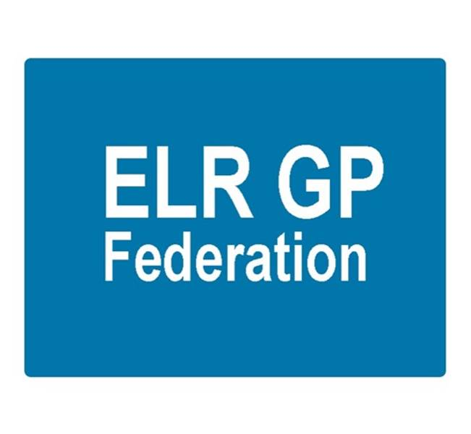

Board meeting
7.00pm 21st August 2019 @ Syston Medical Centre
AGENDA

 |  | Paper
 | Apologies
 | Review of Minutes of the Meeting held on 7th July 2019 | A
 | Matters arising
 | Report from the COO  - PCN development | B, C, D
 | Financial update  - FY18/19  - FY 19/20 Forward cash flow | To be tabled  To be tabled
 | Board issues
 | Communications update
 | Conflicts of Interest register
 | AOB
 | Date & venue of next meeting

