ELR GP Federation Ltd

Minutes of the meeting of The Board of Directors

Wednesday 7th July 2019 – Syston Medical Centre

**Present**: Dr R Bietzk (chair), Dr G Chidlow, J McCrea, J Watkins, Dr L Ryan, H Patel

1. **Apologies** – R Whitehead
2. **Minutes of the Shareholders’ General Meeting held in 22nd May 2019**

JW to make corrections – Dr Duru was present; Dr Ryan was not and check the quoracy section - and circulate to Shareholders. Final version @ **appendix A**.

1. **Minutes of the meeting held on 22nd May 2019**

Agreed as an accurate record with two corrections / amendments;

Page 2 – Washbrook includes South Wigston and Oadby central

Page 7 – point 7 – RB to clarify the name of the person who is taking the comms lead in relation to the development of PCNs in LLR.

1. **Matters arising** 
   * DSN project governance arrangements to be completed. ***Action JW***.
   * JW / GC to follow up the Fracture Liaison Service Business Case. ***Action JW / GC***
   * HP following up the fitters / accreditation for CBS sub-contractors. ***Action HP***
   * RW to review the Federation’s financial management. ***Action RW***
2. **COO Report**
3. **Primary Care Networks**

JW provided the following update on PCN development and the Federation’s support;

|  |  |  |
| --- | --- | --- |
| **PCN** | **ACD** | **Federation support** |
| MSV (Melton, Syston, Vale) | Dr Fahreen Dhanji | * Led the development of the Mandatory Agreement Schedules and will develop a Business Plan for the PCN. * Agreed an initial fee @ £3,350 +VAT for this work (final amount TBC). * On-going support TBC. |
| North Blaby (FH, Limes, Glenfield, Enderby, Kingsway) | Dr Simon Vincent (The Limes) | * Managed ACD recruitment process. * Led the development of the Mandatory Agreement Schedules and will develop a Business Plan for the PCN. * Agreed an initial fee @ £3,850 +VAT for this work. * Non-voting member of the PCN Board. * On-going support TBC. |
| South Blaby (Countesthorpe, Northfield, Masharani, Wycliffe, Hazelmere) | Dr Rachel Omand, (Northfield) | * Nick Glover indicated that Fed support could be helpful and he supports the proposal for the Fed Board to provide a forum for the ACDs to meet and direct the business of the Fed. * Meeting with Rachel Omand (ACD) TBC. * JW provided a draft set of Mandatory Agreement Schedules. |
| Rutland (Oakham, MOSS, Empingham, Uppingham) | Dr Hilary Fox, (MOSS) | * The Fed managed the ACD recruitment process. * The PCN has agreed for the Fed to support the development of the PCN @ 20p per patient, to include demand management. |
| OWI (Severn, Wigston Central, Bushloe, Washbrook, Rosemead) | Dr Richard Palin (Bushloe) | * The Fed managed the ACD recruitment process. * Led the development of the Mandatory Agreement Schedules and will develop a Business Plan for the PCN. * Agreed an initial fee @ £3,850 +VAT for this work. * Non-voting member of the PCN Board. * On-going support TBC. |
| Harborough (SLMG, Billesdon, Croft) | Dr Anuj Chahal, (SLMG) | * Anuj Chahal has indicated that it will be helpful for the Fed to support the PCN development, subject to agreeing costs. * JW provided advice on the Mandatory Agreement Schedules. |
| Market Harborough / Husbands Bosworth | Dr Hamant Mistry | * No support agreed. |

1. **ACDs update**

* Rysz met with ACDs in June 2019 to start this conversation. The ACDs are broadly supportive about working with the Federation and have requested further information on costs.
* JW circulated a budget update information and met with the ACDs on Tuesday 9th July 2019 to progress the discussion regarding the future role of ELR GP Federation and the idea that the ACDs joined the Board. We await feedback. ***Action JW***
* Once feedback has been provided, the Federation Board will suggest that a joint meeting is arranged with the ACDs to finalise the future approach. ***Action RB / JW***

1. **Localities & transformation fund update**

* The various projects have now mainly completed.
* We are in the process of reconciling the project budgets in order to arrange final payments, as appropriate.
* Harborough have decided to extend their FCP pilot until March 2020 and we have assisted the Practices to put a contract in place with Jamie Bell Physiotherapy Ltd.
* We will support the SLAM Locality to review its ECP Project.
* The Federation coordinated the Q4 reports which were reviewed at the final CCG panel on 28th May 2019. We have been asked to prepare an overall summary report of the achievements of the TF projects, comparison between projects where appropriate, lessons learnt and recommendations. ***Action JW***

1. **Urgent Care / extended primary care**

* The Board noted the report on the first month of operation of the contract. The key points listed in the Executive Summary are shown below;
* 111% of contracted capacity provided April 19 (5813 slots)
* 3.3% DNA rate , 149 appointments
* 54% Walked In; 35% booked via NHS111/CNH; 11% were booked by ELR GP Practices.
* Oadby 68% Walk In
* 58% of activity ELRCCG patients ; 28% LCCCG patients
* Oadby seeing more patients from LCCCG area (44%) than from ELRCCG area (43%)
* Performance exceptionally good 4hrs 99.9% ; 1hr 98%+
* To mitigate short 2.5hr shifts in the evening – creative thinking required to combine and extend resource used in other services
* Fragility in the resilience of provision - single clinician manned locations as Commissioned.
* To mitigate short 2.5hr shifts in the evening – creative thinking to combine and extend resource used in other services
* The three Federation Directors on the JV Board will be RB, RW and GC.
* The Shareholding Agreement is being finalised.

1. **NHS England; Clinical pharmacists in general practice Project**

* The contract between the Practices and PSS has been finalised.
* The first Pharmacist started at the beginning of June 2019 and is working well.
* The second Pharmacist decided not to join the scheme, however PSS have recruited a replacement who started at the beginning of July 2019.
* The Lead Practices to complete the Enhanced Service Agreement with NHS E. NHS E have now advised that we should use their original template; having asked us to wait for their update which has not been issued. ***Action JW***
* The Federation will invoice the Practices for their share of its admin fee (@ £5K); which was included in the proposal. ***Action JW***

1. **Community Based Services**

* Further to Leicestershire CC written confirmation that our contract will be extended into the third year; JW has emailed the sub-contracting Practices to update them.
* HP is confirming with our sub-contracting practices their schedule of fitters and their evidence to practice and indemnity certificates. ***Action HP***

1. **Correspondence management**

* A workshop will be organized for the autumn of 2019 for admin staff and GPs from the participating Practices to update on their progress and share best practice. ***Action JW***

1. **Demand Management**

* RB is working with the CCG / East Mids / Lancs CSU review of demand management information.
* The future scope of the Federation’s input will be determined as part of the discussions with the PCN ACDs.

1. **Referral support service (RSS)**

* Danah Cadman (CEO, PCL) has indicated that PCL is keen for the Federation becomes a contractor for the provision of RSS services.
* This will be considered as part of the review of the Federation’s future role with the PCN ACDs.

1. **Diabetes nurse specialists**

* Additional funding has been identified to extend the project into FY19/20 and LHMP have agreed to employ the DSNs until March 2020.
* One DSN has resigned from the project.
* Arrangements are being put in pace with the other two DSNs and a DSN, who we originally appointed but was initially unable to provide any sessions to the project, to provide support to the Practices during FY19/20.  ***Action JW***
* JW will write up a clinical governance process to assure this scheme for Board consideration. ***Action JW***

1. **GP TeamNet**

* The tool is being used by Practices and Localities to varying degrees.
* Each Locality has a portal which will help with PCN development.
* Further workshops will be arranged to support PCN development.
* The two-factor login arrangements are being developed which will enable the CCG to use the tool. This needs to be followed up. ***Action JW***
* The order has been raised for Year 2 for Five Localities plus SLMG. Hina is collecting the outstanding funds in order to pay the invoice. ***Action HP***
* GP TeamNet has functionality that could support internal ‘bank’ working; which will be investigated further.

1. **H Pylori**

* We have received verbal confirmation that the contract will be rolled forward into FY19/20; but still await written confirmation.

1. **GDPR – DPO service**

* An offer was circulated to Practices to renew the DPO service for a further year.
* Some Practices have indicated their wish to continue the service.
* However, we are waiting for clarification on the CCG’s position in light of the national guidance that indicates that they may be responsible for providing this service to Practices. JW to follow up with Tim Sacks / Sharon Rose. ***Action JW***
* JW to send the recently issued BMA guidance to Sharon Rose.  ***Action JW***

1. **Fracture Liaison Service (FLS) project**

* Tim Jones (Osteoporosis Society) has updated the Business Case to respond to CCG comments – which need to be reviewed by GC / JW. ***Action GC / JW***

1. **INR STAR**

* The contract with LumiraDX on behalf of member Practices has been finalised.
* The CCG will pay for the final two weeks on March 2019 – which still needs to be finalised. ***Action JW***

1. **Second blood collection**

* We await further information from the CCG Joint Management Team.

1. **Active signposting**

* ELR CCG has asked the Federation to coordinate a pilot within 1/2 Localities to support practices with Active Signposting
* Two sessions with the OWI and Rutland Practices have now taken place (March and July 2019).
* A final session will be scheduled for the autumn 2019.  ***Action JW***

1. **Diagnostic hubs**

* No further progress – JW to will follow-up with Helen Mather’s team. ***Action JW***
* LR to speak to Sarah Smith. ***Action LR***

*·*

1. **Finance**

* The Board reviewed the financial schedules contained in the minutes of the previous meeting (May 2019) – **see appendix B**. Key points noted;
  + A surplus will be achieved in FY18/19 (c. £75K) (subject to the treatment of the CCG start-up fund and the outcome of the review of the rebate from HMRC - as per the advice from Ballards). This is due to the work completed on the Transformation Projects;
  + Consequently, a reserve will be carried forward to FY19/20 – this was a deliberate plan to help cover the Federation’s operating costs during FY19/20 during a period where the CCG start-up fund / ‘grant’ ceases and PCNs are being developed.
  + The main elements of future cash-flow will be the DHU JV payment and income from the PCNs for their development and operation. The future working / ‘fee’ arrangements with the PCNs are being developed and will be finalised asap. ***Action JW***
* The Federation is now registered for VAT.
* The Federation has been receiving a payroll rebate from HMRC on the basis that it is a small company. JW has questioned whether the Federation is eligible for this rebate and we await advice from Ballards. ***Action JW/HP***
* The recent VAT advice from Ballards included in the minutes of the Board meeting of 22nd May 2019 in relation to the various schemes to support Practices and the treatment of the start-up fund received from the CCG was noted by the Board who confirmed its acceptance of this advice and that the Company should proceed on this basis.
* Robert Whitehead will review the Federation’s financial management arrangements and make recommendations, as appropriate. ***Action RW***

1. **Board issues**

* A letter has been sent to Kirsty Whawell advising that the Federation will take the necessary steps to remove her as a Director as she is no longer an employee of a Sharholder Practice.
* Further to the agreement at the Extra-ordinary meeting on 22nd May 2019, the election of the Directors who are due to retire by rotation in May 2019 will be deferred until the end of October 2019 during which time a discussion will take place with the PCN ACDs regarding the future scope of the Federation and the option of them becoming Federation Board Directors.
* HP to review the patient numbers and the associated impact on Practices’ shareholding, which will include arrangements for removing Narborough Health Centre. ***Action HP***
* HP will arrange for Kirsty Whawell and Nainesh Chotai to be removed as Directors. ***Action HP***
* It was agreed to defer the Annual Shareholders meeting will take place until **10th October 2019 at College Court** to allow sufficient time to complete the discussions with the ACDs regarding the future Board structure. ***Action JW***

1. **Communications**

* The Rutland Hub will provide the Rutland PCN with a useful tool for developing joint working. JM/JW to consider how this web hub tool could be rolled out in other Localities / PCNs. ***Action JM/JW***
* Update the website with information on the Transformation Fund projects. This will also be used to inform the annual report. ***Action JM / JW***

1. **Date & venue of next meeting**

Tuesday 21st August 2019 @ 7pm @ Syston Health Centre.

**Action Log**

|  |  |  |  |  |
| --- | --- | --- | --- | --- |
| **Id** | **Detail** | **Who** | **Update** | **Status** |
| 1 | CQC registration | JW | JW spoken to CQC. We need a contract to trigger an application. | G |
| 2 | Business Plan for FY19/20 | JW | Summary complete | G |
| 3 | Fracture Liaison Service Biz Case | GC/JW | Biz plan updated following information requests from CCG meeting. This needs to be reviewed. | A |
| 4 | NHSE Pharmacists scheme implementation | JW | Finalised the practices will take part. Portal updated. NHS E have confirmed funding. 2WTE pharmacists recruited. SLA/ contract completed. Enhanced service agreement to be signed off. | G |
| 5 | Finalise Federation TF fee arrangements | JW | Complete | G |
| 6 | Urgent Care;   * Follow up Localities / Practices * Finalise JV legals * Organise for resolution of shareholders | JW  JW  JW | Complete  In hand  Complete | G |
| 7 | CBS contract –   * Update accreditation and indemnity details * Comms to Practices * Indemnity arrangements | HP  JW  JW | In process  Complete  Complete | A |
| 8 | Correspondence management workshop | JW | In hand. | G |
| 9 | Clinical governance process for DSN project | GC/JW | Gareth advised on the approach. To be completed. | A |
| 10 | DSN recruitment | JW | In hand | G |
| 11 | GPTeamNet – Y2 quote / implementation | JW | Contract signed. Two factor log-in in hand. Invoice for Y2 in hand. | G |
| 12 | H Pylori contract – check FY19/20 | JW/GC | Verbal confirmation that the contract will be rolled forward. | G |
| 13 | Establish skills / GPSIs in LLR for RSS | JW | In hand | G |
| 14 | DPO | JM/JW | Offer for contract extension circulated to Practices but we are waiting for the CCG to confirm their position. | A |
| 15 | PCN ACDs to become Federation Board Directors / future involvement of the Federation with PCN management and associated budget considerations | RB | Plan to involve / co-opt the ACDs – in hand. Meeting held. Joint meeting btw ACDs and Fed Board to be arranged once a way forward is outlined. | G |
| 16 | Complete Board / shareholder removals | HP | Uppingham/Kingsway/Severn/MHMP to be completed. | A |
| 17 | Investigate the option of becoming a CIC | JW | In hand | G |
| 18 | Policy development | JW | To be developed, as required. | A |
| 19 | VAT registration | HP | Complete | G |
| 20 | Demand management identify next steps and funding for FY19/20 | RB/JW | In hand | G |
| 21 | Locum service next steps | JW | Investigating GPTeamNet potential. | G |
| 22 | Diagnostic hubs proposal | JW / LR | Follow up with Simon Carr / Sarah Smith | A |
| 23 | Review share allocations in light of updated list sizes and determine approach for Narborough shares. | HP/JW | TBD | A |
| 24 | Rutland ECP pilot | RB / JW | Q1 pilot commenced | G |
| 25 | RSS – preparations | JW | Meeting arranged with Danah Cadman – complete. | G |
| 26 | INR – obtain quotes & implement | JW / KW | Complete. CCG invoice for the last two weeks of March to be completed. | G |
| 27 | PCN development – proposal to support Localities | JW | In hand | G |
| 28 | Invite Noel O’Kelly and Jude Smith | JW | In hand | G |
| 29 | Organise follow-up Active Signposting workshops | JW | In hand | G |
| 30 | Review financial management | RW | List to be developed | A |
| 31 | Transformation Fund review report | JW | In hand | A |
| 32 | Follow-up payroll rebate | JW/HP | In hand | G |
| 33 | Change shareholders meeting date to 10.10.19 | JW | In hand | G |
| 34 | Update website with Transformation Fund projects and consider how to roll out the ‘digital hub’ concept | JM/JW | TBC | A |
|  |  |  |  |  |
|  | **Archived Actions** |  |  |  |
|  | Follow-up meeting with Tim Sacks re projects / funding options | JW / RB | Complete | G |
|  | Blaby & Lutterworth Board Director vacancy | JW | No response to the advert. Dr Louise Ryan co-opted. | G |
|  | O&W Director recruitment | JW/JM | Robert Whitehead appointed. | G |
|  | Cancel VitruCare contract | JW/RB | Complete | G |
|  | Physio contracts | JW | Harborough and O&W complete. | G |

**Appendix A**

ELR GP Federation Ltd

General Meeting of Shareholders

Wednesday 22nd May 2019 – Syston Medical Centre

**Present**: Dr R Bietzk (chair), Dr G Chidlow, Dr C Metcalf, Dr S Ghosh, Dr C Duru, J McCrea, J Watkins, R Whitehead, H Patel

1. **JW confirmed that holders of >80% of Ordinary Shares were either in attendance or had appointed a proxy to vote on their behalf.** The quorum at any general meeting of the Company shall be holders of 51% or more of the Ordinary present in person or by proxy and therefore the meeting was quorate.
2. **Directors**

Three Directors came to the end of their three year terms in May 2019 and the Federation Board positions are therefore up for election.

The Federation has developed a proposal to use the ELR GP Federation to support PCN development and provide a forum for them to work together.

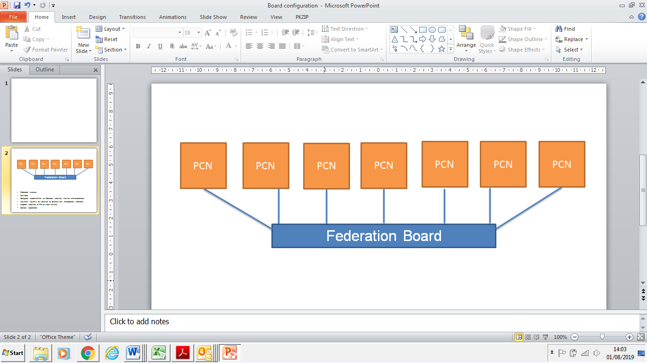

It has been proposed to co-opt the PCNs ACDs onto the Federation Board (if they are not already a Director) to shape and focus the Federation business on activity that supports PCNs to operate effectively; providing a forum for debate at the ’30 level’.

**To allow this proposal to be discussed with the new Accountable Clinical Directors (ACD); it was agreed to defer the election of the Federation Board Directors until the end of October 2019.**

1. **Proposal to form a Joint Venture with DHU**

The proposal (Appendix 1) was approved unanimously.

1. **Removal of a Director**

In line with the Federation’s Articles of Association and Shareholders’ Agreement; it was agreed that Mrs Kirsty Whawell should be removed as a Director as she was no longer an employee of a Shareholding Practice.

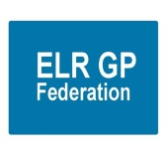**Appendix 1 - Proposal to form a Joint Venture with DHU**

1. **Introduction**

Shareholders will be aware that, in partnership with DHU, ELR GP Federation bid successfully for the contract to manage the ELR Integrated Urgent Care Centres (see configuration below).



**The Federation is now in the process of formalising the Joint Venture Agreement with DHU and requires a resolution of its Shareholders to establish this agreement, in accordance with the Articles of Association of ELR GP Fed Ltd.**

1. **Overview of DHU Health Care CIC**
2. DHU Health Care CIC is a social enterprise and a not for profit company, known locally as DHU.
3. The company was established in April 2007 as a result of a merger between two Derbyshire based companies that were set up by local general practitioners. DHU is now officially classified as a medium sized organisation under The Companies Acts definition and are consequently large enough to be operationally robust but small enough to care and to be flexible in meeting commissioners’ requirements.
4. DHU secured the contracts for GP Out of Hours Services for LLR and the Loughborough Urgent Care Centre on 13th May 2016, stepping in on a caretaking basis following the financial collapse of the previous provider, CNCS.
5. In Autumn 2016, the process for re-procurement of the new service models for urgent care commenced. DHU Health Care CIC has secured the first two contracts that were let by competitive tender. This includes;

* Integrated Primary and Community Urgent Care Service in West Leicestershire in partnership with 4FED (the combined West Leicestershire GP Federations)
* LLR Urgent Care Home Visiting Service which is a 24 hour a day, 7 day a week service spanning a population of 1.1 million

1. In addition DHU is continuing to provide a 24/7 Home Visiting Service to Leicester, Leicestershire and Rutland, the four City Hubs and the LRI Front Door and is continuing to provide and develop the Clinical Navigation Hub.
2. DHU’s ambition was to provide urgent care services across LLR recognising both the clinical benefits and economies of scale that a single provider can bring to LLR by managing capacity and demand across the patch in partnership with local GPs and their Federations.
3. DHU have invested heavily in LLR with the creation of an LLR Divisional Management and Governance Structure which includes an independent Chair, Managing Director, Clinical Director, senior operational and clinical leads along with dedicate support staff. The current structure has been developed to support further expansion.
4. **Benefits of partnering with DHU Health Care CIC**
5. **Tender Process** - ELR GP Federation would not have qualified to bid alone due to limited trading history and track record of mobilisation and delivery of large services. A Dun & Bradstreet score, which is based on financial strength (such as tangible net worth based on financial accounts) and risk indicators (such as minimum data to identify trading activity) is generally undertaken.

DHU Health Care CIC has significant trading history, having traded for the last 30 years, achieving profitable growth which has enabled it to invest its surplus in expansion – as a social enterprise.

The process of submitting a tender is complex, time consuming and requires significant investment in both time and money. Bidders are required to pass a preliminary compliance review, evaluation of qualification and an evaluation of a technical envelope.

1. **Capacity and Capability** - DHU had capacity and capability to invest in a large competitive tender with dedicated programme management, service model development, bid writing, financial modelling through to mobilisation of new contract. Furthermore, it can deliver a commercially viable bid by delivering greater efficiencies for commissioners operating at scale, in partnership and where mutually beneficial.
2. **Set up** – DHU can provide the working capital / early stage funding requirements for pay roll costs, overheads and back office infrastructure such as payroll, governance and financial accounting.
3. **Reputation and Track record** - DHU has a good local reputation and track record of delivery. In addition to mobilising NHS 111 contracts and the recent LLR contracts, DHU have continued to develop the Clinical Navigation Hub and has provided additional support to UHL front door due to staffing difficulties in LRI and the City Hubs.
4. **Arrangements with 4FED and LCH** - DHU has an existing joint venture for the delivery of West Leicestershire Integrated Primary and Urgent Care services in conjunction with 4 FED, (the combined West Leicestershire Federations). DHU is also working in partnership with Leicester City Health who cover 80% of the GP Practices in Leicester City.
5. **Future opportunities –** the creation of a Joint Venture with DHU will provide a vehicle that could bid for future opportunities.
6. **Basis of Proposed Agreement with ELR GP Federation**

It is proposed that the Joint Venture be structured in the following way from an organisational lead and delivery perspective;

1. **DHU expertise in the Joint Venture**

* Management control in the day to day delivery of the services; responsible to the Board.
* Clinical and non-clinical staff as required for the delivery of services within services.
* Clinical Leadership for both strategic and operational elements of integrated urgent care across East Leicestershire within the service.
* Back office support services required to, e.g. Clinical governance, Human Resources, Analytics, Facilities, Finance, Governance, Health & Safety, Insurance, IT and Business Continuity, Provision of data aspiring towards better integrated IT systems to support modelling and inform future service delivery through improved and integrated patient journey.
* Engagement in wider system changes, as appropriate within LLR.

1. **ELR Federation expertise in the Joint Venture**

* Practice engagement & collaborative working with Primary Care (sub-contract arrangements have been put in place with The Croft Medical Centre and Bushloe Surgery to provide the GPs required at Oadby UCC during ‘core hours’, Monday to Friday).
* Primary Care pathway interactions and streamlining of clinical pathways to improve patient experience in to and out of both the services.
* Provision of data aspiring towards better integrated IT systems, including risk stratification to support modelling and inform future service delivery.
* Clinical Leadership for both strategic and operational elements of integrated urgent care across ELR.
* Engagement in wider system changes (e.g. PCN development), as appropriate within ELR.

1. **Governance**

* The Joint Venture will be a Community Interest Company - *‘DHU East Leicestershire & Rutland CIC’* - and will be supported by a robust governance structure.
* A joint strategic Board will be formed to manage the strategic direction of the services with equal representation and voting rights for both parties and the appointment of an Independent Chair.
* The Federation will receive reimbursement for its contribution @ £48K (inc VAT) per annum
* In return for the Federation not being exposed in the event of a deficit; surplus will be retained by DHU up to a cap (TBA), beyond which it will be shared on a 50:50 basis.
* The draft Articles of Association and Shareholders Agreement for the JV are inserted below.

 

1. **Resolution**

**The Directors propose that a special resolution of the shareholders of ELR GP Fed Ltd is made to approve the formation of a Joint Venture CIC with DHU at its General Meeting on 22nd May 2019 @ Syston Health Centre @ 7pm.**

**Appendix B – ELR GP Federation Budget Report for FY18/19**

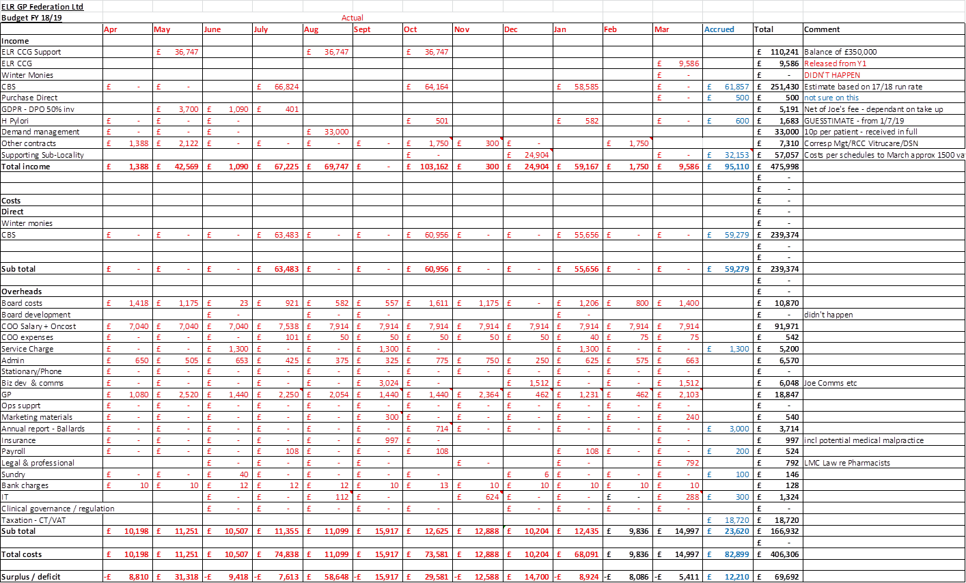

**Annex 2 – ELR GP Federation Budget Forecast for FY19/20**

