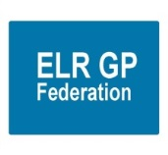**ELR GP Federation Ltd**

**Chief Operating Officer Report – August 2019**

1. **Primary Care Networks**

An update on the PCNs is shown in the table below;

|  |  |
| --- | --- |
| **PCN** | **Federation support** |
| MSV (Melton, Syston, Vale); ACD - Dr Fahreen Dhanji | * Led the development of the Mandatory Agreement Schedules and completed a First Business Plan for the PCN. * Agreed an initial fee @ £3,350 +VAT for this work. * Fahreen has indicated that the PCN wish the Federation to provide further support. |
| North Blaby (FH, Limes, Glenfield, Enderby, Kingsway); ACD – Dr Simon Vincent | * Managed ACD recruitment process. * Led the development of the Mandatory Agreement Schedules and completed a first draft Business Plan for the PCN. * Agreed an initial fee @ £3,850 +VAT for this work. * Non-voting member of the PCN Board. * The PCN has agreed that the Federation should provide further support. |
| South Blaby (Countesthorpe, Northfield, Masharani, Wycliffe, Hazelmere); ACD – Dr Rachel Omand | * Nick Glover indicated support for the proposal for the Fed Board to provide a forum for the ACDs to meet and direct the business of the Fed. * JW provided a draft set of Mandatory Agreement Schedules. * Met with Rachel Omand (ACD) – who indicated that the PCN have reservations about the Federation’s involvement. |
| Rutland (Oakham, MOSS, Empingham, Uppingham); ACD – Dr Hilary Fox | * The Fed managed the ACD recruitment process. * The PCN has agreed for the Fed to support the development of the PCN @ 20p per patient, to include demand management. * Schedules have been completed and a Business Plan drafted. * Supporting the Social Prescriber contract process. |
| OWI (Severn, Wigston Central, Bushloe, Washbrook, Rosemead); ACD – Dr Richard Palin | * The Fed managed the ACD recruitment process. * Led the development of the Mandatory Agreement Schedules and completed a first draft Business Plan for the PCN. * Agreed an initial fee @ £3,850 +VAT for this work. * Non-voting member of the PCN Board. * Supporting the recruitment process for a Social Prescriber. |
| Harborough (SLMG, Billesdon, Croft); ACD – Dr Anuj Chahal | * Anuj Chahal has indicated that it will be helpful for the Fed to support the PCN development, subject to agreeing costs. * JW provided advice on the Mandatory Agreement Schedules. * Provided a first draft Business Plan. |
| Market Harborough / Husbands Bosworth ; ACD – Dr Hamant Mistry | * Provided the PM with information on how the Federation could support the PCN – no feedback so far. |

1. **ACDs update**

* There have been a number of conversations about the PCN ACDs becoming the Federation Directors. JW summarised these conversations in a ‘proposed next steps’ paper for the ACDs to consider at their meeting on 13th August 2019 - see **Appendix 1**. Feedback is awaited.

1. **Localities & transformation fund update**

* We are finalising the project budgets in order to arrange final payments, as appropriate.
* A review of the ECP pilots with DHU needs to be completed.
* The Federation will prepare an overall summary report of the achievements of the TF projects, comparison between projects where appropriate, lessons learnt and recommendations.

1. **Urgent Care / extended primary care**

A Board to Board planning meeting took place on 5th August 2019 – paper @ **Paper C** – which includes an update on progress.

DHU are taking tax advice on two options;

1. the ‘hard’ JV as proposed
2. a ‘soft’ JV.

There will be three Directors from each party. The Federation Directors will be Rysz Bietzk, Gareth Chidlow and Robert Whitehead.

1. **NHS England; Clinical pharmacists in general practice Project**

* The contract between the Practices and PSS has been finalised.
* The first Pharmacist started at the beginning of June 2019 and is working well.
* The second Pharmacist started at the beginning of July 2019 but has since resigned. PSS have identified a replacement to interview.
* The Lead Practices have now completed the Enhanced Service Agreement with NHS E.
* The Federation has invoiced the Practices for their share of its admin fee (@ £5K); which was included in the proposal.

1. **Community Based Services**

* The contract is now in its third year of three – we have not yet been advised on the procurement process that LCC will use for FY20/21 onwards.
* HP has written to our sub-contracting practices to update their schedule of fitters and their evidence to practice and indemnity certificates.

1. **Correspondence management**

* A workshop will be organized for the autumn of 2019 for participating Practices to update on their progress and share best practice.

1. **Demand Management**

* RB is working with the CCG / East Mids / Lancs CSU review of demand management information.
* The future scope of the Federation’s input will be determined as part of the discussions with the PCN ACDs.

1. **Diabetes nurse specialists**

* Additional funding has been identified to extend the project into FY19/20 and LHMP have agreed to employ the DSNs until March 2020.
* One DSN (Maggie Bodington) has resigned from the project but will remain on a ‘zero hours’ basis to provide support as needed.
* Louise Stanleywho we originally appointed but was initially unable to provide any sessions to the project, will now provide support to the Practices during FY19/20.
* Marilyn Frost and Lyndsey Robinson will continue to support the project until March 2020.
* Update & Governance report attached at **Paper D.**
* Appraisals will be conducted with these nurses jointly by James Watkins and Mary Harrison from the Leicester Diabetes Centre.

1. **GP TeamNet**

* The tool is being used by Practices and Localities to varying degrees.
* Each Locality has a portal which will help with PCN development.
* Further workshops can be arranged to support PCN development.
* The two-factor login arrangements have been developed which will enable the CCG to use the tool. We await CCG feedback.
* The order has been raised for Year 2 for Five Localities plus SLMG. Hina has collected the outstanding funds and processed the invoice.
* GP TeamNet has functionality that could support internal ‘bank’ working.

1. **H Pylori**

* We have received verbal confirmation that the contract will be rolled forward into FY19/20; but still await written confirmation.

1. **GDPR – DPO service**

* We have had confirmation that the CCG will provide the DPO service.
* We have therefore advised the Practices that the Federation service has now finished.
* We are seeking payment from the CCG for the June-mid-July period when the service continued pending advice from the CCG on future arrangements.

1. **Fracture Liaison Service (FLS) project**

* Tim Jones (Osteoporosis Society) has updated the Business Case to respond to CCG comments – which need to be reviewed by GC / JW.

1. **INR STAR**

* We are arranging for the CCG to pay for the final two weeks on March 2019.

1. **Second blood collection**

* Yasmin Sidyot (Acting Director of Urgent and Emergency Care) has confirmed that the CCB want more information regarding how many patients end up at GPAU/E for re-bloods post spurious results and is waiting for this from UHL colleagues.

1. **Active signposting**

* ELR CCG has asked the Federation to coordinate a pilot within 1/2 Localities to support practices with Active Signposting
* Two sessions with the OWI and Rutland Practices have now taken place (March and July 2019).
* A final session will be scheduled for the autumn 2019.

1. **Other income**

* Working with Gareth / Rysz to pursue further contract income where possible and appropriate to work at scale - options include ENT, dermatology, minor surgery, diagnostics, Fracture Liaison Service, RSS. These may require CQC registration. Alternatively, we could use the Joint Venture with DHU.

1. **Diagnostic hubs**

* Meeting arranged with Simon Carr for 30th August 2019.

*·*

1. **Finance**

* Draft schedules for the FY18/19 accounts will be tabled at the meeting.
* We await advice from Ballards in relation to eligibility of the rebate that the Federation has received from HMRC on the basis that it is a small company.
* We have received clear advice from Ballards in relation to treatment of the CCG start-up fund as a grant – **see appendix 2.**

**Appendix 1 – ELR GP Federation Budget Update**

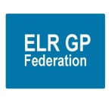**ELR GP Federation – proposed next steps for discussion**

1. **Context**

* Practices in ELR have formed Primary Care Networks (PCN), in line with the National Network Contract DES.
* Whilst PCNs have the freedom to organise themselves in line with their local context; there will be a range of areas where it will make sense for PCNs to operate within a sensible, strategic framework; providing consistency between PCNs and avoid ‘inventing the wheel’.
* It is important that the voice of primary care is clearly articulated at the CCG and wider LLR STP level. For this to be effective there will need to be a level of consistency with PCNs ‘pulling in the same direction’.
* Local NHS organisations will increasingly focus on population health and local partnerships with local authority-funded services through development of Integrated Care Systems (ICS). PCNs will be a key part in the formation and delivery of these services and, as such, ‘integrated PCNs’ will be stronger and provide a more coherent voice within this system.
* There will continue to be a range of issues where it makes sense to organise and/or hold contracts at the ‘30 practice level’.
* As such, it will be important that PCNs within ELR have a forum to work collectively and organise at a ’30 practice level’ where it makes sense to do so.

1. **The Federation’s progress**

The Federation was created by the Practices in ELR and has provided a range of support to Practices since it started including;

* Transformation Fund applications; supporting the development of the six Localities and project managing individual projects
* Other projects - Active Signposting, Correspondence Management, Pharmacist, Diabetes transformation, Demand Management, Rutland Health digital portal, merger support
* Contracts – Urgent Care, CBS, H Pylori, INR Star, DPO, FCP, ECP, GPTeamNet
* Facilitation / honest broker / change agent & project management
* Secured funding / savings for primary care projects @ **>£2 million**
* Supporting the development of PCNs in ELR
* These projects have been subject to the Federation charging a fee for service – the ‘5% barrier’

1. **Post PCN world**

* The Federation will build on its work so far with Practices to support PCN development and provide a forum for them to work together (see figure 1); in line with its strategic priorities;
* **Local service delivery & business development -** facilitating the delivery of more services locally; bidding collectively and / or holding contracts where it is helpful to do so
* **Resilience and sustainability –** innovating and transforming the way that services are delivered to address the pressures currently faced in the local health care system
* **Effective voice -** for our members across ELR

**Figure 1 – suggested structure of PCNs and Federation**

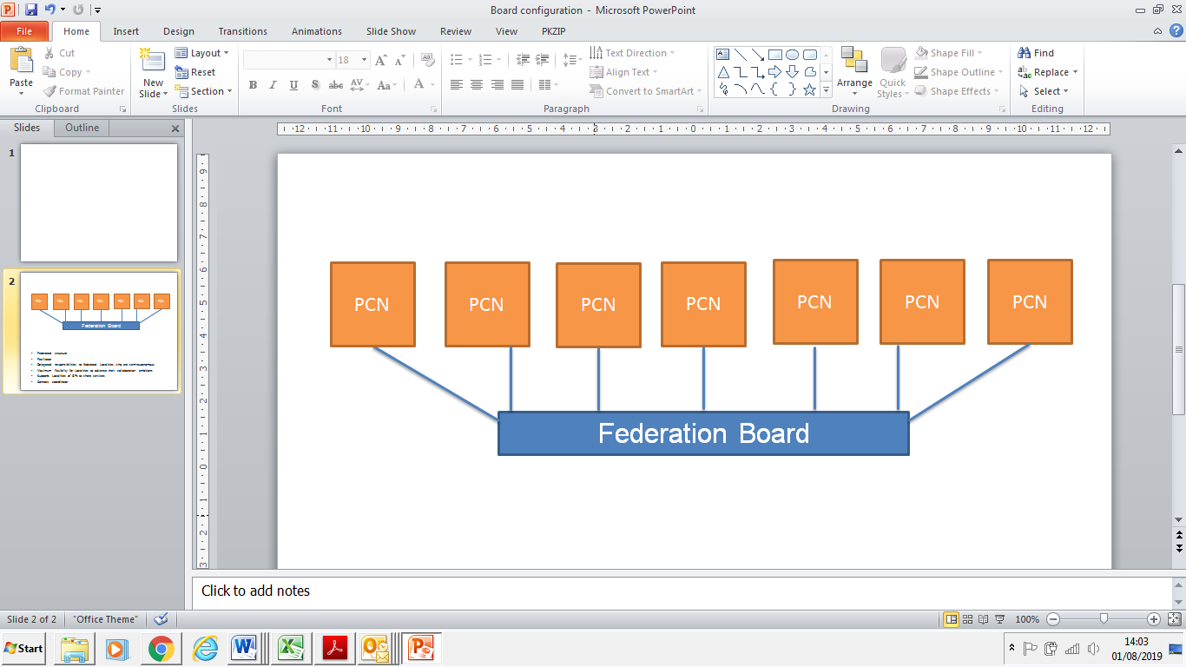

* The Federation’s future role should be shaped and determined by its member PCNs to support primary care in ELR and therefore the ACDs have been invited to join the Board to direct the Federation.
* Areas of ‘PCN support’ are outlined below.  This list is not exhaustive and the plan is that the PCNs / ACDs will inform and direct how this evolves.  The intention is to provide an equitable and consistent level of service, whilst recognising that PCNs’ needs will vary according to individual circumstances.
  + Network Agreement Schedules
  + PCN Business plan
  + Maturity Matrix support
  + Investment & impact fund preparation and proposal
  + ACD / PCN management support
  + Voice –strength in numbers
  + Legal entity – trading divisions
  + Facilitation / honest broker / change agent
  + Project management
  + Share knowledge - don’t reinvent the wheel
  + Back office
  + Demand management
  + Provide vehicle to engage at ‘ELR scale’ where appropriate; eg, with LPT, Public Health, CCG
* Contracts – Urgent Care, CBS, H Pylori, INR Star, GPTeamNet
* Pursue further contract income where possible and appropriate to work at scale - options include ENT, dermatology, minor surgery, diagnostics, Fracture Liaison Service, RSS. This may require CQC registration. Alternatively, we could use the Joint Venture with DHU.

1. **Proposed next steps**

**Board**

1. ACDs join the Federation Board to direct its business wef October 2019; details to be agreed (not all ACDs necessarily need to become legal Directors, in the first instance, but all would attend the Board meetings to shape the Federation’s business plan / priorities).
2. Retain some (?2) ‘non-ACD’ Directors to include a ‘non-ACD’ Chair.
3. Obtain the relevant resolution to adjust the Federation’s governance arrangements at the Shareholders meeting scheduled for 10th October 2019.

**Finance**

**\*\*\* The budget profile, with options, is @ Appendix 1 – this has been prepared to support discussion and can, of course, be adjusted as needed \*\*\***

1. Move to a funding model that comprises a mix of contract income and PCN ‘levy’ contribution **(see Appendix 1)** – maximising contract income, where possible. This will remove the ‘5% barrier’ and enable the PCNs to secure best value from its Federation.
2. JW to reduce to 80% (4 days per week) from October 2019; to be reviewed in March 2020.
3. Budget for Dr Bietzk’s time has been adjusted – for further discussion.
4. ACDs / Board to agree the level of contribution from PCNs in FY19/20; the adjusted budget draft **(Appendix 1)** illustrates 4 options @ 20p, 25p, 30p plus option D which subtracts £1,675 (inc-VAT) from Cross Counties, MH/HB and South Blaby / Lutterworth to reflect the reduced Federation input in Q1.

**Strategy**

1. Over the next 9 months the ACDs will finalise the role for its Federation to support the PCNs / ACDs and determine the future level of resource needed and the associated model for securing the necessary income.



**Appendix 2 – Ballards VAT Advice**

"Mark Skellum" <mark.skellum@ballardsllp.com>

**To**"James Watkins" <james.watkins@elrgpfed.com>

**Cc**"ryszard.bietzk@nhs.net" <ryszard.bietzk@nhs.net>, "hina.patel@elrgpfed.com" <hina.patel@elrgpfed.com>, "Robert.Whitehead@GP-C82013.nhs.uk" <Robert.Whitehead@GP-C82013.nhs.uk>

**Date**Fri, 12 Jul 2019 09:31:57 +0000

**Subject**RE: VAT

James

 I have revised this and am still of the view this can be considered as a grant

 The key to this really comes down to whether there is a supply for VAT purposes. If there is no supply for VAT purposes, then VAT does not come into play.

 Generally, funding which is given to develop a business, which gives no *direct* benefit to the body providing the funding, is a grant as there is no supply.

 The fact that the CCG intends to get *indirect* benefits does not change this position.

 I have also explored as to whether there could be an argument that the payment is expected to give rise to direct benefits to the community, and whether this changes the position, but it does not. This is because under tax law it is not possible to make a taxable supply to a community as a whole.

 The AISMA article is correct to point out that VAT should be a consideration – you would be surprised at the number of federations out there that have been operating for many years at a significant scale that have never even thought about it – but I think the position we have taken is appropriate.

 I hope this gives you the comfort you require. If you need anything further, or more formal in the form of a more formal paper, let me know and we can work this up for you.

 Regards

 Mark

**Mark Skellum**BSc (Hons) FCA

Partner

Ballards LLP

 M: +44 (0) 7917 517 579

 T:   +44 (0) 1905 794 504 (Switchboard)

T:   +44 (0) 1905 783 354 (Direct Dial)

E:   [mark.skellum@ballardsllp.com](mailto:mark.skellum@ballardsllp.com)