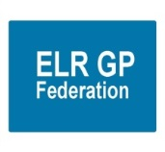
ELR GP Federation Ltd

Chief Operating Officer Report – September 2019

- Future of the Federation / ACDs update
- Six PCNs have confirmed that they will support the Federation – and become its Directors and contribute @ 20 p / patient to the Federation’s costs in FY19/20 – Option A in the next steps paper – see table 1 below. Cross Counties to finalise their decision.

Table 1 – ELR GP Federation Funding Options
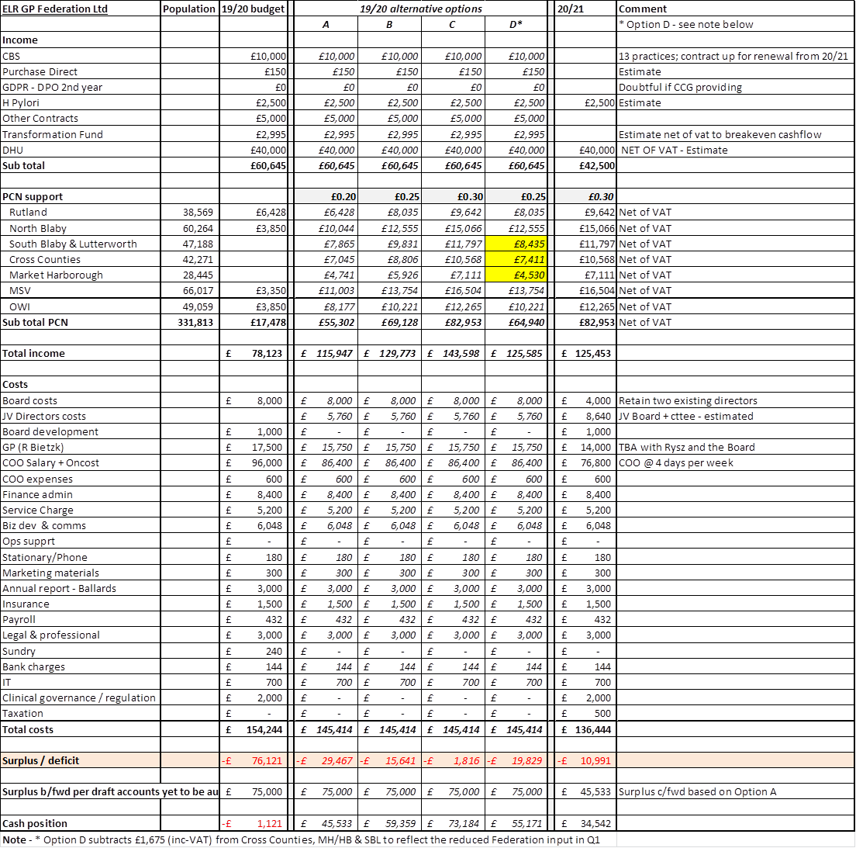

- JW supporting the ACD meetings and set the ACDs up on the GPTeamNet Federation portal.
- The ACD / Federation Board meetings are likely to merge from November 2019.
- JW to will liaise with LMC Law to adjust the Articles of Association.
- The AGM date will be moved to 14th November 2019.
- JW will reduce to 4 days per week wef 1st October 2019 – to be reviewed in March 2020.
- RB / ACDs to review his time allocation
- There will be a LLR PCN development fund @c £800K per annum for 5 years. There is the potential to use a proportion of this fund to develop Federation infrastructure / staff to support the ACDs / PCN working.
- JW has been supporting PCNs / Practices develop applications for the LLR Resilience Fund – this has included an application for ELR GP Federation (at the suggestion of the OWI PCN) – see Paper C.

- Primary Care Networks
- JW will draft a Business Plan for the ACDs / new Board. This will be based on the proposal that was prepared for the ACDs / PCNs whereby the Federation will build on its work so far with Practices to support PCN development and provide a forum for them to work together; in line with its strategic priorities;
- Local service delivery & business development - facilitating the delivery of more services locally; bidding collectively and / or holding contracts where it is helpful to do so
- Resilience and sustainability – innovating and transforming the way that services are delivered to address the pressures currently faced in the local health care system
- Effective voice - for our members across ELR
- Areas of ‘PCN support’ are outlined below. This list is not exhaustive and the plan is that the PCNs / ACDs will inform and direct how this evolves. The intention is to provide an equitable and consistent level of service, whilst recognising that PCNs’ needs will vary according to individual circumstances.

  - Network Agreement Schedules
  - PCN Business plan
  - Maturity Matrix support
  - Investment & impact fund preparation and proposal
  - ACD / PCN management support
  - Voice –strength in numbers
  - Legal entity – trading divisions
  - Facilitation / honest broker / change agent
  - Project management
  - Share knowledge - don’t reinvent the wheel
  - Back office
  - Demand management
  - Provide vehicle to engage at ‘ELR scale’ where appropriate; eg, with LPT, Public Health, CCG

- Contracts – Urgent Care, CBS, H Pylori, INR Star, GPTeamNet

- Pursue further contract income where possible and appropriate to work at scale - options include ENT, dermatology, minor surgery, diagnostics, Fracture Liaison Service, RSS. This may require CQC registration. Alternatively, we could use the Joint Venture with DHU.

- Diagnostic hubs
- JW is working with Alliance and West Federation colleagues to develop a Business Case to shift diagnostic services into Primary Care via PCNs wef April 2020;
  - 24 Hour BP
  - 24 Hour ECG
  - Spirometry
  - 12 Lead ECG
  - FeNo
- JW / GC have developed drafting for 24 hour BP & 24 hour ECG
- Alliance to circulate a draft Business Case w/c 23rd September 2019.
- Meeting scheduled for 15th October to develop the draft.
- In order for funds to be released from UHL, the Business Case will need the support of the wider LLR system including;
  - Clinical Reference Group(s)
  - Planned Care Board
  - Combined Commissioning Board
- PCNs need to determine how they will provide these services, including governance arrangements.
- Governance / training support is available via the Alliance (Dhiraj Vara [‘DD’]).

- Ear irrigation for housebound patients
- ELR CCG have asked Practices / PCNs if they could provide this service
- ACDs have confirmed that they wish to take this on
- JW working with the CCG / PCNs to develop the plan

- Fracture Liaison Service (FLS) project
- JW/GC have updated the Business Case, incorporating the comments and further information received from Tim Jones (Osteoporosis Society).
- Once Tim has reviewed this updated version we will pass it to the commissioners for comment.

- Other service development
- JW has expressed interest in the recent PCL services.
- JW will follow up with Dana Cadman to explore further how the Federation might be able to contribute to this service provision and the Referral Support Service.
- These may require CQC registration. Alternatively, we could use the Joint Venture with DHU; this possibility has been raised with DHU who would be happy to consider potential options.
- Localities & transformation fund update
- HP / JW are finalising the project budgets in order to make the final payments, as appropriate.
- JW to draft an overall summary report of the achievements of the TF projects, comparison between projects where appropriate, lessons learnt and recommendations.

- Urgent Care / extended primary care
- We await DHU’s advice in relation to the ‘hard’ and ‘soft’ Joint Venture options.
- The first JV Board meeting took place on 18th September 2019 – see paper D.

- NHS England; Clinical pharmacists in general practice Project
- The first Pharmacist (Pooja) started at the beginning of June 2019 and is working well.
- PSS have undertaken interviews for the replacement for the second Pharmacist and are confident of an appointment.
- There was some confusion in relation to the amount of funds claimed from NHS E from the County Hub. JW is working with the team to resolve this.
- A review will take place after 6 months.

- Community Based Services
- The contract is now in its third year of three – we await advice on the procurement process that LCC will use for FY20/21 onwards.
- HP has written to our sub-contracting practices to update their schedule of fitters and their evidence to practice and indemnity certificates.

- Correspondence management
- A workshop will be organized for participating Practices to update on their progress and share best practice.

- Demand Management
- RB is working with the CCG / East Mids / Lancs CSU review of demand management information.
- The future scope of the Federation’s input will be determined as part of the discussions with the PCN ACDs.

- Diabetes nurse specialists
- Additional funding has been identified to extend the project into FY19/20 and LHMP have agreed to employ the DSNs until March 2020.
- Louise Stanley who we originally appointed but was initially unable to provide any sessions to the project, has now started.
- Appraisals will be conducted with the team jointly by James Watkins and Mary Harrison from the Leicester Diabetes Centre.

- GP TeamNet
- The tool is being used by Practices and Localities to varying degrees and each Locality has a portal which will help with PCN development.
- The ELR GP Federation Portal is now being used for the ACDs / Federation Board.
- We have the opportunity to arrange further workshops to support PCN development.
- The two-factor login arrangements have been developed which will enable the CCG to use the tool – these are/will be piloted.
- GP TeamNet has functionality that could support internal ‘bank’ working.

- H Pylori
- We await written confirmation that the contract will be rolled forward into FY19/20. We continue to provide the service and claim for the funding.

- GDPR – DPO service
- The CCG have confirmed that they will pay for the service that was provided in June 2019.

- INR STAR
- We are arranging for the CCG to pay for the final two weeks on March 2019.

- Second blood collection
- Yasmin Sidyot (Acting Director of Urgent and Emergency Care) has advised that this work has not progressed but will be picked-up once her Deputy is in place.

- Active signposting
- Two sessions with the OWI and Rutland Practices have now taken place (March and July 2019).
- A final session will be scheduled for Oct/Nov 2019.

- Finance
- A finance update will be tabled at the meeting.
- RW has developed a series of questions to audit the Federation’s financial management process – see Paper E – HP/JW will respond to these and develop actions, as required, for Robert to review.
- As indicated at the last meeting, further to Ballards advice (see below), we will arrange for the Employer’s Allowance to be stopped / repaid, as appropriate.
- The Management Liability insurance has been renewed. The premium was slightly higher due to the projected deficit in FY19/20.

Ballards advice in relation to the Employers Allowance

‘As you know, if you get 50% of your income from the NHS, then you don’t get the EA. The thinking behind this was to prevent GPs and hospitals and the like receiving the allowance.

Personally, I think you are in a different position though in that whilst most of your income comes from the NHS, it could be argued that this is in the form of a grant. Any income from GP practices is not NHS income as these are private businesses.

Strictly, I think the rules would mean you need to repay the Allowance, but you may think a different stance can be justified.’

